Figure S1
R² Distributions for the Childhood Temperament-Only and Personality-Only Models for Health Outcomes
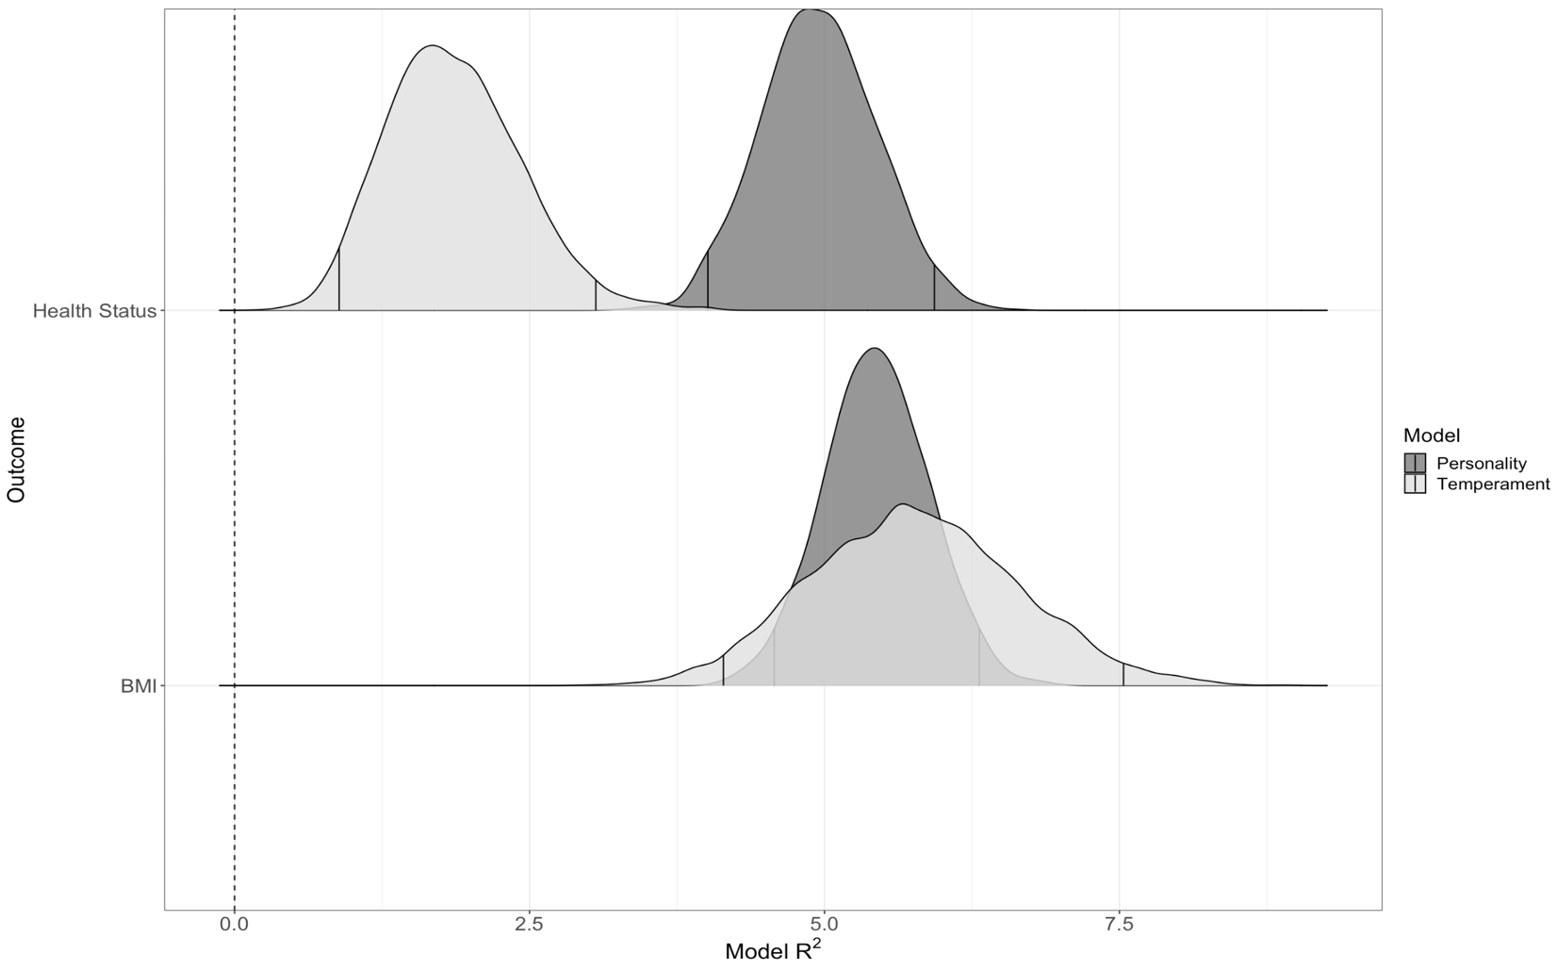
Note. R² values are presented as percentages. The R² for the temperament-only models is plotted in light gray. The R² for the adult-based personality-only models is plotted in dark gray. The 95% credible intervals, representing the R² values that were present in 95% of the posterior distributions, are outlined in each distribution. To the extent that the light gray and dark gray overlap with each other, the childhood temperament traits and adult-based personality traits account for a similar amount of variance in predicting the respective outcome in their separate models.

Figure S2
R² Distributions for the Childhood Temperament-Only and Personality-Only Models for Internalizing Outcomes
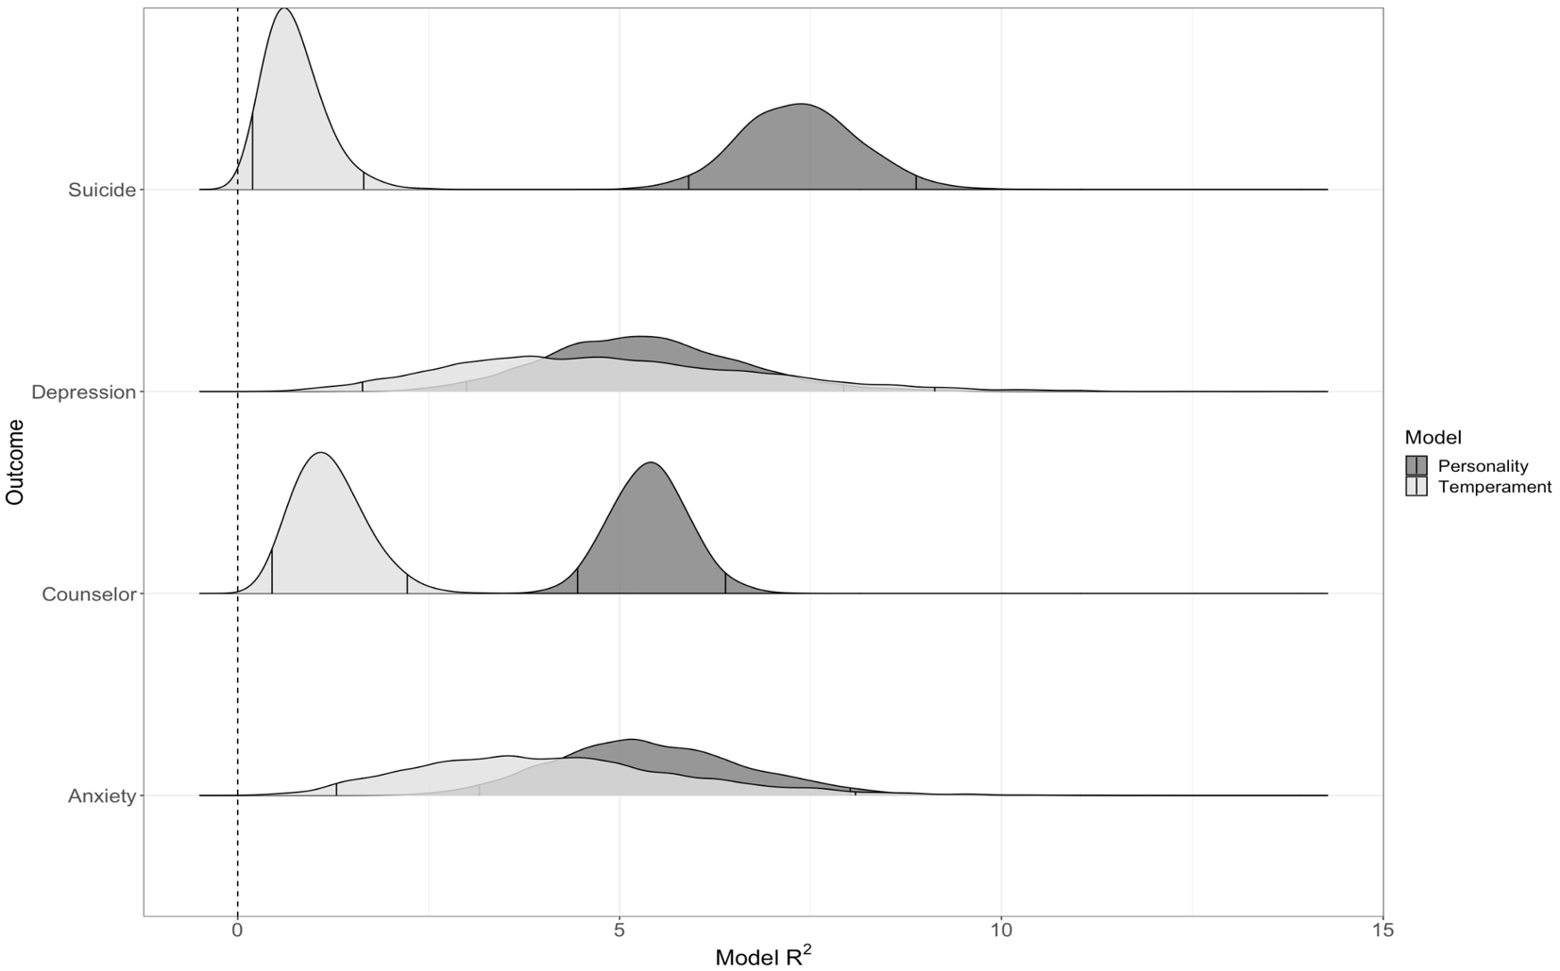
Note. R² values are presented as percentages. The R² for the temperament-only models is plotted in light gray. The R² for the adult-based personality-only models is plotted in dark gray. The 95% credible intervals, representing the R² values that were present in 95% of the posterior distributions, are outlined in each distribution. To the extent that the light gray and dark gray overlap with each other, the childhood temperament traits and adult-based personality traits account for a similar amount of variance in predicting the respective outcome in their separate models.

Figure S3
R² Distributions for the Childhood Temperament-Only and Personality-Only Models for Externalizing Outcomes
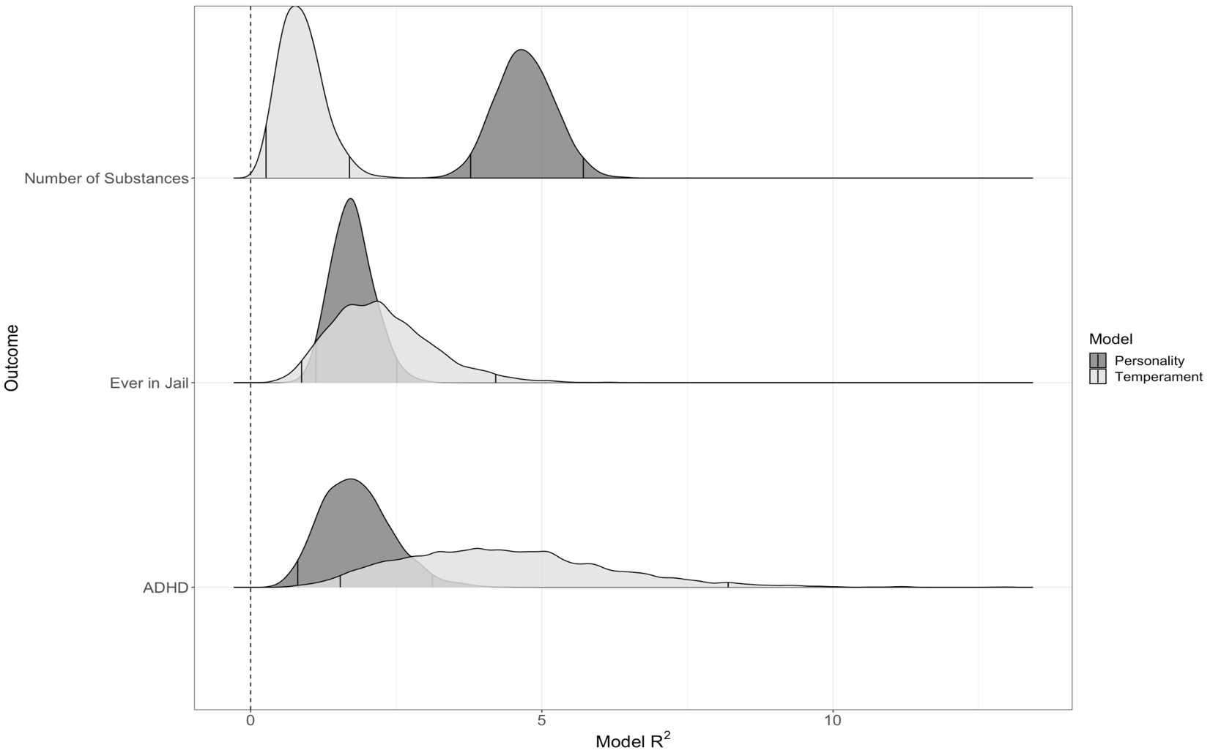
Note. R² values are presented as percentages. The R² for the temperament-only models is plotted in light gray. The R² for the adult-based personality-only models is plotted in dark gray. The 95% credible intervals, representing the R² values that were present in 95% of the posterior distributions, are outlined in each distribution. To the extent that the light gray and dark gray overlap with each other, the childhood temperament traits and adult-based personality traits account for a similar amount of variance in predicting the respective outcome in their separate models.

Figure S4
R² Distributions for the Childhood Temperament-Only and Personality-Only Models for Cognitive Outcomes
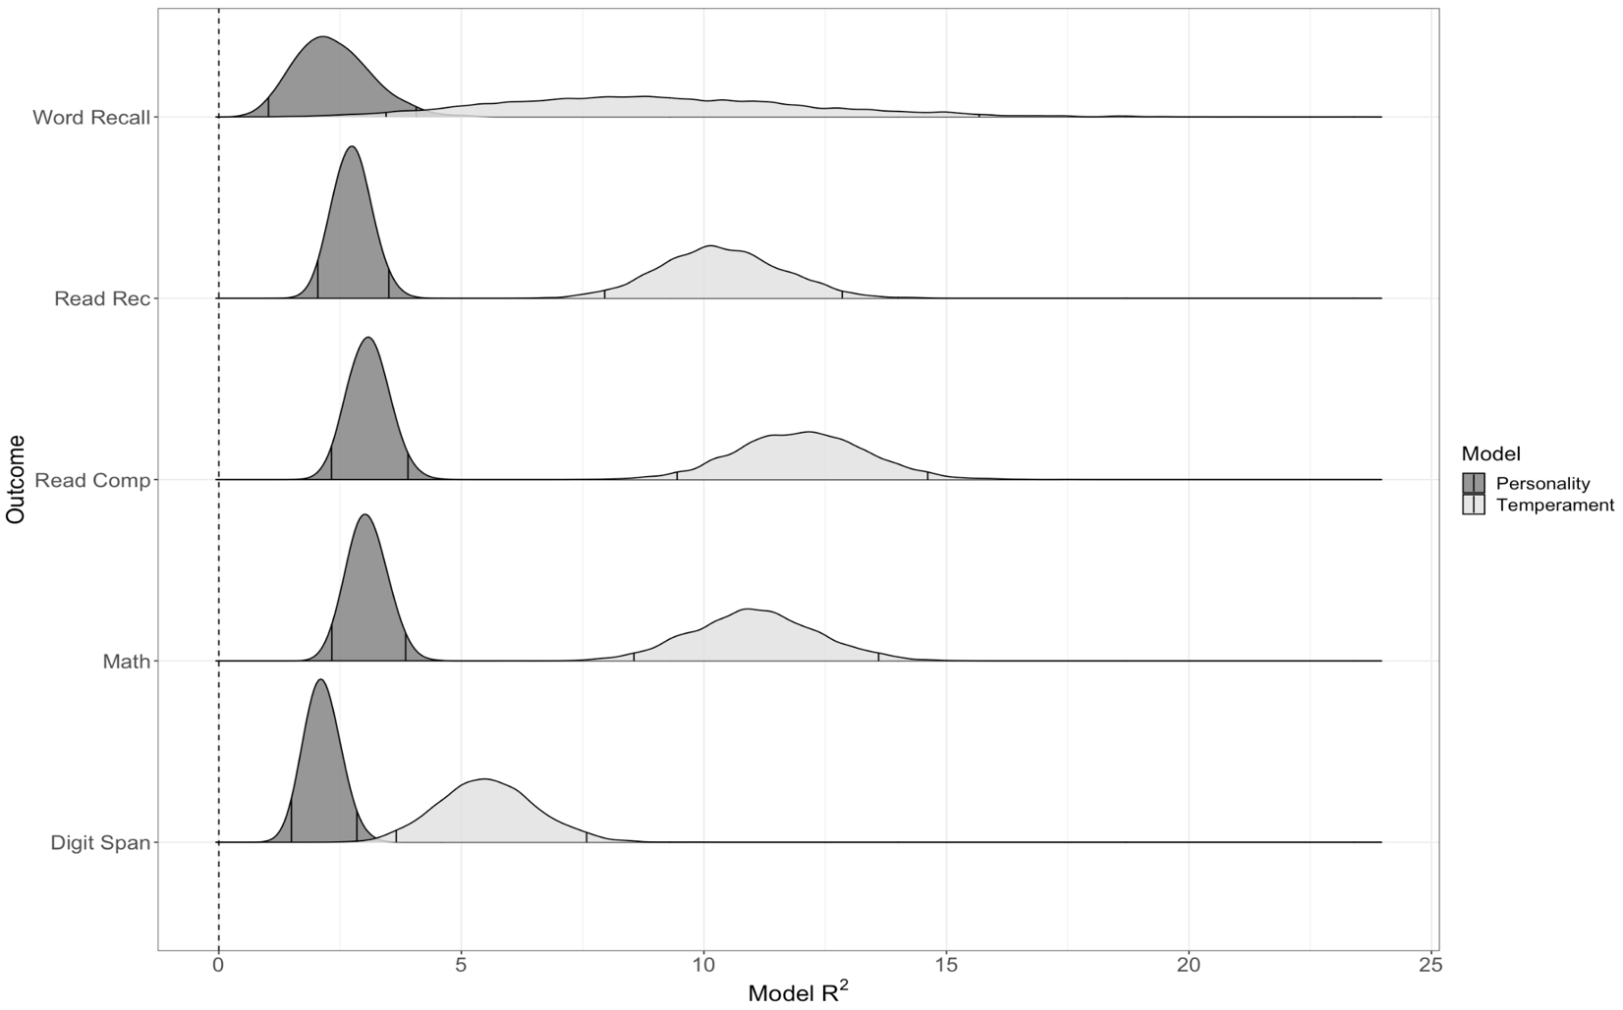
Note. R² values are presented as percentages. The R² for the temperament-only models is plotted in light gray. The R² for the adult-based personality-only models is plotted in dark gray. The 95% credible intervals, representing the R² values that were present in 95% of the posterior distributions, are outlined in each distribution. To the extent that the light gray and dark gray overlap with each other, the childhood temperament traits and adult-based personality traits account for a similar amount of variance in predicting the respective outcome in their separate models.

Figure S5
R² Distributions for the Childhood Temperament-Only and Personality-Only Models for Relationship & Family Outcomes
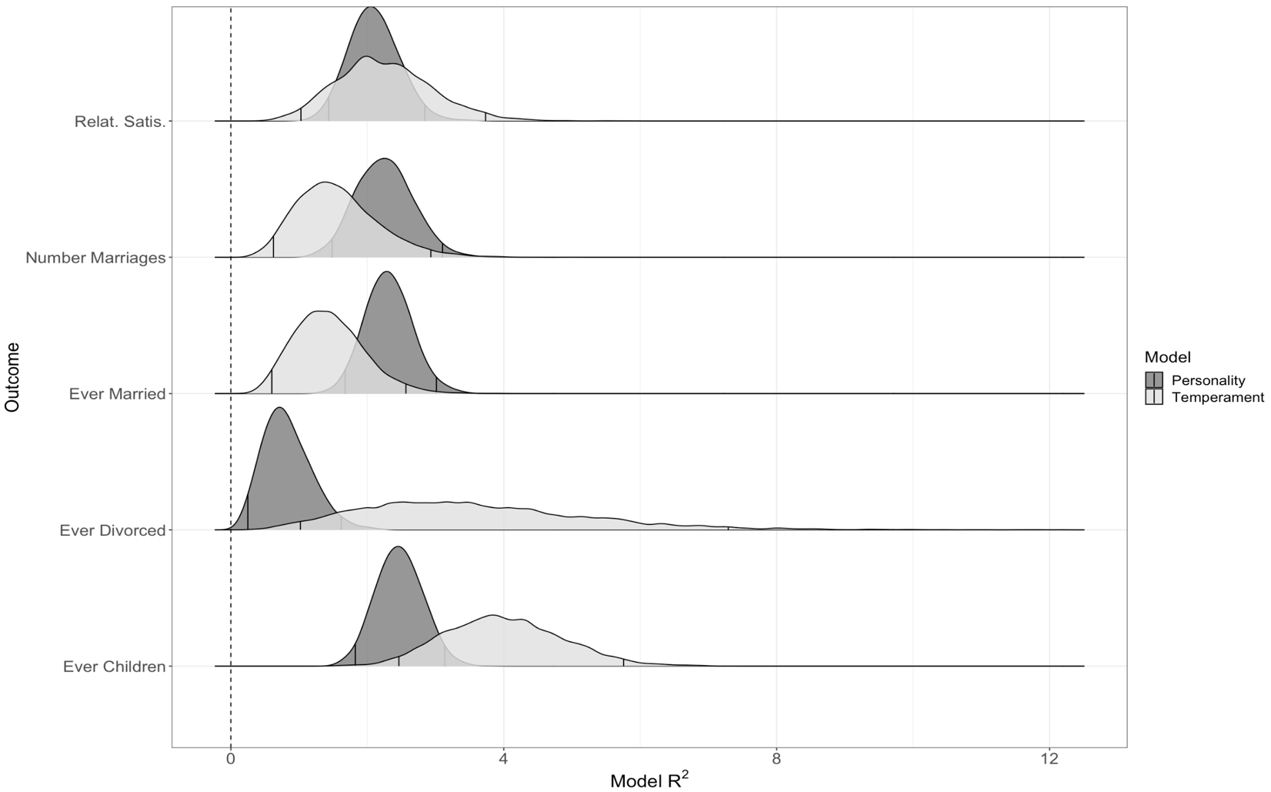
Note. R² values are presented as percentages. The R² for the temperament-only models is plotted in light gray. The R² for the adult-based personality-only models is plotted in dark gray. The 95% credible intervals, representing the R² values that were present in 95% of the posterior distributions, are outlined in each distribution. To the extent that the light gray and dark gray overlap with each other, the childhood temperament traits and adult-based personality traits account for a similar amount of variance in predicting the respective outcome in their separate models.

Figure S6
R² Distributions for the Childhood Temperament-Only and Personality-Only Models for Education, Career, & Financial Outcomes
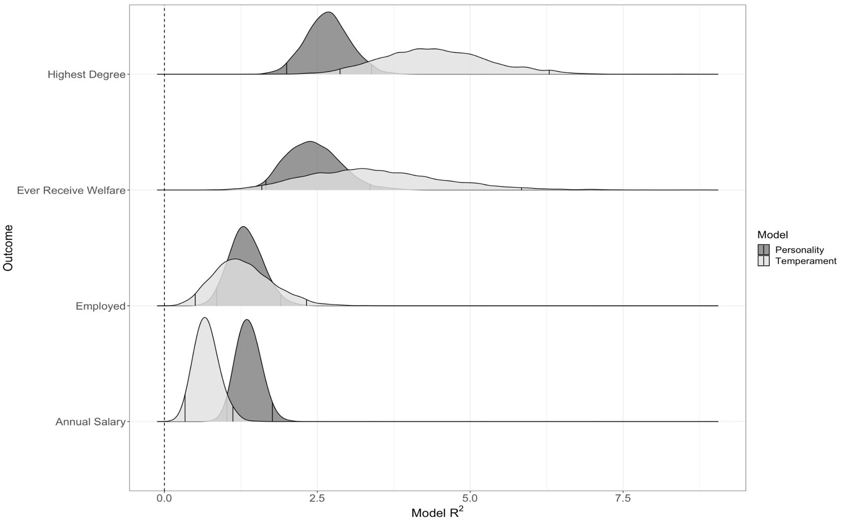
Note. R² values are presented as percentages. The R² for the temperament-only models is plotted in light gray. The R² for the adult-based personality-only models is plotted in dark gray. The 95% credible intervals, representing the R² values that were present in 95% of the posterior distributions, are outlined in each distribution. To the extent that the light gray and dark gray overlap with each other, the childhood temperament traits and adult-based personality traits account for a similar amount of variance in predicting the respective outcome in their separate models.

Figure S7
R² Distributions for the Childhood Temperament-Only and Personality-Only Models for Civic Engagement Outcomes
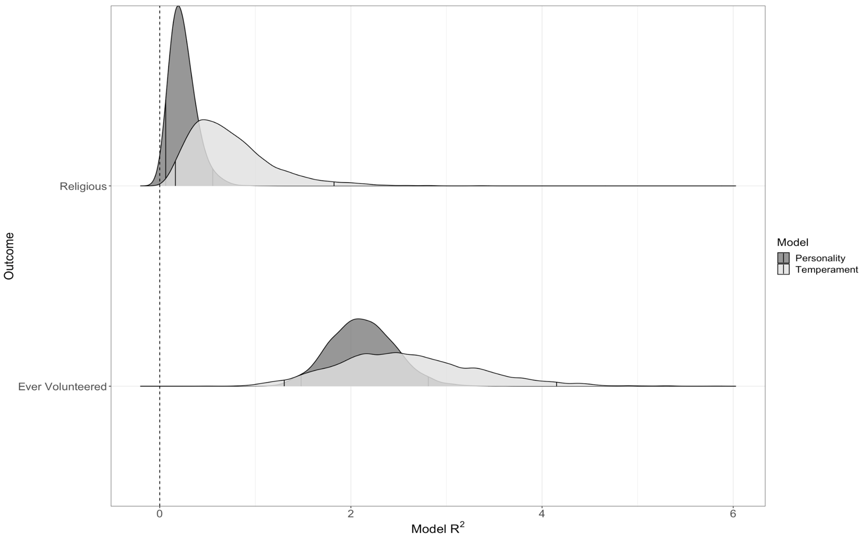
Note. R² values are presented as percentages. The R² for the temperament-only models is plotted in light gray. The R² for the adult-based personality-only models is plotted in dark gray. The 95% credible intervals, representing the R² values that were present in 95% of the posterior distributions, are outlined in each distribution. To the extent that the light gray and dark gray overlap with each other, the childhood temperament traits and adult-based personality traits account for a similar amount of variance in predicting the respective outcome in their separate models.

Figure S8
R² Distributions for the Combined Models and the Incremental Proportion of Variance Accounted for by Childhood Temperament for Health Outcomes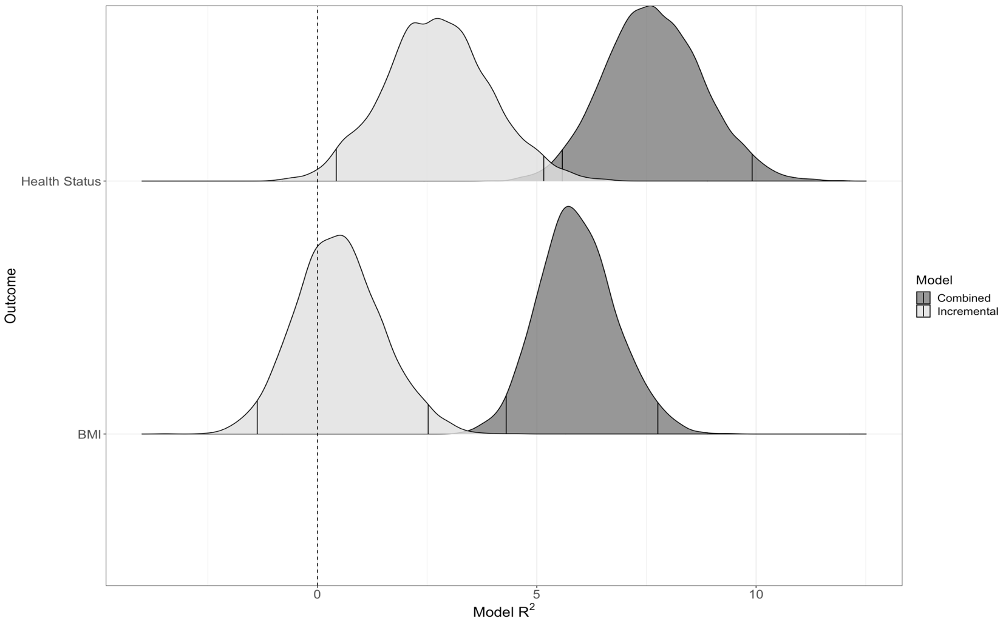
Note. R² values are presented as percentages. The R² for the combined models (temperament & personality predictors) is plotted in dark gray. The portion of the combined R² that has the R² accounted for by the personality traits subtracted out is plotted in light gray (i.e., temperament’s incremental contribution). The 95% credible intervals, representing the R² values that were present in 95% of the posterior distributions, are outlined in each distribution. To the extent that the light gray and dark gray overlap with each other, the temperament traits then account for most of the variance in predicting the respective outcome.

Figure S9
R² Distributions for the Combined Models and the Incremental Proportion of Variance Accounted for by Childhood Temperament for Internalizing Outcomes
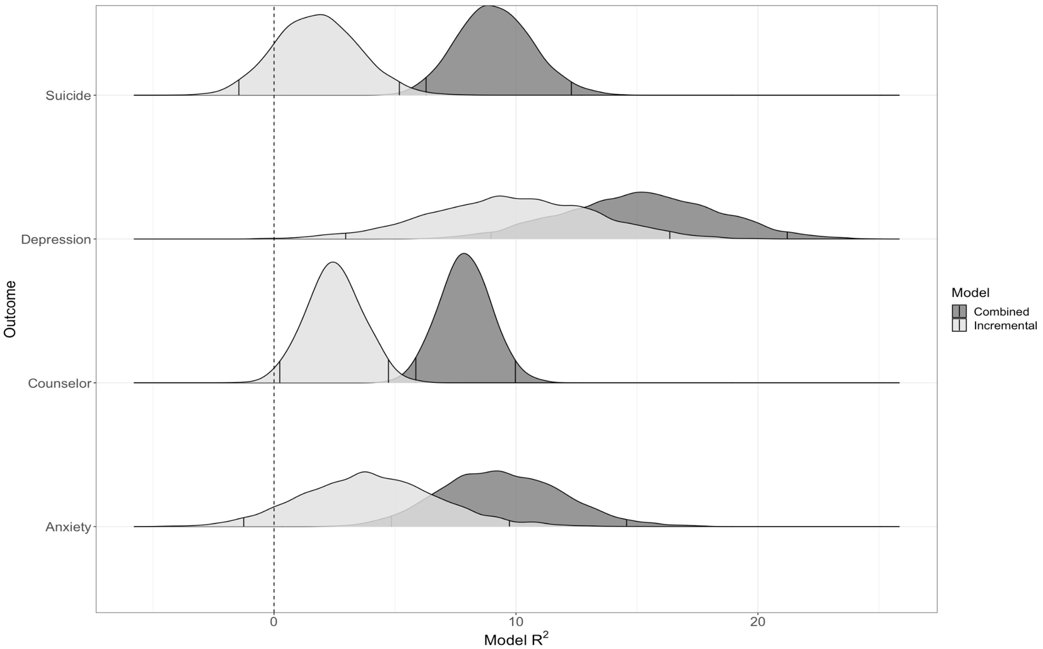
Note. R² values are presented as percentages. The R² for the combined models (temperament & personality predictors) is plotted in dark gray. The portion of the combined R² that has the R² accounted for by the personality traits subtracted out is plotted in light gray (i.e., temperament’s incremental contribution). The 95% credible intervals, representing the R² values that were present in 95% of the posterior distributions, are outlined in each distribution. To the extent that the light gray and dark gray overlap with each other, the temperament traits then account for most of the variance in predicting the respective outcome.

Figure S10
R² Distributions for the Combined Models and the Incremental Proportion of Variance Accounted for by Childhood Temperament for Externalizing Outcomes
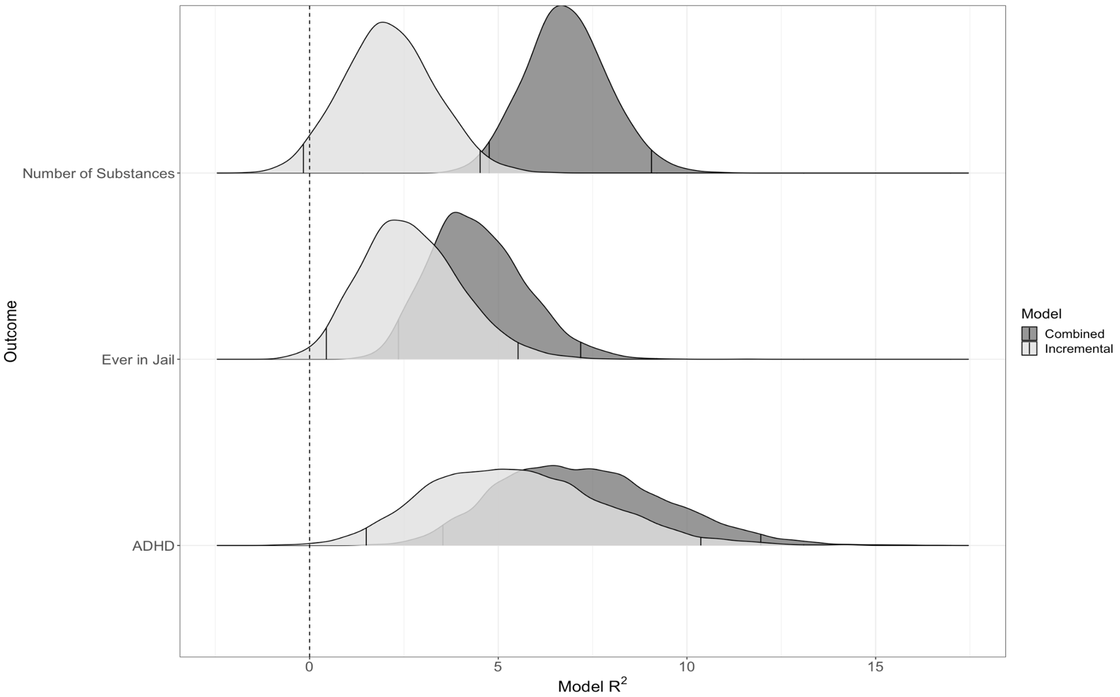
Note. R² values are presented as percentages. The R² for the combined models (temperament & personality predictors) is plotted in dark gray. The portion of the combined R² that has the R² accounted for by the personality traits subtracted out is plotted in light gray (i.e., temperament’s incremental contribution). The 95% credible intervals, representing the R² values that were present in 95% of the posterior distributions, are outlined in each distribution. To the extent that the light gray and dark gray overlap with each other, the temperament traits then account for most of the variance in predicting the respective outcome.

Figure S11
R² Distributions for the Combined Models and the Incremental Proportion of Variance Accounted for by Childhood Temperament for Cognitive Outcomes
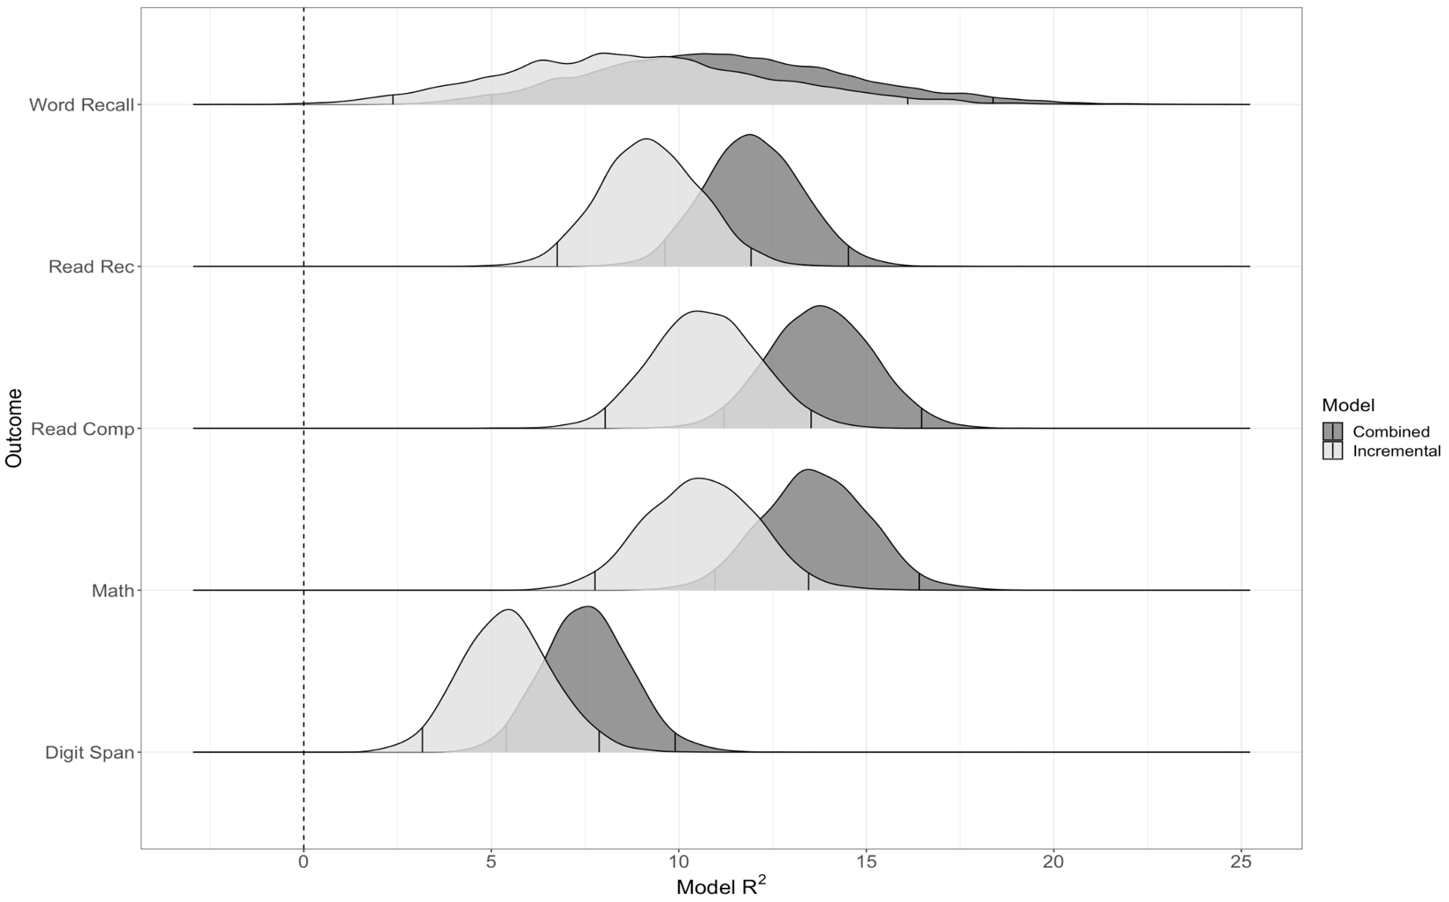
Note. R² values are presented as percentages. The R² for the combined models (temperament & personality predictors) is plotted in dark gray. The portion of the combined R² that has the R² accounted for by the personality traits subtracted out is plotted in light gray (i.e., temperament’s incremental contribution). The 95% credible intervals, representing the R² values that were present in 95% of the posterior distributions, are outlined in each distribution. To the extent that the light gray and dark gray overlap with each other, the temperament traits then account for most of the variance in predicting the respective outcome.

Figure S12
R² Distributions for the Combined Models and the Incremental Proportion of Variance Accounted for by Childhood Temperament for Relationship & Family Outcomes
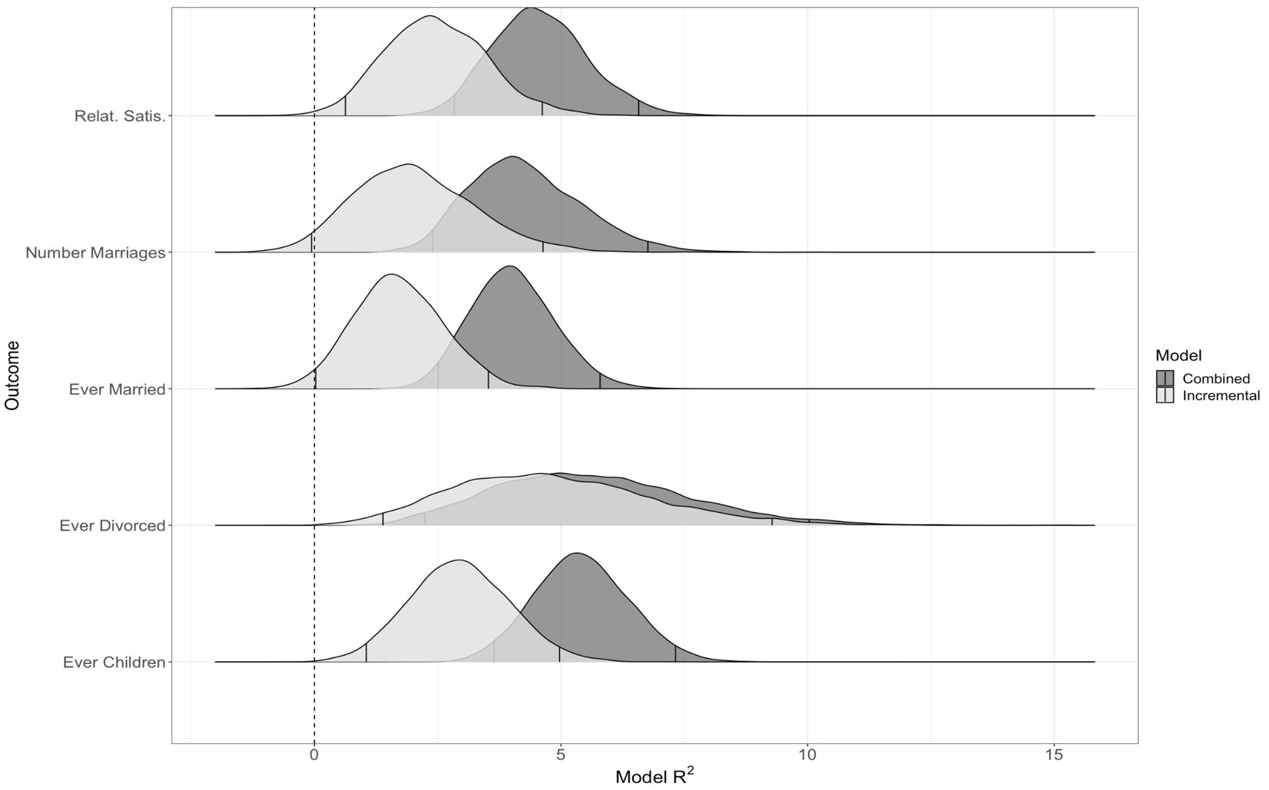
Note. R² values are presented as percentages. The R² for the combined models (temperament & personality predictors) is plotted in dark gray. The portion of the combined R² that has the R² accounted for by the personality traits subtracted out is plotted in light gray (i.e., temperament’s incremental contribution). The 95% credible intervals, representing the R² values that were present in 95% of the posterior distributions, are outlined in each distribution. To the extent that the light gray and dark gray overlap with each other, the temperament traits then account for most of the variance in predicting the respective outcome.

Figure S13
R² Distributions for the Combined Models and the Incremental Proportion of Variance Accounted for by Childhood Temperament for Education, Career, & Financial Outcomes
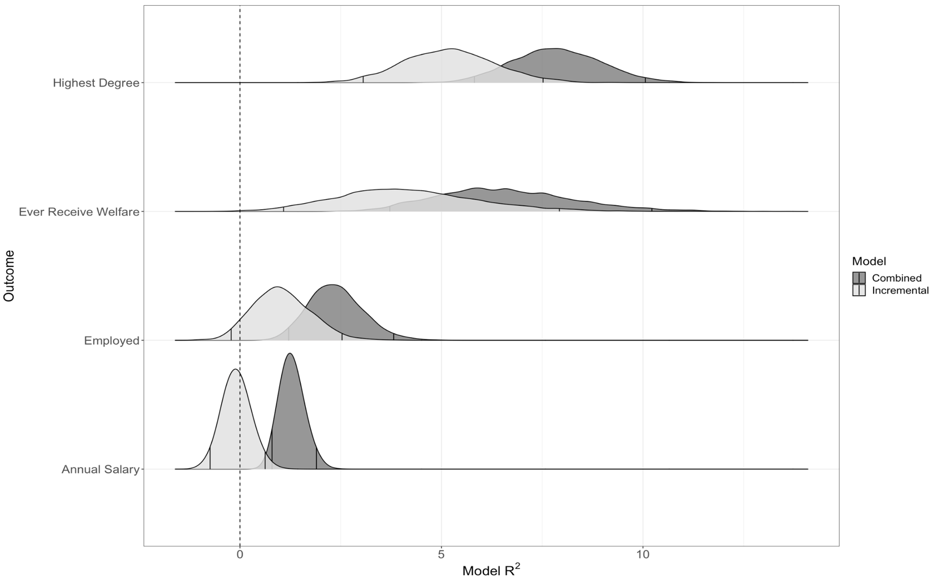
Note. R² values are presented as percentages. The R² for the combined models (temperament & personality predictors) is plotted in dark gray. The portion of the combined R² that has the R² accounted for by the personality traits subtracted out is plotted in light gray (i.e., temperament’s incremental contribution). The 95% credible intervals, representing the R² values that were present in 95% of the posterior distributions, are outlined in each distribution. To the extent that the light gray and dark gray overlap with each other, the temperament traits then account for most of the variance in predicting the respective outcome.

Figure S14
R² Distributions for the Combined Models and the Incremental Proportion of Variance Accounted for by Childhood Temperament for Civic Engagement Outcomes
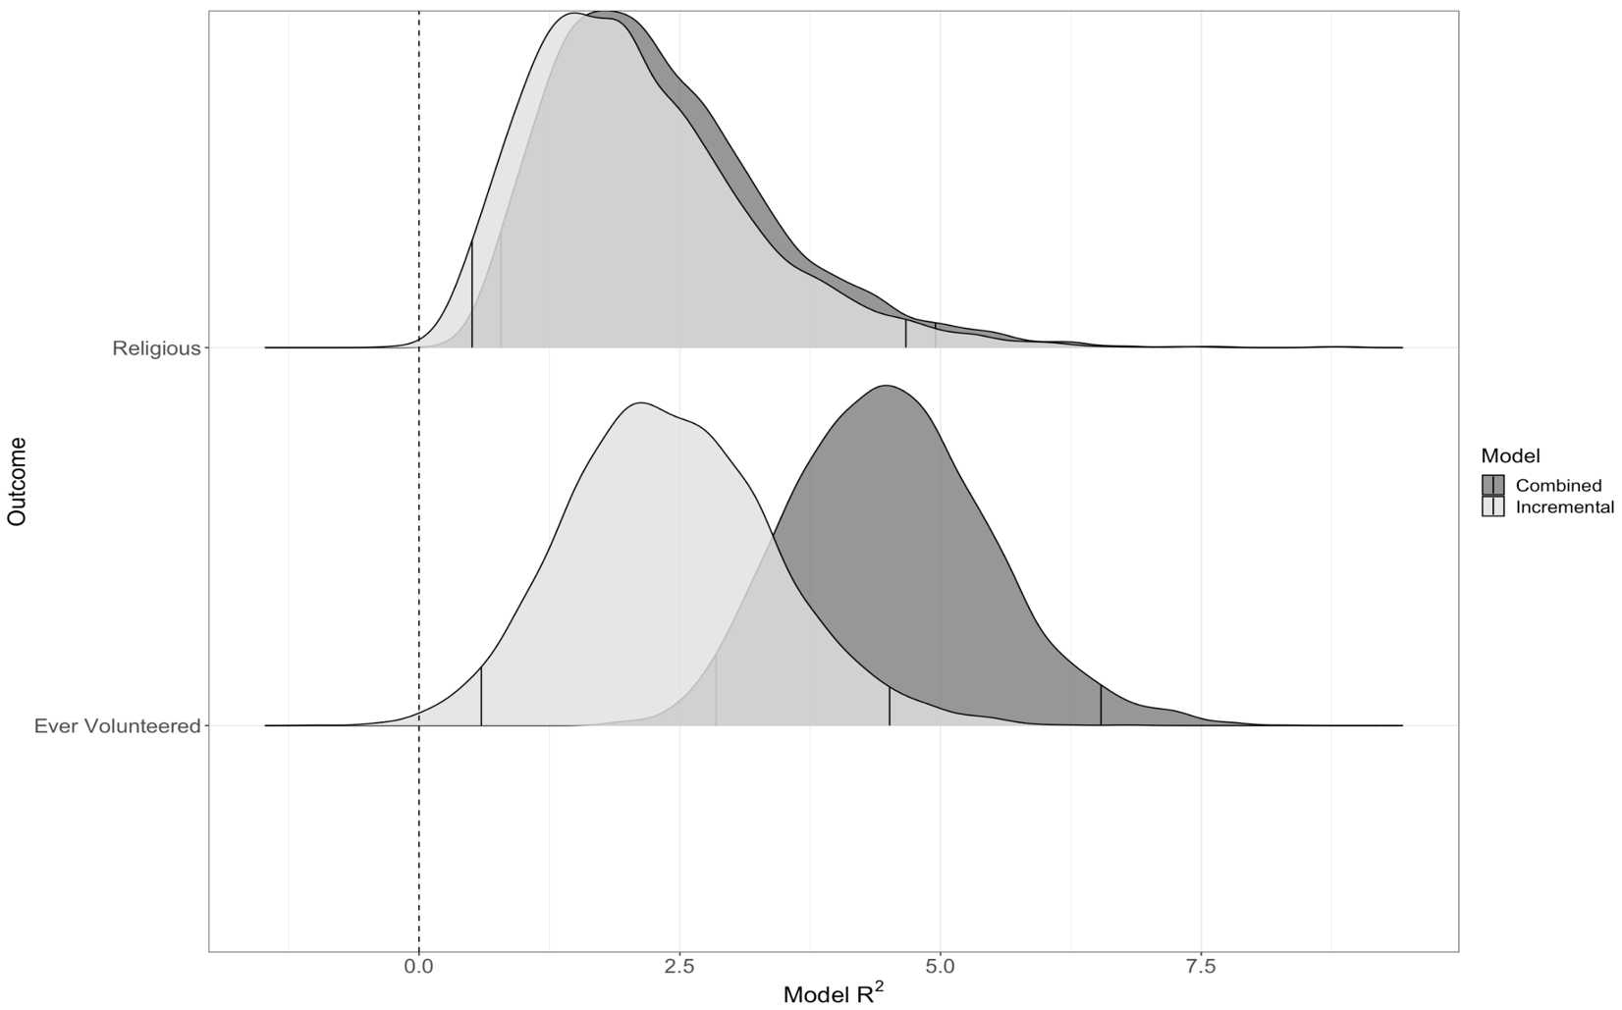
Note. R² values are presented as percentages. The R² for the combined models (temperament & personality predictors) is plotted in dark gray. The portion of the combined R² that has the R² accounted for by the personality traits subtracted out is plotted in light gray (i.e., temperament’s incremental contribution). The 95% credible intervals, representing the R² values that were present in 95% of the posterior distributions, are outlined in each distribution. To the extent that the light gray and dark gray overlap with each other, the temperament traits then account for most of the variance in predicting the respective outcome.

