Appendix A. Search Strategy Example

PsycINFO:
((((MJMAINSUBJECT.EXACT.EXPLODE("Teachers"))) OR noft(school teacher*) OR noft(teacher*) OR noft(teacher trainee) OR noft(pre-service teacher*) OR noft(educator)) AND (noft(treat*) OR noft(interven*) OR noft(program*) OR noft(train*) OR (noft(("support group" OR "support groups"))) OR noft("professional development")) AND ((MAINSUBJECT.EXACT("Mental Disorders") OR MJMAINSUBJECT.EXACT("Mental Health") OR noft("mental health") OR (noft("mental disorder") OR noft("mental disorders")) OR noft(anxi*) OR noft(mood) OR noft(depress*) OR noft(trauma*) OR noft(sleep) OR noft(insomnia) OR noft(stress) OR noft(distress*) OR noft(burn?out) OR noft(exhaust*) OR noft(well-being) OR noft(wellbeing) OR noft("life satisfaction") OR noft("quality of life"))))

Appendix B. Forest Plots

Randomised Controlled Trials
Figure 2.
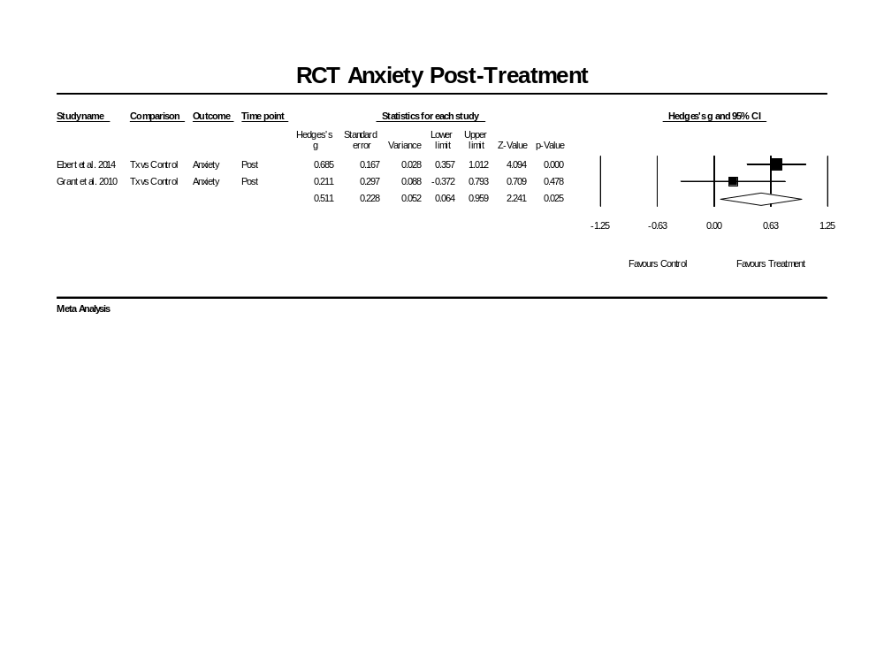
Forest Plot for Anxiety
Figure 3.
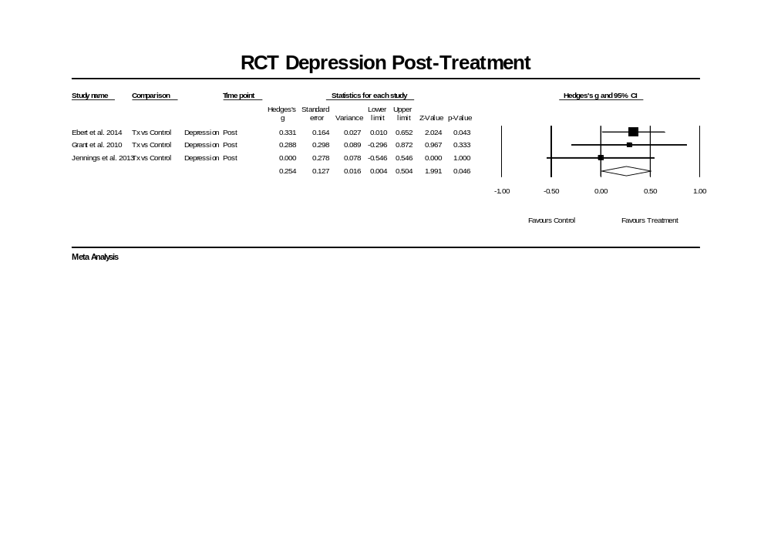
Forest Plot for Depression

Figure 4.
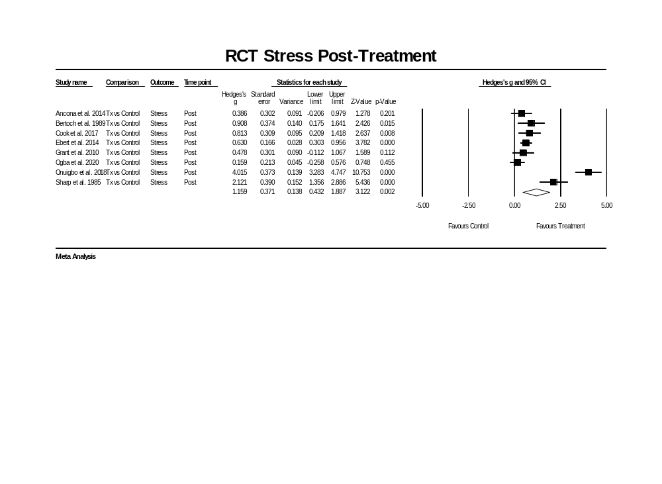
Forest Plot for Stress
Figure 5.
Forest Plot for Psychological Distress
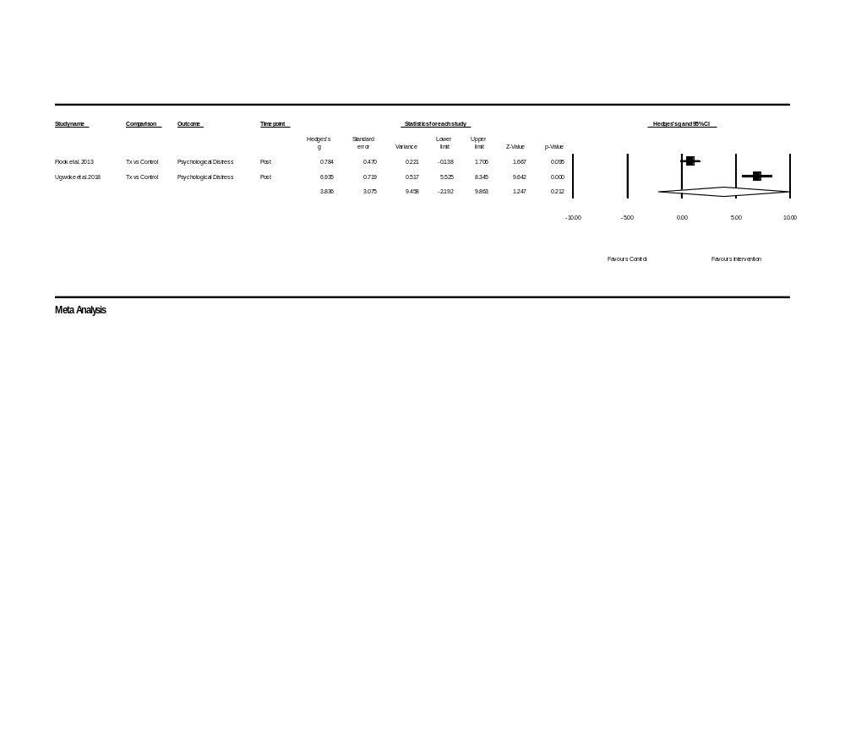

Figure 6.
Forest Plot for Burnout
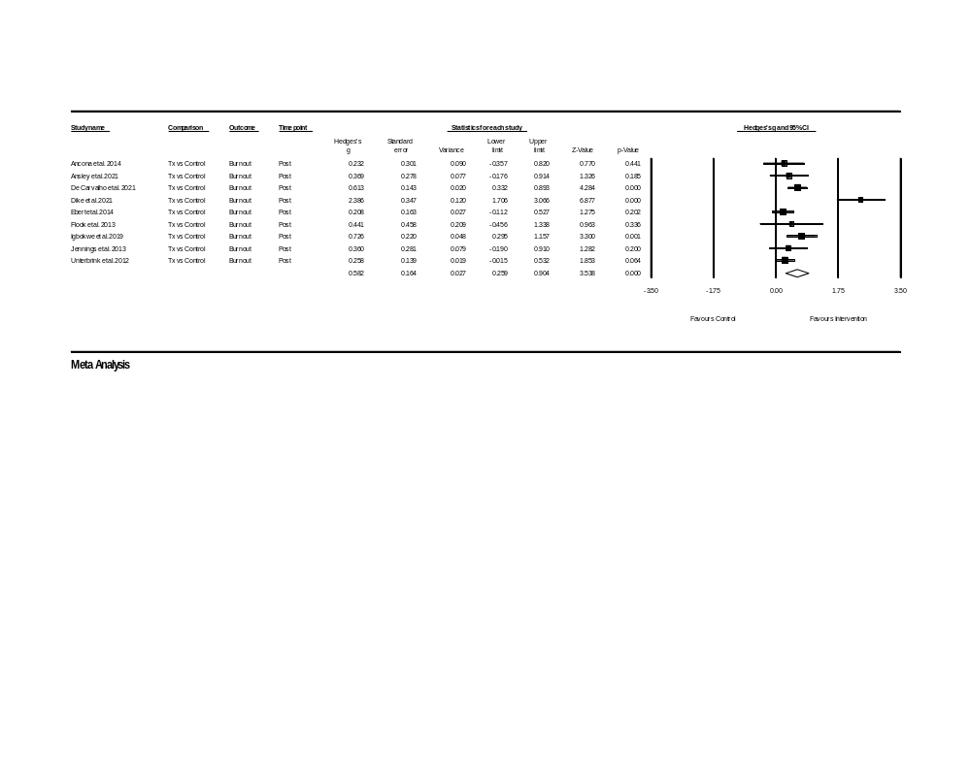
Figure 7.
Forest Plot for Wellbeing
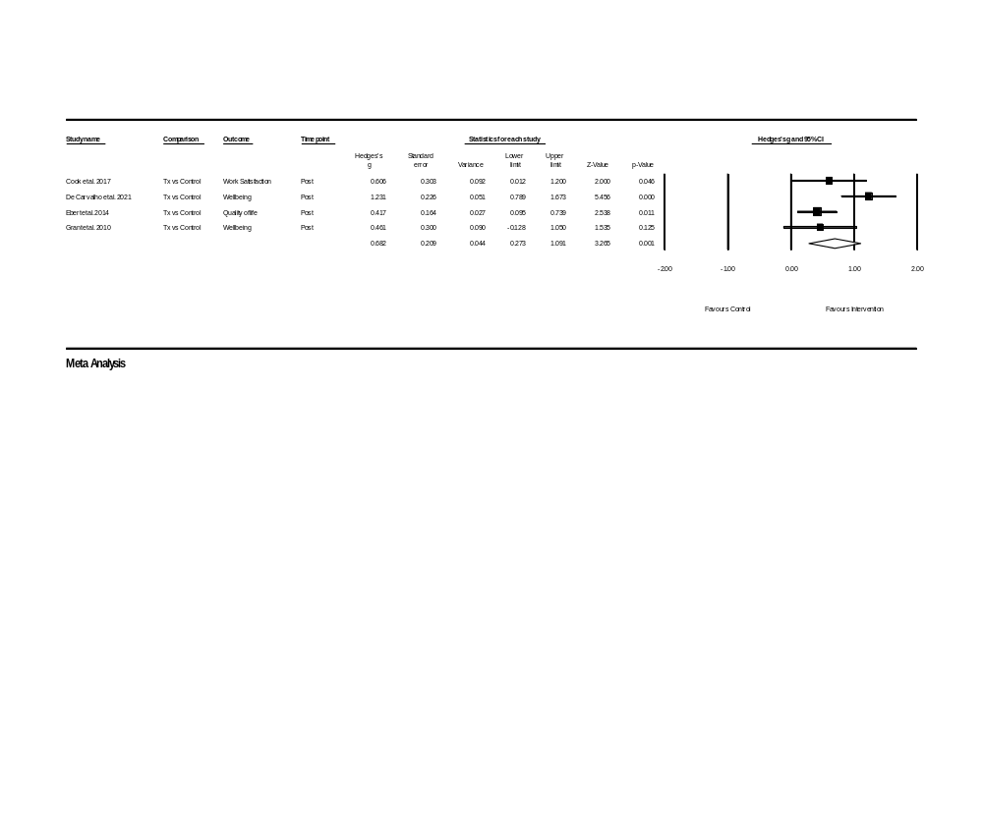
Non-Randomised Controlled Trials
Figure 8.
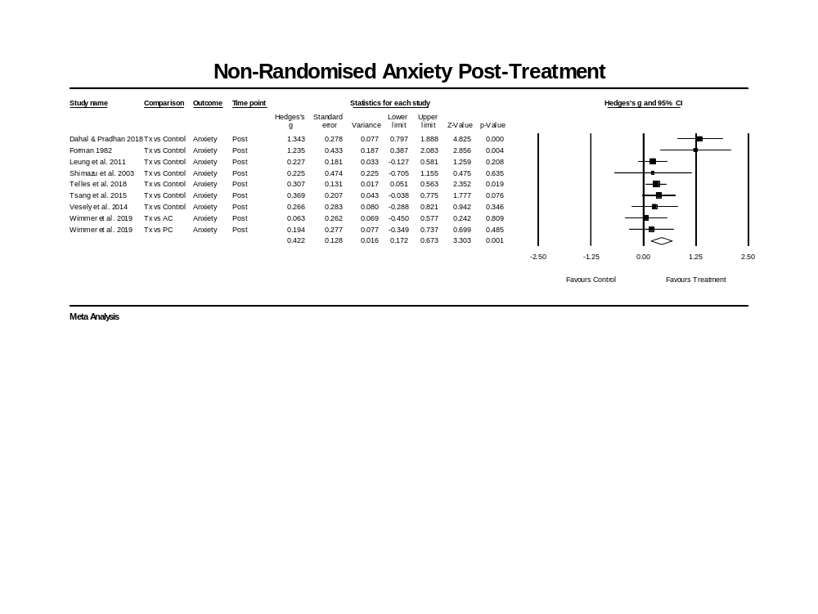
Forest Plot for Anxiety
Figure 9.
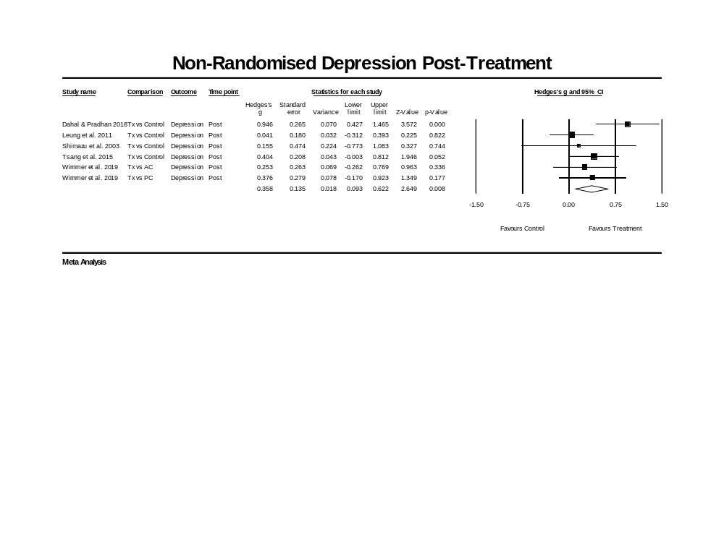
Forest Plot for Depression
Figure 10.
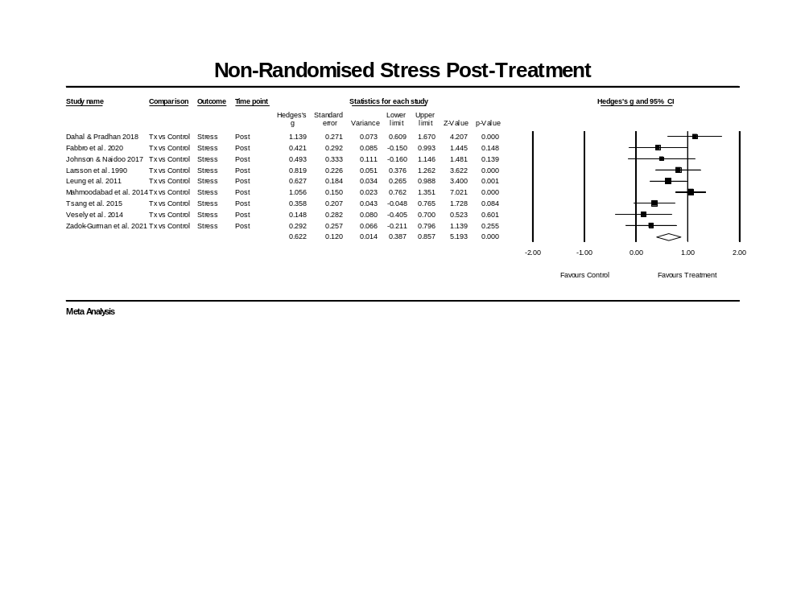
Forest Plot for Stress
Figure 11.
Forest Plot for Burnout
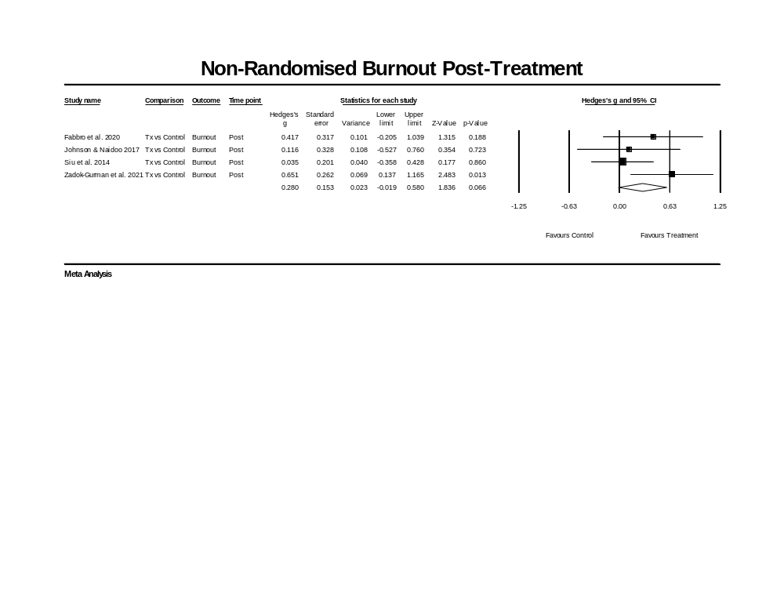
Figure 12.
Forest Plot for Somatisation
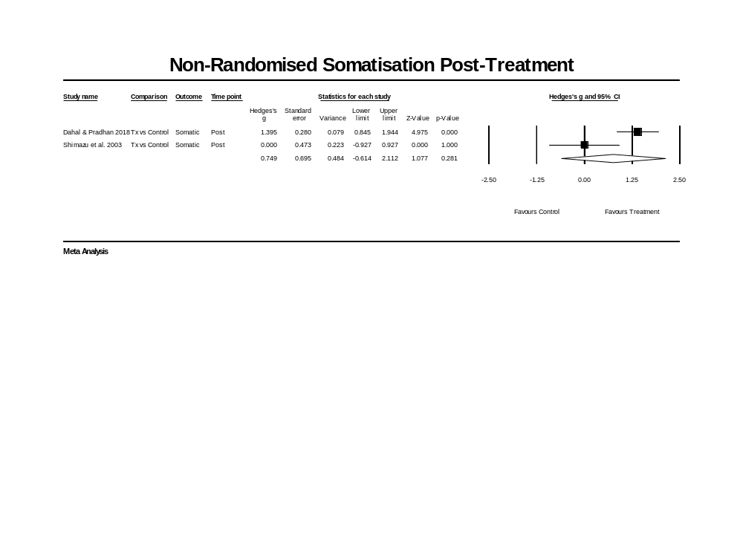
Figure 13.
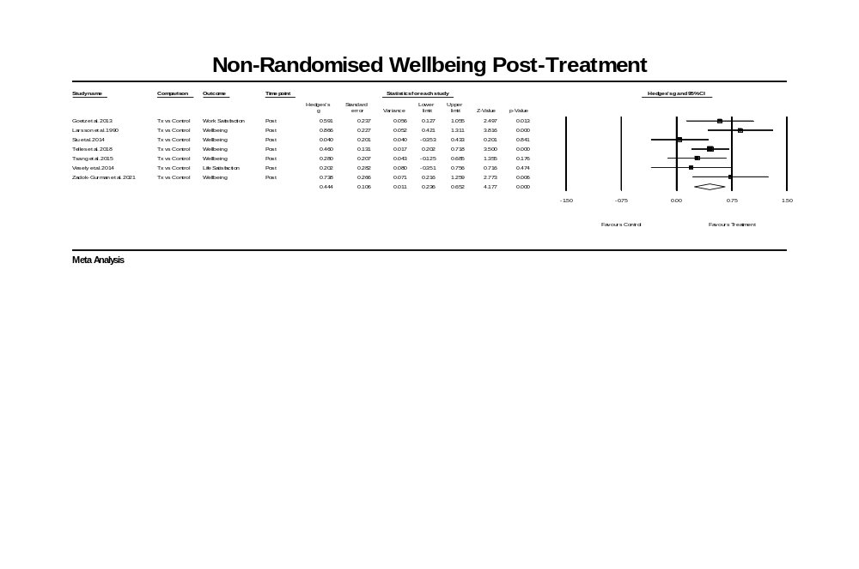
Forest Plot for Wellbeing

