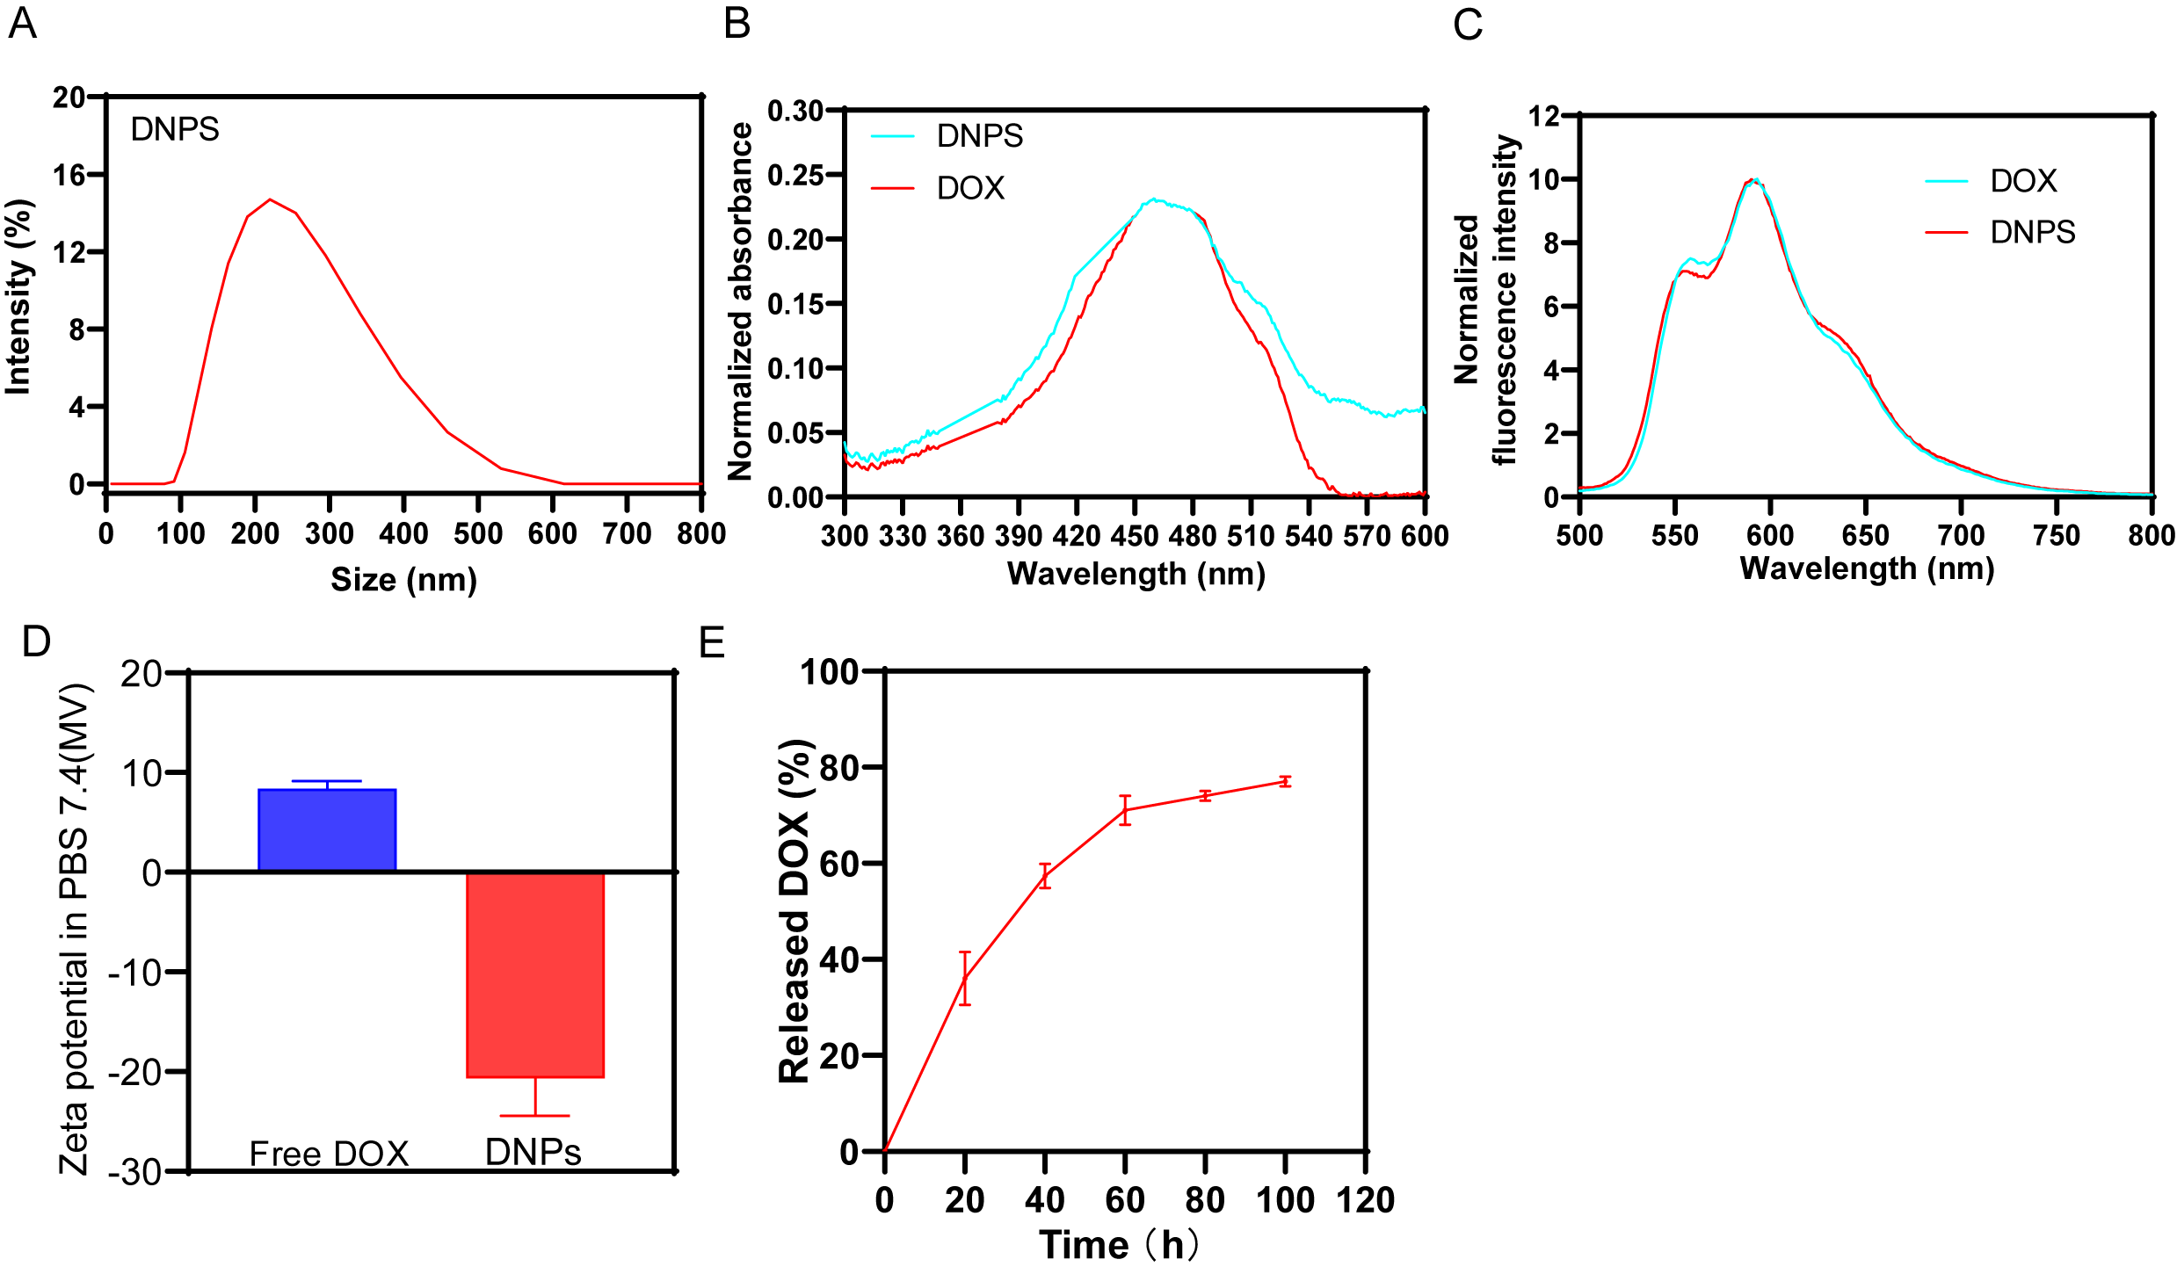
SFigure 1. Characterization of DNPS. (A)Size distribution of DNPs. (B) UV–Vis absorption spectra of DNPs. C) Fluorescence spectra of the DHCNPs.（D) Zeta potential of the DNPS (E) the relased DOX of DNPS in different PH.
SFigure 2. Treg cell connected with DNPS. Confocal laser scanning microscopy (CLSM) images of Treg-DNPS. DNPS was conjugatedto the Treg cell surface via the DBCO/N3 click reaction.
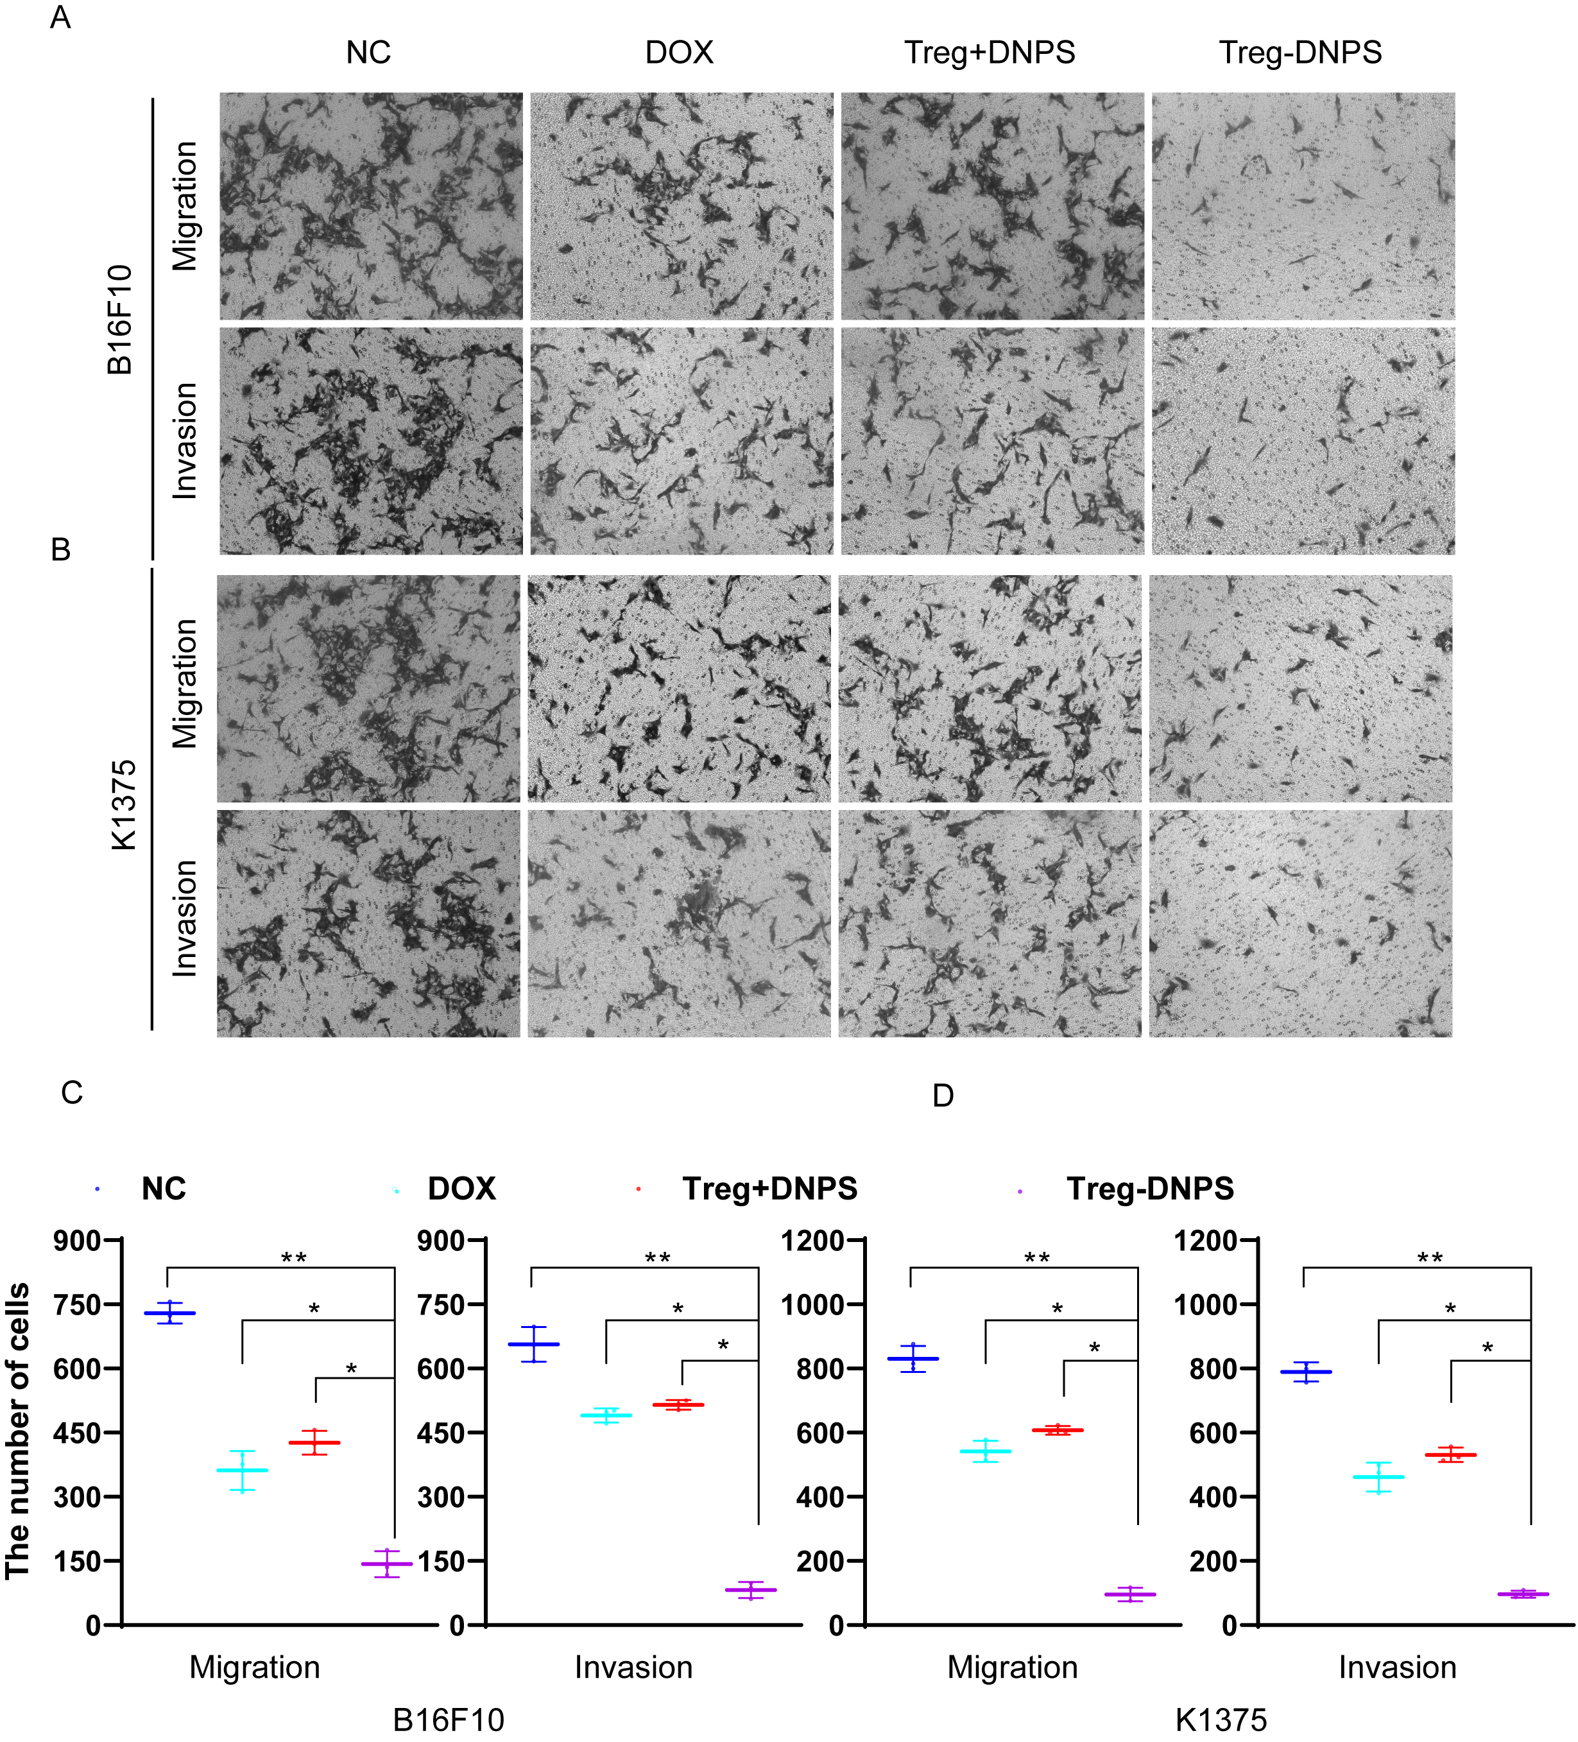
SFigure 3. The inhibition of cancer cell migration and invasion of Treg-DNPS. (A-B) the cancer cell numbers through the transwell. (C) Statistical results of cell numbers.
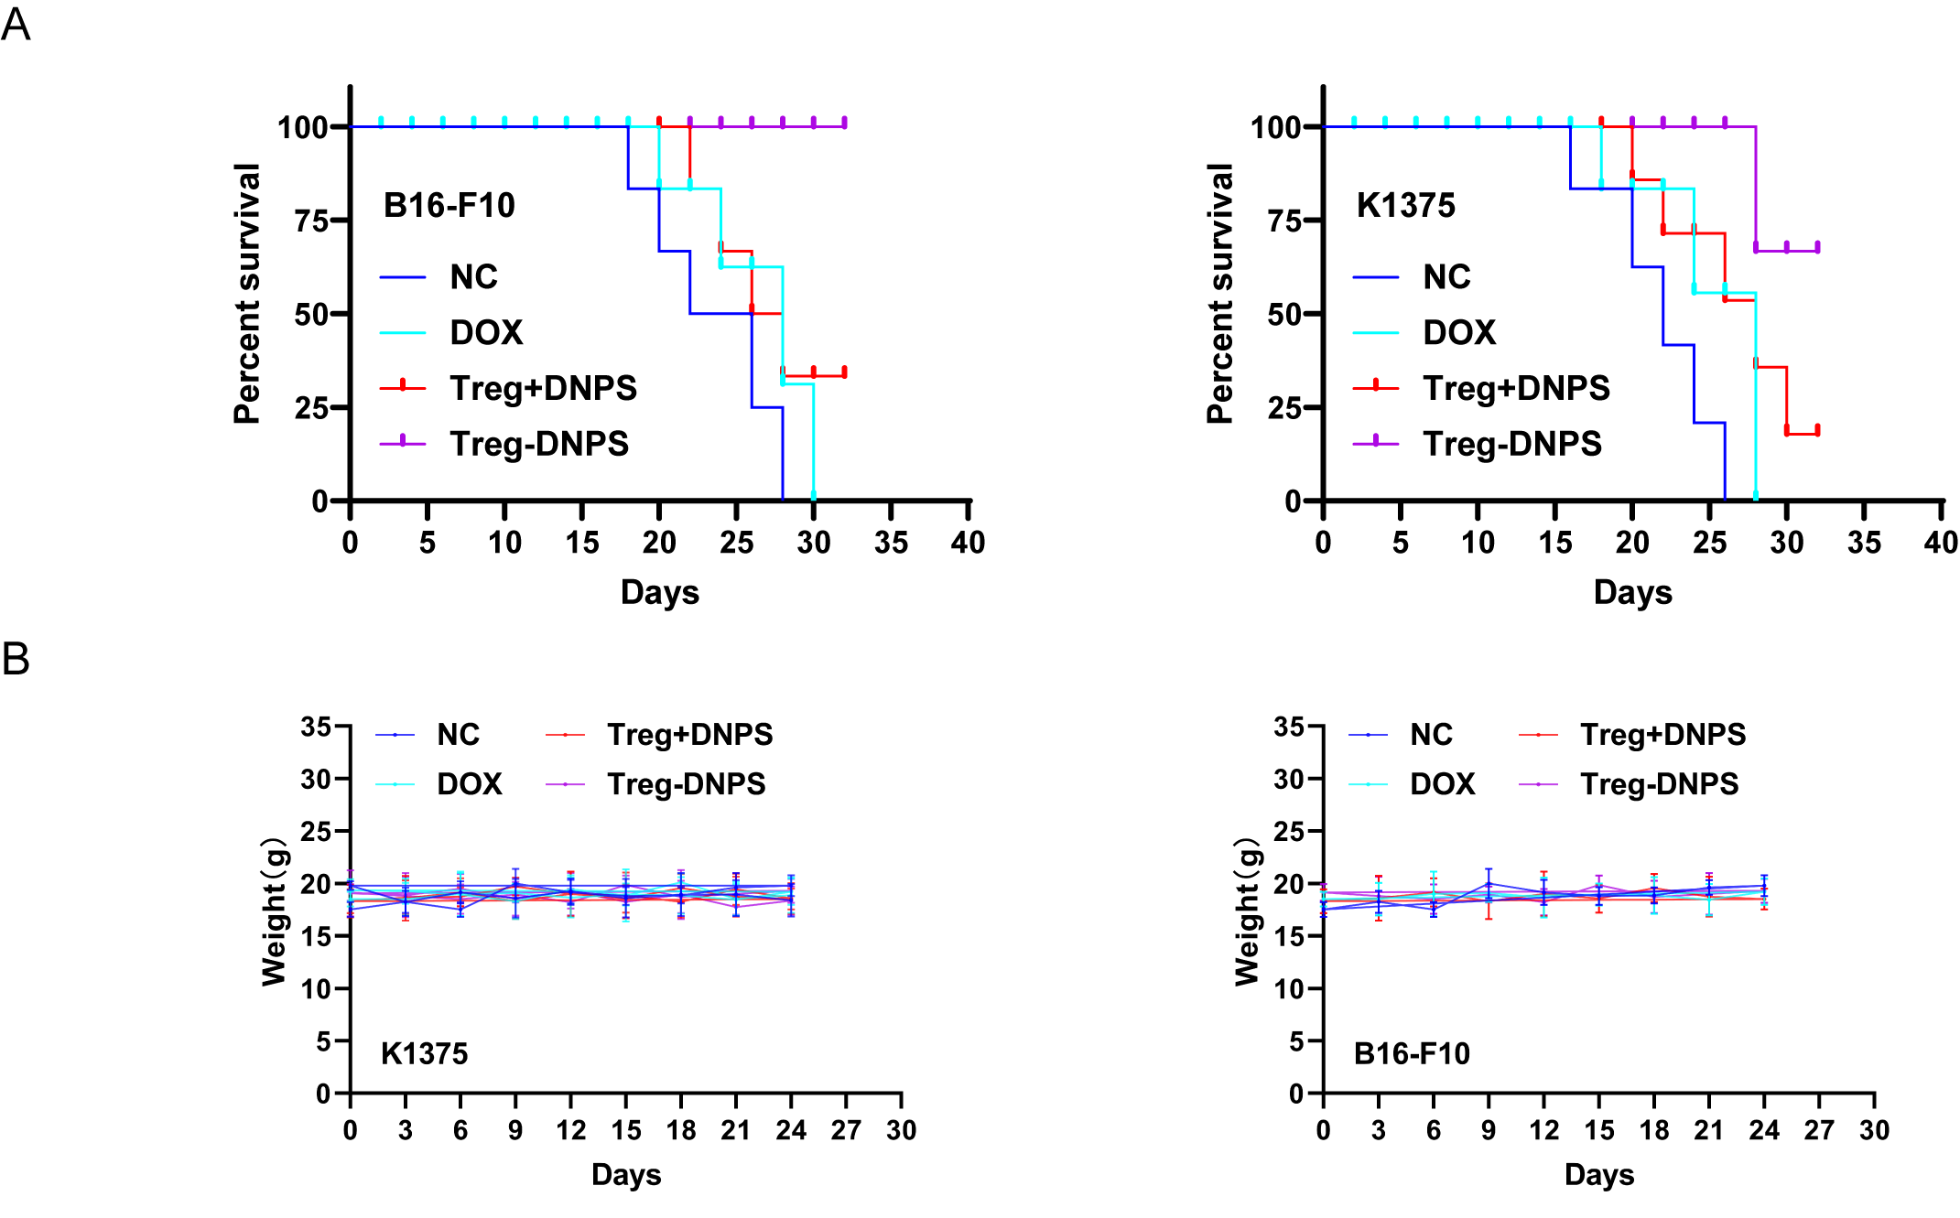
SFigure 4. The anti-tumor effect of Treg-DNPS in vivo. (A)Survival analysis of mice in the various groups. (B)The body weights of the mice were measured during the 24-day evaluation period under different conditions. Data are presented as the means and standard errors. Significance was calculated using one-way ANOVA with Tukey’s posttest, n = 5. *p < 0.05, **p < 0.01.

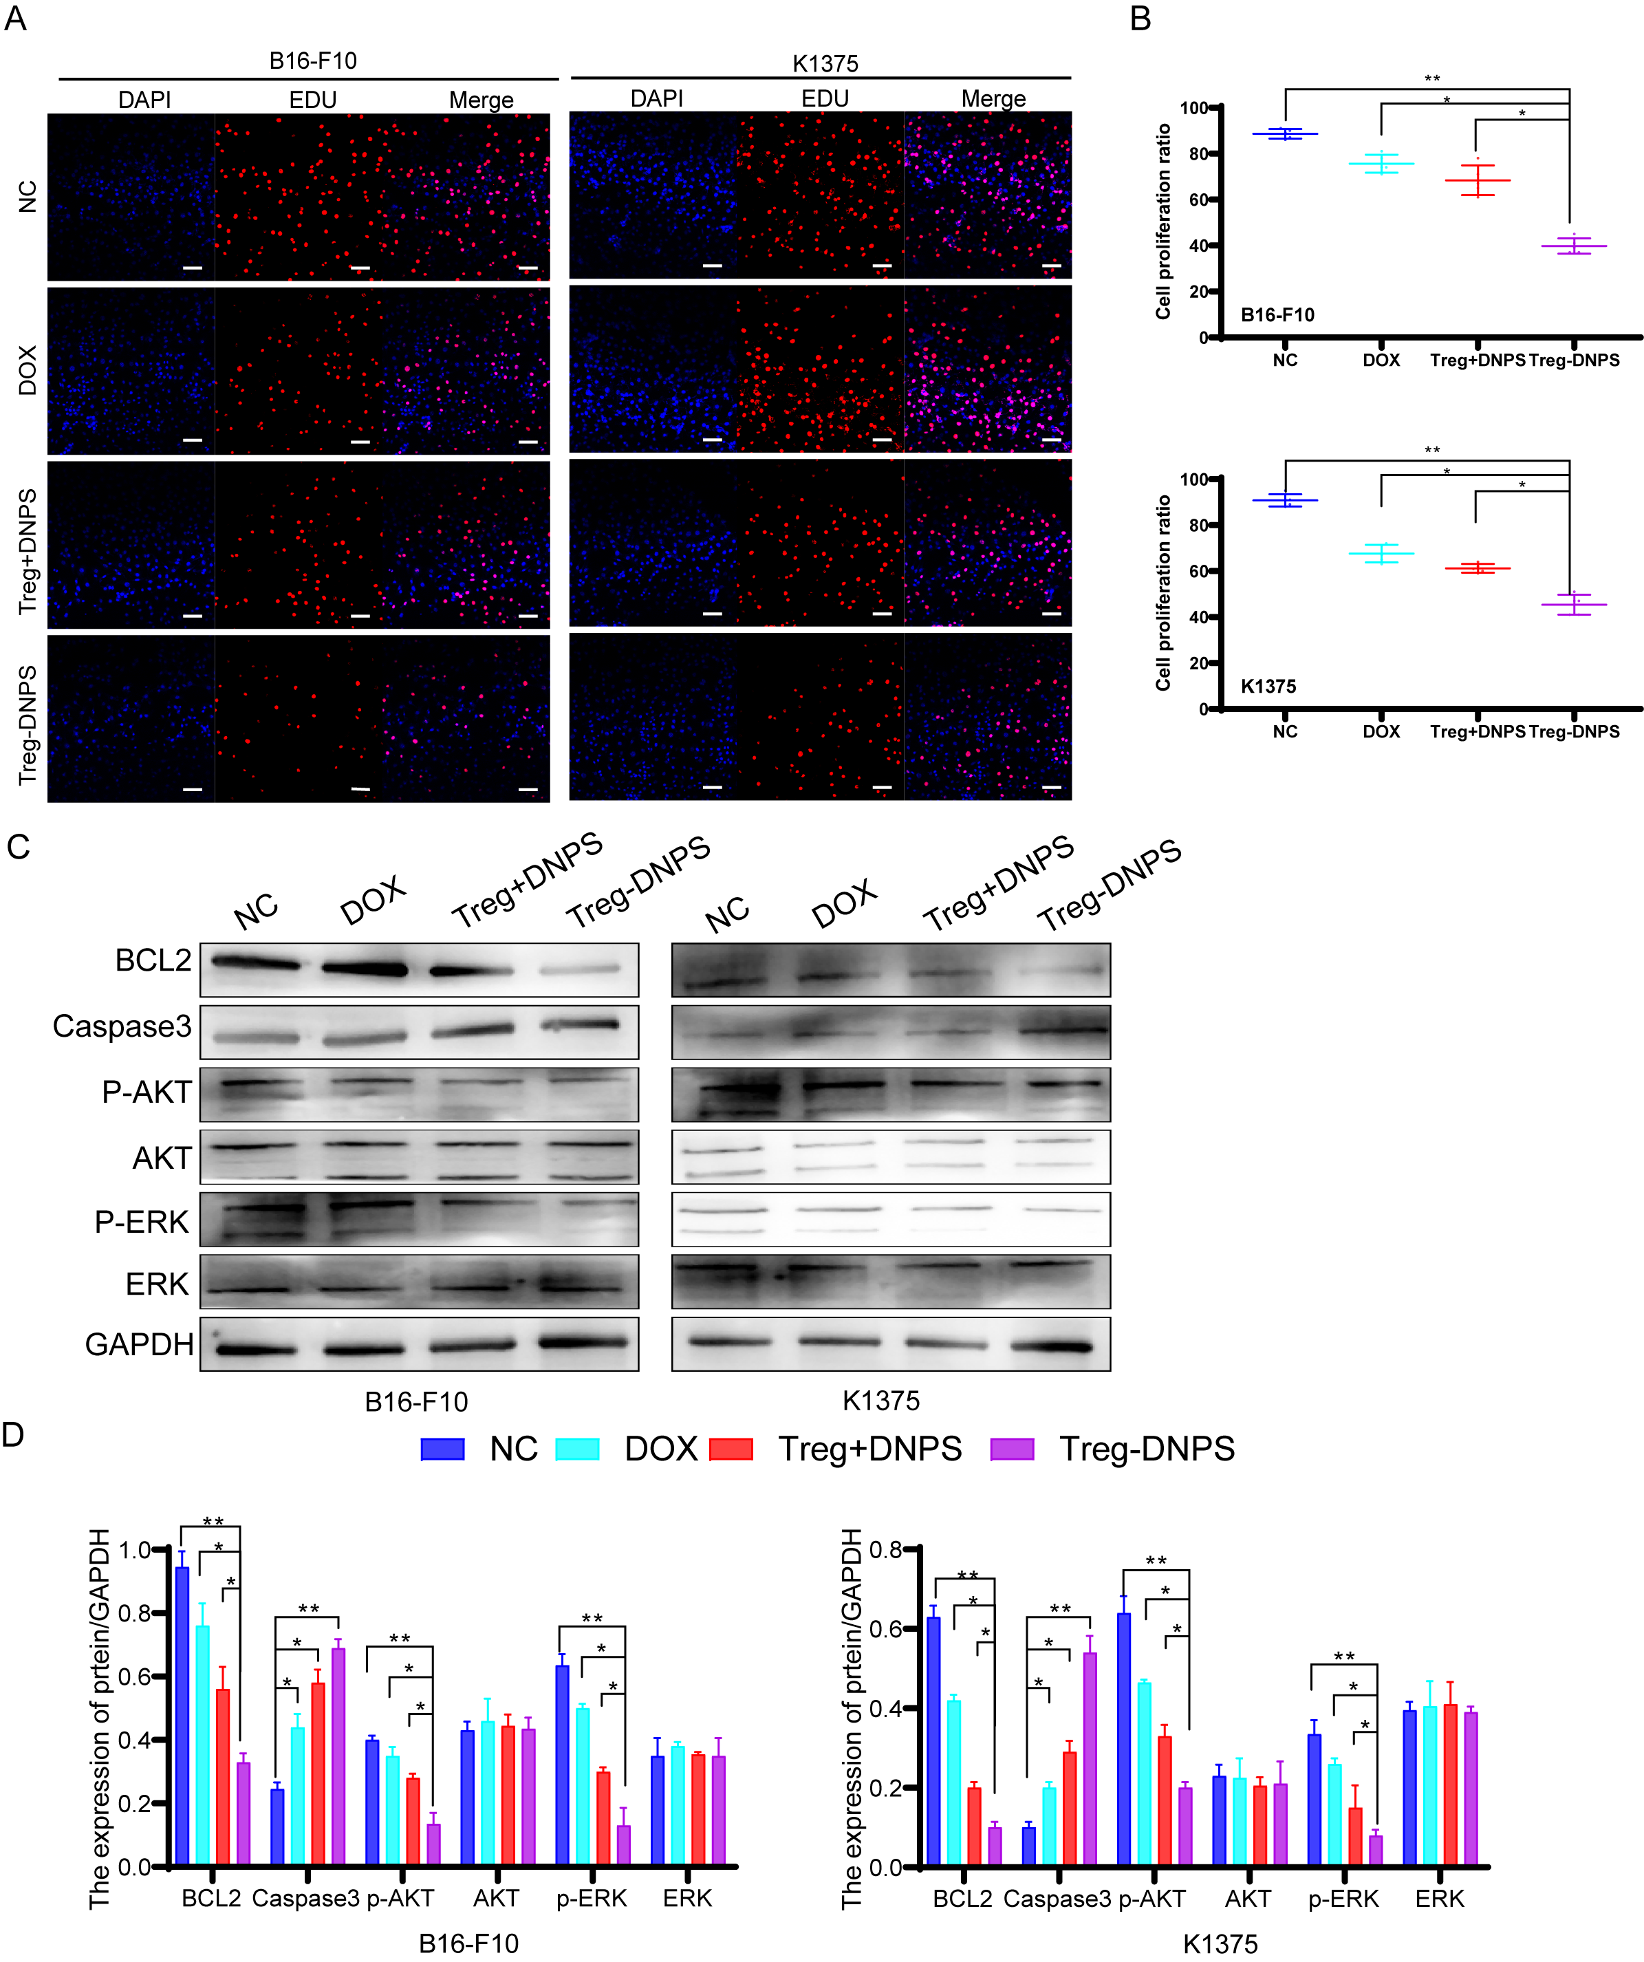
SFigure 5. The tumor suppression of Treg-DNPS in vivo. (A) The inhibition of cell proliferation by Treg-DNPS (NC, DOX, Treg+DNPS). (B) Statistical results of cell proliferation proportion. (C)The expression of BCL2, Caspsae3, P-AKT,AKT, P-ERK, ERK and GAPDH. (E) Statistical results of protein expression. Data are presented as the means and standard errors. Scale bar = 20 mm. Significance was calculated using one-way ANOVA with Tukey’s posttest, n = 5. *p < 0.05, **p < 0.01.

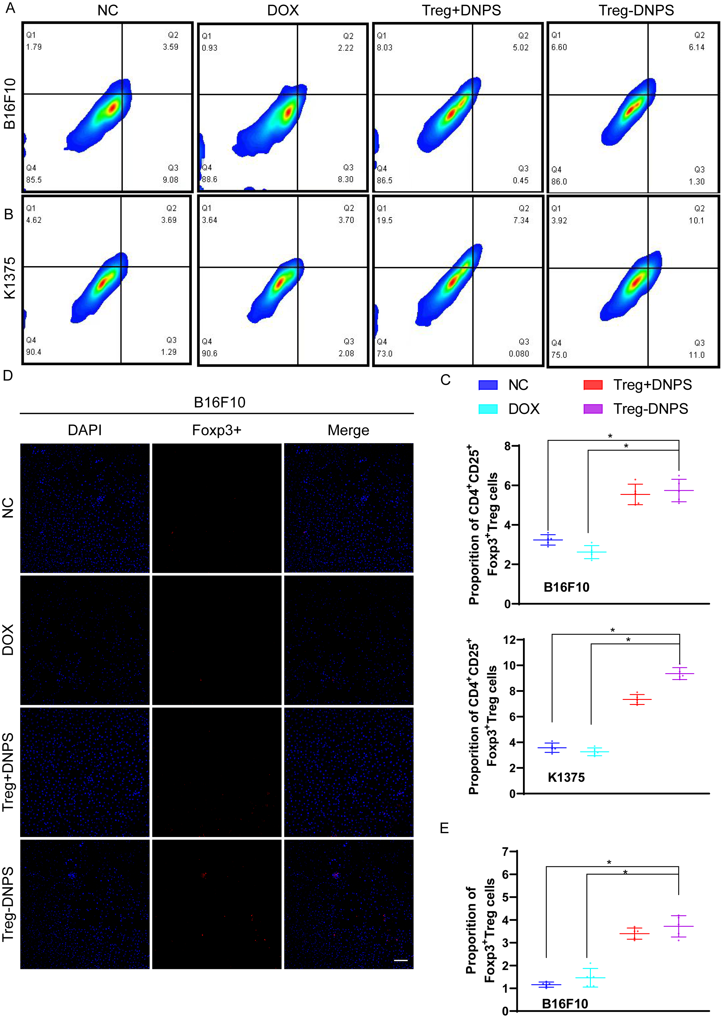
SFigure 6. Distribution of Treg cells. (A-B) Flow cytometry analysis of Treg-DNPS. (C) Statistical results of positive cells proportion. (C) the result of Ac4Ga1NAz-Treg cells activity tested by CCK8.(D)Confocal laser scanning microscopy (CLSM) images of Foxp3+ Treg-DNPS in tissue. (E) Statistical results of Foxp3+Treg cells proportion. Scale bar = 20 μm. Data are presented as the means and standard errors. Significance was calculated using one-way ANOVA with Tukey’s posttest, n = 5. *p < 0.05, **p < 0.01.

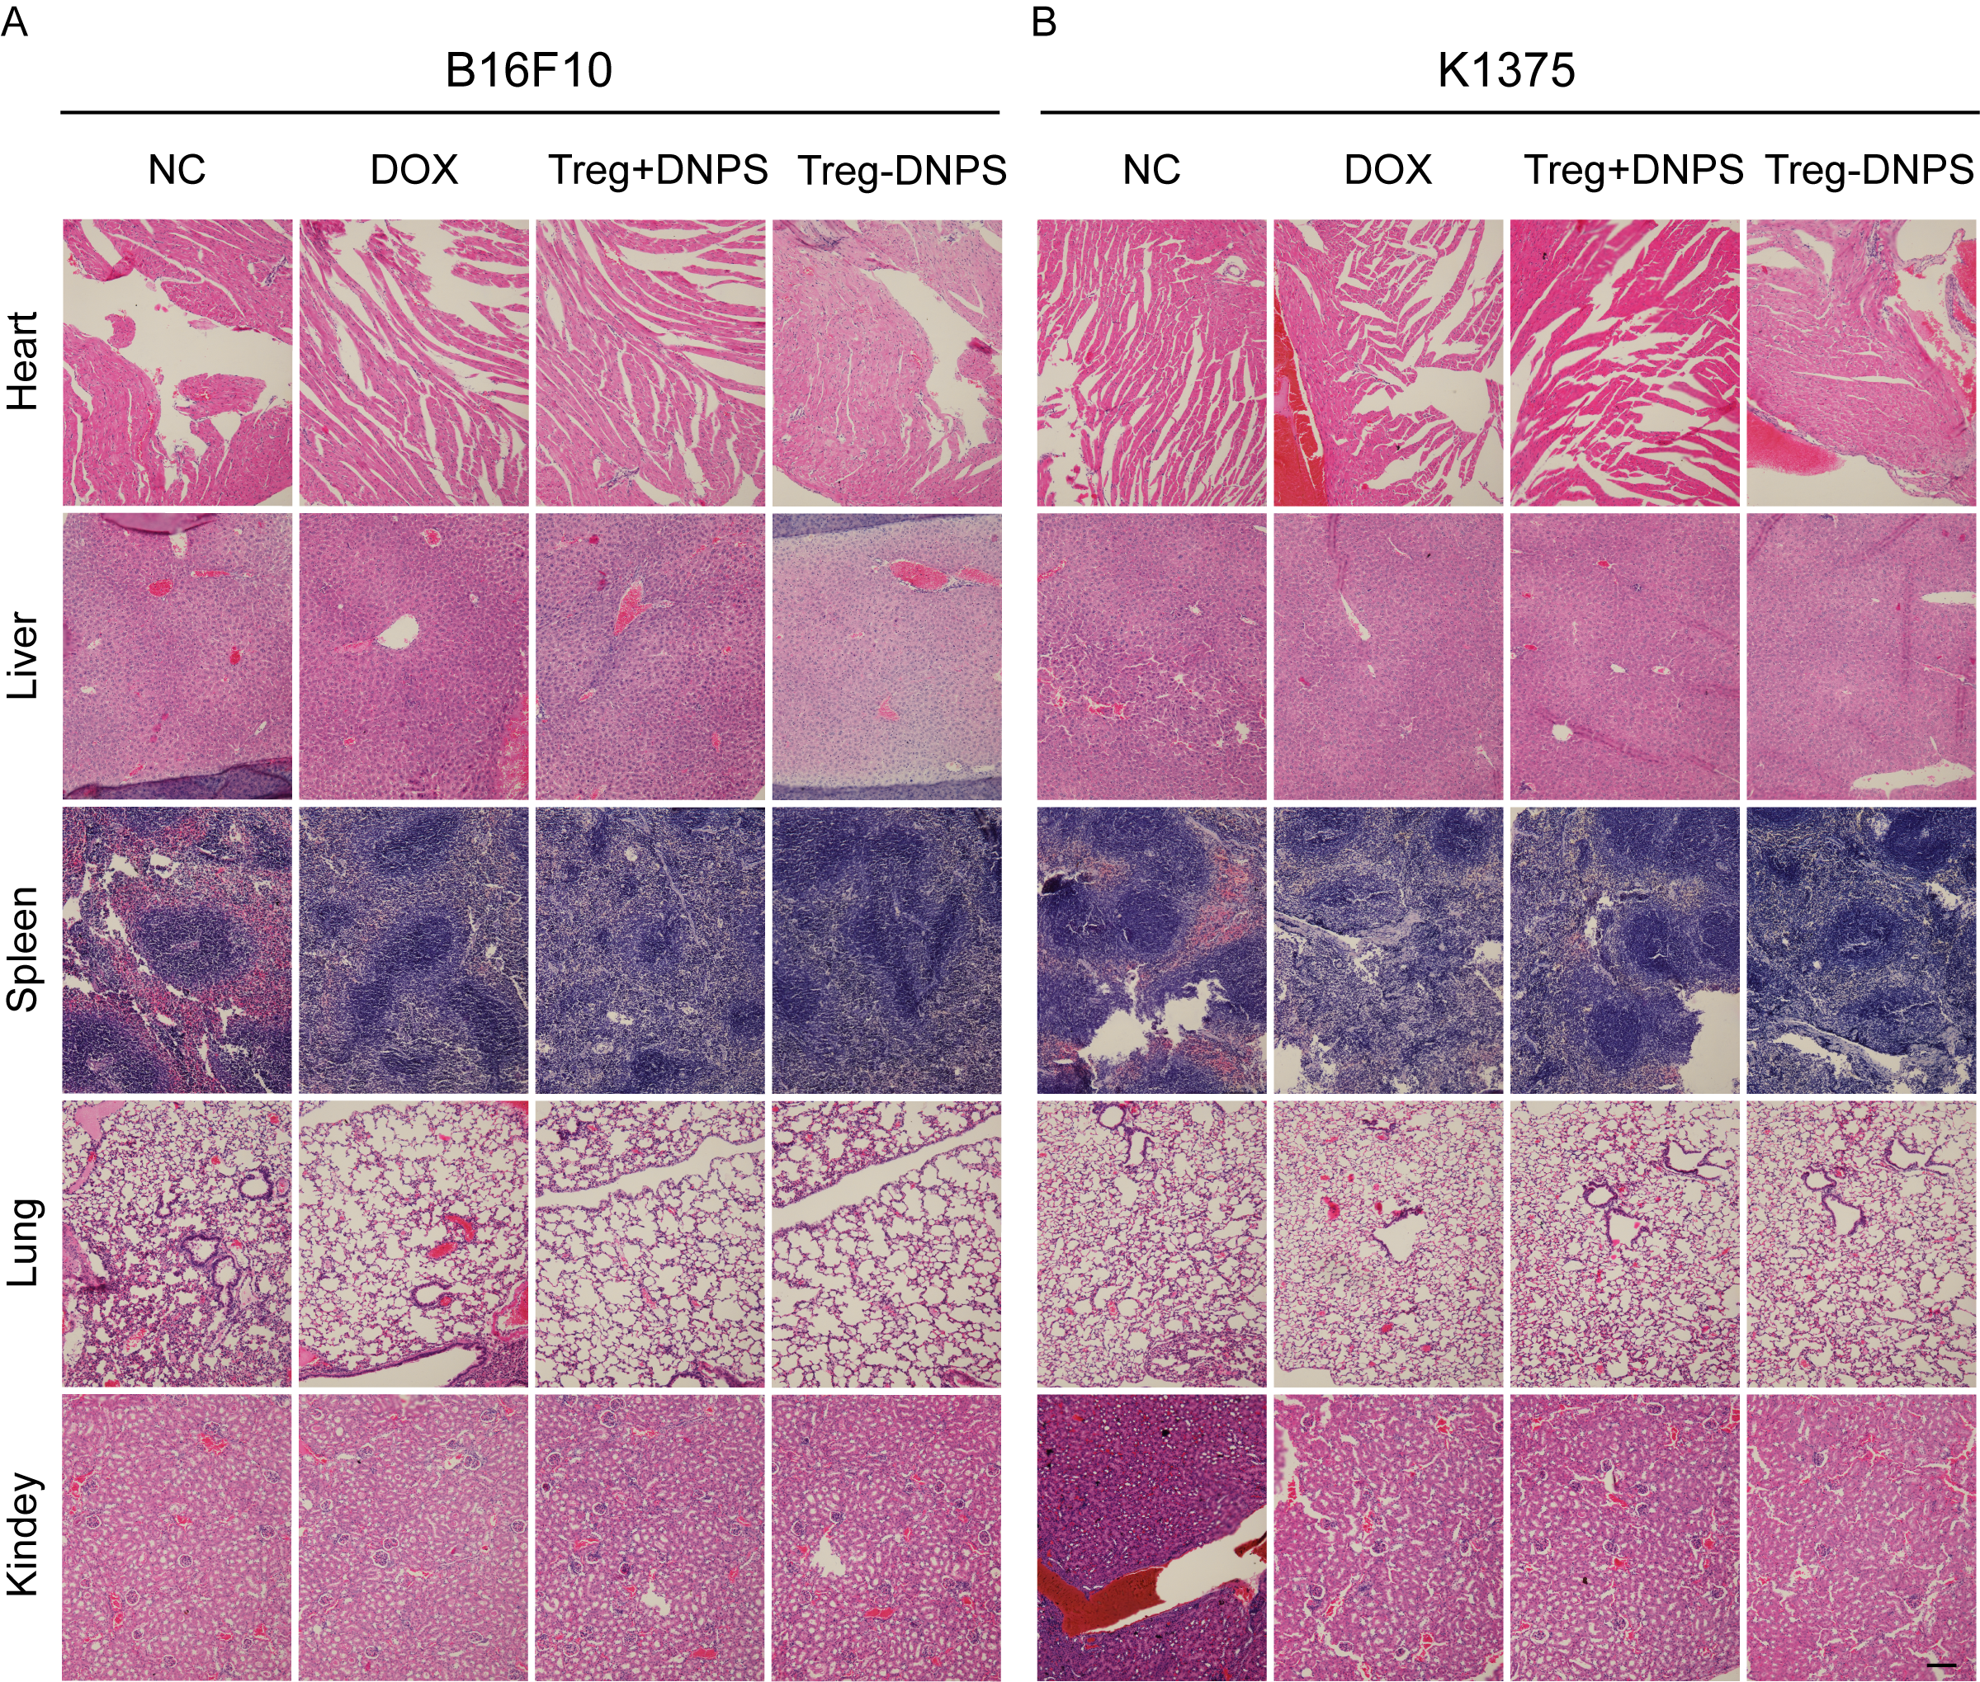
SFigure 7. Biosafety assessment by H&E staining of mice organs (hearts, livers, spleens, lungs, and kidney) (scale bar 50μm).
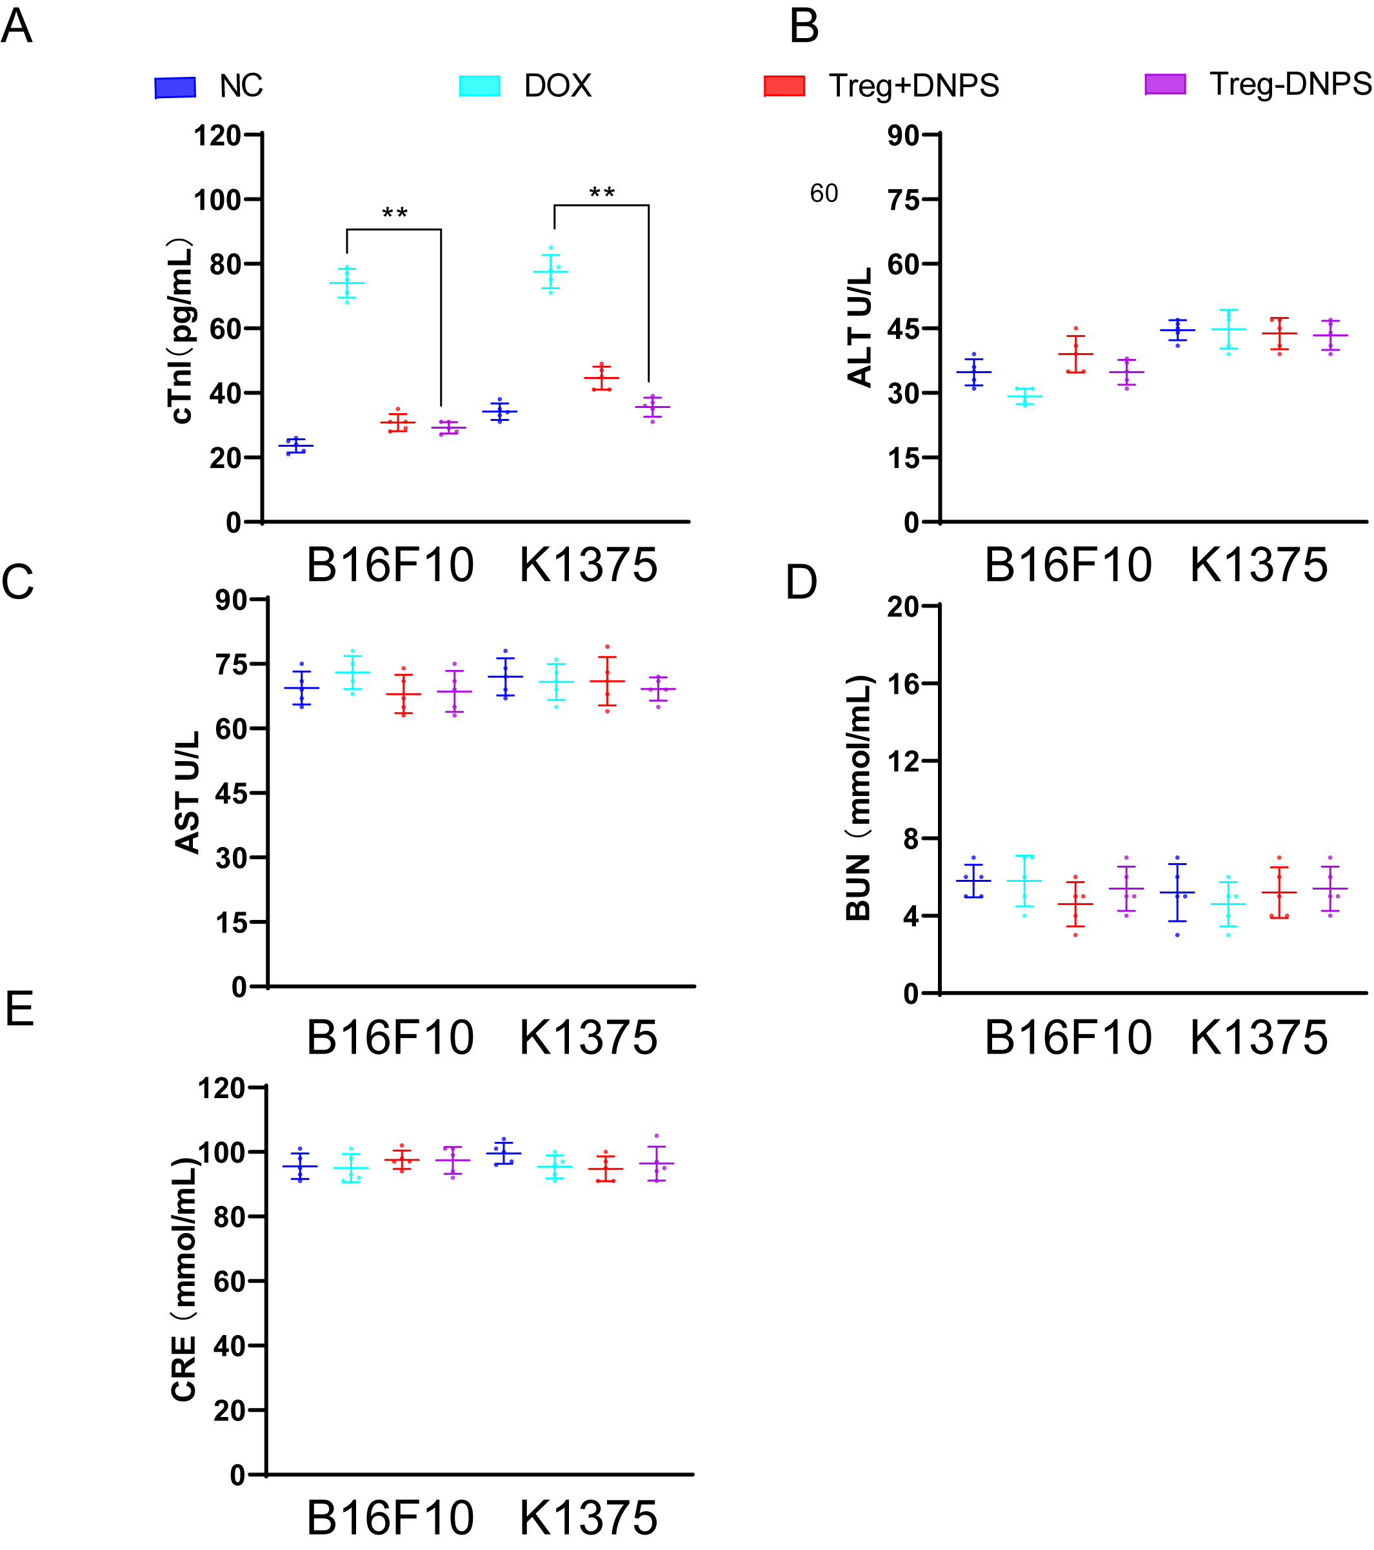
SFigure 8. The biosafety evaluation of Treg-DNPS. (A-C) Serum levels of cTnI, ALT, AST, BUN, and CRE at 24 days post-treatment. Statistical P-values: *P < 0.05, **P < 0.01.

