Extended data
Extended data Figure 1. Phylo- and pan-genomic analyses of Hydrotheml plume ^{U}Sulfurimonas pluma. a, Rooted outgroup phylogenetic tree based on concatenated single copy genes (SCG = 258) of Sulfurimonas and Sulfuricurvum using partition substitution models. The scale bar represents the expected number of changes per amino acids position. UFBoot values based on 1000 replicates are reported for each branch. b, Pangenome analysis of Sulfurimonas isolate genomes and MAGs from different environments. Starting from the centre, the first 13 circles show the occurrence of gene clusters in a given Sulfurimonas genome. The external circle reports the gene clusters in which at least one gene was functionally annotated to COGs. The 7569 gene clusters (GCs) are organized based on their distribution across the genomes. The genomes are organized based on gene clusters they share (using Euclidian distance and Ward clustering). The barplots show some general features of each genome, the heatmap shows the ANI between genomes, and the dendrograms above it represents the hierarchical clustering of genomes based on the occurrence of gene clusters. GR: Gakkel Ridge; MCR: Mid Cayman Rise; MAR: Mid Atlantic Ridge; MOT: Mid Okinawa Trough.
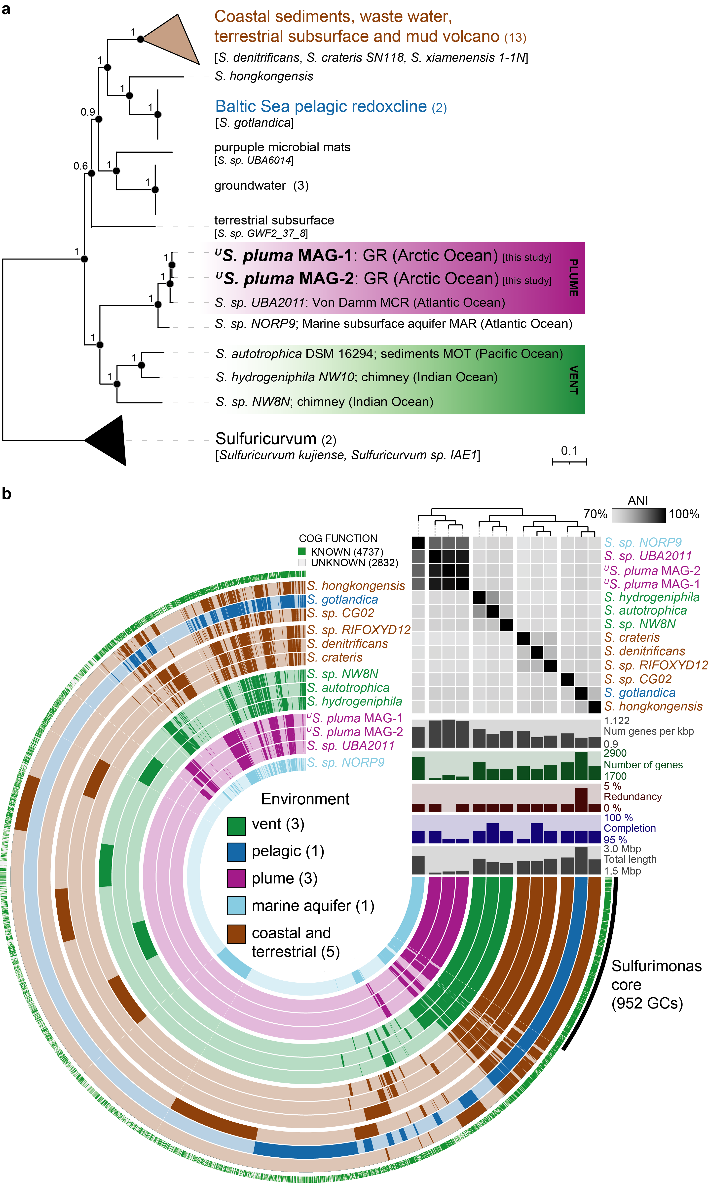
Extended data Figure 2. World map showing the geographic origin, and environment of the samples used for the analysis of Sulfurimonas oligotypes. The point size is proportional to the number of samples collected at each location. HV: hydrothermal vent.
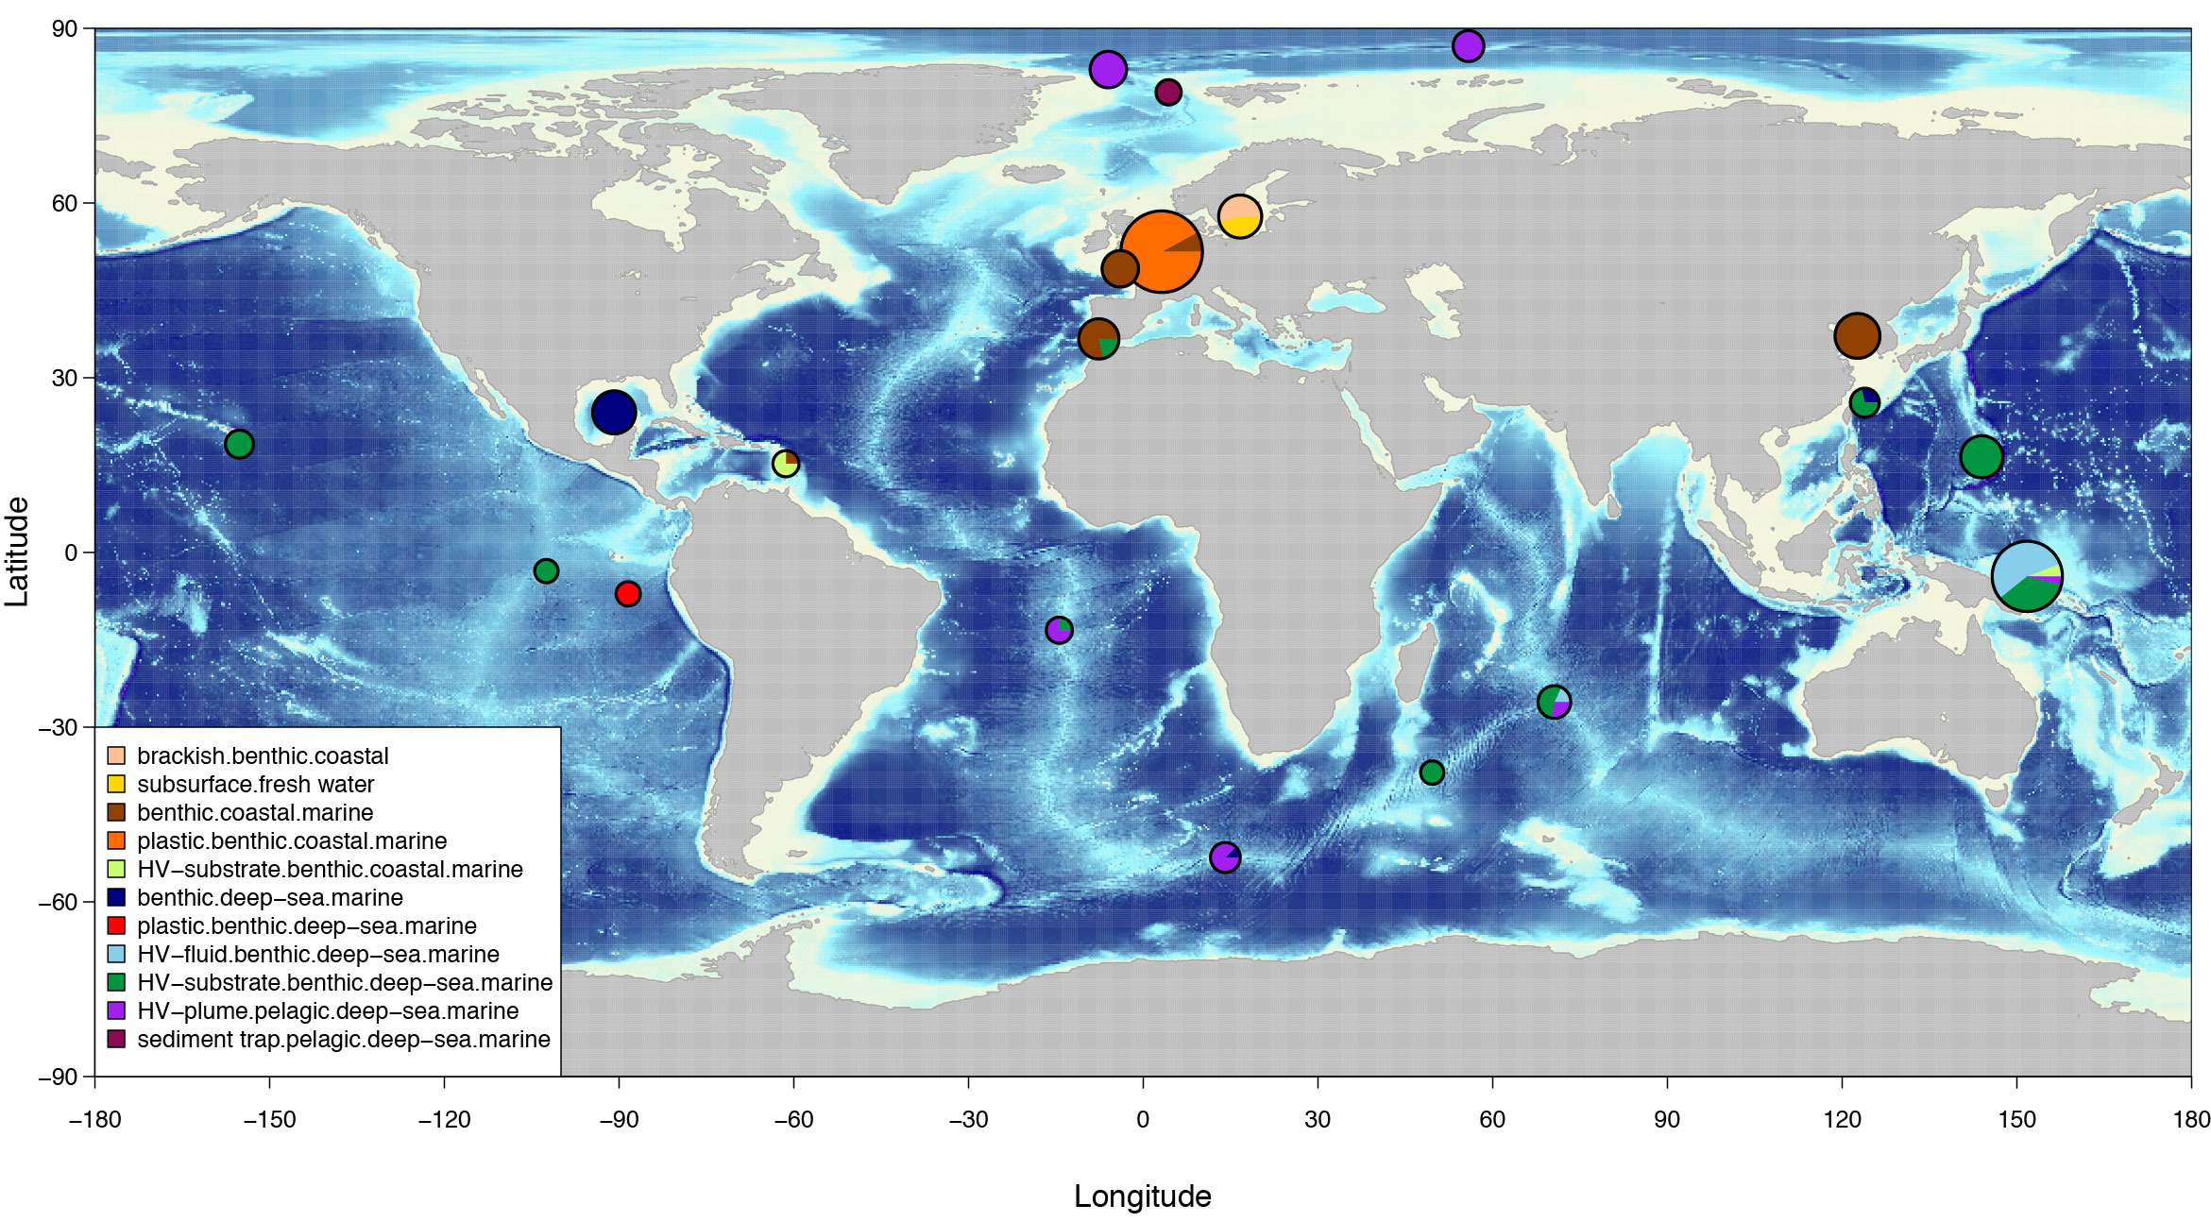

Extended data Figure 3. Heatmap of the distribution of Sulfurimonas oligotypes across samples. Samples ordered based on average linkage clustering of Jaccard dissimilarities. Asterisks indicate samples of hydrothermal origin. Top panel: percentage of samples an oligotype occurs in (sample coverage). Right panel: percentage of Sulfurimonas sequences of total sequences per sample. Bottom panel: Ecotypes per environmental category (brackish pelagic and benthic, as well as pelagic deep-sea and hydrothermal plume were pooled).
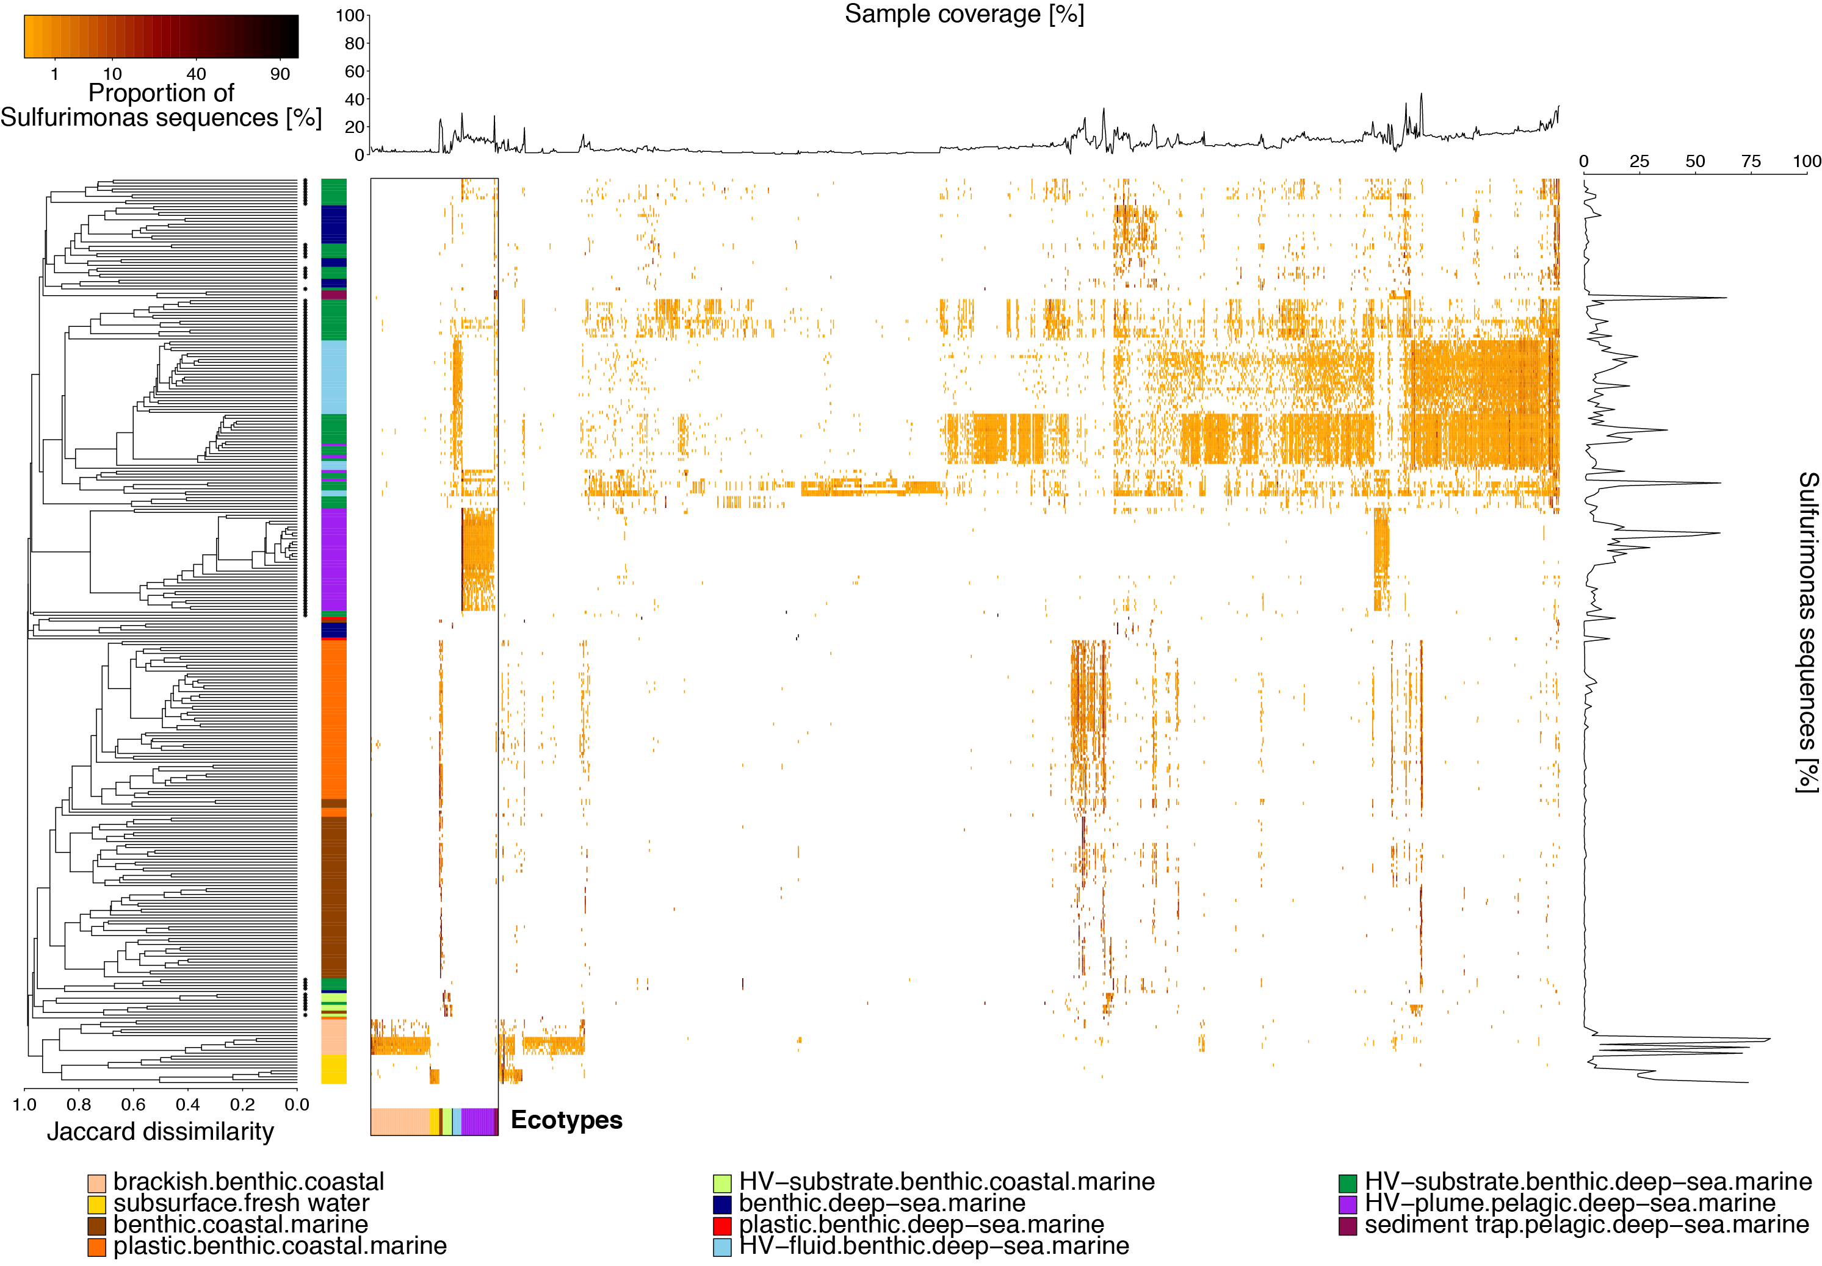

Extended data Figure 4. Metapangenome analysis of Sulfurimonas isolates genomes (S. denitrificans, S. hongkongebsis, S. gotlantica, S. autotrophica) and hydrothermal plume ^{U}S. pluma. Starting from the centre: the first 5 circles show the occurrence of gene clusters in a given Sulfurimonas genomes; then the following 8 circles report the expression of gene clusters of ^{U}S. pluma in hydrothermal plume, seawater and fluid as inferred from metatransciptomic (MT) read recruitment (only representatives for available ridge systems are reported); finally, the external circles report the gene clusters in which at least one gene was functionally annotated (green and grey for known and unknown functions, respectively). The 4854 gene clusters (GCs) and the genomes are organized based on their distribution across the genomes and on gene clusters they share (using Euclidian distance and Ward clustering), respectively. The barplot shows the percentage of genes expressed, the heatmap shows the percentage of Sulfurimonas reads recruited by five genomes (inner circle) from metagenomes (MG; average value is reported for habitats having more than one metagenome available per ridge system; the number of metagenomes is reported in parenthesis), and the dendrograms above it represents the hierarchical clustering of genomes based on the occurrence of gene clusters.
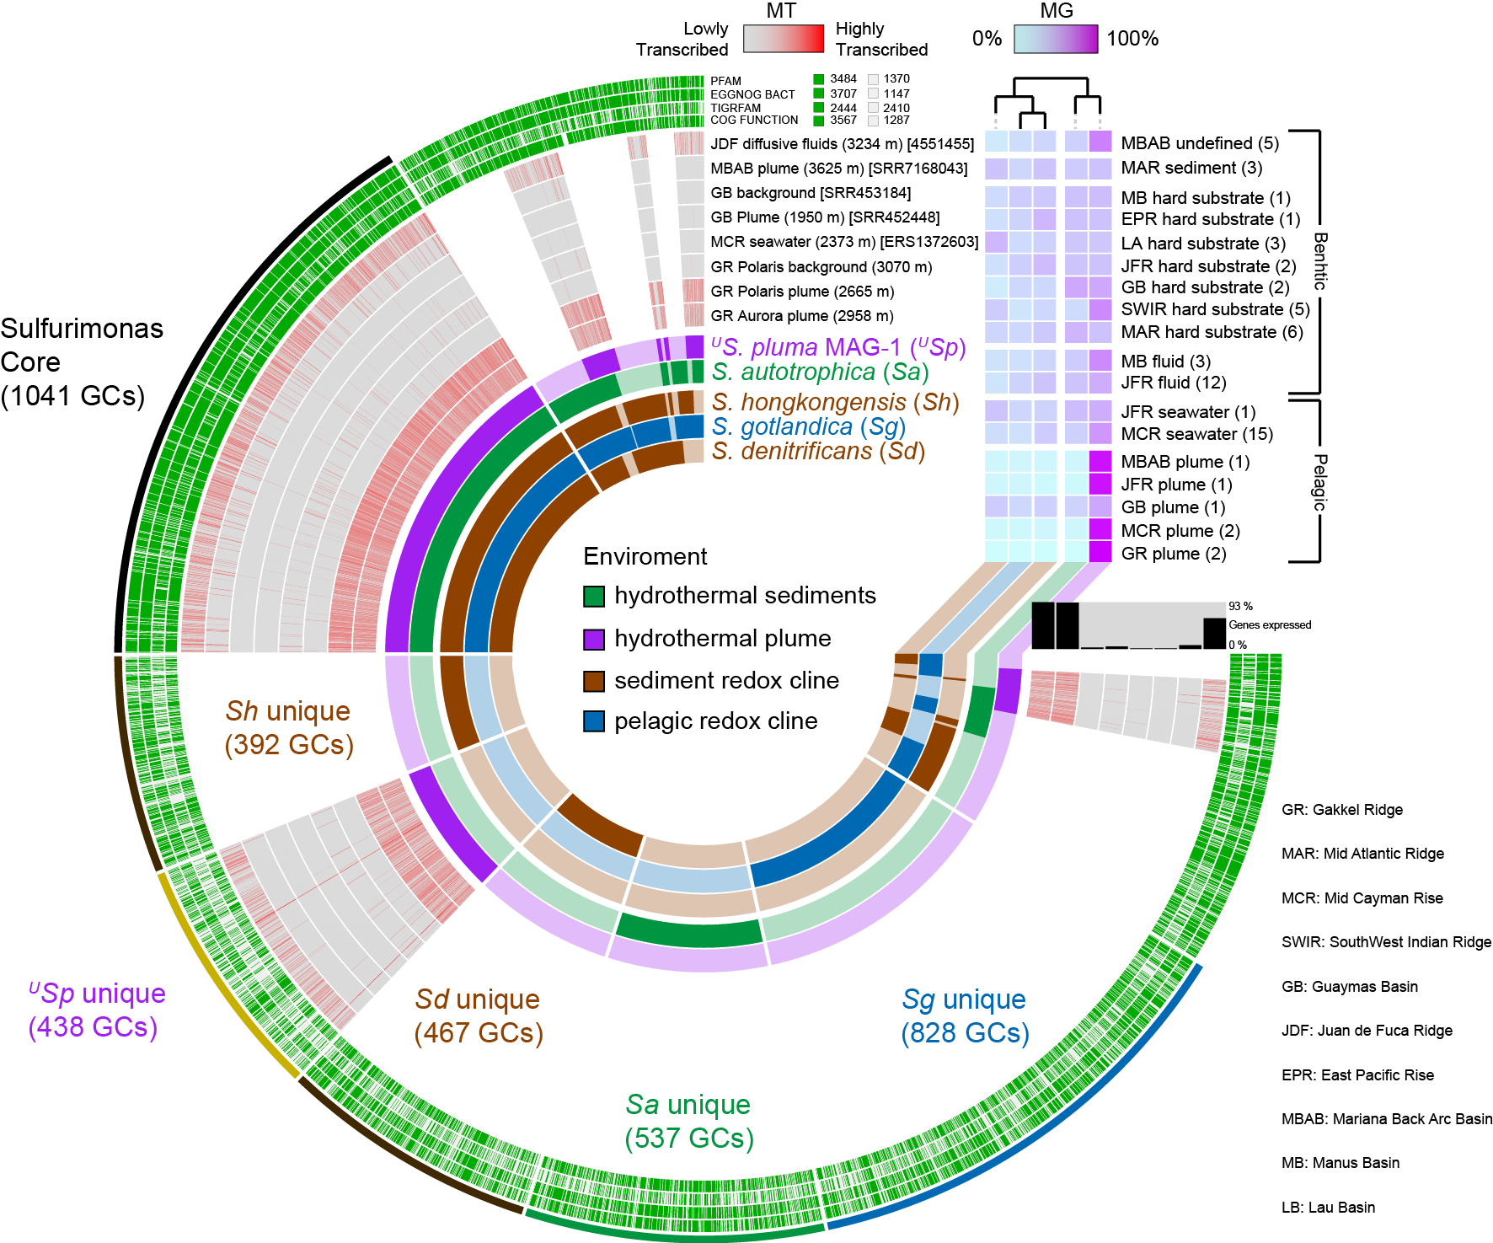

Extended data Figure 5. Phylogenetic relationships between alpha subunit of 2-oxoglutarate:ferredoxin oxidoreductase (oorA) and alpha subunit of pyruvate:ferredoxin oxidoreductase (porA). The scale bar represents the expected number of changes per amino acids position. UFBoot and SH-aLRT values are based on 1000 replicates. Best substitution model: LG+R4.
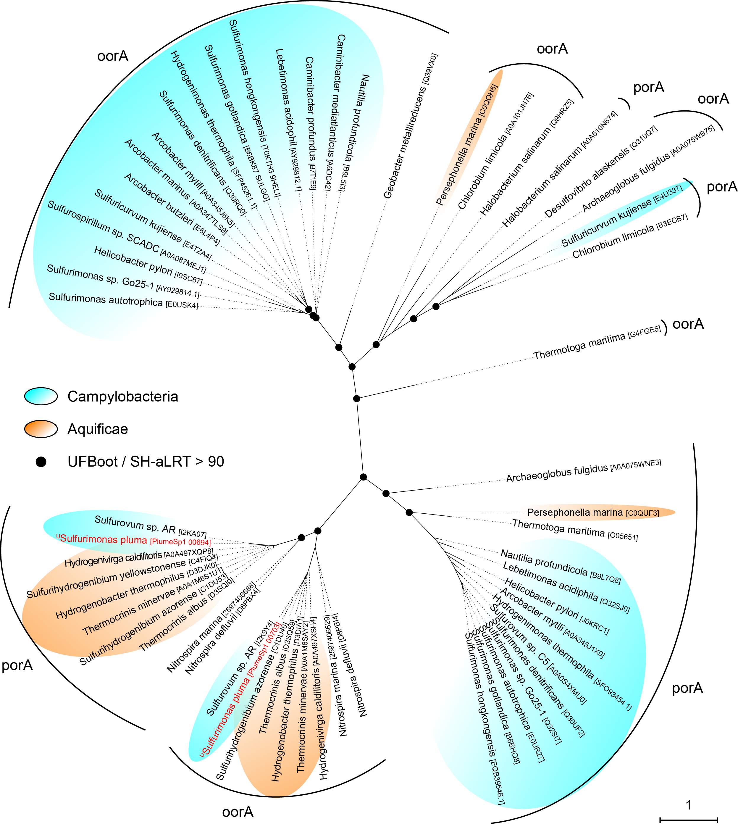

Extended data Figure 6. Gene cluster organization of the five subunits of 2-oxaglutarate-ferrodoxin oxidoreductase and pyruvate-ferrodoxin oxidoreductase in the genomes of ^{U}Sulfurimonas pluma, Sulfurovum AR, and Aquificales’ representatives.
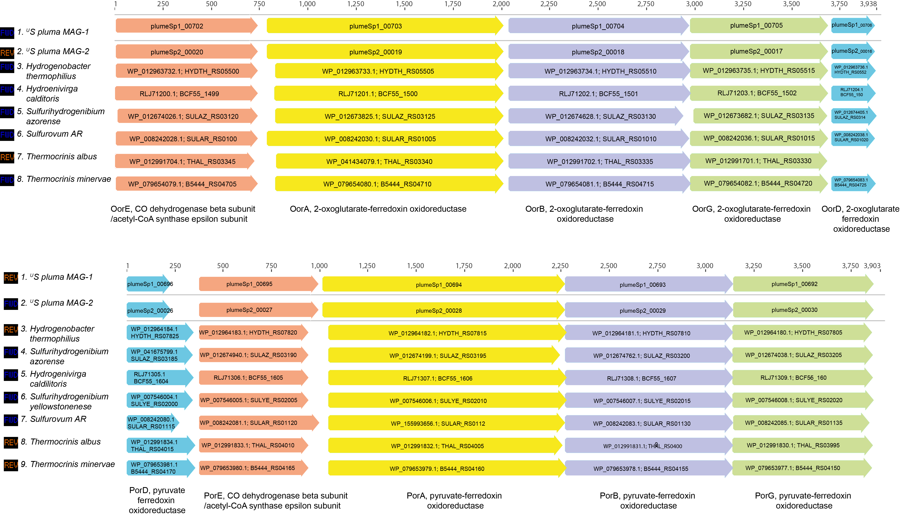

Extended data Figure 7. Phylogenetic relationships between beta subunit of Flavocytochrome c sulfide dehydrogenase (FCC) and Sulfide:quinone oxidoreductase (SQR). The scale bar represents the expected number of changes per amino acids position. UFBoot and SH-aLRT values are based on 1000 replicates. Best substitution model: LG+R4. Sulfurimonas species are in bold. *: partial sequence.
