Supplementary Information

Supplementary Notes
Supplementary Note 1: Hydrogen oxidation in presence of oxygen. The presence and high expression of genes coding for the membrane-bound group 1b [NiFe]-hydrogenase suggest that hydrogen is the main energy source for ^{U}S. pluma in the plume (Table 1 and Figure 2). This type of hydrogenase is present in all genomes of isolated Sulfurimonas strains¹ (Supplementary Table 5) with the exception of S. paralvinellae². Neither S. autotrophica nor natural Sulfurimonas populations from hydrothermal vents have been shown to oxidize hydrogen under aerobic condition^{3,4}. Yet, others Sulfurimonas strains from hydrothermal vents and some isolates closest related to S. autotrophica (99.9 % similarity) obtained from Iheya North deep-sea hydrothermal field oxidized H₂ using O₂ as electron acceptor at a temperature of 25−37 °C ^{5,2}. Our findings showed for the first time overexpression of the genes for the membrane-bound [NiFe]-hydrogenase by natural populations of Sulfurimonas and at temperature <0 °C. Group 1b [NiFe]-hydrogenase is described as the prototypical oxygen-sensitive hydrogenase⁶. It is therefore interesting that hydrothermal plume ^{U}S. pluma uses this enzyme under aerobic conditions and low hydrogen concentrations (i.e. nM), and does not have other types of hydrogenases more tolerant to oxygen, like group 1d ⁷ found in another hydrogen-oxidizing chemolithotrophs living in hydrothermal plumes (i.e. SUP05)⁸, and group 2d present in S. denitrificans, S. hongkongensis, S. gotlantica and in some Sulfurimonas isolates from hydrothermal vent suggested to be relevant under low hydrogen concentrations^{1,2}. The ability of ^{U}S. pluma to use hydrogen as electron donor in presence of oxygen seems not be related to chemical and structural features of the hydrogenase, but rather to the presence of effective O₂ protection systems that reduce the cytoplasmic O₂ concentrations (i.e. cytochrome aa3 oxidase, antioxidant enzymes) or availability (i.e. hemerythrin).

Supplementary Note 2: Sulfide oxidation pathways. Two main pathways for sulfide oxidation exist in chemolitotrophic bacteria: one involving a sulfide:quinone reductase (SQR) and a second one involving a two subunit complex called flavocytochrome c sulfide dehydrogenase (FCC). This FCC complex consists of two subunits: a flavoprotein (fccB) and a cytochrome c (fccA). Previous studies have only reported the presence of several genes encoding for different types of SQR in the known Sulfurimonas’ genomes¹ (Supplementary Table 5). Sulfide oxidation by SQR provides more energy than sulfide oxidation by FCC⁹, suggesting the SQR is more suitable for growing in the hydrothermal plumes, as documented for other plume sulfur-oxidizing bacteria⁸. Therefore, SQR was expected to be the mechanism for sulfide oxidation also in ^{U}S. pluma. But, unexpectedly, hydrothermal plume genomes contain only one gene encoding for a SQR Type VI (PlumeSp1_1390 and PlumeSp2_1561), instead of several genes encoding for different SQR types as in other Sulfurimonas. Moreover, the gene is much shorter than it should be, presumably because it is truncated, and showed very low levels of expression (Figure 3a). Surprisingly, ^{U}S. pluma contains a gene (PlumeSp1_00736 and PlumeSp2_01027) annotated as flavocytochrome c sulfide dehydrogenase (fccB). However, no fccA could be found. We checked the presence of fccB in previous Sulfurimonas genomes, and we could detect the presence of previously unreported fccB genes in them (except for S. autotrophica), usually annotated as FAD-dependent oxidoreductase (Table 1). In all of these genomes the fccA was also missing. Since fccB and SQR both belong to Group I flavoprotein disulfide reductases (FDR)¹⁰, we decided to build a phylogenetic tree for their amino acid sequences to resolve the position of the fccB genes (Extended data Figure 7). The fccB sequences of ^{U}S. pluma form a cluster with other fccB sequences from Sulfurimonas hongkongensis and Sulfurovum. This cluster is closely related to a second cluster of Sulfurimonas fccB that also contains sequences from Aquifex aeolicus and Arcobacter mytili. These two clusters are more related to the canonical fccB than to the SQR, but they do not have a fccA subunit. However adjacent to fccB gene there is a protein annotated as small subunit of arsenite:cytochrome c oxidoreductase (aioB, 28.7% amino acid identity), involved in the oxidation of arsenic¹¹. This protein has a Rieske 2fe-2S cluster domain that would transfer arsenite-derived electron from molybdenum centre of catalytic subunit (aioA) to the cytochrome c ¹². This gene is present in all members of putative FCC clusters (data not shown), thus we hypothesize that it may act as the electron carrier for fccB. However, we cannot exclude that fccB transfer the electron directly to the quinone pool as in the canonical SQR. Therefore, whether the electron can be used to generate only proton motive force or also reducing power for carbon dioxide fixation it remains an open question. A further relevant question is why ^{U}S. pluma has lost canonical SQRs, typical of all other members of Sulfurimonas and hydrothermal plume sulfur-oxidizing SUP05 (Extended data Figure 7), in favor of a new SQR or a not-canonical FCC. The similarity between fccB and aioA of ^{U}S. pluma and sequences from other aerobic environments (i.e. aerobic marine sediment enrichment¹³ and oxic subsurface aquifer; Extended data Figure 7) suggest that the acquisition of this enzyme may be an adaptation to aerobic environments.

Supplementary Figures

Supplementary Figure 1. Active bacterial community structure at Aurora and Polaris water types. Dominant active bacterial taxa (cut-off ≥1.5 %) as detected by 16S rRNA sequencing (cDNA). Average of sequences proportion is reported. The most abundant and active chemolithotrophs are in bold. Number of observations (n) is reported in round brackets.
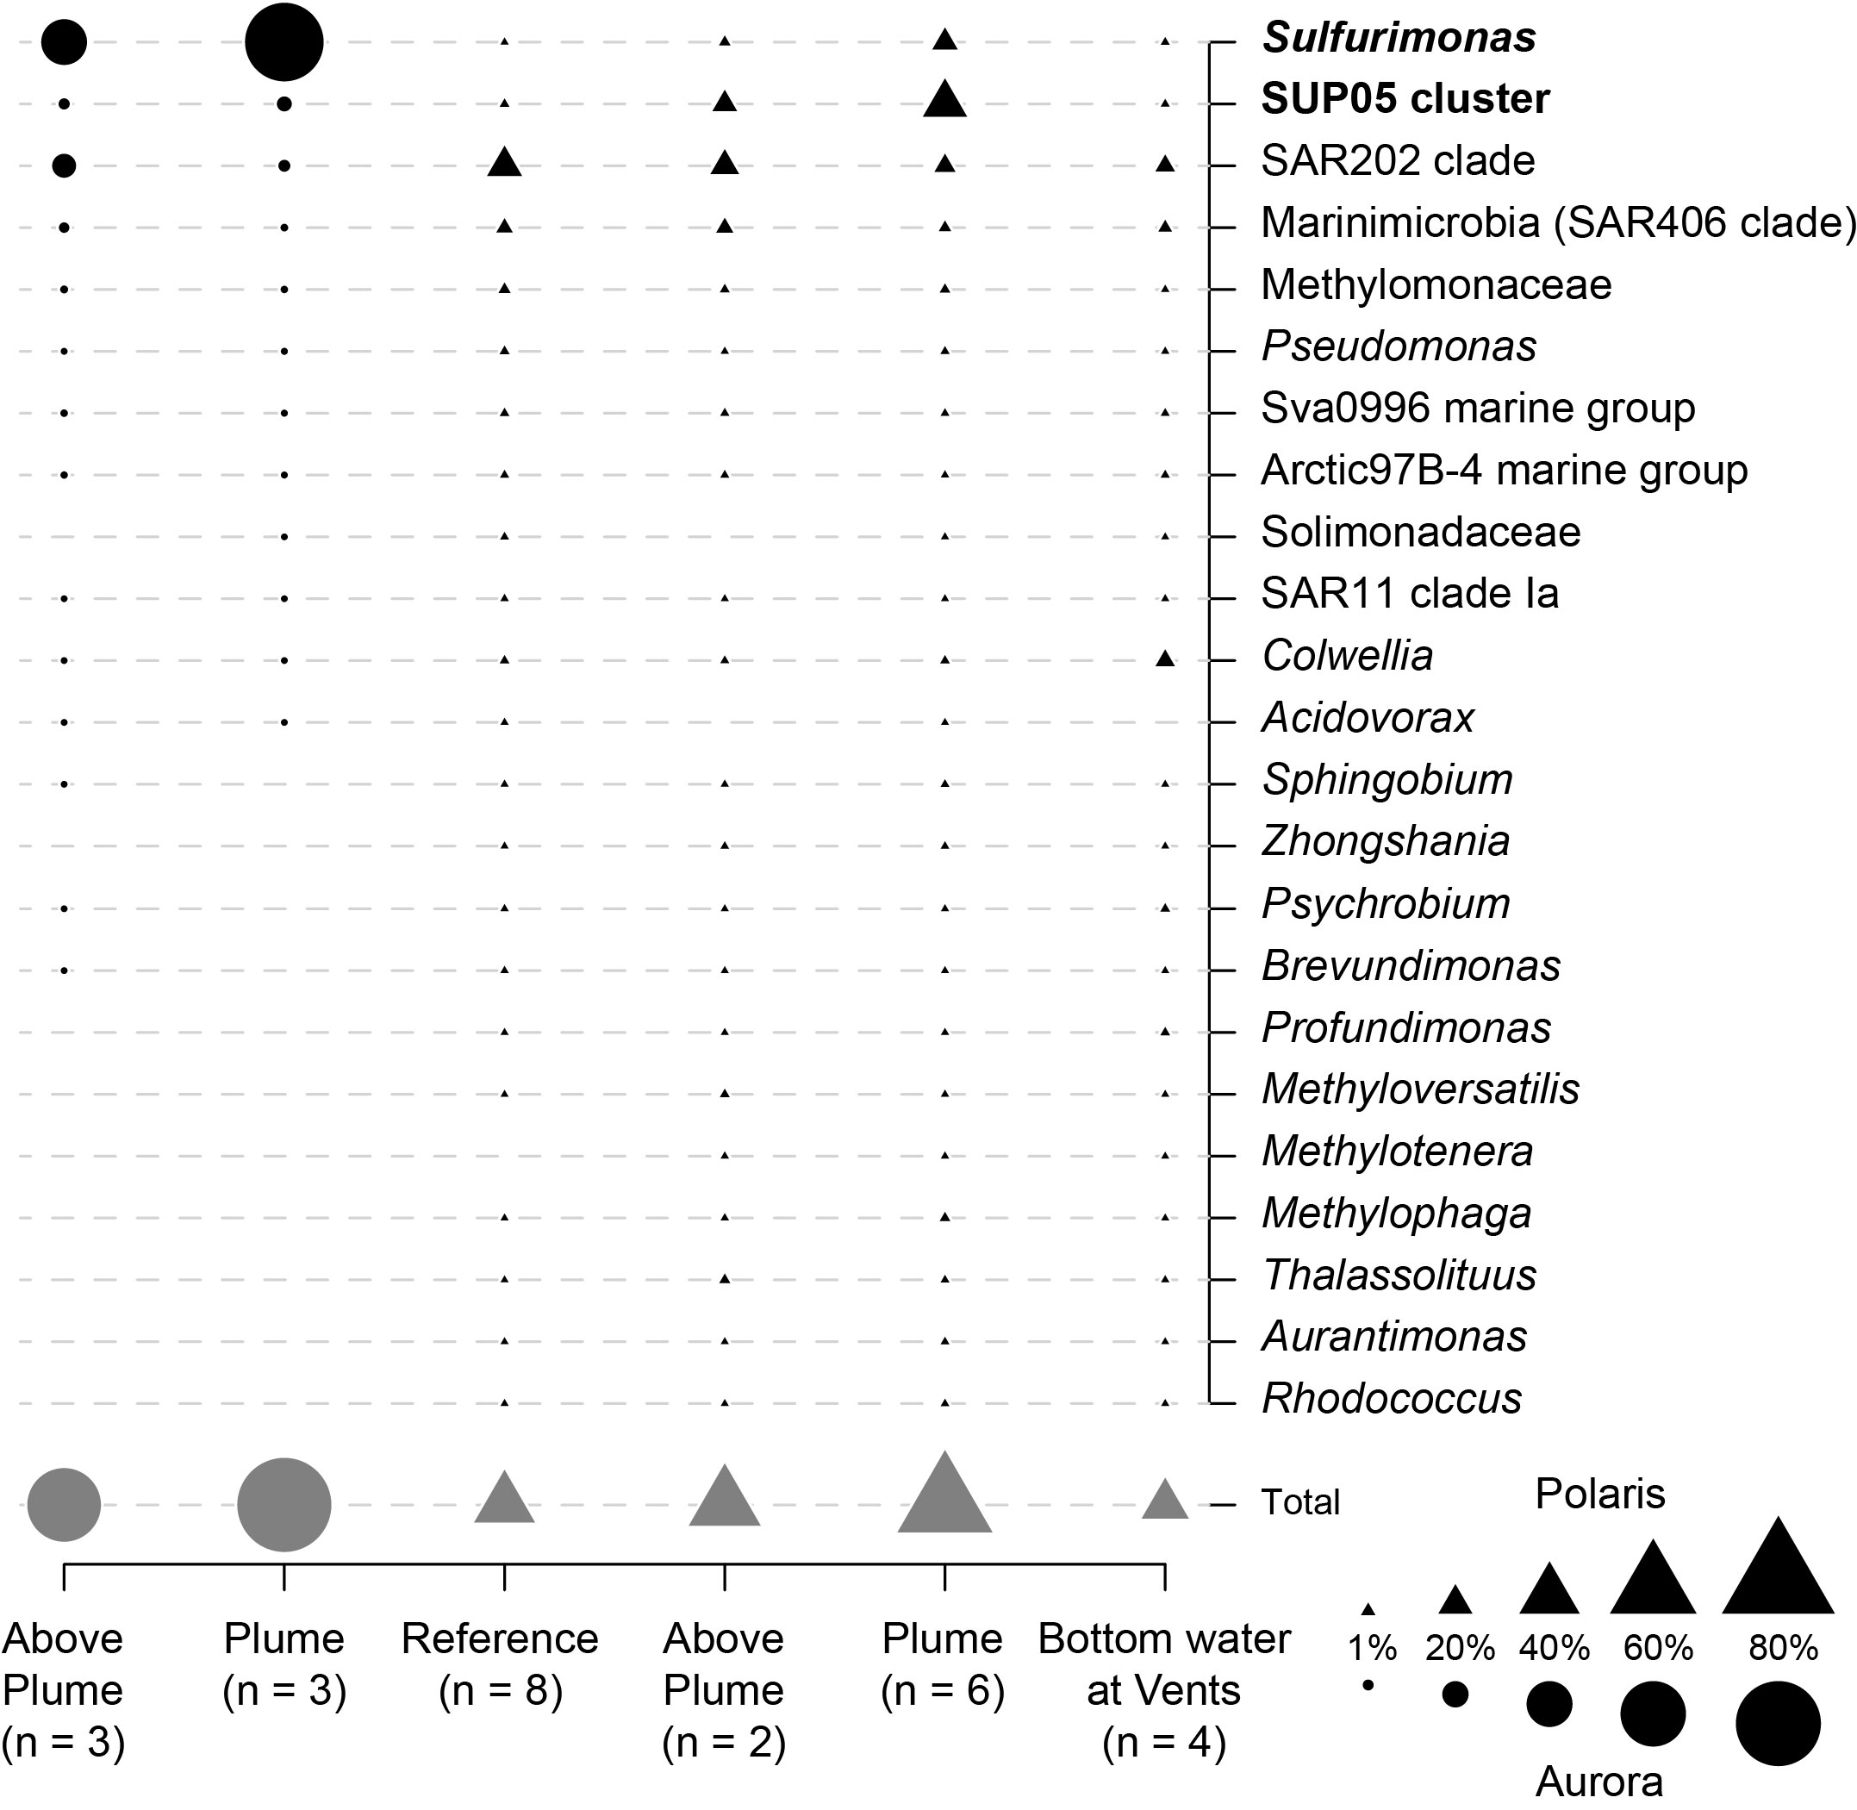

Supplementary Figure 2. Number of detected Sulfurimonas oligotypes depending on sampling effort (gamma diversity).
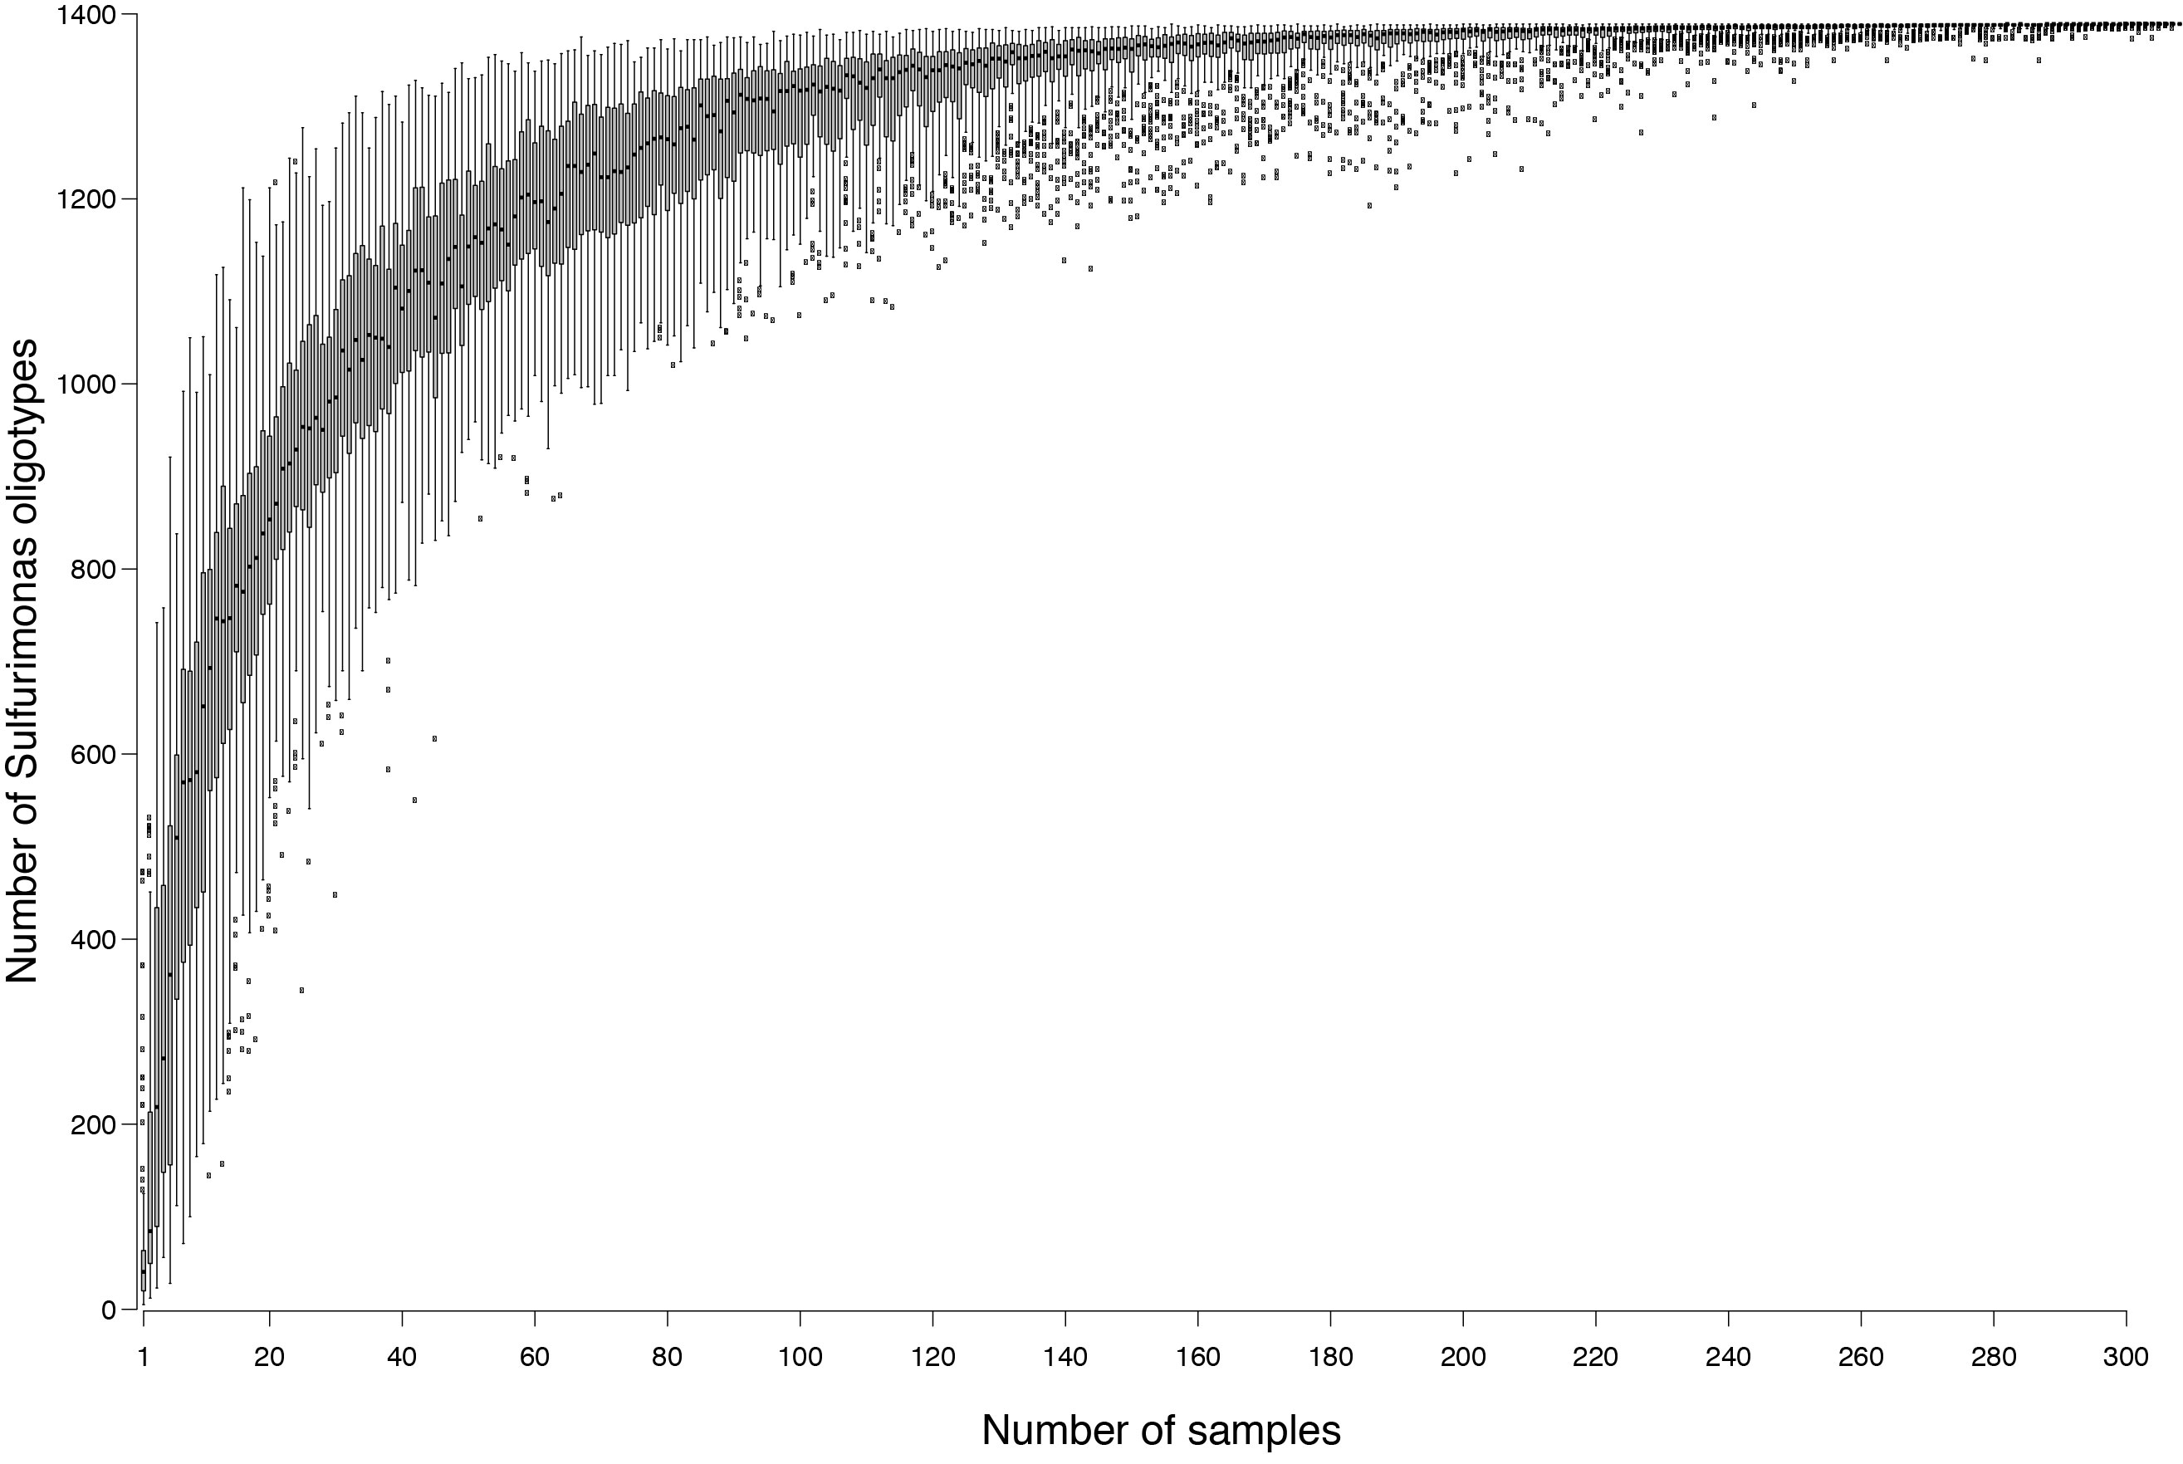

Supplementary Tables

Supplementary Table 1. Number of sequences (seq. n.) of Campilobacterota’s genera and their contribution to the total number of Campilobacterota sequences (%). a, based on 16S rRNA gene paired-end Illumina sequencing (MiSeq). b, base on 16S rRNA single-end Illumina sequencing (HiSeq). In brackets the water depths’ range and number of stations (n) are reported for different water types. un. = unclassified.
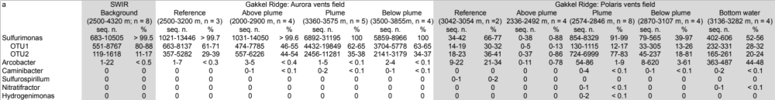
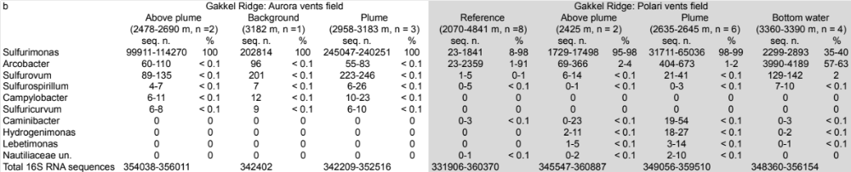
SWIR: SouthWest Indian Ridge
Seq. n: number of sequences
%: percentage of total number of Campilobacterota sequences

Supplementary Table 2. Statistics for draft genomes of ^{U}Sulfurimonas pluma assembled from Gakkel Ridge's hydrothermal plumes.
 | MAG-1 |  | MAG-2
No. scaffolds | 36 |  | 24
Total length | 1697626 |  | 1655783
GC content | 34.18 |  | 34.19
Completeness | 96.6 |  | 93.1
Redundancy | 1.7 |  | 0
Strain Heterogeneity | 0 |  | 0
N50 | 113080 |  | 127483
No. protein coding genes | 1905 |  | 1839
No. rrna | 8ª |  | 8ª
No. trna | 44 |  | 43
Longest contig | 363405 |  | 218596
Coding density | 1.12 |  | 1.11

ª 5S rRNA in 5 copies

Supplementary Table 3. Compilation of data from environments hosting large proportion of 16S rRNA gene sequences of Sulfurimonas. The data reported refer to samples of sediments and their porewaters or water for aquifer and hard substrate (benthic), or to samples of seawater (pelagic). The concentrations of chemical species refer to dissolved compounds in porewater and water if not stated otherwise.
Environments | Geographic region | Sulfurimonas | Temperature | Free hydrogen sulfide (H₂S) | H₂ | O₂ | NO₃⁻ | Fe | Reference
 |  | % | ºC | µmol L⁻¹ | µmol L⁻¹ | µmol L⁻¹ | µmol L⁻¹ | µmol L⁻¹
Benthic
Coastal brackish benthic redox cline | Baltic Sea | up to 84 | 6.5 | na | na | 25 | 3 | 1−9ª | ¹⁴
Coastal marine benthic redox cline | North Sea | 0.1−2 | 9.6 | 0−100 | na | 10−100 | 0−10.9 | na | ¹⁵
Subsurface fresh water | Sweden | up to 83 | 12−15 | 0.53−1.29 | na | 2.3−7.2 | 185−223 | 23.5−27.8 | ¹⁶
Hydrothermal vent microbial mat | Mariana Arc | 9−13 | 18.7−30.5 | <0.4−816 | <0.01−0.02 | na | na | <0.1−96.7 | ¹⁷
Hydrothermal vent rock/chimney | Manus Basin | <1−37 | na | na | na | na | na | na | ¹⁸
Hydrothermal vent water/fluid | Manus Basin | 5−24 | 3.6−98.6 | 0−3761 | 0.02−0.8 | 0−310 | na | na | ¹⁸
 | Axial Seamount | 12−16 | 24.5−27.9 | 452 | <1−1.4 | <30^{b} | 7.2 | na | ¹⁹
Pelagic
Marine pelagic redox cline | Baltic Sea | 20^{c} | 5−6 | 1.3−30 | na | 0.6−41.4 | 1 | na | ²⁰
Rainbow non-buoyant hydrothermal plume | Mid Atlantic Ridge | 21−58 | <4 | na | na | 255−275 | 18−22 | 0.04−0.36^{d} | ²¹
Irina plume (Logatchev field) | Mid Atlantic Ridge | ~70 | <4 | bdl | 0.014 | 226 | na | na | ²²
Aurora non-buoyant hydrothermal plume | Gakkel Ridge | 15−64 | −0.89 | na | Up to 0.300e | 307 | 15.6 | up to 0.150^{d} | this study, ²³
Polaris non-buoyant hydrothermal plume | Gakkel Ridge | 4−17 | −0.74 | na^{f} | up to 0.360 | 303 | 14.8 | bdl | this study, ²⁴
ª total iron;
^{b} estimated from percent seawater;
^{c} based on cell count;
^{d} solid iron (Fe³⁺);
^{e} calculated minimum concentration from thermodynamic equilibrium (based on the assumption of ΔG=0 at 370°C for the H₂/CO₂−CH₄ couple) and dilution of non-buoyant hydrothermal plume;
^{f} some samples had sulfidic smell;
na: not available; bdl: below detection limit.
Supplementary Table 4. Metadata and sequence statistics of the samples used in the analysis of Sulfurimonas oligotypes.”
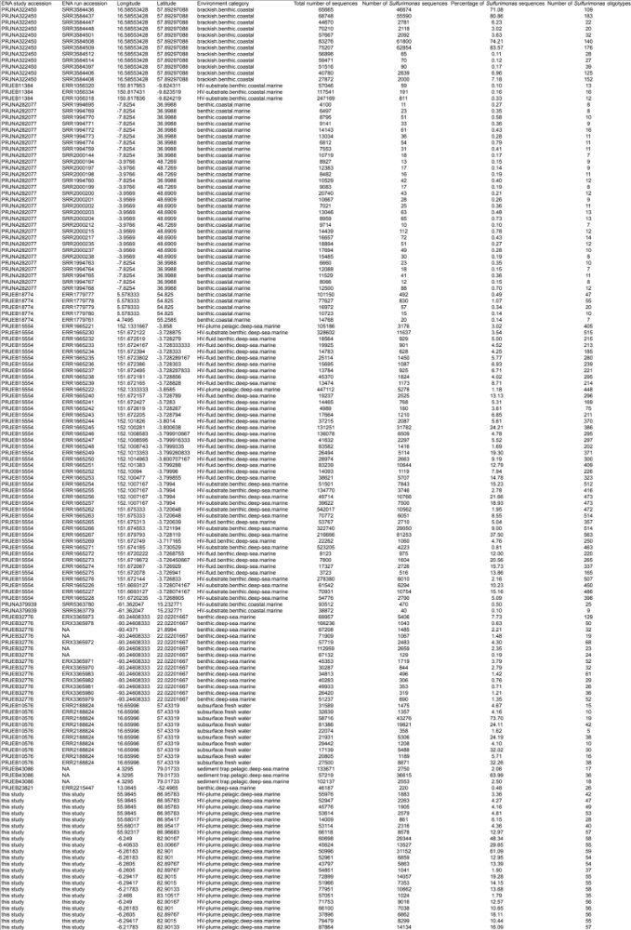

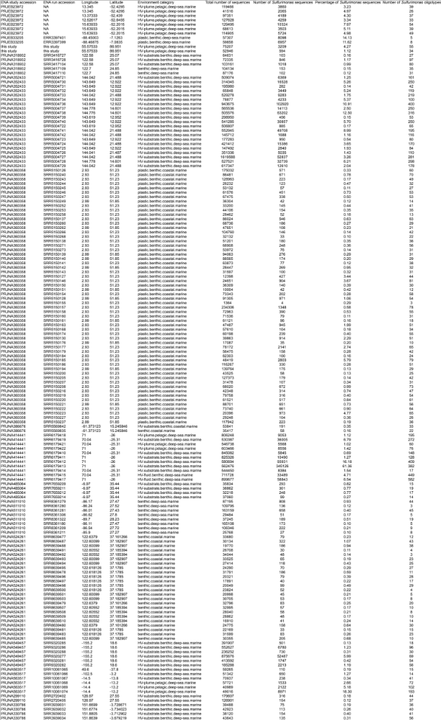
Supplementary Table 5. Comparison of marker genes for main metabolic pathways between Sulfurimonas isolates and ^{U}Sulfurimonas pluma. The number of gene copy is given in round brackets.
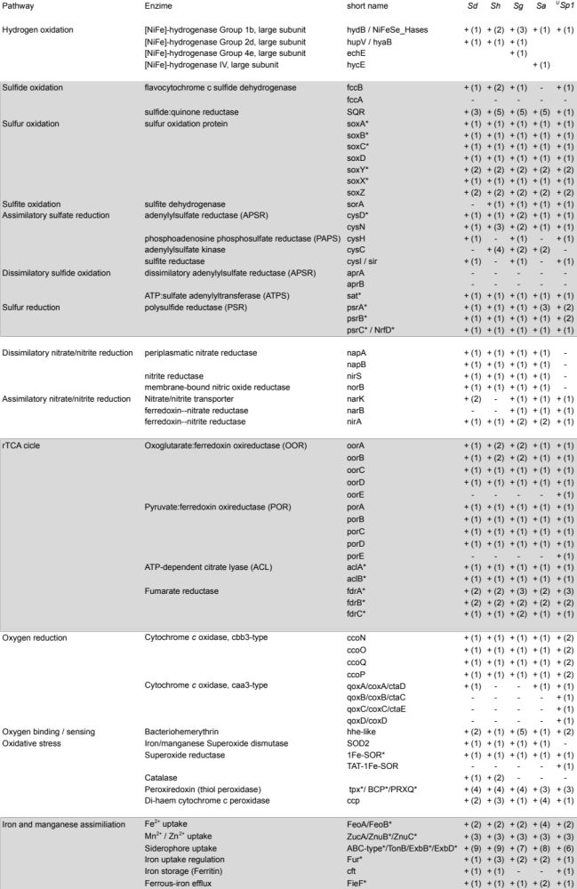
Sd: Sulfurimonas denitrificans; Sh: Sulfurimonas hongkongensis; Sg: Sulfurimonas gotlandica; Sa: Sulfurimonas autotrophica; ^{U}Sp1: ^{U}Sulfurimonas pluma MAG-1.
* Core genes.

Supplementary Table 6. Comparison of hydrothermal systems and vent fluids types for neutrally buoyant hydrothermal plumes hosting chemolithotrophic ^{U}S. pluma and SUP05 cluster (family Thioglobaceae). Percentage refers to the proportion of 16S rRNA gene sequences in neutrally buoyant hydrothermal plumes.
Ridge system | Vent field | Vent site | Rock hosting system | Fluid type | ^{U}S. pluma | SUP05 | Reference
 |  |  |  |  | % | %
Mid Atlantic Ridge | Logatchev | Irina I | Ultramafic | Hydrogen-Metal-rich | up to 70 | < 10 | ^{25,22}
 | Rainbow | − | Ultramafic | Hydrogen-Metal-rich | up to 60 | < 10 | ^{26,27,21}
SouthWest Indian Ridge | Longqi | DFF1, DFF3, DFF5, DFF6 | Basalt | Sulfide-Metal-rich | up to 21 | < 5 | ^{28,29}
Guaymas Basin | − | − | Basalt and Organic-rich sediments | Methane-Ammonia-rich | < 2 | 30 | ^{30,31}
Gakkel Ridge | Aurora | − | Basaltic / Ultramafic | Hydrogen-Metal-rich | up to 79ª | < 10ª | this study, ²³
 | Polaris | − | Basaltic | Hydrogen-rich | < 18ª | up to 40ª | this study, ²⁴
ª based on 16S rRNA sequences from metatranscriptomes (Supplementary Figure 1).
Supplementary Table 7. List of stations and sequencing approaches applied in this study.
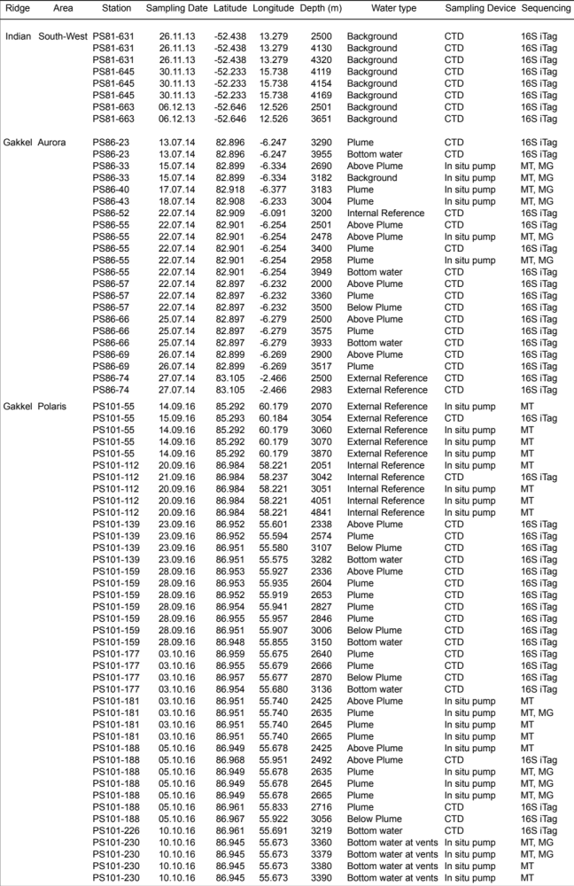
16S iTag: 16S rRNA gene paired-end illumina sequencing (MiSeq); MT: metatranscriptomes, single-end illumina sequencing (HiSeq); MG: metagenomes, pared-end illumina sequencing (MiSeq). Background seawater: seawater without physico-chemical signatures for hydrothermal plume, but potentially affected by hydrothermal plume. Rerefence seawater: seawater without physico-chemical signatures for hydrothermal plume, and not affected by hydrothermal plume.

Supplementary Table 8. Data sets used for oligotyping of Sulfurimonas, including accession number, sample origin, and related publication if available.
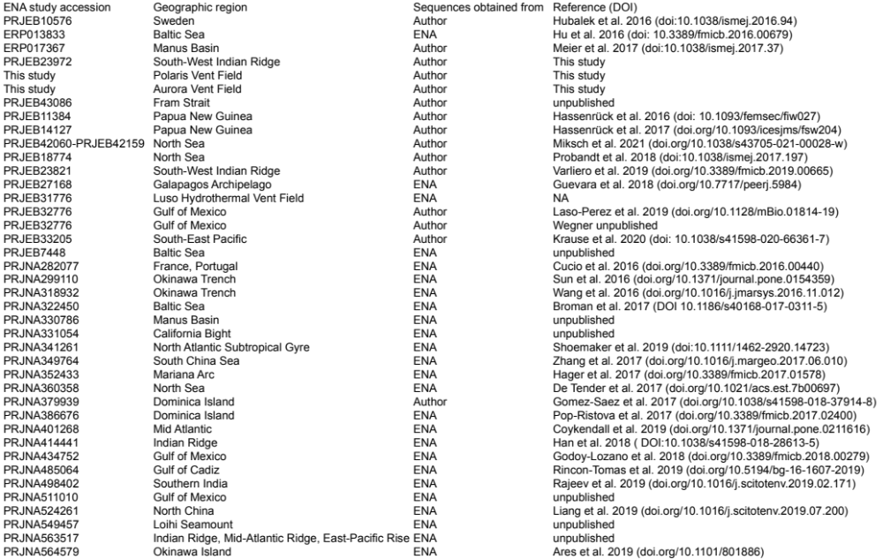
Supplementary Table 9. a, information for isolate genome and MAG. b, information for hydrothermal vent meta-genomes and -transcriptomes used in this study.
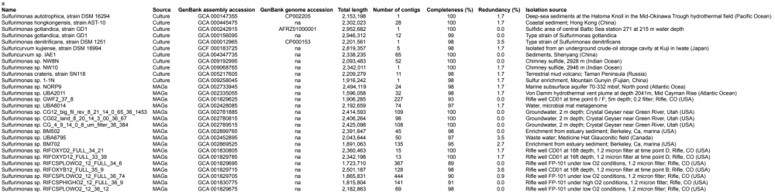
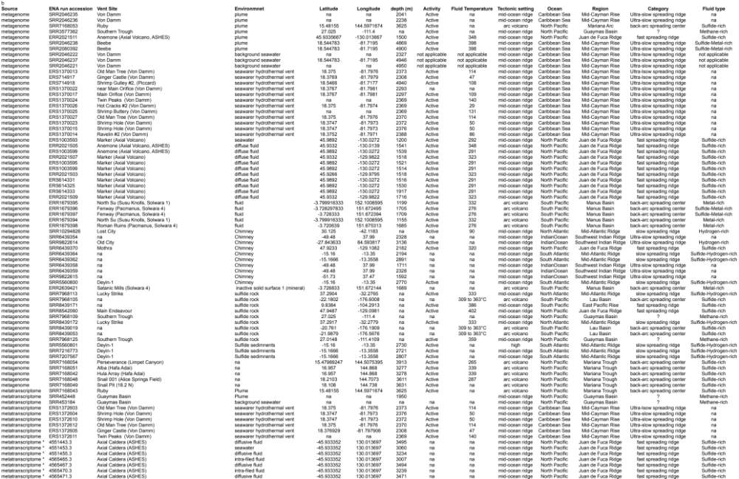
* downloaded from MG-RAST; na: not available

References
1. Han, Y. & Perner, M. The globally widespread genus Sulfurimonas: versatile energy metabolisms and adaptations to redox clines. Front. Microbiol. 6, 989 (2015).
2. Wang, S. et al. Characterization of Sulfurimonas hydrogeniphila sp. nov., a Novel Bacterium Predominant in Deep-Sea Hydrothermal Vents and Comparative Genomic Analyses of the Genus Sulfurimonas. Front. Microbiol. 12, 1–20 (2021).
3. Inagaki, F., Takai, K., Kobayashi, H., Nealson, K. H. & Horikoshi, K. Sulfurimonas autotrophica gen. nov., sp. nov., a novel sulfur-oxidizing ɛ-proteobacterium isolated from hydrothermal sediments in the Mid-Okinawa Trough. Int. J. Syst. Evol. Microbiol. 53, 1801–1805 (2003).
4. Perner, M., Petersen, J. M., Zielinski, F., Gennerich, H. & Seifert, R. Geochemical constraints on the diversity and activity of H₂-oxidizing microorganisms in di¡use hydrothermal fluids from a basalt- and an ultramafic-hosted vent. FEMS Microbiol. Ecol. 74, 55–71 (2010).
5. Nakagawa, S. et al. Distribution , phylogenetic diversity and physiological characteristics of epsilon-Proteobacteria in a deep-sea hydrothermal field. Environ. Microbiolo. 7, 1619–1632 (2005).
6. Greening, C. et al. Genomic and metagenomic surveys of hydrogenase distribution indicate H₂ is a widely utilised energy source for microbial growth and survival. ISME J. 10, 761–777 (2015).
7. Pandelia, M., Lubitz, W. & Nitschke, W. Evolution and diversification of Group 1 [NiFe] hydrogenases. Is there a phylogenetic marker for O₂-tolerance? BBA - Bioenerg. 1817, 1565–1575 (2012).
8. Anantharaman, K., Breier, J. A., Sheik, C. S. & Dick, G. J. Evidence for hydrogen oxidation and metabolic plasticity in widespread deep-sea sulfur-oxidizing bacteria. PNAS 110, 330–335 (2013).
9. Griesbeck, C., Hauska, G. & Schütz, M. Biological Sulfide Oxidation: Sulfide-Quinone Reductase (SQR), the Primary Reaction. in Recent Research Developments in Microbiology (ed. Pandalai, S. G.) 4, 179–203 (Research Signpost, Trivadrum , India., 2000).
10. Argyrou, A. & Blanchard, J. S. Flavoprotein Disulfide Reductases: Advances in Chemistry and Function. Prog. Nucleic Acid Res. Mol. Biol. 78, 89–142 (2004).
11. Watson, C. et al. Electron transfer through arsenite oxidase: Insights into Rieske interaction with cytochrome c. BBA - Bioenerg. 1858, 865–872 (2017).
12. Ellis, P. J., Conrads, T., Hille, R., Kuhn, P. & Synchrotron, S. Crystal Structure of the 100 kDa Arsenite Oxidase from Alcaligenes faecalis in Two Crystal Forms at 1.64 Å and 2.03 Å. Structure 9, 125–132 (2001).
13. Park, B. et al. Cultivation of Autotrophic Ammonia-Oxidizing Archaea from Marine Sediments in Coculture with Sulfur-Oxidizing Bacteria. Appl. Environ. Microbiol. 76, 7575–7587 (2010).
14. Broman, E., Sjöstedt, J., Pinhassi, J. et al. Shifts in coastal sediment oxygenation cause pronounced changes in microbial community composition and associated metabolism. Microbiome 5, 96 (2017).
15. Probandt, D., Knittel, K., Tegetmeyer, H. E., Ahmerkamp, S., Holtappels, M. & Amann R. Permeability shapes bacterial communities in sublittoral surface sediments. Environ Microbiol. 19:1584-1599 (2017).
16. Hubalek, V., Wu, X., Eiler, A. et al. Erratum: Connectivity to the surface determines diversity patterns in subsurface aquifers of the Fennoscandian shield. ISME J. 10, 2556 (2016).17.
17. Hager, K. W., Fullerton, H., Butterfield, D. A. & Moyer, C. L. Community Structure of Lithotrophically-Driven Hydrothermal Microbial Mats from the Mariana Arc and Back-Arc. Front. Microbiol. 8:1578 (2017).
18. Meier, D., Pjevac, P., Bach, W. et al. Niche partitioning of diverse sulfur-oxidizing bacteria at hydrothermal vents. ISME J. 11, 1545–1558 (2017).
19. Akerman, N. H., Butterfield, D. A., Huber, J. A., Huber, J. A. & Paul, J. B. Phylogenetic diversity and functional gene patterns of sulfur-oxidizing subseafloor Epsilonproteobacteria in diffuse hydrothermal vent fluids. Front. Microbiol. 4, 1–14 (2013).
20. Rogge, A., Vogts, A., Voss, M. & Labrenz, M. Success of chemolithoautotrophic SUP05 and Sulfurimonas GD17 cells in pelagic Baltic Sea redox zones is facilitated by their lifestyles as K- and r-strategists. Environ. Microbiol. 19, 2495–2506 (2017).
21. Haalboom, S., Price, D. M., Mienis, F., Bleijswijk, J. D. L. et al. Patterns of (trace) metals and microorganisms in the Rainbow hydrothermal vent plume at the Mid-Atlantic Ridge. Biogeosciences 17, 2499–2519 (2020).
22. Perner, M., Gonnella, G., Hourdez, S., Böhnke, S., Kurtz, S. & Girguis, P. In situ chemistry and microbial community compositions in five deep-sea hydrothermal fluid samples from Irina II in the Logatchev field. Environ Microbiol. Environ. Microbiol. 15, 1551–1560 (2013).
23. Boetius, A. The Expedition PS86 of the Research Vessel POLARSTERN to the Arctic Ocean in 2014. (2015). doi:doi:10.2312/BzPM_0685_2015
24. Boetius, A. & Purser, A. The Expedition PS101 of the Research Vessel POLARSTERN to the Arctic Ocean in 2016. (2017). doi:doi: 10.2312/BzPM_0706_2017
25. Schmidt, K., Koschinsky, A., Garbe-schönberg, D., de Carvalho, L. & Seifert, R. Geochemistry of hydrothermal fluids from the ultramafic-hosted Logatchev hydrothermal field, 15° N on the Mid-Atlantic Ridge: Temporal and spatial investigation. Chem. Geol. 242, 1–21 (2007).
26. Perner, M. et al. The influence of ultramafic rocks on microbial communities at the Logatchev hydrothermal field, located 15 degrees N on the Mid-Atlantic Ridge. FEMS Microbiol. Ecol. 61, 97–109 (2007).
27. Douville, E. et al. The rainbow vent fluids (36°14’N, MAR): the influence of ultramafic rocks and phase separation on trace metal content in Mid-Atlantic Ridge hydrothermal fluids. Chem. Geol. 184, 37–48 (2002).
28. Ji, F. et al. Deep – Sea Research I Geochemistry of hydrothermal vent fluids and its implications for subsurface processes at the active Longqi hydrothermal field, Southwest Indian Ridge. Deep. Res. Part I 122, 41–47 (2017).
29. Li, J. et al. Distribution and Succession of Microbial Communities Along the Dispersal Pathway of Hydrothermal Plumes on the Southwest Indian Ridge. Front. Mar. Sci. 7, 581381 (2020).
30. Anantharaman, K., Breier, J. A., Sheik, C. S. & Dick, G. J. Evidence for hydrogen oxidation and metabolic plasticity in widespread deep-sea sulfur-oxidizing bacteria. PNAS 110, 330–335 (2013).
31. Dick, G. J. & Tebo, B. M. Microbial diversity and biogeochemistry of the Guaymas Basin deep-sea hydrothermal plume. Environ. Microbiol. 12, 1334–1347 (2010).

