Additional File 2
Supplementary Figures

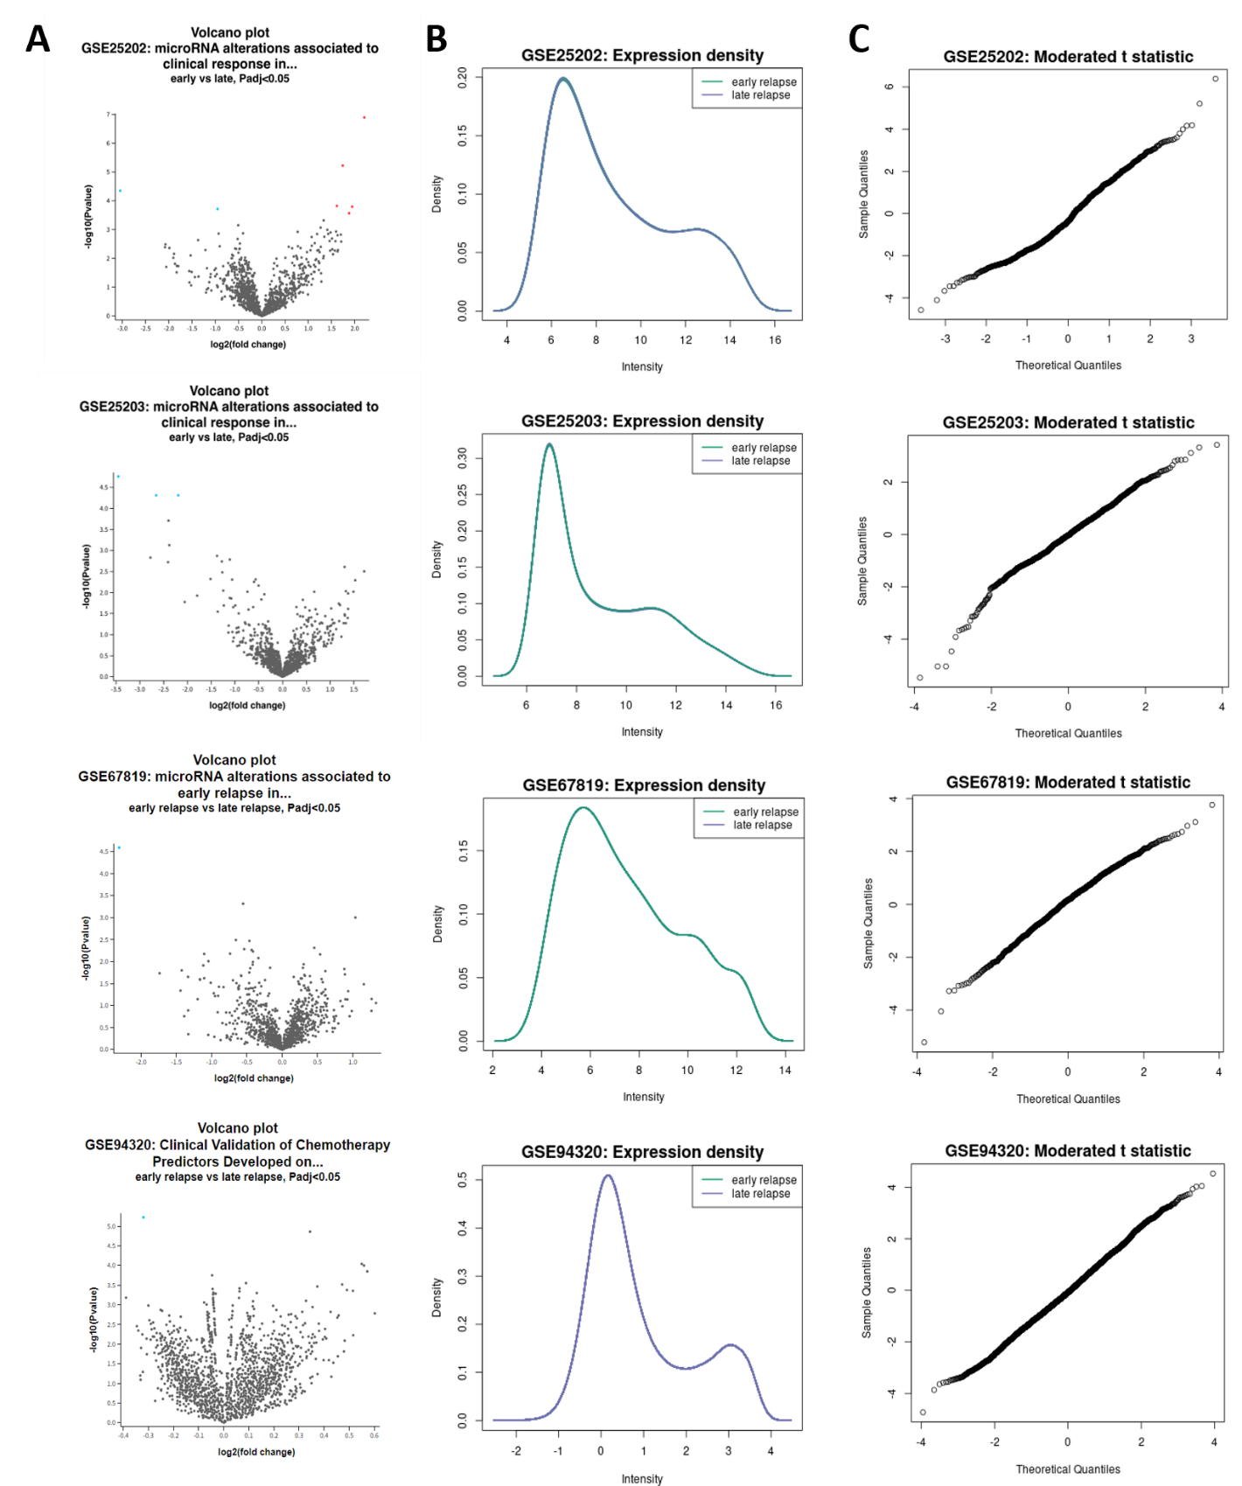

Figure S1 Volcano plots, expression densities, and moderated t statistics for the miRNAs at each dataset. A Volcano plots, B expression densities, and C moderated t statistics for miRNAs in GSE25202, GSE25203, GSE67819, and GSE94320 datasets.
Figure SEQ Figure \* ARABIC 2: Volcano plots of datasets obtained from GEO2R analysis of patients with HGSOC. Each dots show different miRNAs: Blue dots are upregulated miRNAs whereas red dots are downregulated miRNAs

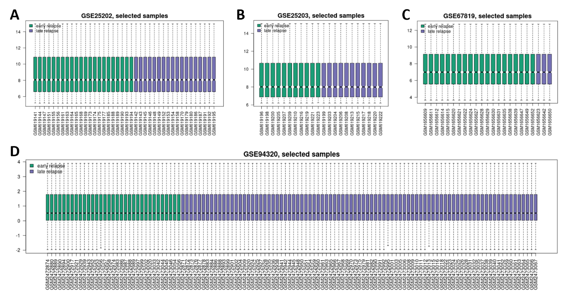

Figure S2 Box plots for the samples normalized with the Benjamini-Hochberg procedure in four datasets. A GSE25202, B GSE25203, C GSE67819, and D GSE94320 datasets.
Figure SEQ Figure \* ARABIC 2: Volcano plots of datasets obtained from GEO2R analysis of patients with HGSOC. Each dots show different miRNAs: Blue dots are upregulated miRNAs whereas red dots are downregulated miRNAs

