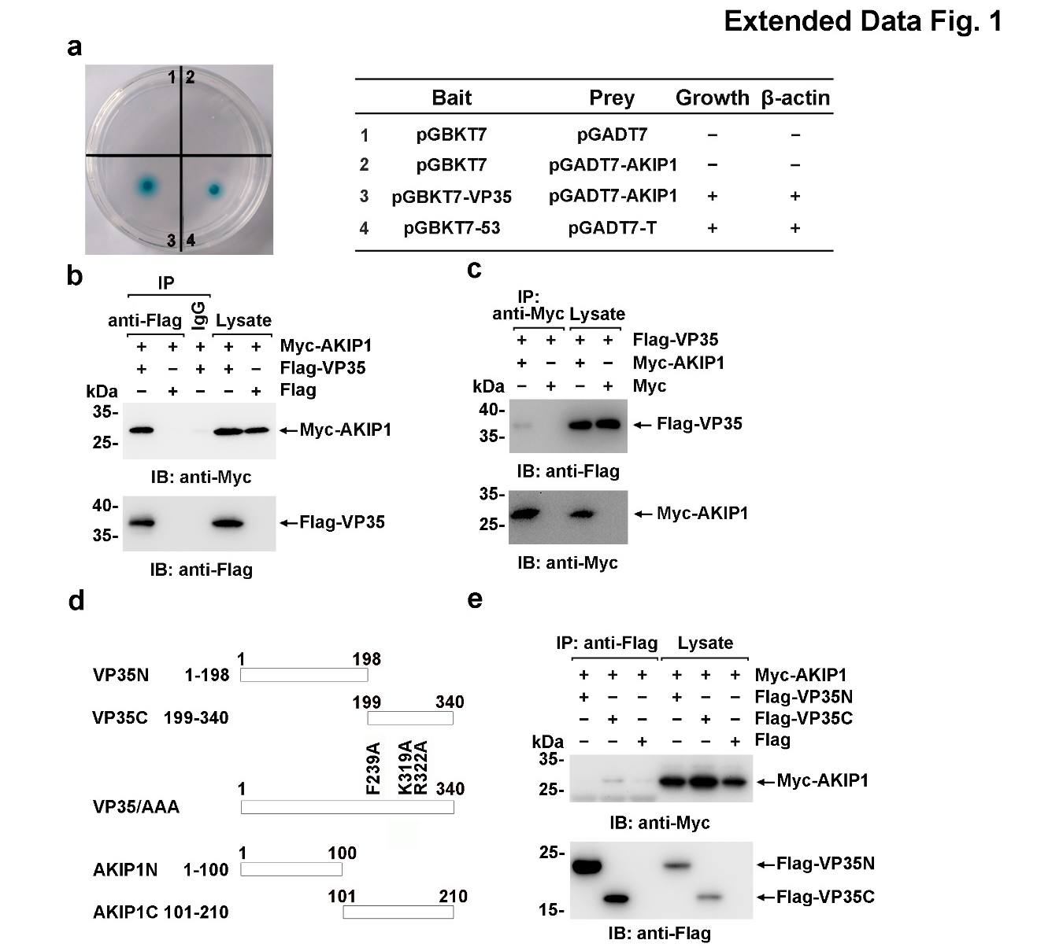
Extended Data Fig. 1 The interaction between EBOV VP35 and AKIP1.
a, Yeast Y2HGold cells were transformed with the indicated plasmids (bait and prey for the two-hybrid assay) and grown on selective medium. Positive interactions were indicated by colonies that grow on selective medium and have β-galactosidase activity (blue). b, c, e, Lysates of HEK293 cells co-transfected with indicated plasmids were analyzed by immunoprecipitation and immunoblotting. d, Graphical representation of VP35 and AKIP1 mutants.

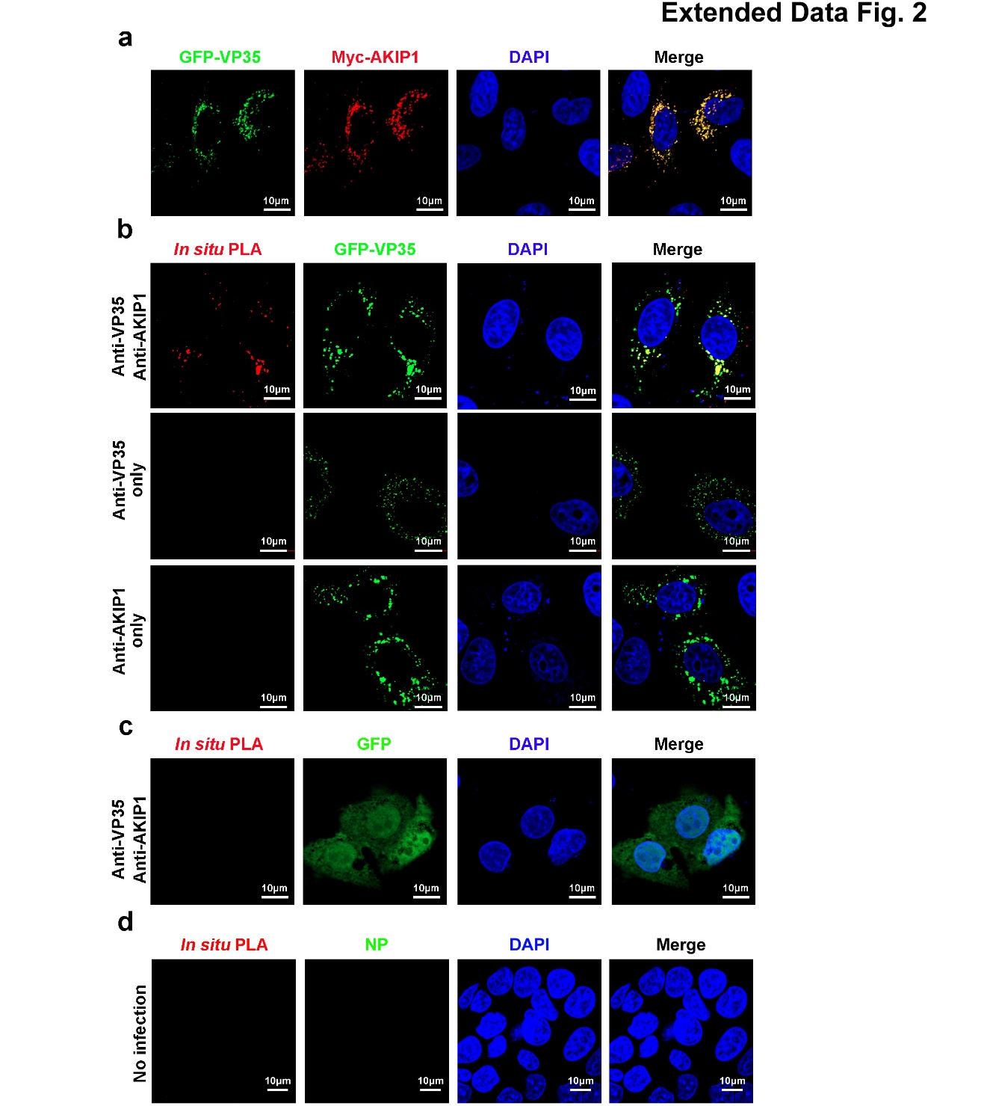
Extended Data Fig. 2 In situ association of EBOV VP35 with cellular AKIP1.
a, HeLa cells were co-transfected with GFP-VP35 and Myc-AKIP1 and immunostained with an anti-AKIP1 (red) antibody. b, c, HepG2 cells were transfected with GFP-VP35 (b) or GFP vector (c), and then subjected to an in situ PLA assay with indicated antibodies. d, As control of the main text Fig. 1e, uninfected HepG2 cells were subjected to in situ PLA assay and immunofluorescent staining with an anti-NP antibody.
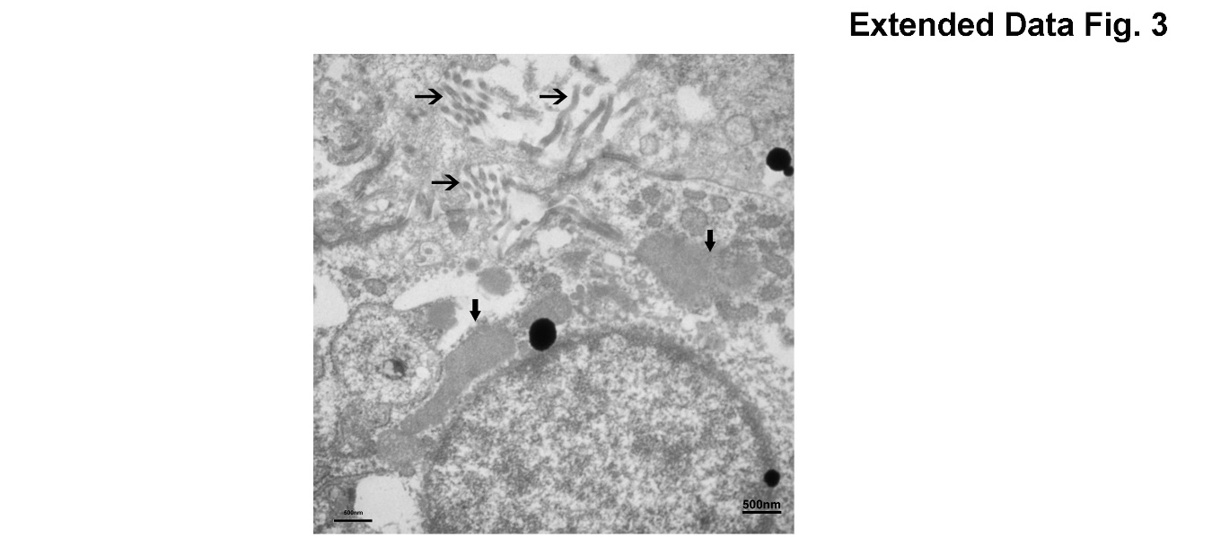
Extended Data Fig. 3 Transmission electron microscopy of HepG2 cells transfected with EBOV minigenome system.
HepG2 cells transfected with EBOV minigenome (p0) were observed with a HITACHI H-7650 transmission electron microscopy at an accelerating voltage of 80 kV. The VIBs and viral particles are marked with bold arrows and regular arrows, respectively.

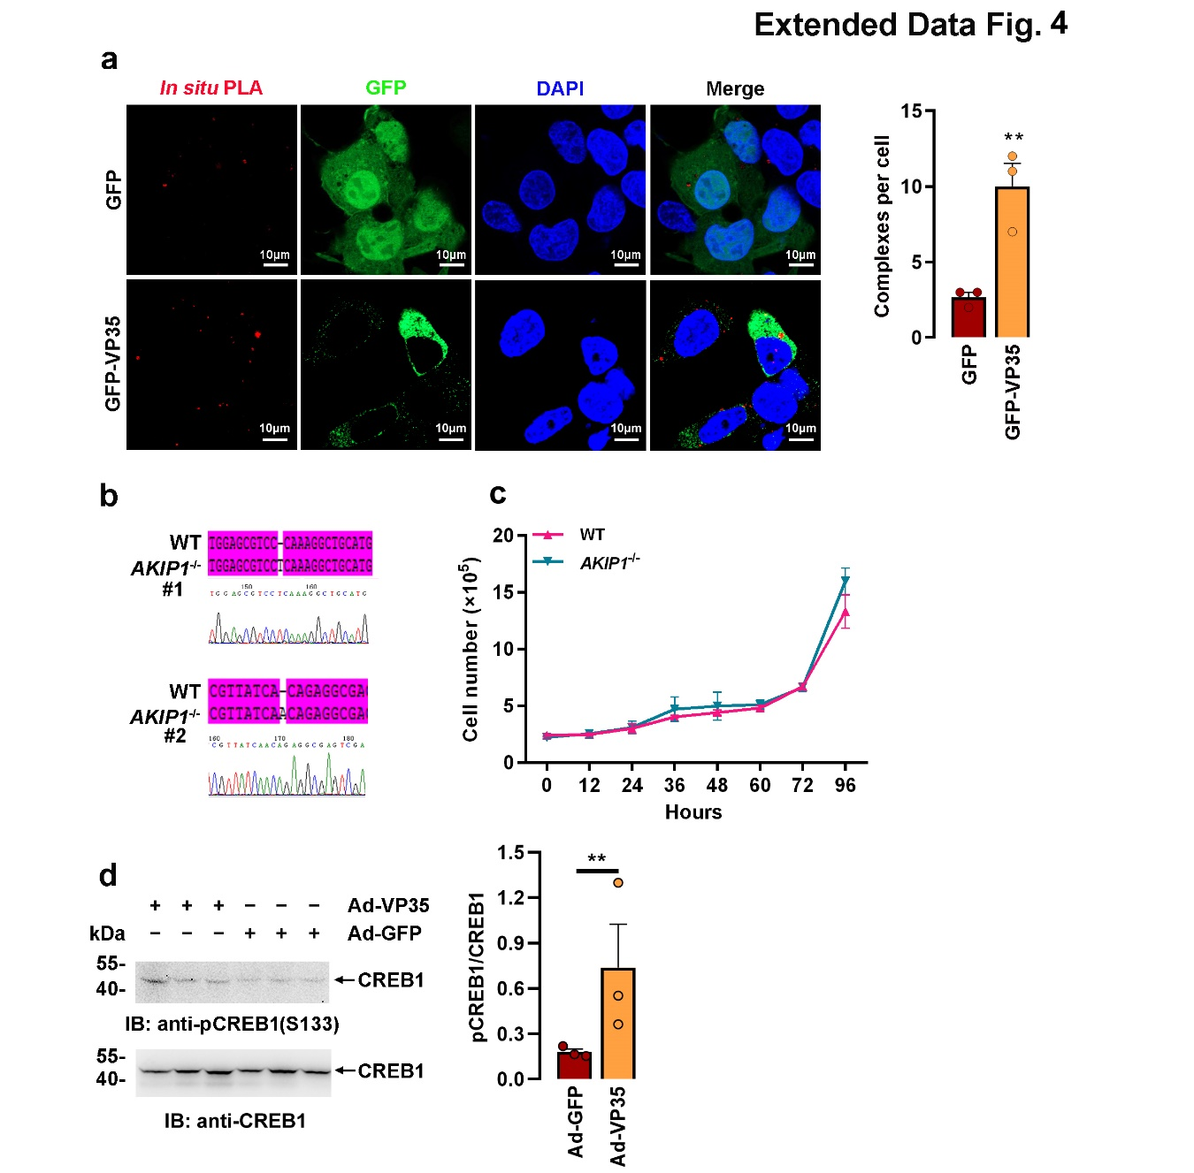
Extended Data Fig. 4 EBOV VP35 promotes AKIP1-PKA interaction and CREB1 activation.
a, HepG2 cells transfected with GFP-VP35 or GFP were subjected to in situ PLA with anti-AKIP1 and anti-PRKACA antibodies (left), and PLA complex signal in each cell were counted for at least 10 cells and presented as mean ±SEM (right). b, c, Two independent clones of AKIP1 KO HepG2 cell (KO1 and KO2) were generated with CRISPR/Cas9, and confirmed by sequencing (b). Cell proliferation was compared in (c). d, C57BL/6N mice (10 weeks) were infected with Ad-VP35 or Ad-GFP (2×10⁹ PFU) via tail vein injection twice at 24 h intervals. Three days later, the liver tissues were fragmented by a homogenizer and analyzed by immunoblotting with anti-CREB1 pS133 and anti-CREB1 antibodies (left). (Right panel) The ratio of CREB1 pS133/CREB1 was quantified by grayscale scanning using ImageJ software (n=3) (right). All data of 3 independent replications were presented as mean ±SEM (**P<0.01).

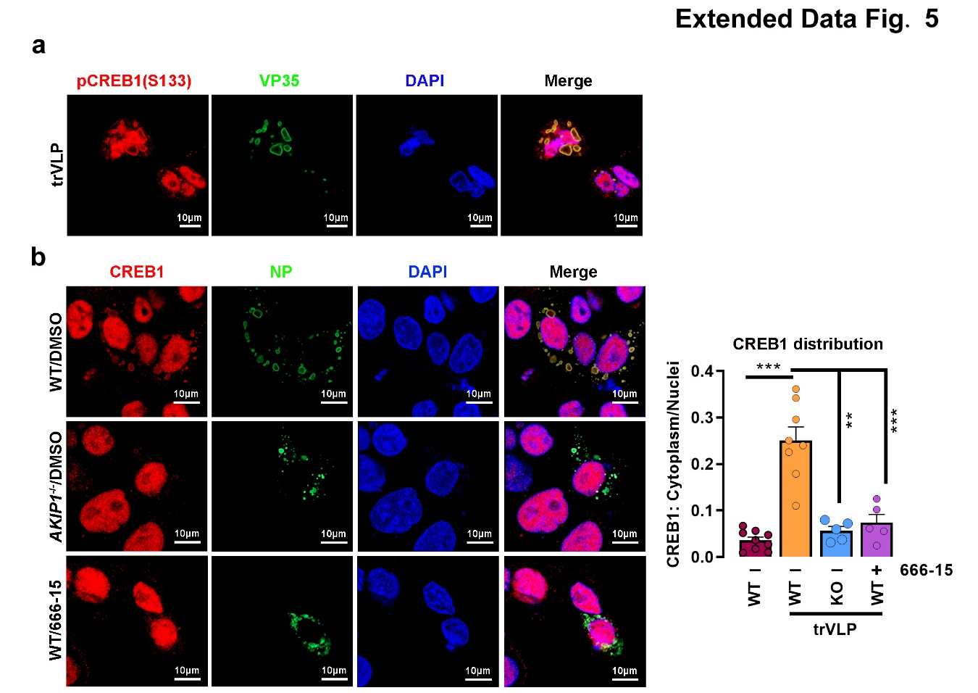
Extended Data Fig. 5 CREB1 is hijacked by viral VP35 in the V IBs of trVLPs-infected cells.
a, b, WT and AKIP1 KO HepG2 cells transfected with EBOV minigenome (p0) and treated with or without 666-15 (1 μM) were immunostained with indicated antibodies. Cytoplasm/nuclei distribution of CREB1 in (b, left) was analyzed by ImageJ software (b, right). The ratio of CREB1 distribution in at least 10 cells was expressed as mean ±SEM (***P<0.001).

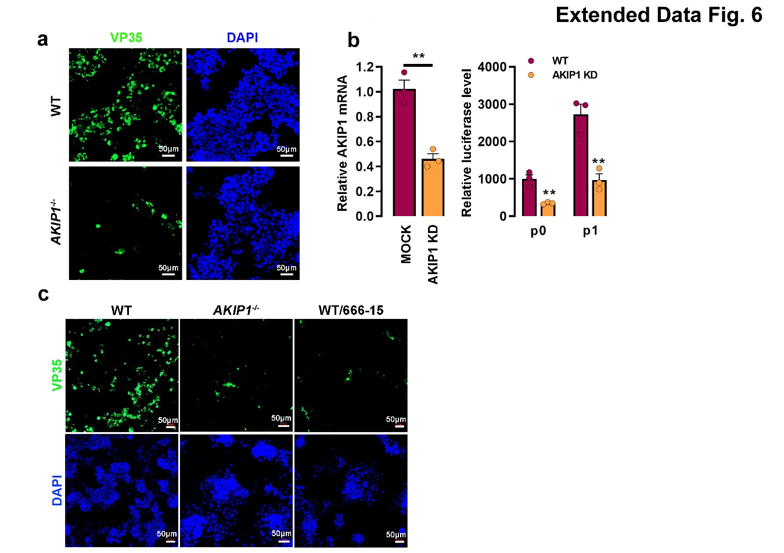
Extended data Fig. 6 EBOV trVLPs replication was compromised by AKIP1 knockdown or knockout.
a, WT and AKIP1 KO HepG2 cells transfected with EBOV minigenome (p0 and p1) for 48 h. were immunostained with an anti-VP35 antibody (green). b, HepG2 cells were transfected with EBOV minigenome (p0 and p1) for 12 h. Then, p1 cells were transfected with AKIP1 siRNA or scrambled siRNA. siRNA efficiency of AKIP1 was determined by qRT-PCR (left), and The amounts of trVLPs were determined by luciferase activity assay (right). c, WT and AKIP1 KO HepG2 cells infected with live EBOV were treated with 666-15 (1 μM) or vehicle for 48 h. Cells were then analyzed by immunostaining with an anti-VP35 antibody (green). All data of 3 independent replications were presented as mean ±SEM (**P<0.01).

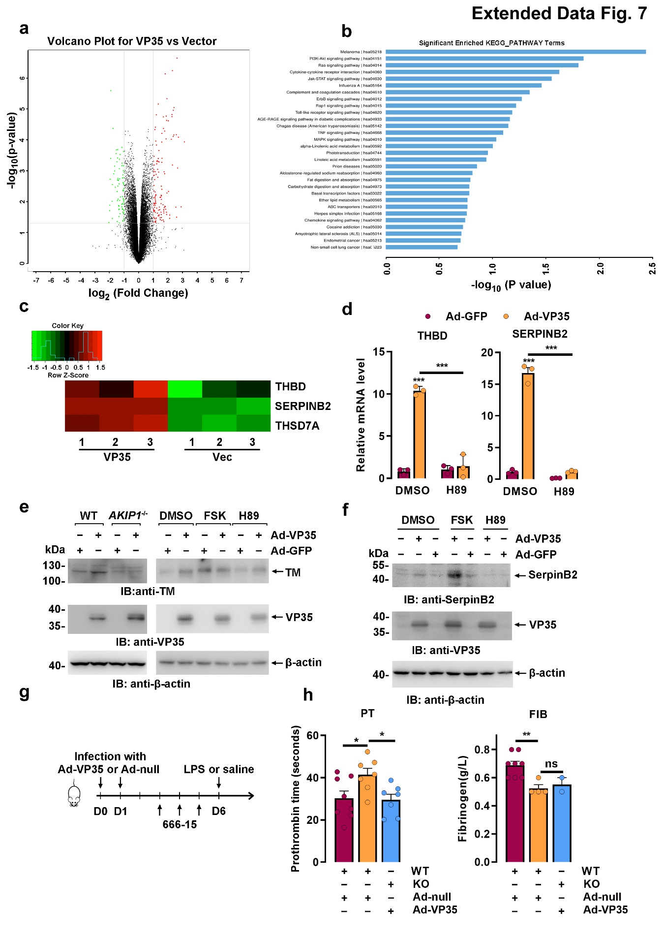
Extended Data Fig. 7 EBOV VP35 promotes the transcription and expression of coagulation-related genes via the AKIP1-PKA-CREB1 axis.
a, Gene expression in HepG2 transfected with VP35 or vector was analyzed with gene expression microarray. Differentially expressed genes regulated by VP35 in HepG2 cells were presented via a gene expression spectrum scatter plot. b, Top 20 KEGG pathways enriched in differentially expressed genes (≥2 fold or ≤-2 fold) regulated by VP35. c, Transcription of coagulation-related genes regulated by VP35 were shown by heat map. d, HepG2 cells infected with Ad-VP35 or Ad-GFP for 48 h were treated with or without the H89 (10 μM) for another 4 h. THBD and SERPINB2 mRNA levels were determined by qRT-PCR and normalized fold induction was demonstrated. e, f, HepG2 cells (the left of e, f) or HUVEC cells (e, right) infected with Ad-VP35 or Ad-GFP were treated with FSK (25 μM), H89 (10 μM) or vehicle for 4 h. Cell lysates were analyzed by immunoblotting. g, Schematic experimental design of Ad-VP35 or Ad-null infection, as well as 666-15 and LPS administration. h, WT and Akip1^{-/-} C57BL/6N mice (10 weeks) were intravenously injected with Ad-VP35 or Ad-null (2×10⁹ PFU) via tail vein injection twice at an interval of 24 h. Six days post infection, the mice were injected with LPS (5 mg/kg) via the tail vein. 4 h later, the blood clotting times (PT) and serum fibrinogen (FIB) concentrations were determined (n=2-8). All data of 3 independent experiments were presented as the mean ±SEM (*P<0.05; **P<0.01; ***P<0.001)
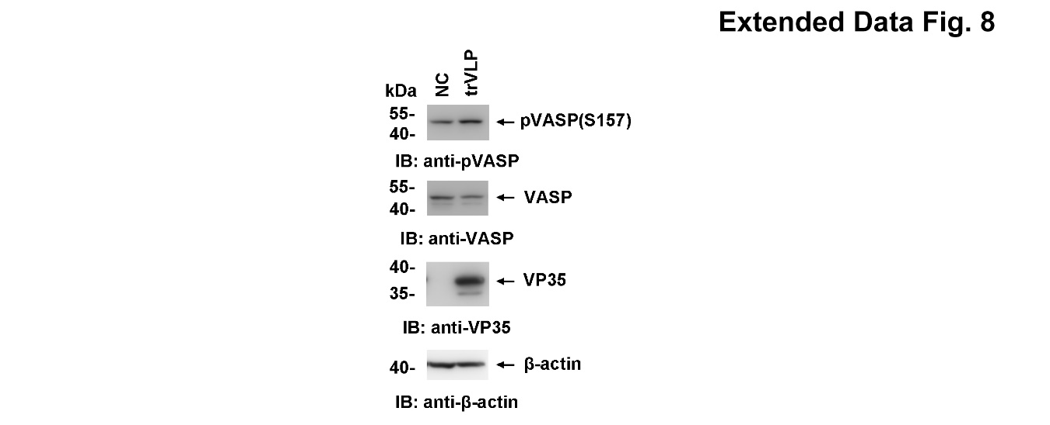
Extended Data Fig. 8 EBOV trVLPs promotes VASP phosphorylation. HepG2 cells transfected with or without EBOV minigenome (p0) were lysed and analyzed by immunoblotting.
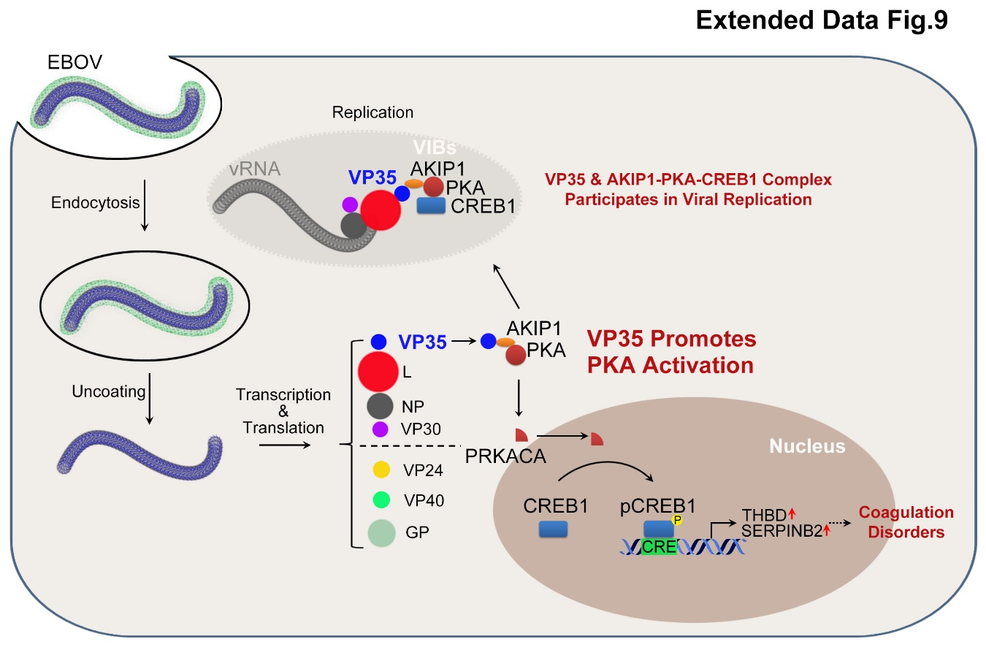
Extended Data Fig. 9 Graphical view of AKIP1-PKA-CREB1 axis-regulated viral replication and coagulation disorders through VP35:AKIP1 interaction.
Extended Data Table 1. Primers used for qRT-PCR.
Gene Product | Forward primer (5’ to 3’) | Reverse primer (5’ to 3’)
h-GAPDH | AAggTCATCCCTgAgCTgAAC | ACgCCTgCTTCACCACCTTCT
h-AKIP1 | AAggCTggCTCTAgAAgTgC | CTgTTTCTCTAggTggggCg
h-THBD | CCCAACACCCAggCTAgCT | gATgTCCgTgCAgATgAAACC
h-SerpinB2 | gTTACCCCCATgACTCCAgA | CgCAgACTTCTCACCAAACA
VP40 | GGAGGCCATATACCCTGTCAGGTC | GCCTGGTGTGTGGCTGGCAT
3Le | TCTCCgAAgggAgCAAgggCA | ACCCCAAgCTTTAgggTTgTTgAATC
5Tr | TggCCTCTCTCCCTgCgTgA | TCAACCAAAgCACTATTCCATCTggC

