TABLES
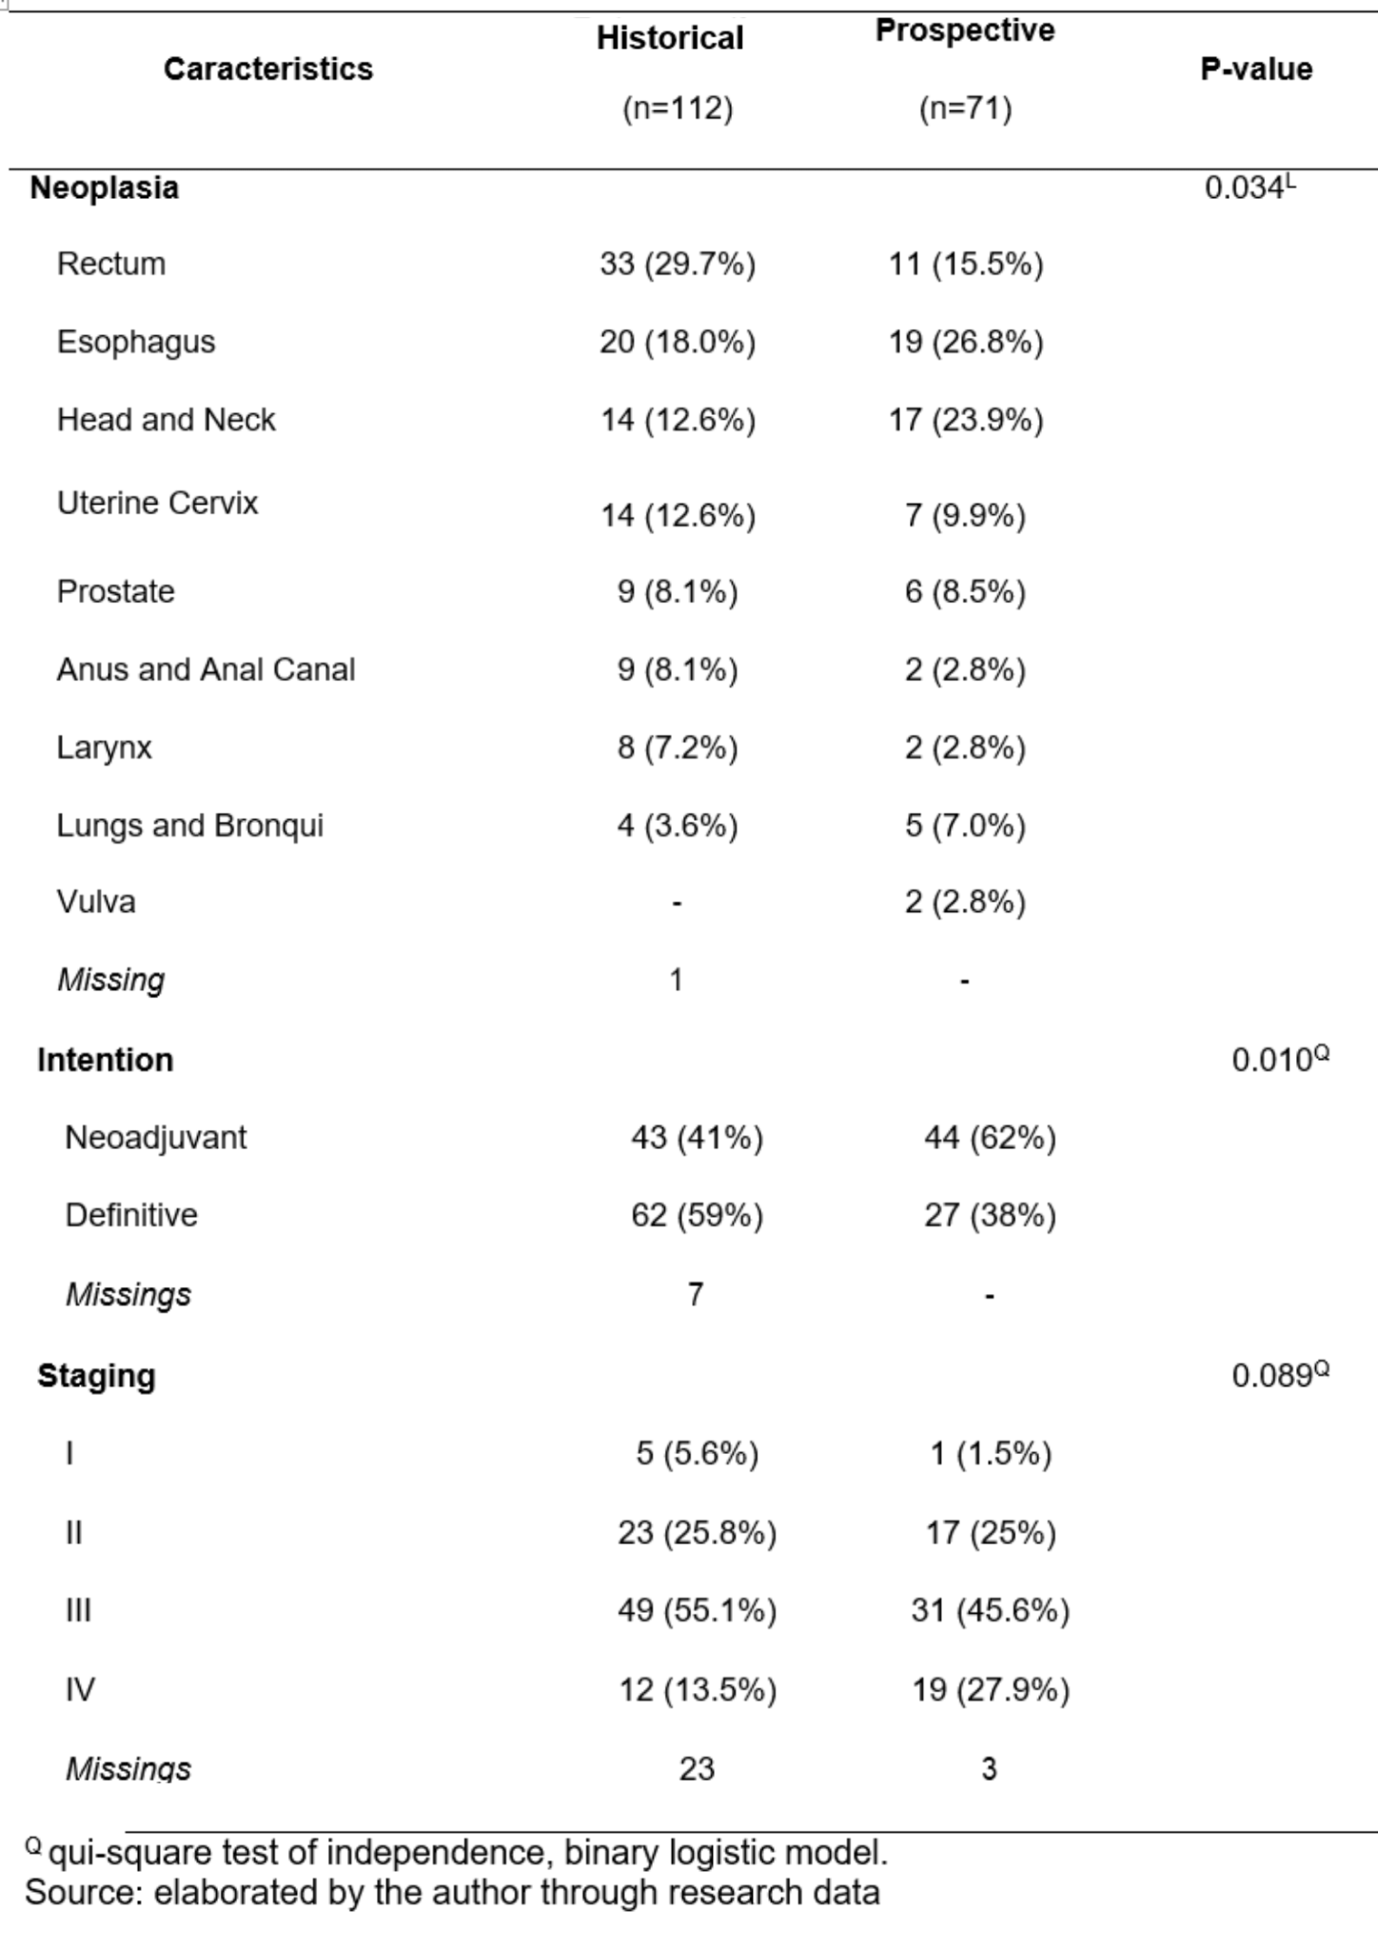
Table 1: Baseline data from retrospective and prospective cohorts.

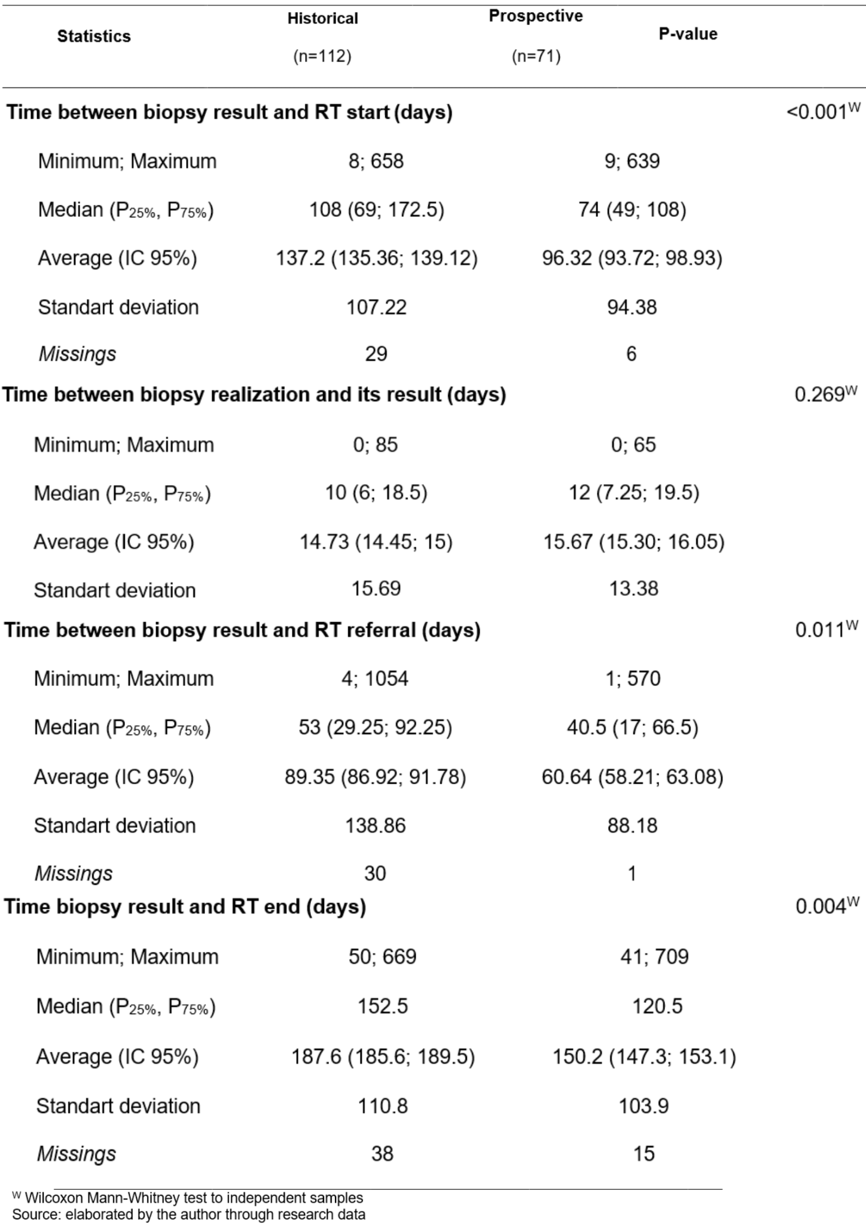
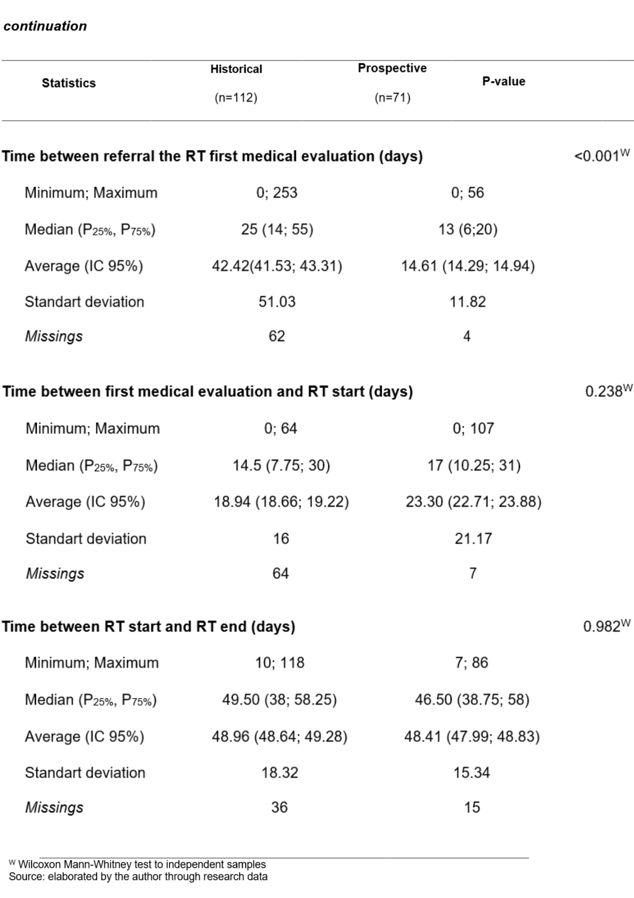
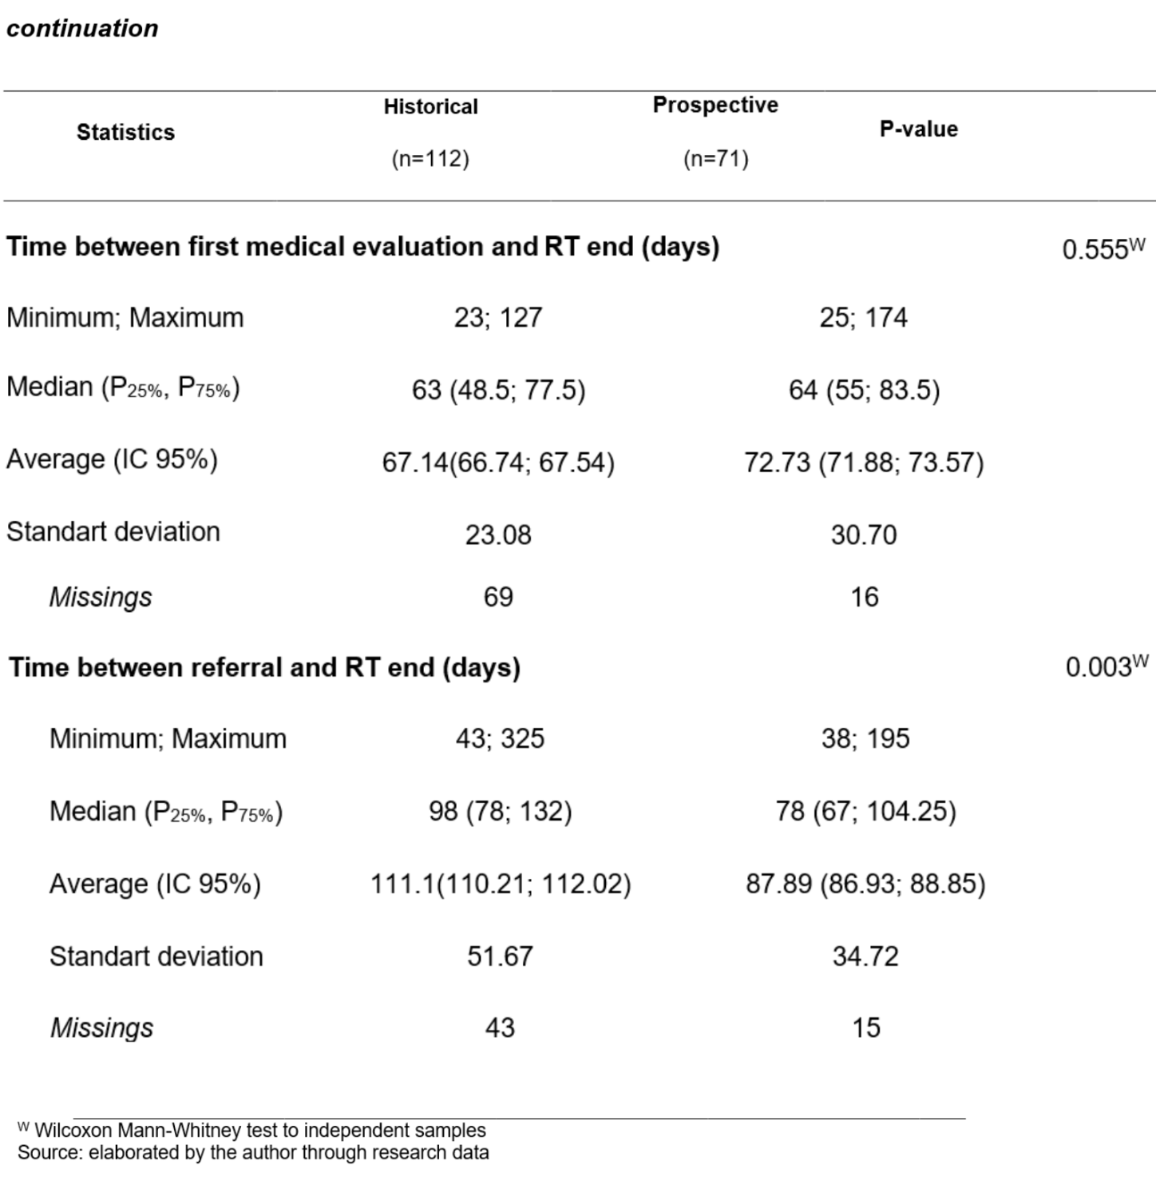
Table 2: Radiotherapy time lapse comparison between retrospective and prospective evaluation.
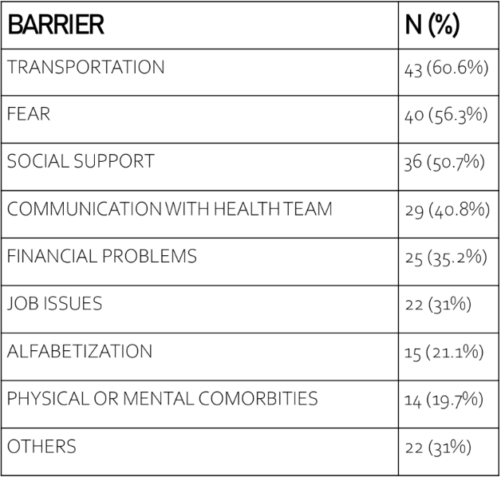
Table 3: Barriers for RT access.
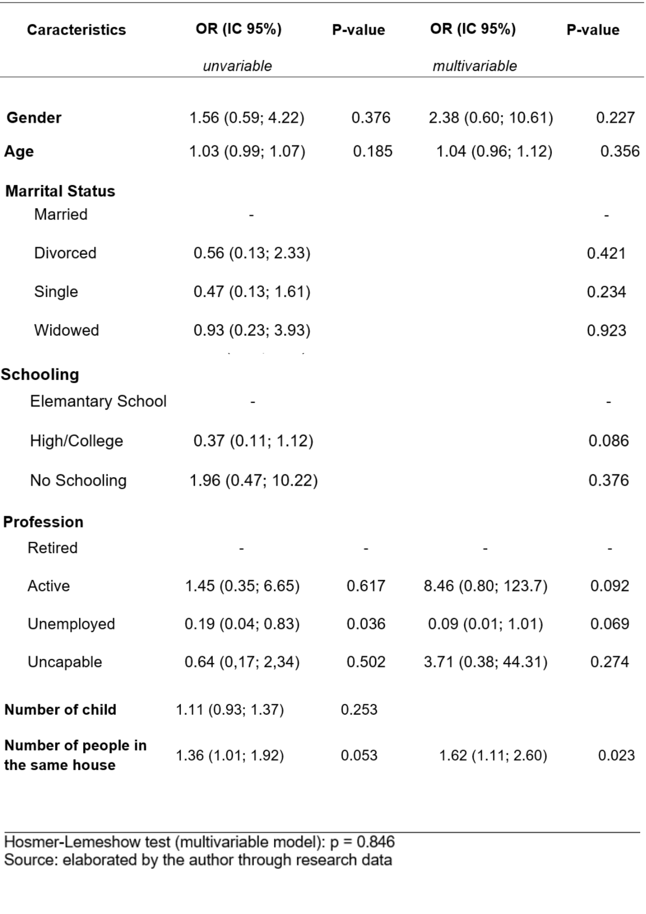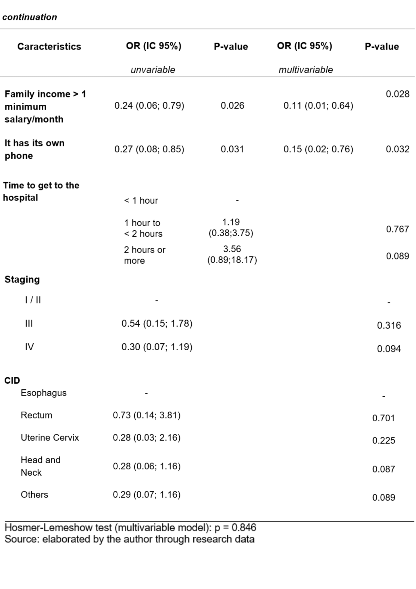
Table 4: - Associated factors to the longest time between the biopsy result and RT start (prospective study).

