Multilevel model inference using Classical and Bayesian approaches
Multilevel or hierarchical levels of grouped data are a commonly occurring phenomenon ¹. For example, in organizational studies, information about firms as well as workers are available such that there exists a hierarchical structured data of individual workers nested within multiple firms. Multilevel models (also called as hierarchical linear models, random coefficients models, mixed-effects models) are statistical models with parameters that capture variability across multiple levels of data.
In the classical or frequentist approach, multilevel models can be considered as an extension of an ordinary least squares (OLS) regression model used to analyze variance in the outcome variables when the predictor variables are at varying hierarchical levels. A two-level hierarchical linear model can be mathematically expressed as follows:
 | Level 1: $Y_{ij}=β_{0j}+\sum_{k=1}^{K}{β_{kj}V_{kij} }+r_{ij}$ | (1)
 | Level 2: $β_{kj}=γ_{k0}+\sum_{m=1}^{M}{γ_{km}W_{mj} }+u_{kj}$ | (2)
where $Y_{ij}$ is the outcome, $β_{kj}$are the level-1 coefficients, $V_{kij}$ are level-1 input variables, $r_{ij}$ are level-1 residuals, $γ_{km}$ are level-2 coefficients, $W_{mj}$ are level-2 input variables and $u_{kj}$ are level-2 variables for $i^{th}$observation of $j^{th}$individual for $k∈Z_{K}$ and $m∈Z_{M}$. The assumptions for the model are as follows:
 | $$E\left(r_{ij}\right)=0;var\left(r_{ij}\right)=σ^{2}; {E(u}_{kj})=0;cov\left(u_{kj},r_{ij}\right)=0 ∀i,j,k; \left[\begin{matrix}u_{11} & … \\ … & u_{kj}\end{matrix}\right]=T$$ | (3)
where $T$ is the level-2 variance covariance component that model the inter-relationship between level-2 errors. Combining equations (1) and (2), we can represent hierarchical linear models as follows:
 | $$y_{ij}=β_{0}+γ_{0j}+\sum_{k=1}^{K}{β_{k}x_{kij}}+\sum_{m=1}^{M}{γ_{mj}z_{mij}}+ϵ_{ij}$$ | (4)
where $β=\left\{β_{0},β_{1},…, β_{K}\right\}$ are fixed effects coefficients, $γ=\left\{γ_{0j},γ_{1j},…, γ_{Mj}\right\}$are random-effects coefficients for $J$ groups$j∈Z_{J}$, and $ϵ_{ij}$ is the sum of fixed-effects error and random-effects error components. In matrix notation, the above equation is represented as follows:
 | $$Y=α+Xβ+Zγ+ϵ$$ | (5)
where $X$is a matrix of fixed effects and $Z$ is a matrix of random effects. Conditional to the above assumptions, the parameters in the model can be estimation by maximizing the likelihood function y as shown below:
 | $$y \sim N(α+Xβ, σ^{2}I+Z^{'}TZ)$$ | (6)
The significance of the fixed effects and random effects are tested using Wald test, Likelihood Ratio Test, F-test, parametric bootstrap or MCMC methods ¹. Model fit can be compared using AIC, deviance and R-squared approximations ².
Bayesians, on the other in-hand describe their beliefs about the unknows in a hierarchical linear model before observing data with prior distributions and the following likelihood function:
 | $$y \sim N(α+Xβ+Zb, σ^{2}I)$$ | (7)
A single level regression disregards between-group heterogeneity is called model with complete pooling and can yield parameter estimates that are wrong if there is between-group heterogeneity. On the other hand, regression models for each group of the level-2 data independently are called modeling with no pooling and result in imprecise parameter estimates, for they ignore common variance across groups. Hierarchical linear models are considered as a subset of Hierarchical Bayesian models that are models with partial pooling ³. Parameters are allowed to vary by group at lower levels of the hierarchy while estimating common parameters at higher levels. Note that the level-2 and higher effects are not part of the error variance as in the classical/frequentist approach but modeled as parameters themselves (also called varying coefficients). The varying parameters have hyper-parameters that are estimated based on level-2 and higher order grouping in the data. The estimated posterior distribution of parameters for a hierarchical linear model with normally distributed error and identity link function has the following form:
 | $$p\left(α, β,γ, σ_{Y}, σ_{γ}\right|Y, X, Z, U) ∝$$ | (8)
$$\prod_{j=1}^{J}{\prod_{i=1}^{n_{j}}{N\left(Y\right| }} β_{0}+γ_{0j}+βX+γ_{j}Z, σ_{Y}^{2})\prod_{j=1 }^{J}{N\left(γ_{0j},γ_{j}\right|α_{0}+αU, } σ_{γ}^{2})$$
MCMC estimation approaches such as Metropolis Hastings, Gibbs Sampling, and Hamiltonian Monte Carlo families of methods are used to estimate the posterior probability given the prior distribution of all parameters and likelihood of given data ⁴. Comparison of implementations and general purpose software packages for classical and Bayesian multilevel modeling is done in West and Galecki (2011) ⁵, Mai and Zhang (2018) ⁶, respectively.

Univariate transformation-based modeling method
In the univariate transformation-based modeling method, we first convert the data into a long format as shown in Figure 1.
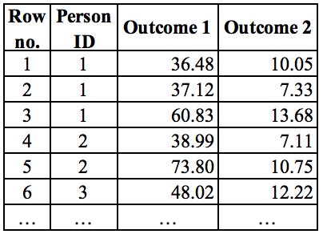 | 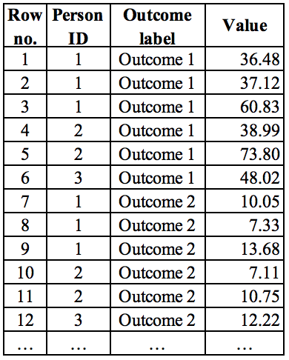
Figure 1: Converting data in wide format to long format for univariate representation of multivariate outcomes
Equation resembles the equation for multilevel model for univariate outcome, except that each variable is subscripted with $h$which indicates the value for the $h^{th}$outcome.
 | $$y_{hij}=β_{0}+γ_{0j}+\sum_{k=1}^{K}{β_{k}x_{hkij}}+\sum_{m=1}^{M}{γ_{mj}z_{hmij}}+ϵ_{ij}^{(h)}$$ | (9)
Here, residual errors $ϵ_{ij}^{(h)}$ are defined as $N\left(0, σ_{h}^{2}\right)$with estimated independent error variances for each outcome $h$. Marginal contributions of any outcome on input variables can be derived by including an indicator function in an interaction effect. For example, to derive marginal effects of level-1 variables, model is shown as follows:
 | $$y_{hij}=β_{0}+γ_{0j}+\sum_{k=1}^{K}{β_{k}x_{hkij}·I(h)}+\sum_{m=1}^{M}{γ_{mj}z_{hmij}}+ϵ_{ij}^{(h)}$$ | (10)
where $I\left(φ\right)$ is an indicator function equal to 1 if condition $φ$ is true, otherwise equal to 0.
References
1. Raudenbush, S. W. & Bryk, A. S. Hierarchical Linear Models: Applications and Data Analysis Methods. (Sage, 2002).
2. Nakagawa, S. & Schielzeth, H. A general and simple method for obtaining R2 from generalized linear mixed-effects models. Methods in Ecology and Evolution 4, 133–142 (2013).
3. Gelman, A. & Hill, J. Data Analysis Using Regression and Multilevel/Hierarchical Models. Cambridge: Cambridge University Press (Cambridge University Press, 2006). doi:10.1017/CBO9780511790942.
4. Gelman, A. et al. Bayesian Data Analysis. Bayesian Data Analysis (CRC press, 2014).
5. West, B. T. & Galecki, A. T. An Overview of Current Software Procedures for Fitting Linear Mixed Models. The American Statistician 65, 274–282 (2011).
6. Mai, Y. & Zhang, Z. Software Packages for Bayesian Multilevel Modeling. Structural Equation Modeling: A Multidisciplinary Journal 25, 650–658 (2018).

