Supplementary Information

Functional geometry of auditory cortical resting state networks derived from intracranial electrophysiology

Matthew I. Banks^{1,2*}, Bryan M. Krause¹, D. Graham Berger¹, Declan I. Campbell¹, Aaron D. Boes³, Joel E. Bruss³, Christopher K. Kovach⁴, Hiroto Kawasaki⁴, Mitchell Steinschneider^{5,6},
Kirill V. Nourski^{4,7}

¹Department of Anesthesiology, University of Wisconsin, Madison, WI, USA
²Department of Neuroscience, University of Wisconsin, Madison, WI, USA
³Department of Neurology, The University of Iowa, Iowa City, IA 52242, USA
⁴Department of Neurosurgery, The University of Iowa, Iowa City, IA 52242, USA
⁵Department of Neurology, Albert Einstein College of Medicine, New York, NY 10461, USA
⁶Department of Neuroscience, Albert Einstein College of Medicine, New York, NY 10461, USA
⁷Iowa Neuroscience Institute, The University of Iowa, Iowa City, IA 52242, USA

Supplementary Table 1. Participant demographics.
Participant | Age | Sex | Handedness | Language  dominance | Subdural  arrays | Seizure focus
L275 | 30 | M | R | L | Y | L lateral ventral temporal, R posterior ventral frontal
L282 | 40 | M | R | ? | N | L posterior superior temporal, L posterior lateral ventral frontal
L287 | 18 | M | R | ? | Y | L parietal
R288 | 21 | M | R | L | Y | R temporal pole
L292 | 50 | F | L | R | Y | L medial temporal
R294 | 35 | M | R | ? | Y | R dorsal frontal pole
L307 | 32 | M | R | L | Y | L posterior insula
R316 | 31 | F | R | ? | Y | R medial temporal
R320 | 51 | F | R | ? | Y | R medial temporal
R322 | 28 | F | R | ? | Y | R posterior medial frontal
R329 | 20 | M | R | ? | Y | R medial frontal
R334 | 39 | M | L | L | Y | R posterior medial temporal
R335 | 32 | M | R | L | Y | bilateral medial temporal
L357 | 36 | M | R | L | Y | L medial temporal
L362 | 59 | M | R | B | Y | bilateral multiple locations
R369 | 30 | M | R | L | Y | R medial temporal
L372 | 34 | M | R | L | Y | L temporal pole
R376 | 48 | F | R | L | Y | R medial temporal
R399 | 22 | F | R | L | Y | R temporal (uncertain medial & neocortical)
L400 | 59 | F | R | L | Y | L amygdala (medial temporal)
L403 | 56 | F | R | L | Y | L medial temporal
L405 | 19 | M | R | L | Y | L frontal (posterior lateral)
L409 | 31 | F | R | L | Y | L medial temporal, L temporal pole
R413 | 22 | M | L | R | Y | R medial temporal
L416 | 33 | M | B | L | Y | L ventral occipital, L lateral temporal
R418 | 25 | F | R | L | Y | R temporal (medial & lateral posterior cortex)
L423 | 51 | M | R | L | Y | L medial temporal
L425 | 52 | M | L | ? | Y | L medial temporal
R429 | 32 | F | R | L | Y | R medial temporal and temporal pole
R434 | 39 | F | R | L | Y | R medial temporal
L439 | 37 | M | R | L | N | R medial frontal (posterior dorsal)
L442 | 33 | F | R | L | Y | multifocal L frontal, temporal, parietal
R456 | 31 | M | L | ? | Y | R medial temporal, R posterior lateral superior temporal
L457 | 18 | M | R | ? | N | L medial temporal
R458 | 23 | M | R | L | N | R temporal (middle & posterior lateral)
L460 | 52 | M | R | L | Y | L hippocampus (medial temporal)
L477 | 23 | F | R | L | Y | L parietal
L514 | 46 | M | R | L | N | L insula (anterior)
R515 | 21 | F | R | L | N | R medial temporal
R524 | 18 | M | L | L | N | R medial temporal, L medial temporal
L525 | 46 | F | R | L | Y | Bilateral multifocal (predominantly L frontal & temporal)
R532 | 42 | F | R | L | Y | R ventral frontal (posterior)
L538 | 18 | F | R | L | N | L insula and orbitofrontal
R559 | 27 | F | R | L | N | R inferior frontal (middle - posterior)
R567 | 33 | M | R | ? | N | R insula
L585 | 39 | F | R | L | Y | L medial temporal
Supplementary Table 2. ROIs and electrode coverage.
ROI group | ROI | ROI abbreviation | Overall average embedding |  | Language dominance |  | fMRI
ROI group | ROI | ROI abbreviation | N_{participants} | n_{sites} | N_{participants} | n_{sites} | N_{participants} | n_{sites}
Auditory core | Heschl’s gyrus, posteromedial portion | HGPM | 35 | 168 | 33 | 157 | 10 | 49
Auditory non-core | Heschl’s gyrus, anterolateral portion | HGAL | 29 | 109 | 28 | 104 | 7 | 22
Auditory non-core | Planum temporale | PT | 20 | 61 | 18 | 56 | 8 | 22
Auditory non-core | Planum polare | PP | 23 | 49 | 21 | 47 | 8 | 22
Auditory non-core | Superior temporal gyrus, posterior portion | STGP | 36 | 352 | 34 | 313 | 10 | 83
Auditory non-core | Superior temporal gyrus, middle portion | STGM | 34 | 223 | 32 | 195 | 10 | 53
Auditory-related | Superior temporal gyrus, anterior portion | STGA | 28 | 64 | 26 | 60 | 8 | 19
Auditory-related | Posterior insula | InsP | 30 | 87 | 29 | 85 | 9 | 15
Auditory-related | Superior temporal sulcus, upper bank | STSU | 23 | 107 | 22 | 106 | 4 | 13
Auditory-related | Superior temporal sulcus, lower bank | STSL | 24 | 75 | 24 | 75 | 5 | 17
Auditory-related | Middle temporal gyrus, posterior portion | MTGP | 36 | 410 | 34 | 376 | 10 | 98
Auditory-related | Middle temporal gyrus, middle portion | MTGM | 37 | 278 | 35 | 250 | 10 | 74
Auditory-related | Middle temporal gyrus, anterior portion | MTGA | 32 | 110 | 30 | 100 | 9 | 34
Auditory-related | Supramarginal gyrus | SMG | 37 | 351 | 34 | 309 | 10 | 93
Auditory-related | Angular gyrus, posterior portion | AGP | 15 | 66 | 14 | 62 | 6 | 27
Auditory-related | Angular gyrus, anterior portion | AGA | 29 | 156 | 27 | 140 | 9 | 65
Prefrontal | Inferior frontal gyrus, pars opercularis | IFGop | 35 | 109 | 33 | 101 | 10 | 32
Prefrontal | Inferior frontal gyrus, pars triangularis | IFGtr | 37 | 184 | 35 | 176 | 9 | 48
Prefrontal | Inferior frontal gyrus, pars orbitalis | IFGor | 18 | 42 | 17 | 38 | 4 | 9
Prefrontal | Middle frontal gyrus | MFG | 40 | 489 | 37 | 443 | 9 | 106
Prefrontal | Superior frontal gyrus | SFG | 23 | 201 | 21 | 192 | 5 | 59
Prefrontal | Anterior cingulate cortex | ACC | 23 | 38 | 21 | 36 | 5 | 6
Prefrontal | Orbital gyri | OG | 40 | 369 | 38 | 353 | 10 | 104
Prefrontal | Transverse frontopolar gyrus | TFG | 20 | 85 | 20 | 85 | 7 | 23
Prefrontal | Frontomarginal gyrus | FMG | 4 | 9 | 4 | 9 | 0 | 0
Sensorimotor | Precentral gyrus, dorsal portion | dPreCG | 28 | 96 | 27 | 93 | 7 | 19
Sensorimotor | Postcentral gyrus, dorsal portion | dPostCG | 24 | 91 | 22 | 80 | 4 | 14
Sensorimotor | Precentral gyrus, ventral portion | vPreCG | 39 | 215 | 37 | 202 | 10 | 48
Sensorimotor | Postcentral gyrus, ventral portion | vPostCG | 35 | 184 | 32 | 170 | 9 | 47
Sensorimotor | Paracentral lobule | ParaCL | 5 | 12 | 5 | 12 | 0 | 0
Other | Premotor cortex | PMC | 39 | 166 | 36 | 146 | 9 | 35
Other | Cingulate gyrus, middle portion | CingM | 19 | 34 | 16 | 29 | 5 | 9
Other | Cingulate gyrus, posterior portion / Precuneus | PCC/preCun | 18 | 77 | 15 | 68 | 2 | 5
Other | Parahippocampal gyrus | PHG | 28 | 109 | 27 | 107 | 8 | 24
Other | Fusiform gyrus | FG | 33 | 152 | 31 | 147 | 9 | 25
Other | Inferior temporal gyrus, posterior portion | ITGP | 24 | 85 | 23 | 83 | 8 | 24
Other | Inferior temporal gyrus, middle portion | ITGM | 30 | 109 | 29 | 107 | 7 | 22
Other | Inferior temporal gyrus, anterior portion | ITGA | 28 | 111 | 26 | 102 | 8 | 38
Other | Temporal pole | TP | 33 | 281 | 31 | 259 | 10 | 77
Other | Anterior insula | InsA | 26 | 58 | 24 | 55 | 9 | 16
Other | Frontal operculum | fOperc | 13 | 21 | 12 | 20 | 4 | 7
Other | Parietal operculum | pOperc | 5 | 15 | 5 | 15 | 1 | 2
Other | Gyrus rectus | GR | 30 | 62 | 29 | 60 | 9 | 15
Other | Subcallosal gyrus | SubcG | 5 | 8 | 4 | 7 | 1 | 1
Other | Superior parietal lobule / Intraparietal sulcus | SPL | 15 | 91 | 13 | 80 | 4 | 13
Other | Cuneus | Cun | 4 | 7 | 4 | 7 | 2 | 3
Other | Lingual gyrus | LingG | 10 | 24 | 10 | 24 | 3 | 5
Other | Occipital pole | OP | 2 | 4 | 2 | 4 | 0 | 0
Other | Superior occipital gyrus | SOG | 4 | 9 | 3 | 7 | 0 | 0
Other | Middle occipital gyrus | MOG | 18 | 73 | 17 | 64 | 5 | 23
Other | Inferior occipital gyrus | IOG | 8 | 20 | 8 | 20 | 3 | 8
Other | Amygdala | Amyg | 29 | 73 | 28 | 72 | 6 | 19
Other | Hippocampus | Hipp | 29 | 77 | 28 | 76 | 6 | 15
Other | Putamen | Put | 8 | 13 | 8 | 13 | 3 | 4
Other | Globus pallidus | GP | 1 | 1 | 0 | 0 | 1 | 1
Other | Caudate nucleus | Caud | 5 | 10 | 5 | 10 | 0 | 0
Other | Substantia innominata | SubInn | 2 | 5 | 2 | 5 | 2 | 5
Other | Ventral striatum | vStr | 1 | 2 | 1 | 2 | 1 | 2
Total |  |  | 46 | 6487 | 43 | 6014 | 10 | 1619
Participant and site numbers that were not included in group averages are denoted in gray italics.
Supplementary Table 3. List of abbreviations.
ACC | Anterior cingulate cortex
AGA | Angular gyrus, anterior portion
AGP | Angular gyrus, posterior portion
Amyg | Amygdala
ATL | Anterior temporal lobe
Caud | Caudate nucleus
CingM | Cingulate gyrus, middle portion
Cun | Cuneus
DME | Diffusion map embedding
dPostCG | Postcentral gyrus, dorsal portion
dPreCG | Precentral gyrus, dorsal portion
FG | Fusiform gyrus
FMG | Frontomarginal gyrus
fMRI | Functional magnetic resonance imaging
fOperc | Frontal operculum
GP | Globus pallidus
GR | Gyrus rectus
HGAL | Heschl’s gyrus, anterolateral portion
HGPM | Heschl’s gyrus, posteromedial portion
Hipp | Hippocampus
iEEG | Intracranial electroencephalography
IFGop | Inferior frontal gyrus, pars opercularis
IFGor | Inferior frontal gyrus, pars orbitalis
IFGtr | Inferior frontal gyrus, pars triangularis
InsA | Anterior insula
InsP | Posterior insula
IOG | Inferior occipital gyrus
ITGA | Inferior temporal gyrus, anterior portion
ITGM | Inferior temporal gyrus, middle portion
ITGP | Inferior temporal gyrus, posterior portion
LingG | Lingual gyrus
MFG | Middle frontal gyrus
MNI | Montreal Neurological Institute
MOG | Middle occipital gyrus
MRI | Magnetic resonance imaging
MTGA | Middle temporal gyrus, anterior portion
MTGM | Middle temporal gyrus, middle portion
MTGP | Middle temporal gyrus, posterior portion
OG | Orbital gyri
OP | Occipital pole
ParaCL | Paracentral lobule
PCC/preCun | Cingulate gyrus, posterior portion / Precuneus
PHG | Parahippocampal gyrus
PMC | Premotor cortex
pOperc | Parietal operculum
PP | Planum polare
PT | Planum temporale
Put | Putamen
ROI | Region of interest
RS | Resting state
SFG | Superior frontal gyrus
Supplementary Table 3. List of abbreviations (continued).
SMG | Supramarginal gyrus
SNR | Signal to noise ratio
SOG | Superior occipital gyrus
SPL | Superior parietal lobule / Intraparietal sulcus
STGA | Superior temporal gyrus, anterior portion
STGM | Superior temporal gyrus, middle portion
STGP | Superior temporal gyrus, posterior portion
STSL | Superior temporal sulcus, lower bank
STSU | Superior temporal sulcus, upper bank
SubcG | Subcallosal gyrus
SubInn | Substantia innominata
TFG | Transverse frontopolar gyrus
TP | Temporal pole
vPostCG | Postcentral gyrus, ventral portion
vPreCG | Precentral gyrus, ventral portion
vStr | Ventral striatum

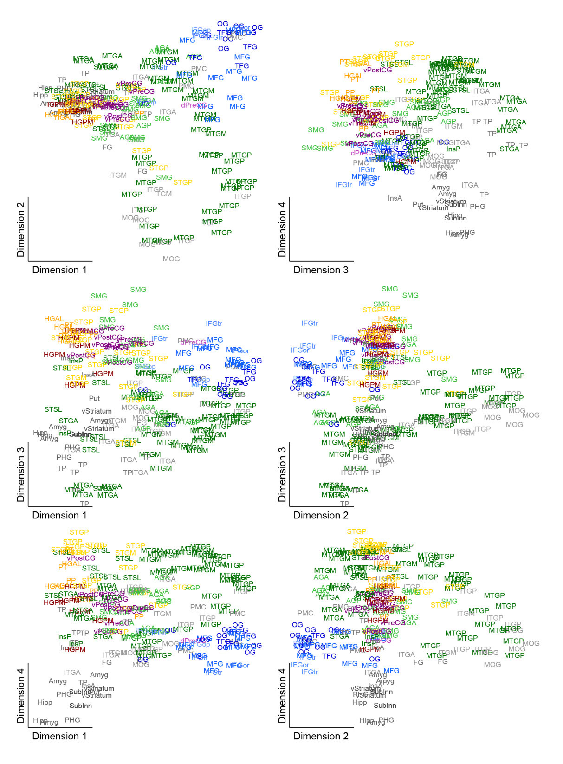
Supplementary Figure 1. Embedding plots in participant R376 plotted in four dimensions. Scale bar: 0.04.
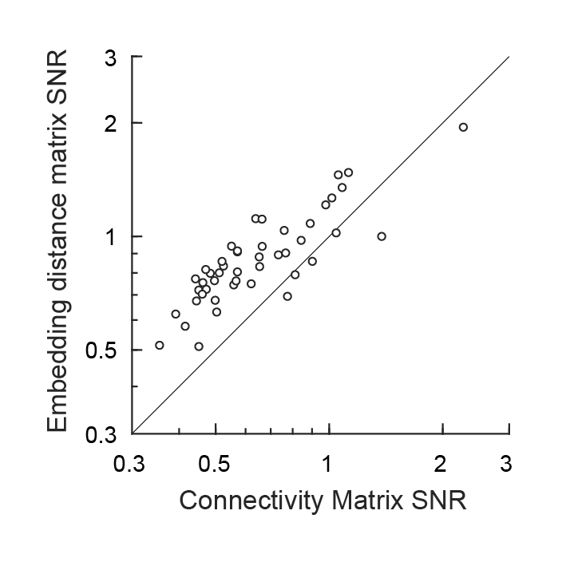
Supplementary Figure 2. Comparison of signal to noise ratio (SNR) for the embedding analysis versus direct analysis of functional connectivity. Each symbol corresponds to one participant. For each participant, the SNRs of embedding distances and connectivity were calculated from the recorded RS block as described in Methods. In most participants, the embedding analysis exhibited superior noise characteristics compared to direct analysis of connectivity.
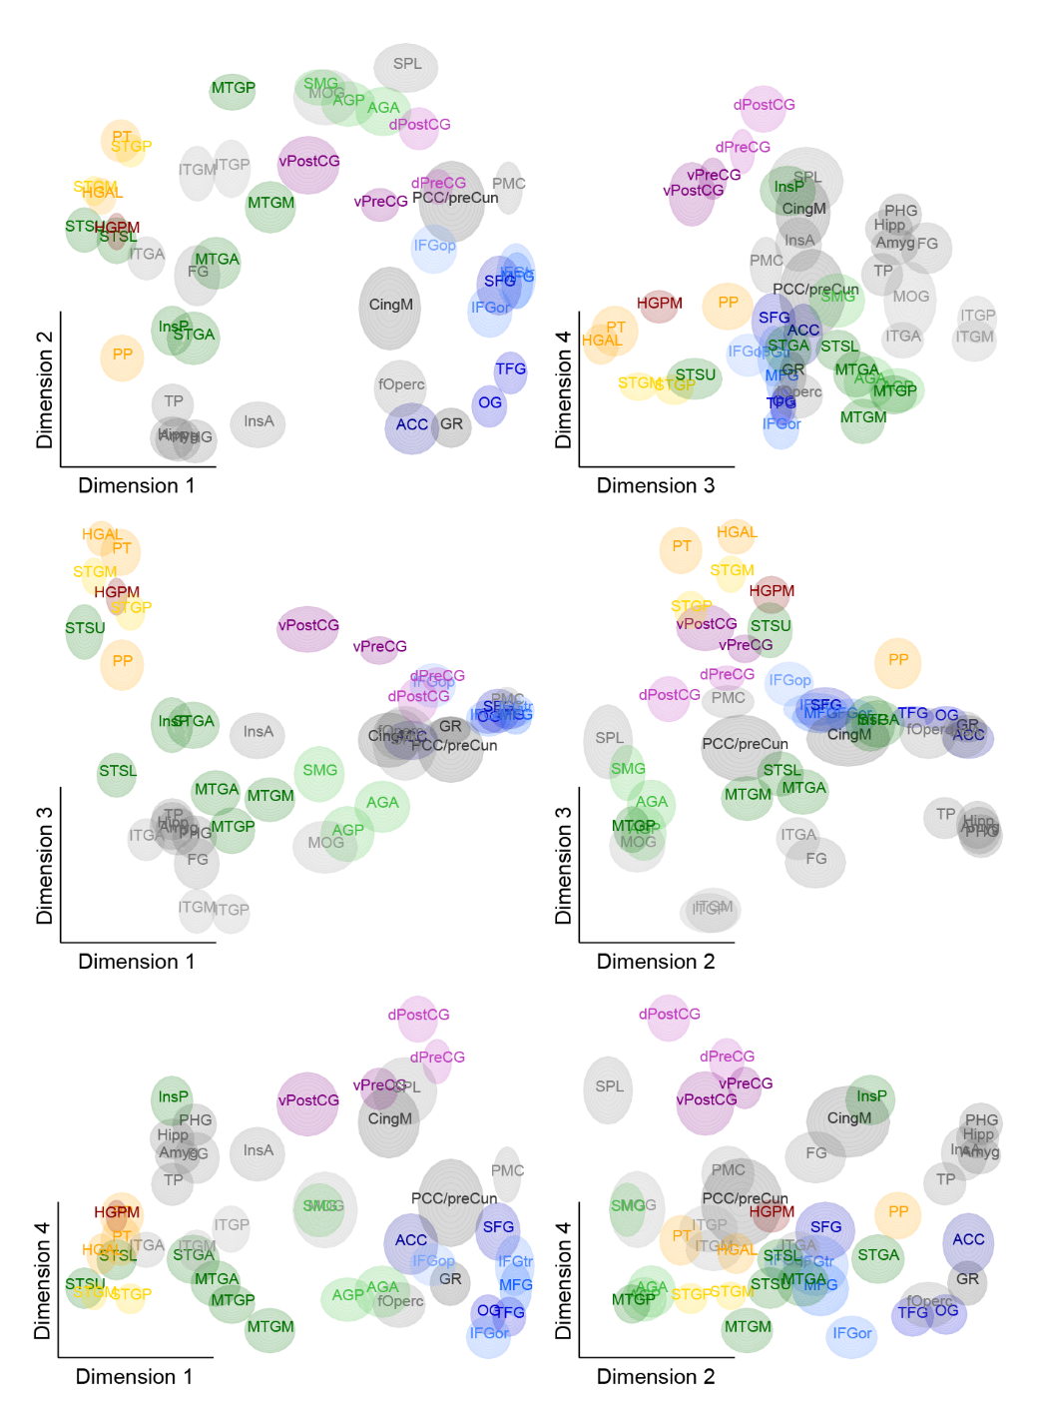
Supplementary Figure 3. Average embedding plots in four dimensions. Scale bar: 0.1.

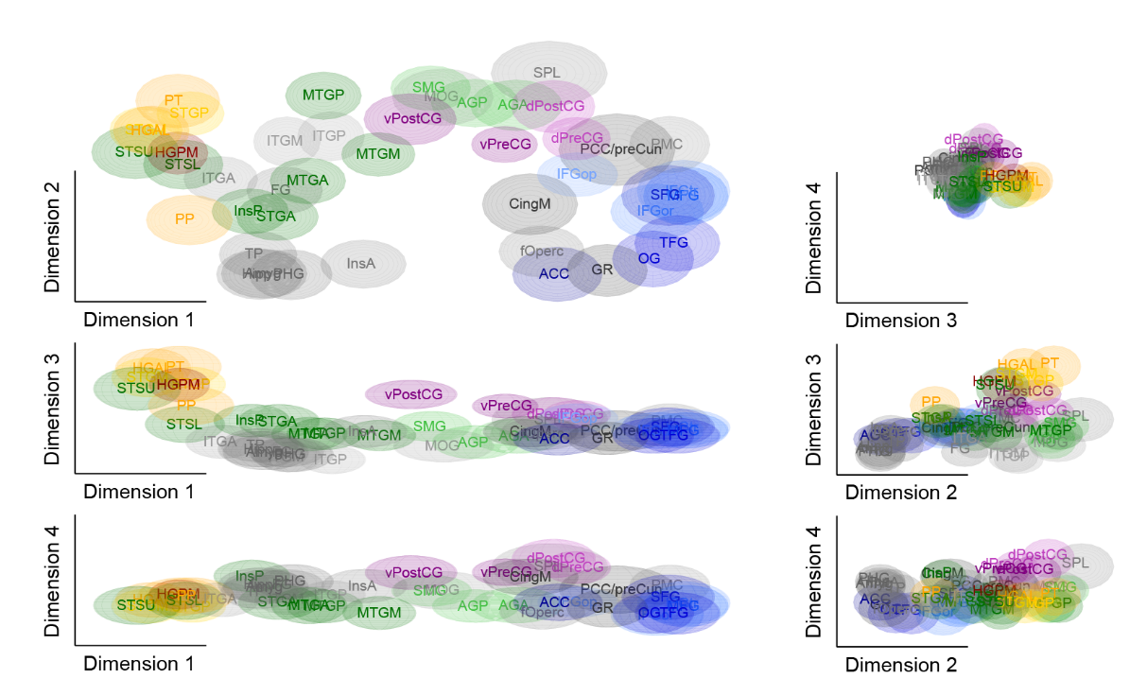
Supplementary Figure 4. Analysis of data at a larger spatial scale. Data plotted in embedding space for t = 5. Data plotted in the first four dimensions of embedding space. Scale bar: 0.01.

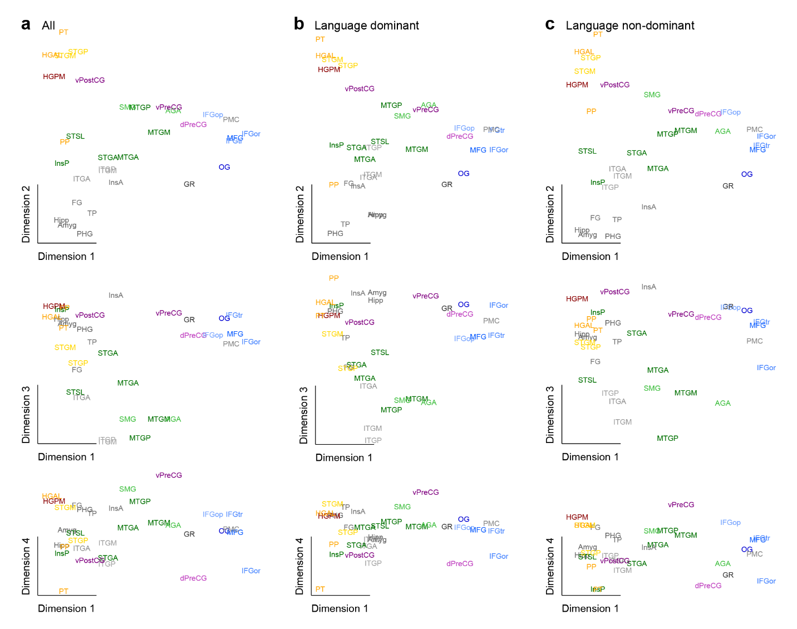

Supplementary Figure 5. Auditory networks do not differ between hemispheres. Data plotted in the first 4 dimensions of embedding space for all dominant and non-dominant participants (a), just dominant (b), and just non-dominant (c). Scale bar: 0.1. D. Inter-ROI distances in embedding space for non-dominant versus dominant hemisphere participants.
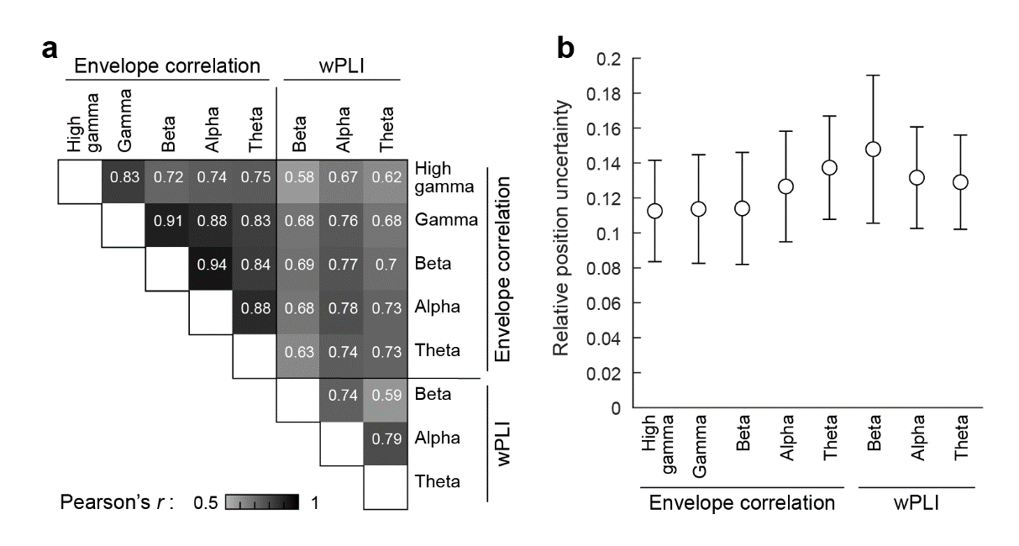
Supplementary Figure 6. Comparison of embedding results across frequency bands and functional connectivity measures. A: Correlations of embedding distances between measures and bands. B: Variability of embedding positions as a function of measure and band.

