Supplementary Materials
Fig. S1 Chemical composition analysis of the volatile constituents (odor) in the stir-frying process of hawthorn by headspace solid-phase microextraction gas chromatography-mass spectrometry (HS-SPME-GC/MS) analysis.
Table S1 TIC chromatograms between raw hawthorn and charred hawthorn. the contents of chemical composition of the volatile constituents (odor) increased in the processingof stir-fryingof hawthorn. A: 3-methyl-butyraldehyd, 2-methyl-butyraldehyde; B: Furaldehyde; C: 1-(2-furanyl)-ethanone; D: 3-hexene-2,5-diketone, 5-methyl-2(3H)-furanone, isomaltol; E: 2,5-furaldehyde, 2,5-dimethyl-4-hydroxy-3 (2H) -furanone; F: 2,3-dihydro-3,5-dihydroxy-6-methyl- 4h-pyran-4-one; G: 5-hydroxymethylfurfural.
Table S2 Hawthorn products in the different stir-frying temperatures
Table S3 Hawthorn products in the different stir-frying time
Table S4 Organic acid content in hawthorn and charred hawthorn
Table S5 Flavonoids content in hawthorn and charred hawthorn. (S5-1) Linear relation; (S5-2) Results in precision study; (S5-3) Results in stability study; (S5-4) Results in repeatability study; (S5-5) Results in the recovery test.
Table S6 Amylase activity in hawthorn and charred hawthorn. (S6-1) Linear relation; (S6-2) Results in precision study; (S6-3) Results in stability study; (S6-4) Results in repeatability study; (S6-5) Results in the recovery test.
Table S7 Protease activity in hawthorn and charred hawthorn. (S7-1) Linear relation; (S7-2) Results in precision study; (S7-3) Results in stability study; (S7-4) Results in repeatability study; (S7-5) Results in the recovery test.
Table S8 Results of protein amino acids before and after frying of hawthorn.
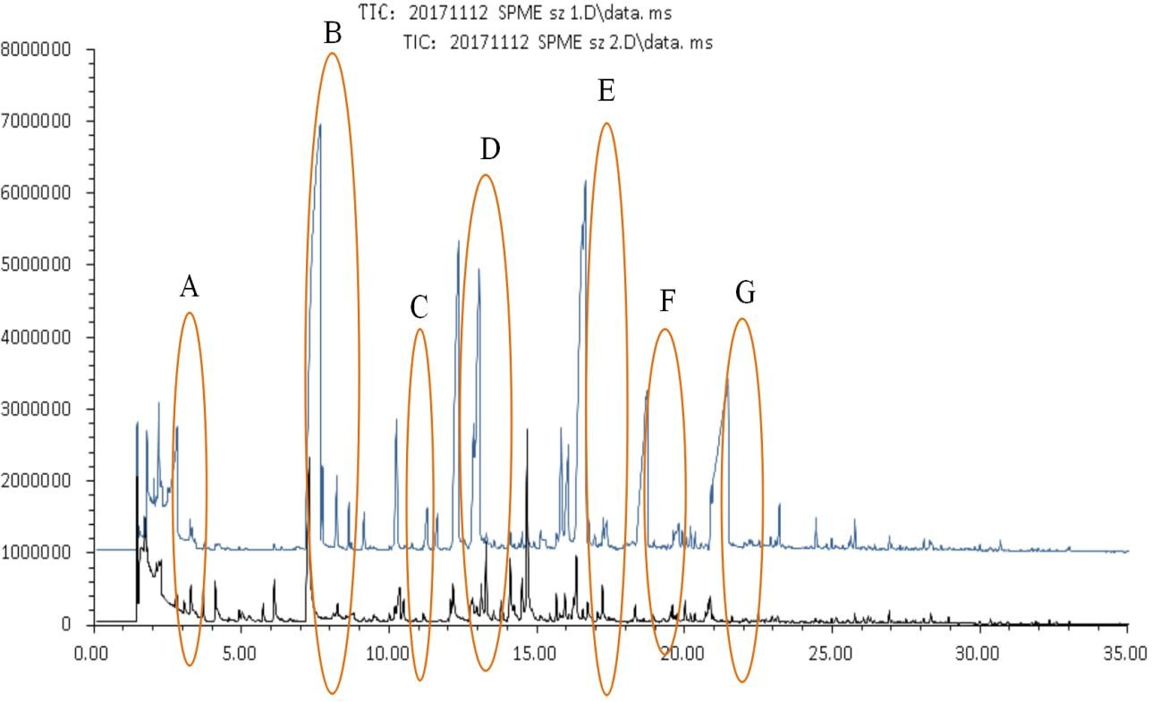
Fig. S1 Chemical composition analysis of the volatile constituents (odor) in the stir-frying process of hawthorn by headspace HS-SPME-GC/MS analysis.

Table S1 TIC chromatograms between raw hawthorn and charred hawthorn.
 | Raw hawthorn |  |  | Charred hawthorn
 | RT(min) | Peak area | Peak area% | RT(min) | Peak area | Peak area%
3-methyl-butyraldehyde | 2.703 | 111432 | 0.009403 | 2.712 | 11998281 |  | 1.0124
2-methyl-butyraldehyde | 2.815 | 1309859 | 0.11053 | 2.823 | 26625959 |  | 2.2467
Furaldehyde | 7.295 | 30556923 | 7.8176 | 7.671 | 241341262 |  | 20.364
1-(2-furanyl)-ethanone | 10.193 | 1506892 | 0.38552 | 10.245 | 16777530 |  | 1.4157
3-hexene-2,5-diketone | -- | -- | -- | 12.279 | 35136852 |  | 2.9648
5-methyl-2(3H)-furanone | 12.159 | 5634391 | 1.4415 | 12.348 | 72214028 |  | 6.0934
Isomaltol | -- | -- | -- | 12.878 | 15934768 |  | 1.3446
2,5-Furaldehyde | 16.246 | 2145429 | 0.54888 | 16.529 | 34650589 |  | 2.9238
2,5-dimethyl-4-hydroxy-3-(2H) -furanone | -- | -- | -- | 16.666 | 49805023 |  | 4.2025
2,3-dihydro-3,5-dihydroxy-6-methyl-4h-pyran-4-one | 18.3327 | 1745445 | 0.44655 | 18.7432 | 14284005 |  | 1.2053
5-hydroxymethyl-furfural | 20.872 | 1027980 | 0.2492 | 21.470 | 35644427 |  | 3.0077
RT = Retention time; “--” means the contents < 1%
Table S2 Processed products under different levels of heat
NO | Degree of heating (℃) | Yield(%) | The final temperature (℃)
SZ1 | Low fire  (280-350,average: 315) | 96.0 | 77
SZ2 | Middle fire  (380-450,average: 410) | 92.0 | 116
SZ3 | High fire  (520-580,average: 550) | 87.0 | 136

Table S3 Different processed products of processing time in Middle fire condition
NO | Processing time (min) | The initial  temperature (℃) | Temperature  changes | Yield(%) | The final temperature(℃)
SZ0 | 0 | 449 | 0 | 100.0 | 23
SZ4 | 2 | 449 | 370 ± 30 | 99.0 | 68
SZ5 | 4 | 371 | 380 ± 30 | 96.0 | 80
SZ6 | 6 | 368 | 375 ± 30 | 96.0 | 86
SZ7 | 8 | 403 | 360 ± 30 | 93.0 | 102
SZ8 | 10 | 402 | 360 ± 30 | 92.0 | 106
SZ9 | 12 | 396 | 400 ± 30 | 90.0 | 118

Samples | Content（mg/g） |  |  | Mean（mg/g）
Samples | 1 | 2 | 3 | Mean（mg/g）
Raw hawthorn | 74.28 | 75.37 | 75.02 | 74.89
Charred hawthorn | 56.31 | 54.28 | 55.40 | 55.33
Table S4 Organic acid content in hawthorn and charred hawthorn

Table S5 Flavonoids content in hawthorn and charred hawthorn
Samples | Absorbance (A) |  | Mean | Contents (mg/g)
Samples | Measured value |  | Mean | Contents (mg/g)
Samples | 1 | 2 | Mean | Contents (mg/g)
Hawthorn | 0.482 | 0.484 | 0.483 | 51.21
Charred hawthorn | 0.558 | 0.556 | 0.557 | 58.80

Table S5-1 Linear relation
Concentration(μg/ml) | 0.00 | 16.00 | 32.00 | 48.00 | 64.00 | 80.00 | 96.00
Absorbance (A) | 0.000 | 0.185 | 0.365 | 0.561 | 0.758 | 0.957 | 1.170

Table S5-2 Results in precision study
NO | 1 | 2 | 3 | 4 | 5 | 6 | Mean | RSD%
Absorbance (A) | 0.561 | 0.561 | 0.562 | 0.560 | 0.562 | 0.562 | 0.561 | 0.15

Table S5-3 Results in stability study
Time（min） | 0 | 10 | 20 | 30 | 40 | 50 | 60 | Mean | RSD%
Absorbance (A) | 0.572 | 0.568 | 0.562 | 0.562 | 0.561 | 0.559 | 0.557 | 0.563 | 0.93

NO | Absorbance (A) | Content(mg/g） | Mean( mg/g) | RSD（%）
1 | 0.557 | 58.72 | 59.02 | 0.59
2 | 0.563 | 59.05 | 59.02 | 0.59
3 | 0.559 | 58.82 | 59.02 | 0.59
4 | 0.564 | 59.13 | 59.02 | 0.59
5 | 0.567 | 59.61 | 59.02 | 0.59
6 | 0.556 | 58.73 | 59.02 | 0.59
Table S5-4 Results in repeatability study

Table S5-5 Results in the recovery test
NO | Samples quality(g) | Original quality(g) | Added quality(g) | Actual quality(g) | Recovery(%) | Average  Recovery(%) | RSD (%)
1 | 0.5075 | 29.9527 | 30.0000 | 60.1390 | 100.62 | 100.57 | 0.88
2 | 0.5095 | 30.0707 | 30.0000 | 59.9361 | 99.55 | 100.57 | 0.88
3 | 0.5012 | 29.5808 | 30.0000 | 59.5302 | 99.83 | 100.57 | 0.88
4 | 0.5090 | 30.0589 | 30.0000 | 60.6463 | 101.96 | 100.57 | 0.88
5 | 0.5075 | 29.9527 | 30.0000 | 60.0375 | 100.28 | 100.57 | 0.88
6 | 0.5065 | 29.8936 | 30.0000 | 60.2405 | 101.16 | 100.57 | 0.88

Table S6 Amylase activity in hawthorn and charred hawthorn
Samples | Amylase activity(mg/mL） |  |  | Mean(mg/mL) | Amylase activity  (mg·min⁻¹·g⁻¹)
Samples | 1 | 2 | 3 | Mean(mg/mL) | Amylase activity  (mg·min⁻¹·g⁻¹)
Raw hawthorn | 0.026 | 0.025 | 0.025 | 0.025 | 2.533
Charred hawthorn | 0.020 | 0.021 | 0.020 | 0.020 | 2.036

Table S6-1 Linear relation
Maltose concentration (mg/mL) | 0.027 | 0.040 | 0.053 | 0.067 | 0.080
Absorbance (A) | 0.251 | 0.404 | 0.553 | 0.698 | 0.847

Table S6-2 Results in precision study
NO | 1 | 2 | 3 | 4 | 5 | 6 | Mean | RSD%
Absorbance (A) | 0.561 | 0.563 | 0.560 | 0.560 | 0.559 | 0.562 | 0.561 | 0.28

Table S6-3 Results in stability study
Time(h) | 1 | 2 | 3 | 4 | 5 | 6 | Mean | RSD%
Absorbance (A) | 0.483 | 0.483 | 0.482 | 0.480 | 0.477 | 0.479 | 0.481 | 0.50

Table S6-4 Results in repeatability study
NO | Samples quality(g) | Absorbance  (A) | Maltose Concentration  (mg/mL) | Amylase activity  (mg·min⁻¹·g⁻¹) | Mean  (mg·min⁻¹·g⁻¹) | RSD%
1 | 1.0023 | 0.483 | 0.047 | 4.713 | 4.717 | 1.88
2 | 1.0027 | 0.480 | 0.047 | 4.686 | 4.717 | 1.88
3 | 1.0007 | 0.476 | 0.046 | 4.650 | 4.717 | 1.88
4 | 1.0032 | 0.498 | 0.048 | 4.848 | 4.717 | 1.88
5 | 1.0018 | 0.492 | 0.048 | 4.794 | 4.717 | 1.88
6 | 1.0002 | 0.472 | 0.046 | 4.614 | 4.717 | 1.88

Table S6-5 Results in the recovery test
NO | Samples quality(g) | Original quality(g) | Added quality(g) | Absorbance (A) | Measured quality(g) | Recovery  Rates(%) | Average recovery rates(%) | RSD  (%)
1 | 0.5012 | 11.821 | 11.800 | 0.478 | 23.339 | 97.61 | 97.65 | 1.68
2 | 0.5022 | 11.844 | 11.800 | 0.481 | 23.474 | 98.56 | 97.65 | 1.68
3 | 0.5015 | 11.828 | 11.800 | 0.479 | 23.384 | 97.93 | 97.65 | 1.68
4 | 0.5003 | 11.800 | 11.800 | 0.484 | 23.610 | 100.09 | 97.65 | 1.68
5 | 0.5001 | 11.795 | 11.800 | 0.472 | 23.068 | 95.53 | 97.65 | 1.68
6 | 0.5008 | 11.811 | 11.800 | 0.474 | 23.158 | 96.16 | 97.65 | 1.68

Table S7 Protease activity in hawthorn and charred hawthorn
Samples | Tyrosine content (μg/mL) |  |  | Mean (μg/mL) | Protease activity (μg·min⁻¹·g⁻¹)
Samples | 1 | 2 | 3 | Mean (μg/mL) | Protease activity (μg·min⁻¹·g⁻¹)
Raw hawthorn | 2.812 | 2.881 | 2.854 | 2.849 | 820.650
Charred hawthorn | 1.998 | 2.113 | 2.024 | 2.045 | 588.876

Table S7-1 Linear relation
Tyrosine concentration (μg/mL) | 2.222 | 4.444 | 6.667 | 8.889 | 11.111
Absorbance (A) | 0.171 | 0.327 | 0.468 | 0.624 | 0.768

Table S7-2 Results in precision study
NO | 1 | 2 | 3 | 4 | 5 | 6 | Mean | RSD%
Absorbance (A) | 0.468 | 0.476 | 0.470 | 0.479 | 0.469 | 0.470 | 0.472 | 0.94

Table S7-3 Results in stability study
Time（h） | 1 | 2 | 3 | 4 | 5 | 6 | Mean | RSD%
Absorbance (A) | 0.246 | 0.246 | 0.244 | 0.242 | 0.243 | 0.242 | 0.244 | 0.18

Table S7-4 Results in repeatability study
NO | Samples quality(g) | Absorbance  (A) | Casein Concentration  (μg/mL) | Amylase activity  (μg·min⁻¹·g⁻¹) | Mean  (μg·min⁻¹·g⁻¹) | RSD%
1 | 1.0002 | 0.246 | 3.304 | 951.369 | 973.196 | 1.96
2 | 1.0007 | 0.254 | 3.423 | 985.206 | 973.196 | 1.96
3 | 1.0003 | 0.256 | 3.453 | 994.182 | 973.196 | 1.96
4 | 1.0006 | 0.250 | 3.364 | 968.146 | 973.196 | 1.96
5 | 1.0012 | 0.255 | 3.438 | 989.001 | 973.196 | 1.96
6 | 1.0003 | 0.246 | 3.304 | 951.273 | 973.196 | 1.96

Table S7-5 Results in the recovery test
NO | Samples quality(g) | Original quality  (mg) | Added quality  (mg) | Absorbance (A) | Measured quality  (mg) | Recovery  Rates(%) | Average recovery rates(%) | RSD  (%)
1 | 0.5002 | 2.434 | 2.400 | 0.244 | 4.715 | 95.038 | 97.07 | 2.74
2 | 0.5011 | 2.438 | 2.400 | 0.251 | 4.865 | 101.115 | 97.07 | 2.74
3 | 0.5002 | 2.434 | 2.400 | 0.249 | 4.822 | 99.509 | 97.07 | 2.74
4 | 0.5005 | 2.435 | 2.400 | 0.244 | 4.715 | 94.977 | 97.07 | 2.74
5 | 0.5000 | 2.433 | 2.400 | 0.246 | 4.758 | 96.867 | 97.07 | 2.74
6 | 0.5007 | 2.436 | 2.400 | 0.244 | 4.715 | 94.937 | 97.07 | 2.74

mino acid | Raw hawthorn | Charred hawthorn | Rate of change(%)
Asp | 0.395 | 0.389 | -1.52
Thr | 0.127 | 0.136 | +7.09
Ser | 0.154 | 0.162 | +5.19
Glu | 0.464 | 0.497 | +7.11
Gly | 0.142 | 0.154 | +8.45
Ala | 0.164 | 0.175 | +6.71
Cys | 0.014 | 0.017 | +21.43
Val | 0.159 | 0.173 | +8.81
Met | 0.016 | 0.013 | -18.75
Ile | 0.132 | 0.145 | +9.85
Leu | 0.197 | 0.218 | +10.66
Tyr | 0.073 | 0.083 | +13.70
Phe | 0.121 | 0.138 | +14.05
GABA | 0.076 | 0.068 | -10.53
Orn | 0.002 | 0.002 | 0.00
Lys | 0.192 | 0.170 | -11.46
His | 0.074 | 0.079 | +6.76
Trp | 0.005 | 0.007 | 40.00
Arg | 0.156 | 0.155 | -0.64
Hypro | 0.046 | 0.051 | +10.87
Pro | 0.136 | 0.144 | +5.88
Totals | 2.845 | 2.976 | +4.60
Essential | 0.949 | 1.000 | +5.37
Non-essential | 1.896 | 1.976 | +4.22
Table S8 Results of protein amino acids before and after frying of hawthorn
“+” means the contents increases; “-” means the contents decreases.

