Supplementary Materials
for Multiomics Longitudinal Modeling of Preeclamptic Pregnancies
Authors: Ivana Marić¹⁺, Kévin Contrepois²⁺, Mira Moufarrej⁵, Ina Stelzer³, Dorien Feyaerts³, Xiaoyuan Han⁸, Andy Tang³, Natalie Stanley³, Ronald J. Wong¹, Gavin M. Traber², Mathew Ellenberger², Alan Chang³ , Ramin Fallahzadeh³, Huda Nassar³, Martin Becker³, Maria Xenochristou³, Camilo Espinosa³, Davide De Francesco³, Mohammad Sajjad Ghaemi^{3,10}, Elizabeth Costello⁹, Anthony Culos³, Xuefeng B. Ling⁷, Karl G. Sylvester⁷, Gary L. Darmstadt, Virginia D. Winn⁴, Gary M. Shaw¹, David A. Relman^{9,*}, Stephen R. Quake^{5,*}, Martin Angst^{3,*}, Michael P. Snyder^{2,*}, David K. Stevenson^{1,*}, Brice Gaudilliere^{1,3,*}, Nima Aghaeepour^{1,3,6,*}

¹Department of Pediatrics, Stanford University School of Medicine
²Department of Genetics, Stanford University School of Medicine
³Department of Anesthesiology, Perioperative and Pain Medicine, Stanford University School of
Medicine
⁴Department of Obstetrics and Gynecology, Stanford University School of Medicine
⁵Departments of Bioengineering and Applied Physics, Stanford University and Chan Zuckerberg
Biohub
⁶Department of Biomedical Data Science, Stanford University
⁷Department of Surgery, Stanford University School of Medicine
⁸University of the Pacific, Arthur A. Dugoni School of Dentistry
⁹ Departments of Medicine, and of Microbiology & Immunology, Stanford University School of Medicine
¹⁰Digital Technologies Research Centre, National Research Council Canada, Toronto, Ontario, Canada

⁺Co-first authorship
*Co-senior authorship

CORRESPONDING AUTHOR:
Ivana Marić, PhD
Division of Neonatology and Developmental Medicine, Department of Pediatrics
Stanford University School of Medicine
Medical School Office Building, X1C55
1265 Welch Road
Stanford, CA 94305
Phone: 650-724-9571
Fax: 650-721-5751
Email: ivanam@stanford.edu

Table S1. Patient and pregnancy characteristics
 | Discovery Cohort 1 (N=33) |  | Validation Cohort (N=16)
Demographics | Controls (N=16) | Preeclampsia (N=17) | Controls (N=4) | Preeclampsia (N=12)
Maternal age at enrollment  (years, mean ± SD) | 32.1 ± 4.9 | 31.1 ± 6.3 | 30.7 ± 4.8 | 32.3 ± 4.5
Gravida (N, % nulliparous) | 7 (43.7) | 6 (35.3) | 2 (50) | 5 (41.7)
Ethnicity (N, %)
Hispanic | 0 (0) | 8 (47) | 0 (0) | 2 (16.7)
Non-Hispanic | 16 (100) | 9 (53) | 4 (100) | 9 (75)
Unknown | 0 (0) | 0 (0) | 0 (0) | 1 (8.3)
Race (N, %)
White | 16 (100) | 9 (52.9) | 4 (100) | 5 (41.7)
African-American | 0 (0) | 1 (6.0) | 0 (0) | 1 (8.3)
Asian | 0 (0) | 4 (23.5) | 0 (0) | 4 (33.3)
Unknown | 0 (0) | 3 (17.6) | 0 (0) | 1 (8.3)
Other | 0 (0) | 0 (0) | 0 (0) | 1 (8.3)
Preexisting hypertension | 0 (0) | 4 (23.5) | 0 (0) | 4 (33.3)
Height  (cm, mean ± SD) | 166.9 ± 7.4 | 158.8 ± 6.2 | 163 ± 3.5 | 163.8 ± 7.7
Weight  (kg, mean ± SD) | 61.9 ± 9.1 | 74.0 ± 20.3 | 62.6 ± 8.1 | 79.6 ± 25.9
BMI (mean ± SD) | 22.8 ± 3.3 | 29.4 ± 7.9 | 23.5 ± 2.5 | 29.4 ± 7.7
Multiple gestation (N, %) | 0 (0) | 2 | 0 (0) | 0 (0)
Baby gender (male N, %) | 8 (50) | 11 (64.7) | 4 (100) | 6 (50)

Table S2. Preeclampsia patient characteristics.
 | Cohort 1 (n=17) | Validation Cohort (n=12)
Gestational age at the onset of  preeclampsia (mean ± SD) | 35.8 ± 3.8 | 36.6 ± 3.7
Early Onset (N, %) | 5 (29.4) | 1 (8.3)
Severe preeclampsia (N, %) | 10 (58.8) | 7 (58.3)

Table S3. List of annotated urine metabolites selected in EN models.
Compound ID | Mode | Molecular Ion | Metabolite | Formula | KEGG | HMDB | MSI annotation level
368.2789_8.5 | pRPLC | [M+H]+ | C14:2 AC (Tetradecadiencarnitine) | C21H37NO4 |  | HMDB13331 | 2
249.0074_2.8 | nRPLC | [M-H]- | Dihydroxyphenylglycol O-sulfate | C8H10O7S |  | HMDB01474 | 3
153.0193_1.5 | nRPLC | [M-H]- | Dihydroxybenzoic acid | C7H6O4 |  | HMDB13676 | 2
298.2009_5.1 | pRPLC | [M+H]+ | C9:2 AC (Nonadienoylcarnitine) | C16H27NO4 |  |  | 2
632.2045_0.8 | nRPLC | [M-H]- | Sialyllactose | C23H39NO19 |  | HMDB00825 | 2
263.0231_4.8 | nRPLC | [M-H]- | Methoxy hydroxyphenylethyleneglycol sulfate | C9H12O7S |  | HMDB00559 | 3
359.0984_3.9 | nRPLC | [M-H]- | Methoxy hydroxyphenylglycol glucuronide | C15H20O10 | C03033 | HMDB00496 | 3
136.0614_0.9 | pRPLC | [M+H]+ | Adenine | C5H5N5 | C00147 | HMDB00034 | 1
385.2366_8.1 | pRPLC | [M+H-H2O]+ | Dehydrocholic acid | C24H34O5 |  |  | 2
189.1598_17.5 | pHILIC | [M+H]+ | N6,N6,N6-Trimethyl-L-lysine | C9H20N2O2 | C03793 | HMDB01325 | 1
131.0713_2.3 | nRPLC | [M-H]- | C6:0,OH FA (Hydroxyhexanoic acid) | C6H12O3 |  | HMDB00409 | 2
425.0804_12.3 | nHILIC | [M-H]- | Cysteineglutathione disulfide | C13H22N4O8S2 |  | HMDB00656 | 3
232.1178_3.5 | pRPLC | [M+H]+ | Isovalerylglutamic acid | C10H17NO5 |  | HMDB00726 | 3
352.1246_3.4 | pRPLC | [M+H]+ | N-Acetyl-O-acetylneuraminic acid | C13H21NO10 |  | HMDB60492 | 3
289.2159_8.8 | pRPLC | [M-H]- | Dehydroepiandrosterone | C19H28O2 | C01227 | HMDB00077 | 3
169.1235_7.9 | nRPLC | [M-H]- | C10:1 FA (Decenoic acid) | C10H18O2 |  | HMDB41012 | 2
189.0767_3.1 | nRPLC | [M-H]- | C8:0, OH DC FA (Hydroxysuberic acid) | C8H14O5 |  | HMDB00325 | 3
176.1029_0.5 | pRPLC | [M+H]+ | Citrulline | C6H13N3O3 | C00327 | HMDB00904 | 1
299.0631_2 | nRPLC | [M-H]- | Uric acid ribonucleoside | C10H12N4O7 | C05513 | HMDB29920 | 3
189.1234_8.2 | pHILIC | [M+H]+ | N-epsilon-acetyl-L-lysine | C8H16N2O3 | C02727 | HMDB00206 | 1
202.1437_6.8 | pRPLC | [M+H]+ | N-Acetylaminooctanoic acid | C10H19NO3 |  | HMDB59745 | 3
302.2323_6.2 | pRPLC | [M+H]+ | C9:0 AC (Nonanoylcarnitine) | C16H31NO4 |  | HMDB13288 | 2
157.0602_8.2 | pHILIC | [M+H]+ | Imidazolelactic acid | C6H8N2O3 | C05132 | HMDB02320 | 3
139.0497_0.7 | pRPLC | [M+H]+ | Nicotinamide N-oxide | C6H6N2O2 |  | HMDB02730 | 1
263.023_1.7 | nRPLC | [M-H]- | Methoxy hydroxyphenylethyleneglycol sulfate | C9H12O7S |  | HMDB00559 | 3
209.0665_8.5 | nHILIC | [M-H]- | 1,5-anhydroglucitol (1,5-AG) | C7H14O7 | C07326 | HMDB02712 | 3
314.2324_5.5 | pHILIC | [M+H]+ | C10:1 AC (Decenoylcarnitine) | C17H31NO4 |  | HMDB13205 | 2
230.1034_3.5 | nRPLC | [M-H]- | Isovalerylglutamic acid | C10H17NO5 |  | HMDB00726 | 3
284.1854_3.9 | pRPLC | [M+H]+ | C8:2 AC (Octadienoylcarnitine) | C15H25NO4 |  |  | 2
281.1494_2 | pHILIC | [M+H]+ | Tyr-Val | C14H20N2O4 |  | HMDB29118 | 2
342.2634_8 | pRPLC | [M+H]+ | C12:1 AC (Dodecenoylcarnitine) | C19H35NO4 |  | HMDB13326 | 1
314.2323_6.7 | pRPLC | [M+H]+ | C10:1 AC (Decenoylcarnitine) | C17H31NO4 |  | HMDB13205 | 2
153.0547_5 | pRPLC | [M+H]+ | 2-Hydroxyphenylacetic acid | C8H8O3 | C05852 | HMDB00669 | 2
448.3065_4.7 | nHILIC | [M-H]- | Glycoursodeoxycholic acid | C26H43NO5 |  | HMDB00708 | 3
166.0862_10.4 | pHILIC | [M+H]+ | Pyridinebutanoic acid | C9H11NO2 |  | HMDB01007 | 3
330.227_5.7 | pRPLC | [M+H]+ | C10:1, OH AC (Hydroxydecenoylcarnitine) | C17H31NO5 |  |  | 2
263.1289_6.1 | nRPLC | [M-H]- | gamma-CEHC | C15H20O4 |  | HMDB01931 | 2
565.3016_9.4 | nRPLC | [M-H-H2O]- | Cholic acid glucuronide | C30H46O10 |  | HMDB02577 | 3
286.1396_11.1 | pHILIC | [M+H]+ | Glycylprolylhydroxyproline | C12H19N3O5 |  | HMDB02171 | 3
467.2655_9.8 | nRPLC | [M-H]- | 5alpha-Androstan-3alpha,17beta-diol 17-glucuronide | C25H40O8 |  |  | 3
258.1698_3.1 | pRPLC | [M+H]+ | C6:1 AC (Hexenoylcarnitine) | C13H23NO4 |  | HMDB13161 | 2
302.2325_5.5 | pHILIC | [M+H]+ | C9:0 AC (Nonanoylcarnitine) | C16H31NO4 |  | HMDB13288 | 2
229.1545_0.5 | pRPLC | [M+H]+ | N,N,N-trimethyl-alanylproline betaine (TMAP) | C11H20N2O3 |  | HMDB0240365 | 2
230.1031_8.4 | nHILIC | [M-H]- | Isovalerylglutamic acid | C10H17NO5 |  | HMDB00726 | 3
455.2473_12 | nRPLC | [M-H]- | Sulfolithocholic acid | C24H40O6S |  | HMDB00907 | 2
360.2744_5.5 | pHILIC | [M+H]+ | C12:0,OH AC (Hydroxydodecanoylcarnitine) | C19H37NO5 |  | HMDB13164 | 2
448.307_9.3 | nRPLC | [M-H]- | Glycoursodeoxycholic acid | C26H43NO5 |  | HMDB00708 | 3
514.284_4.8 | nHILIC | [M-H]- | Taurocholic acid | C26H45NO7S | C05122 | HMDB00036 | 3
176.103_9.1 | pHILIC | [M+H]+ | Citrulline | C6H13N3O3 | C00327 | HMDB00904 | 1
129.0658_8.5 | pHILIC | [M+H]+ | Dihydrothymine | C5H8N2O2 | C00906 | HMDB00079 | 1
100.0757_1.2 | pRPLC | [M+H]+ | 2-Piperidinone | C5H9NO |  | HMDB11749 | 2
375.2888_11 | pRPLC | [M+H]+ | Hydroxycholenoic acid | C24H38O3 |  | HMDB00308 | 3
144.0301_5.9 | nHILIC | [M-H]- | Keto-glutaramic acid | C5H7NO4 | C00940 | HMDB01552 | 3

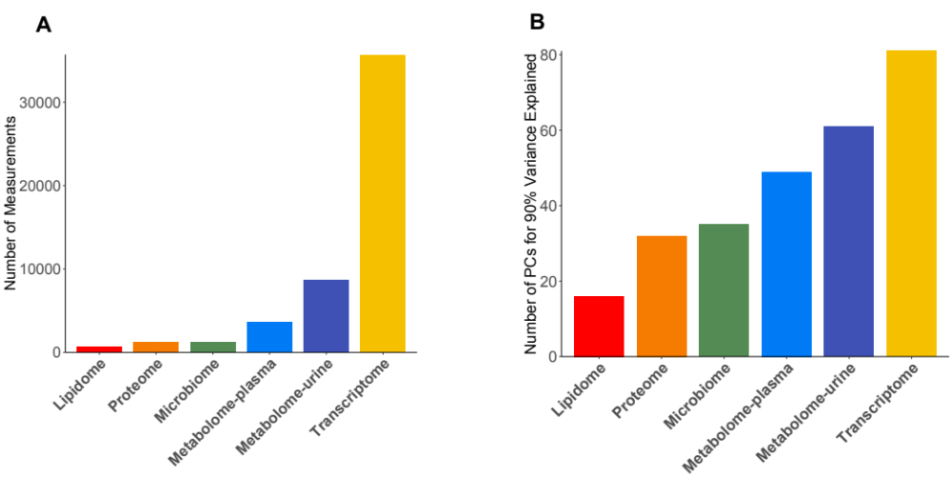
Figure S1. Features of six omics datasets. A. Number of measurements in each dataset; B. Number of principal components to account for 90% of the variance. Datasets containing more strongly correlated features yield fewer principal components.

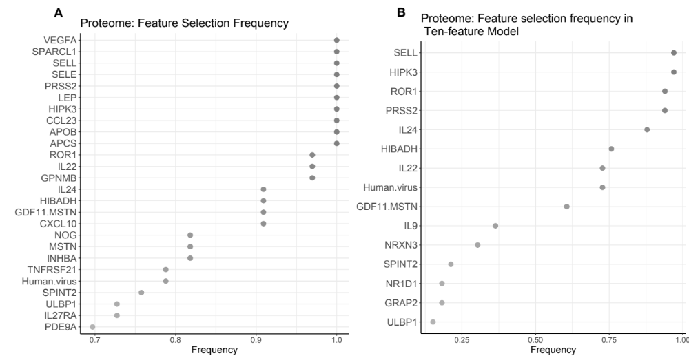
Figure S2. Proteomics feature selection frequency in prediction model over gestation. A. Elastic net model. B. Elastic net model with 10 features. Y-axis shows proteins chosen with the highest frequency across all EN prediction models, where one EN prediction model is built in each cross-validation step. X-axis shows the frequency with which each protein is chosen across all models.

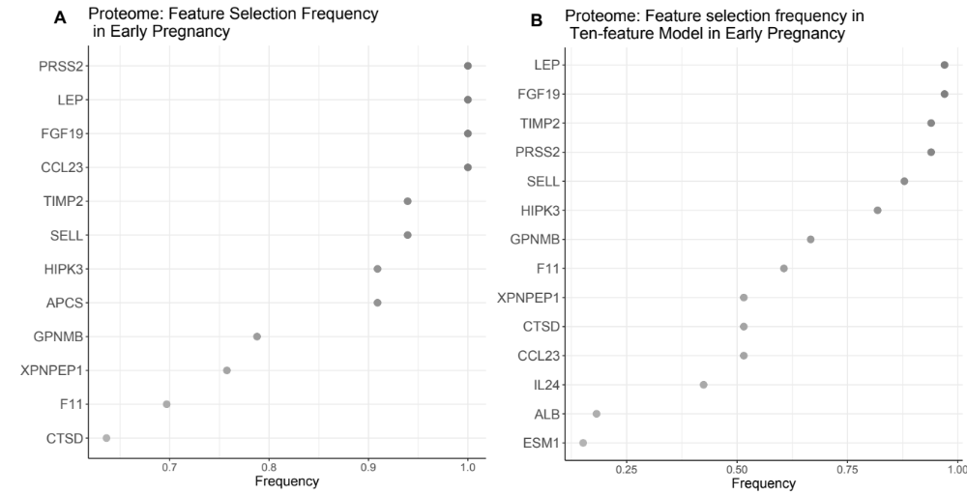
Figure S3. Proteomics feature selection frequency in prediction model in early pregnancy. A. Elastic net model. B. Elastic net model with 10 features. Y-axis shows proteins with highest frequency of selection in the prediction model. One elastic net model is built in each cross-validation step using the train data for that set. X-axis shows the frequency with which each protein is chosen across all models.

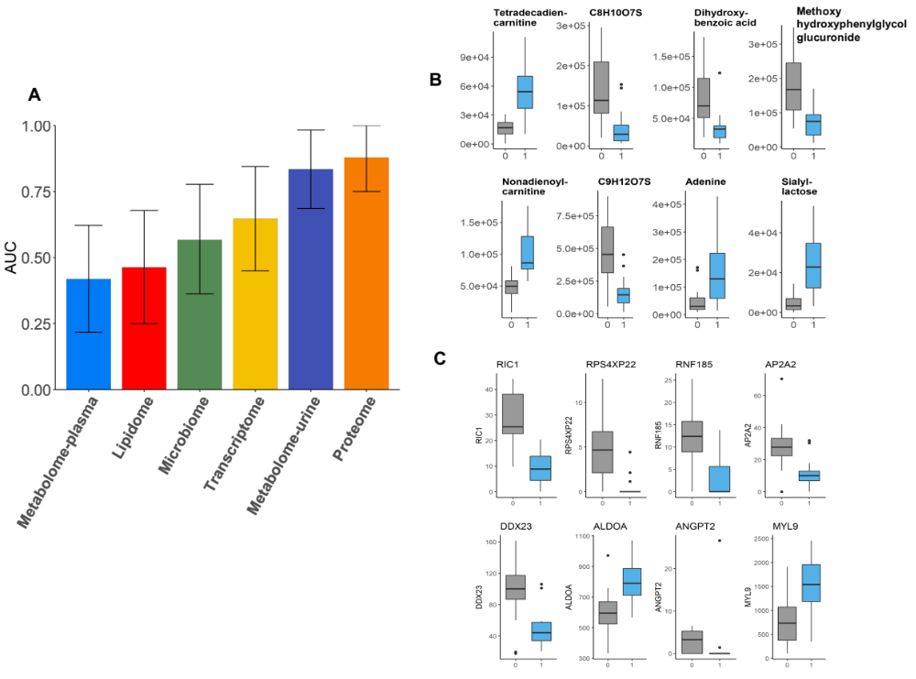
Figure S4. Prediction models in early pregnancy. A. Performance comparison of prediction models derived in individual omics data sets as indicated by respective AUCs. The plasma proteomic and urine metabolomic models performed best (AUC=0.88, 95% CI of [0.75, 1] proteome; AUC=0.83, 95% CI of [0.69, 0.98] urine metabolome). B. Top-ranking eight urine metabolites. C. Top-ranking eight genes. Y-axis shows the value in early pregnancy stratified by normal (grey) versus preeclamptic pregnancy (light-blue).

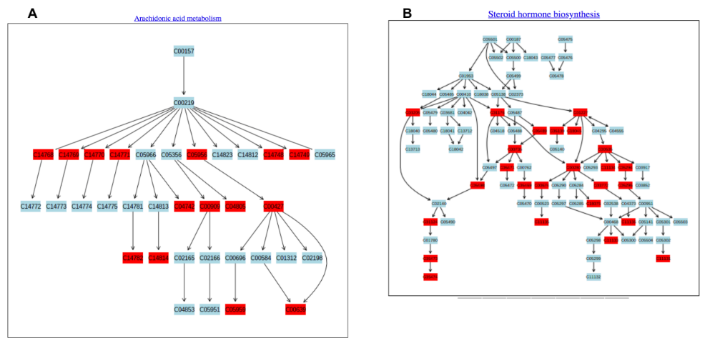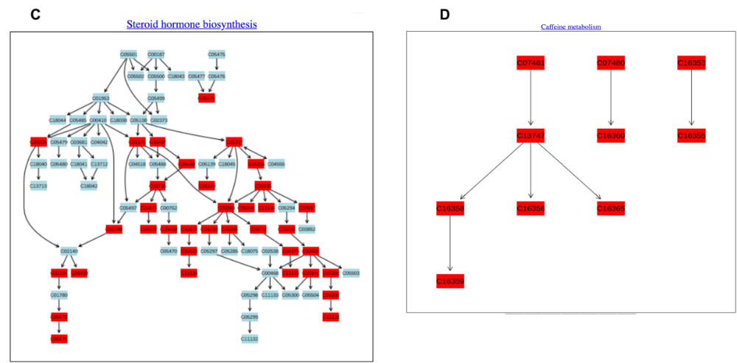
Figure S5. Identified pathways enriched in urine metabolomic data obtained in early pregnancy and over gestation. A. Metabolites in the arachidonic acid pathway in early pregnancy. Metabolites present in the data with high level of significance are shown in red. Metabolites not present in the data are shown in light blue. B. Metabolites in the steroid hormone biosynthesis pathway in early pregnancy. C. Metabolites in the steroid hormone biosynthesis pathway over gestation. D. Metabolites in the caffeine metabolism pathway over gestation.

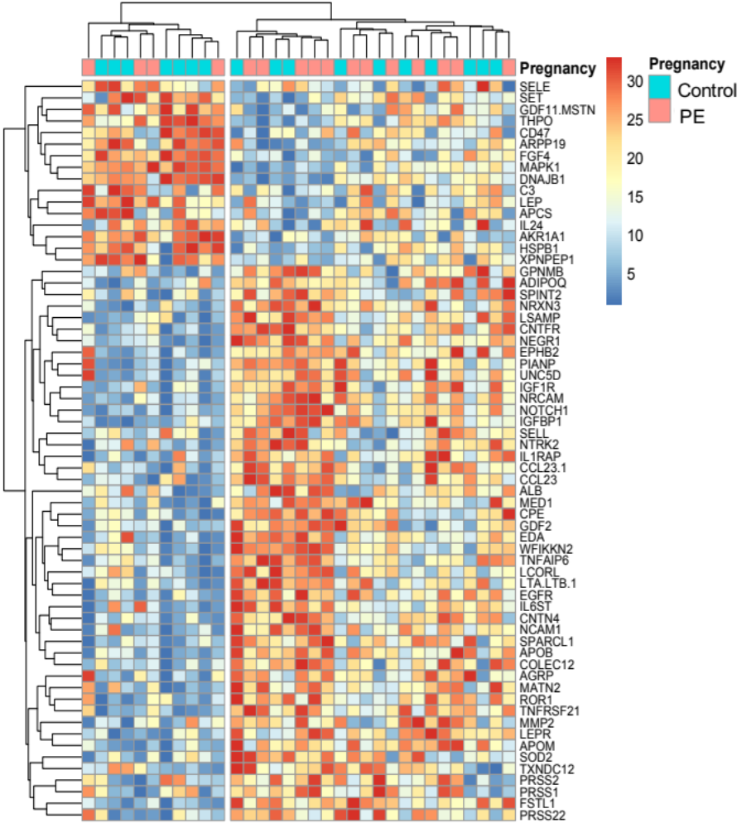
Figure S6. Univariate analysis of proteomic data collected over gestation. Heatmap of the ranked average value of the protein over three trimesters. Changes over gestation of 437 proteins were significantly associated with preeclampsia outcome (Benjamini-Hochberg, FDR < 0.05); 64 proteins with the smallest p-value ($p<5∙{10}^{-5}$, Linear Mixed-Effects Model) are shown.
Figure S7. Enriched protein pathways showing two-level hierarchical structure. Pathways at the first level are grouped into ten biological processes.

Figure S8. Enriched cfrna pathways in two-level hierarchical structure.
Figure S9. Network of features from different omics sets over gestation. Features with significant association with preeclampsia are shown (FRD<0.05, Linear Mixed-Effects Model with Bonferroni-Hochberg correction). Proteome, urine metabolome, plasma metabolome and transcriptome are shown respectively in orange, dark blue, light blue and yellow. 17 distinct communities were identified.

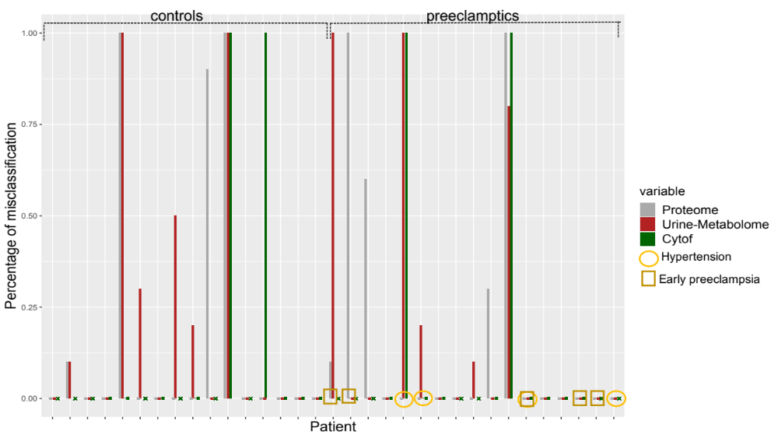
Figure S10. Misclassification rate per each patient in the cohort. Misclassification rate is shown for three prediction algorithms: proteome (gray), urine metabolome (red) and immunome (green).

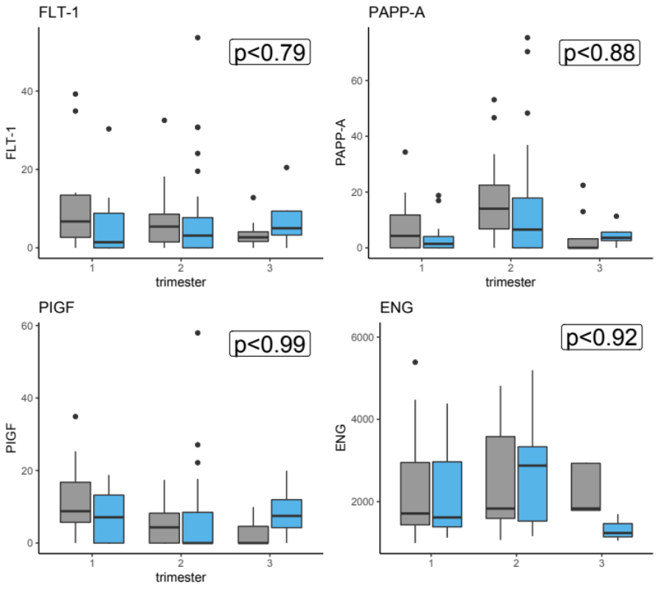
Figure S11. Values of FLT-1, PAPP-A, PIGF, ENG, known biomarkers of preeclampsia over gestation. Y-axis shows a value stratified by normal pregnancy (grey) and preeclamptic pregnancy (blue). P-value using LME model is shown. None of the shown markers came as significant.

Biological Assays
- Cell-free RNA Transcriptome
Cell-free RNA (cfRNA) was extracted from 1 mL of plasma using Plasma/Serum Circulating RNA and Exosomal Purification kit (Norgen, cat 29500) following manufacturer instructions. Residual DNA was digested using BaselineZERO DNase (Epicentre) and then cleaned using RNA Clean and Concentrator-96 kit (Zymo). RNA was eluted to 12 ul in elution buffer. Libraries were prepared using 4 uL cfRNA and SMARTer Stranded Total RNAseq Kit v2 -Pico Input Mammalian Components (Clontech Cat No 634419) and SMARTer RNA Unique Dual Index Barcodes (Set A, Cat 634452) according to the manufacturer’s manual. Short read sequencing was performed using the Illumina NovaSeq (2 × 75 bp) platform to an average depth of 50 million reads per sample. Raw sequencing reads were trimmed with trimmomatic and then mapped to the human reference genome (hg38) with STAR. Duplicates were removed by Picard and then unique reads were quantified using htseq-count. Mapping quality statistics were aggregated using MultiQC.

To estimate RNA degradation, we first counted the number of reads per exon and annotated each exon with its corresponding gene ID and exon number using htseq-count. We then counted the number of genes for which all reads mapped exclusively to the 3’ most exon per sample and divided by the total number of genes detected to obtain the fraction of genes where all reads mapped to the 3’ most exon.

Finally, we estimated ribosomal read fraction by counting the number of reads that mapped to the ribosomal region (GL00220.1:105424-118780) using samtools view.

- Proteome
Proteomic assay: Blood was collected into EDTA tubes, immediately placed in ice, centrifuged (3,000 rpm), and plasma was removed and transferred into 1.5-ml microfuge tubes. Tubes were then spun at 13,000 rpm for 1 min, plasma was transferred into another set of microfuge tubes and spun again for 1 min. Plasma was stored at -80°C. All processing was completed within 60 min of collection.

All proteomic analyses were performed blinded and in randomly allocated samples by SomaLogic, Inc. (Boulder, CO) using a highly multiplex aptamer-based platform. [1-5] The assay quantifies relative concentrations of 1,310 proteins over a wide dynamic range (> 8 log) using chemically-modified aptamers with slow off-rate kinetics (SOMAmer reagents). Each SOMAmer reagent is a unique, high-affinity, single-strand DNA endowed with functional groups mimicking amino acid side chains. Nucleotide signals are quantified using relative florescence on microarrays (Agilent Technologies, Santa Clara, CA). The assay has a historic median intra- and inter-run coefficient of variation of about 5%, and median lower and upper limits of quantification of 3.0 pM and 1.5 nM.¹

Quality control at the sample level included the use of control SOMAmers on the microarray to monitor for differences in hybridization efficiency, and the calculation of the median signal over all SOMAmers to account for technical variability. The resulting hybridization and median scale factors were used for data normalization across samples. Acceptable scale factors ranged between 0.4 and 2.5 based on historic runs. Quality control at the SOMAmer level included the use of replicate calibrator plasma samples (7) and biological controls (4) to monitor for repeatability and batch-to-batch variability. Historic values were used for each SOMAmer to derive a calibration scale factor. Acceptance criteria were a median scale factor between 0.8 and 1.2, and deviation by less than 0.4 from the plate median for 95% of SOMAmers.
All quality metrics for the proteomic assay were met with plate scale factors of 1.24 and 1.46, and SOMAmer calibration factors < 0.4 for 95% of SOMAmers. The median coefficient of variation was 4.1%.

3. Microbiome
Self-sampling of the vagina was performed weekly by study participants. Sterile Catch-AllTM Sample Collection Swabs (Epicentre Biotechnologies, Madison, WI, USA) were used to obtain material from: vagina (midvaginal wall). All clinical specimens were placed immediately after collection at −20◦C until transport to the laboratory for storage at −80◦C until further
processing. Whole genomic DNA was extracted from each vaginal swab by means of
the PowerSoil DNA isolation kit (MO BIO Laboratories) according to the manufacturer’s protocol except for the inclusion of a 10-min incubation at 65◦C immediately after the addition of solution C1. The V4 hypervariable region of the 16S rRNA gene was amplified by PCR. The forward PCR primer (50 AAT GAT ACG GCG ACC ACC GAG ATC TAC ACG CTN NNN NNN NNN NNT ATG GTA ATT GTG TGY CAG CMG CCG CGG TAA 30) was a 75-nucleotide (nt) fusion primer consisting of the 32-nt Illumina adapter (designated by bold), a unique 12-nt barcode to label each amplicon (designated by the N’s), a 10-nt forward primer pad, a 2-nt linker (GT), and the 19-nt broad-range bacterial primer 515F (designated by underlining). The 56-nt reverse primer (5’ CAA GCA GAA GAC GGC ATA CGA GAT AGT CAG CCA GCC GGA CTA
CNV GGG TWT CTA AT 30) consisted of the 24-nt Illumina adapter (designated by bold), a 10-nt reverse primer pad, a 2-nt reverse primer linker (CC), and the 20-nt broad-range bacterial primer 806R (designated by underlining). Triplicate 25-µL PCRs were carried out by using 1× HotMasterMix (5 PRIME), 0.4 µM concentrations of each commercially synthesized primer, and
3 µL of prepared DNA template. Thermal cycling conditions consisted of an initial denaturing step of 94◦C for 3 min, followed by 30 cycles of 94◦C for 45s, 50◦C for 60s, and 72◦C for 90s, with a final extension step of 72◦C for 10 minutes. Upon completion of the PCRs, the corresponding triplicate reaction mixtures were pooled and purified by using the Ultra-clean-htp 96-well PCR clean-up kit (Mo Bio Laboratories) according to the manufacturer’s protocol.
DNA concentrations from each triplicate pool were quantified using the QuantiT High-Sensitivity dsDNA Assay Kit (Invitrogen) and combined in equimolar
14 ratios into a single tube. The resulting amplicon mixture was concentrated
by ethanol precipitation and resuspended in 100 µL of molecular biology-grade
water (Life Technologies). The resuspended amplicon mixture was gel purified
and recovered using a QIAquick gel extraction kit (Qiagen). Recovered PCR products were sequenced on an Illumina HiSeq 2500 instrument (Illumina) at the W. M. Keck Center for Comparative Functional Genomics at the University of Illinois, Urbana–Champaign, IL. Bioinformatics processing largely followed the DADA2 Workflow for Big Data (benjjneb.github.io/dada2/bigdata_paired.html). Forward/reverse read pairs were trimmed and filtered, with forward reads truncated at 245 nt and reverse reads at 235 nt, no ambiguous bases allowed, and each read required to have less than two expected errors based on their quality scores. The relationship between quality scores and error rates was estimated for each sequencing run to reduce batch effects arising from run-to-run variability. ASVs were independently inferred from the forward and reverse of each sample using the run-specific error rates, and then read pairs were merged. Chimeras were identified in each sample, and ASVs were removed if identified as chimeric in a sufficient fraction of the samples in which they were present. Taxonomic assignment was performed against the Silva v123 database using the implementation of the RDP naive Bayesian classifier available in the dada2 R package [Wang et al., 2007, Quast et al., 2012]. Lactobacillus species were assigned by hand via BLAST against sequences from cultured Lactobacillus strains.

4. Immunome
Whole blood samples were stimulated for 15 min with either LPS, IFNα, a cocktail containing IL-2 and IL-6, or left unstimulated. Samples were then processed using a standardized protocol for fixation (SmartTube Inc), barcoding and antibody staining of whole blood samples for mass cytometry analysis [Bodenmiller et al., 2012]. For further details see Aghaeepour et al. [2017]. Three categories of immune features were derived for integrative analysis: Cell frequency features: cell frequencies were expressed as a percentage of gated singlets in the case of neutrophils, and as a percentage of mononuclear cells (CD45+CD66−) in the case of all other cell types. Endogenous signaling immune features: Endogenous intracellular signaling
activities were derived from the analysis of unstimulated blood samples. The signal intensity of the following functional markers was simultaneously quantified per single cell: phospho (p) STAT1, pSTAT3, pSTAT5, pNFκB, total IκB, pMAPKAPK2, pP38, prpS6, pERK1/2, and pCREB. For each cell type, signaling immune features were calculated as the median signal intensity (arcsinh transformed value) of each signaling protein. Intracellular signaling response features: the signal intensity of all functionalmarkers was analyzed from samples stimulated with LPS, IFNα or IL. For each cell type, signaling responses were calculated as the difference in median signal intensity (arcsinh transformed value) of each signaling protein between the
stimulated and unstimulated conditions.

5. Untargeted Metabolomics by Liquid Chromatography (LC)- Mass Spectrometry (MS).
LC-MS-grade solvents and mobile phase modifiers were obtained from Fisher Scientific (water, acetonitrile, methanol) and Sigma−Aldrich (acetic acid, ammonium acetate). Urine and plasma samples were analyzed using a broad-spectrum metabolomics platform consisting of hydrophilic interaction chromatography (HILIC) and reverse phase liquid chromatography (RPLC)–MS (Contrepois et al., 2015).
Sample preparation. Frozen urine samples were thawed on ice and centrifuged at 17,000g for 10 min at 4°C. Supernatants (25 µl) were then diluted 1:4 with 75% acetonitrile and 100% water for HILIC- and RPLC-MS experiments, respectively. Samples for HILIC-MS experiments were further centrifuged at 21,000g for 10 min at 4°C to precipitate proteins. Frozen plasma samples were thawed on ice and metabolites were prepared from 100 µl of plasma using 1:1:1 acetone:acetonitrile:methanol, evaporated to dryness under nitrogen, and reconstituted in 1:1 methanol:water. Each sample was spiked-in with 15 analytical-grade internal standards (IS).
Data acquisition. Metabolic extracts were analyzed using HILIC and RPLC separations in both positive and negative ionization modes. Data were acquired on a Thermo Q Exactive HF mass spectrometer equipped with a Heated Electrospray Ionization probe (HESI-II) and operating in full MS scan mode. MS/MS data were acquired at different fragmentation energies (NCE 25, 35 and 50) on pooled samples consisting of an equimolar mixture of all the samples in the study. HILIC experiments were performed using a ZIC-HILIC column 2.1 x 100 mm, 3.5 μm, 200Å (Merck Millipore) and mobile phase solvents consisting of 10 mM ammonium acetate in 50/50 acetonitrile/water (A) and 10 mM ammonium acetate in 95/5 acetonitrile/water (B). RPLC experiments were performed using a Zorbax SBaq column 2.1 x 50 mm, 1.7 μm, 100Å (Agilent Technologies) and mobile phase solvents consisting of 0.06% acetic acid in water (A) and 0.06% acetic acid in methanol (B).
Data quality was ensured by: (1) sample randomization for metabolite extraction and data acquisition, (2) multiple injections of a pooled sample to equilibrate the LC-MS system prior to running the sequence (12 and 6 injections for HILIC and RPLC methods, respectively), (3) spike-in labeled IS during sample preparation to control for extraction efficiency and evaluate LC-MS performance, (4) checking mass accuracy, retention time and peak shape of the IS in each sample and (5) injection of a pooled sample every 10 injections to control for signal deviation over time.
Data processing. Data from each mode were independently processed using Progenesis QI software (v2.3) (Nonlinear Dynamics). Metabolic features from blanks and that did not show sufficient linearity upon dilution in QC samples (r < 0.6) were discarded. Only metabolic features present in > 2/3 of the samples were kept for further analysis. Inter- and intra-batch variations were corrected by applying locally estimated scatterplot smoothing local regression (LOESS) on pooled samples injected repetitively along the batches (span = 0.75). Dilution effects for urine samples were corrected using probabilistic quotient normalization (PQN). Missing values were imputed by drawing from a random distribution of low values in the corresponding sample. Data from each mode were then merged, producing a dataset containing 8718 and 3622 metabolic features for urine and plasma, respectively. Metabolite abundances were reported as spectral counts.
Metabolic feature annotation. Peak annotation was first performed by matching experimental m/z, retention time and MS/MS spectra to an in-house library of analytical-grade standards. Remaining peaks were identified by matching experimental m/z and fragmentation spectra to publicly available databases including HMDB (http://www.hmdb.ca/), MoNA (http://mona.fiehnlab.ucdavis.edu/) and MassBank (http://www.massbank.jp/) using the R package ‘metID’ (v0.2.0) (Shen X, Wang R, Xiong X, Yin Y, Cai Y, Ma Z, et al. Metabolic reaction network-based recursive metabolite annotation for untargeted metabolomics. Nat Commun. 2019 Apr 3;10(1):1516.). Briefly, metabolic feature tables from Progenesis QI were matched to fragmentation spectra with a m/z and a retention time window of ± 15 ppm and ± 30 s (HILIC) and ± 20 s (RPLC), respectively. When multiple MS/MS spectra match a single metabolic feature, all matched MS/MS spectra were used for the identification. Next, MS1 and MS2 pairs were searched against public databases and a similarity score was calculated using the forward dot–product algorithm which considers both fragments and intensities. Metabolites were reported if the similarity score was above 0.4. We used the Metabolomics Standards Initiative (MSI) level of confidence to grade metabolite annotation confidence (level 1 - level 4). Level 1 represents formal identifications where the biological signal matches accurate mass, retention time and fragmentation spectra of an authentic standard run on the same platform. For level 2 identification, the biological signal matches accurate mass and fragmentation spectra available in one of the public databases listed above. Level 3 represents putative identifications that are the most likely name based on previous knowledge of blood and urine composition. Level 4 consists in unknown metabolites. Annotated urine metabolites selected in the prediction models are reported in Table S3.

References

      - L. Gold, D. Ayers, J. Bertino, C. Bock, A. Bock, E. N. Brody, J. Carter, A. B. Dalby, B. E. Eaton, T. Fitzwater, D. Flather, A. Forbes, T. Foreman, C. Fowler, B. Gawande, M. Goss, M. Gunn, S. Gupta, D. Halladay, J. Heil, J. Heilig, B. Hicke, G. Husar, N. Janjic, T. Jarvis, S. Jennings, E. Katilius, T. R. Keeney, N. Kim, T. H. Koch, S. Kraemer, L. Kroiss, N. Le, D. Levine, W. Lindsey, B. Lollo, W. Mayfield, M. Mehan, R. Mehler, S. K. Nelson, M. Nelson, D. Nieuwlandt, M. Nikrad, U. Ochsner, R. M. Ostroff, M. Otis, T. Parker, S. Pietrasiewicz, D. I. Resnicow, J. Rohloff, G. Sanders, S. Sattin, D. Schneider, B. Singer, M. Stanton, A. Sterkel, A. Stewart, S. Stratford, J. D. Vaught, M. Vrkljan, J. J. Walker, M. Watrobka, S. Waugh, A. Weiss, S. K. Wilcox, A. Wolfson, S. K. Wolk, C. Zhang, D. Zichi, PloS one 2010, 5, e15004.

