Supplemental Figures:

Supplemental Figure 1 : Flow chart of participant recruitment for sodium MRI studies who were initially recruited as part of a peptide-based vaccine immunotherapy trial

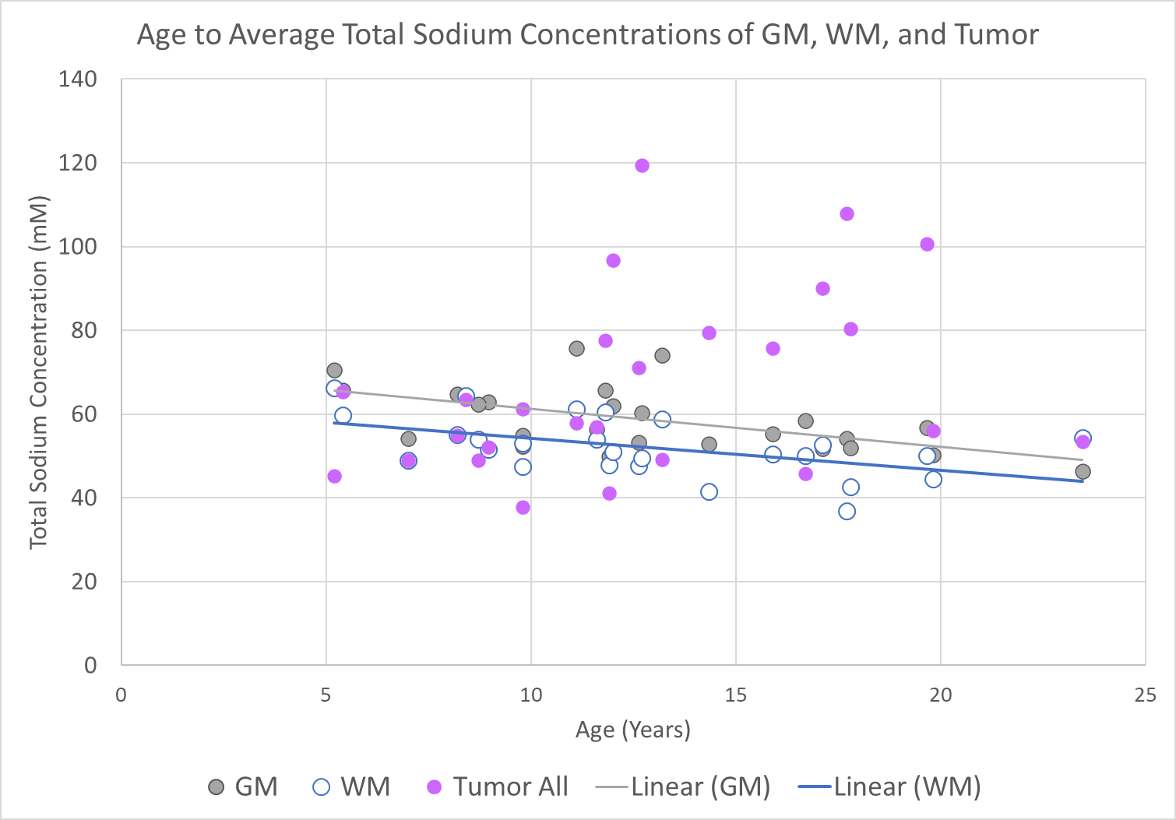

Supplemental Figure 2: Regression Analysis relating age to average total sodium concentration (TSC) of uninvolved gray matter (GM), uninvolved white matter (WM), and tumor regions. The GM and WM exhibited linear relationship between average TSC and age, while tumor region was not significant.

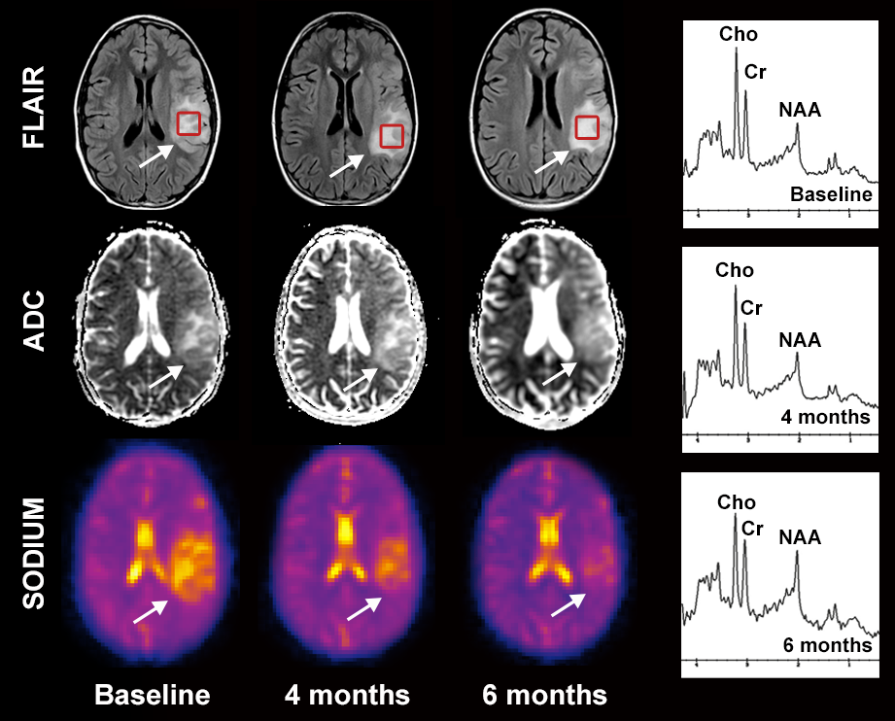
Supplemental Figure 3: Serial total sodium concentration (TSC) imaging suggesting pseudoprogression. The fluid-attenuated inversion recovery (FLAIR) imaging shows an infiltrative mass in the posterior frontal/parietal region which initially demonstrated increased TSC at baseline. After 4 doses of a vaccine, there is decrease in TSC signal while FLAIR, apparent diffusion coefficient (ADC) and magnetic resonance spectroscopy (white square) are essentially unchanged. At 6 months, there was a clinical concern for progression. However, the sodium continues to show a decreased TSC while the FLAIR signal demonstrates a slight increase with concomitant decreases in ADC and the ratios of Choline/Creatine and Choline/NAA. The sodium MRI and MRS supported pseudoprogression over true progression.

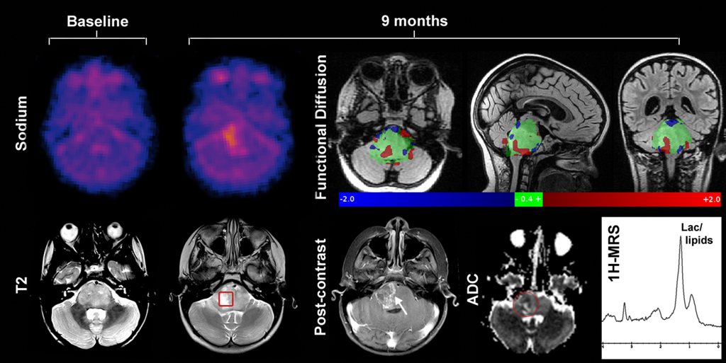
Supplemental Figure 4: Serial TSC in pediatric brainstem glioma [ diffuse intrinsic pontine glioma -DIPG]: At baseline, DIPGs have relatively low total sodium concentration (TSC). After therapy, T₂-weighted image demonstrated an increased hyperintensity within the brainstem. Areas of non-enhancing and enhancing tumor began to evolve in the right inferior brainstem. Sodium MRI revealed a slight increase in TSC within the core of the necrotic region, which was confirmed to be tumor progression. The ADC map demonstrated heterogeneous signal at the cross-sectional timepoint, while a longitudinal analysis of the serial changes (functional diffusion maps) showed spatially and temporally heterogeneous response consisting of areas where there is a clear increase in diffusion (red voxels; co-localizing to the area of increased sodium), decreased diffusion (blue voxels), large areas unchanged (green voxels). The magnetic resonance spectroscopy (MRS) revealed a huge lipid peak, which can be seen both in treatment and tumor related necrosis (red square on bottom posttherapy axial T₂ is the MRS voxel).

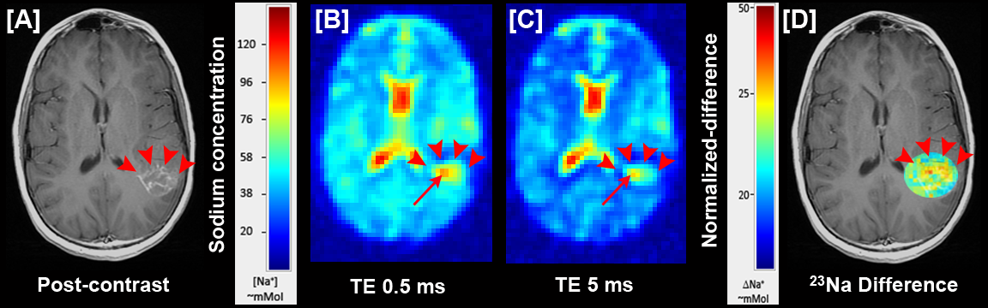

Supplemental Figure 5. Two-TE sodium (²³Na) MRI of a necrotic recurrent lesion in pediatric supratentorial high-grade glioma. [A] shows a ring enhancing necrotic lesion (red arrowheads); [B] ultra short echo time (TE₁ = 0.5 ms) and [C] relatively long echo time (TE₂ = 5 ms) sodium MRI images showing the total and free (extracellular) sodium increasing in the periphery of the lesion (red arrow); [D] relevant region from the bound (intracellular) sodium concentration (vBSC) overlaid on a co-registered structural image, showing the bound sodium increased in the periphery of the necrosis (red and yellow voxels) but decreased in the center (blue voxels), a typical tumor-related cavitation/necrosis. This necrosis was confirmed as a recurrent tumor by the follow up images.

