Supplementary information

Severe Neuro-COVID is associated with peripheral immune signatures, autoimmunity and neurodegeneration: a prospective cross-sectional study

Etter et al.

Supplementary Figures

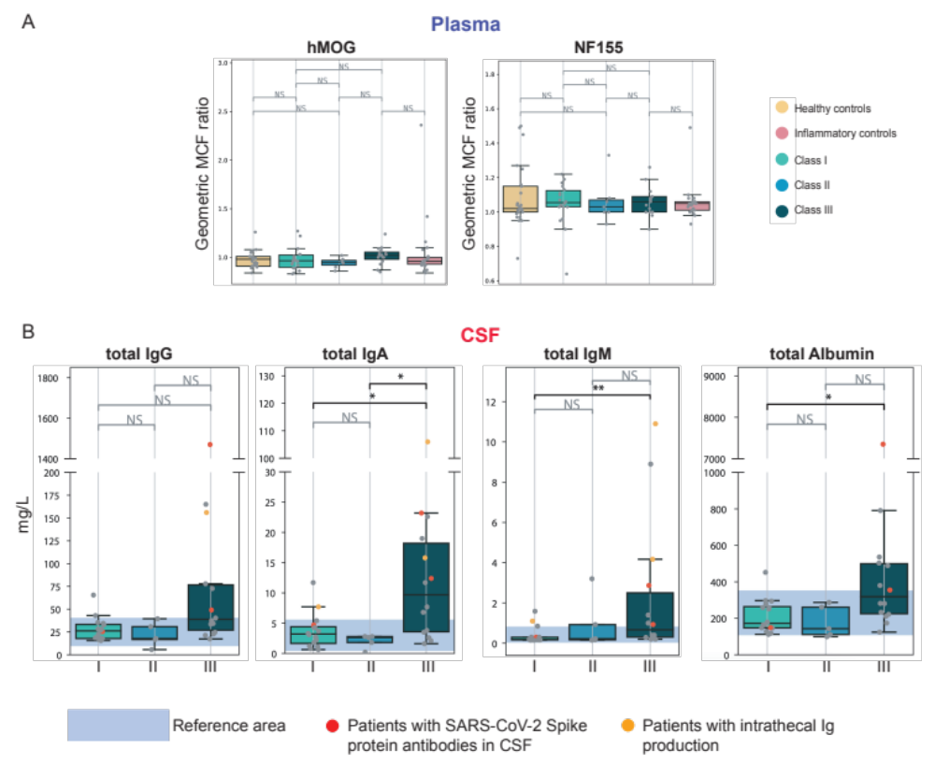
Supplementary Figure 1

Supplementary Figure 1: Antibody reactivities against known CNS myelin antigens and total Ig and albumin values per Neuro-COVID class.
Box plot representations of anti-(non)-self reactivities in plasma, total Ig and albumin levels in plasma and CSF, and anti-myelin plasma reactivities. a Anti-BSA, -dsDNA, anti-gut bacteria (RePOOPulate) IgG/IgA reactivities (OD450 nm) in plasma. b Total CSF IgG/A/M and albumin levels (mg/L). Blue boxes indicate the clinical reference area. c Plasma IgG reactivities against hMOG and NF155, plotted as geometric mean channel fluorescence (MCF) ratio.

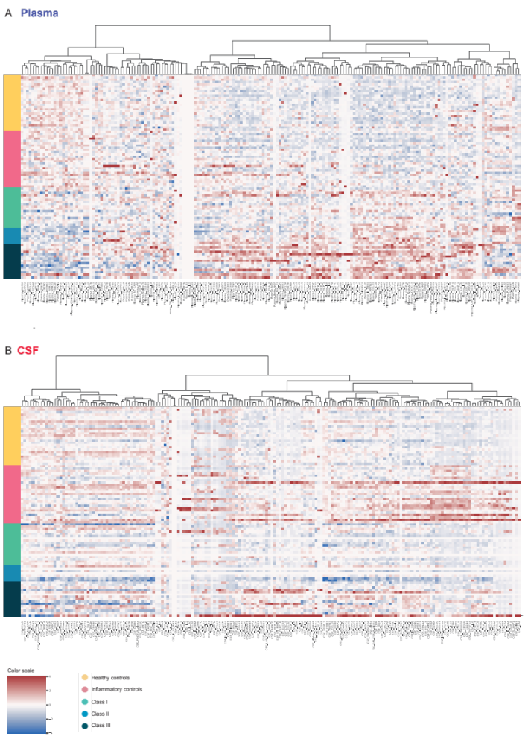
Supplementary Figure 2

Supplementary Figure 2: Heatmap of individual CSF and plasma analytes.
Z-score clustered heatmap visualization for each patient, group and sample source. a Plasma analytes are represented on the X-axis. Each quadrant represents a single protein and individual participant. Participants and groups are represented on the Y-axis. Z-scores are color-coded with red colors (high), white (neutral) and blue colors (low). b CSF analytes are represented on the X-axis. Each quadrant represents a single protein and individual participant. Participants and groups are represented on the Y-axis. Z-scores are color-coded with red colors (high), white (neutral) and blue colors (low).
Supplementary Figure 3

Supplementary Figure 3: Low CSF/plasma soluble protein ratios are prevalent in Neuro-COVID patients indicating peripheral synthesis, whereas inflammatory controls display predominant intrathecal changes.
a Rose plots illustrating the log₂-fold change of the CSF/plasma ratio for each cytokine in each group. A value of 0 corresponds to equality, a value of -1 refers to a 2 times less CSF concentration, a value of 1 means a 2 times less plasma concentration. For better visualization, the analytes were split into two separate rose plots. Range: SEM. b CSF/plasma ratios of each molecule were assessed to identify significant differences across groups. The ratio of 49 molecules significantly differed between groups after BH-procedure. These molecules are represented on the Y-axis on the right of the heatmaps. Ratio values are color-coded with red colors illustrating a higher ratio and blue colors illustrating a lower ratio. The 3 vertical differently colored lines on the Y-axis demonstrate specific ratio differences between (from left to right) class III vs inflammatory, class II vs healthy, and class I vs healthy controls. Heatmaps are separated into molecules with a CSF/plasma ratio ≥0 (upper heatmap), indicating intrathecal synthesis, and a CSF/plasma ratio ≤0 (lower heatmap), indicating peripheral synthesis. The main ratio changes in Neuro-COVID patients take place in the plasma, whereas inflammatory controls display a stronger intrathecal immune response (1) compared to Neuro-COVID patients and (2) compared to immune reactions in their plasma.

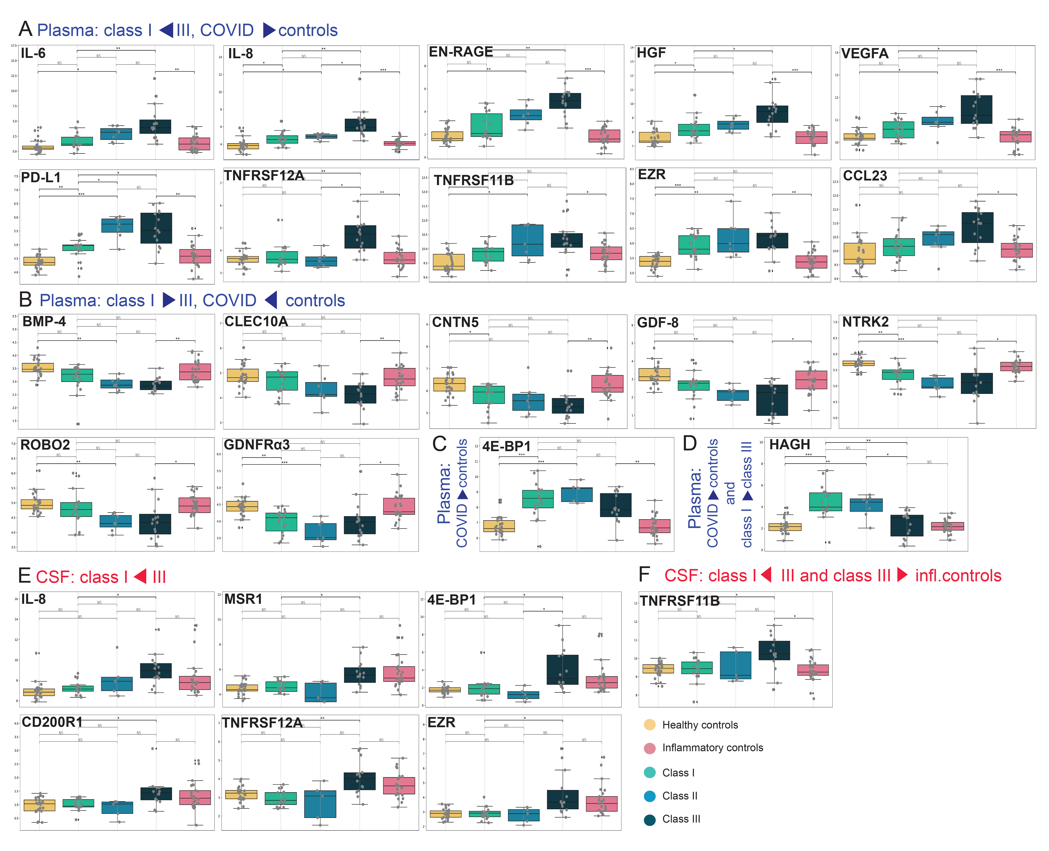
Supplementary Figure 4

Supplementary Figure 4: Individual CSF and plasma analytes discriminating different groups.
Box plot representations of marginalized NPX of individual analytes significantly discriminating selected groups. a Plasma, increasing NPX from class I to III, and higher than in controls: IL-6 (class III vs I: d=2.72, adj. p=0.007, class III vs infl. ctrl d=2.71, adj. p=0.001), IL-8 (class III vs I: d=1.4, adj. p=0.003, class III vs infl. ctrl d=1.8, adj. p=0.0002 ), HGF (class III vs I: d=1.36, adj. p=0.04, class III vs infl. ctrl d=1.76, adj. p=0.0007), VEGFA (class III vs I: d=0.6, adj. p=0.01, class III vs infl. ctrl d=0.8, adj. p=0.0005), EN-RAGE (class III vs I: d=2.86, adj. p=0.003, class III vs infl. ctrl d=3.34, adj. p=0.0002), TNFRSF12A (class III vs I: d=1.12, adj. p=0.006, class III vs infl. ctrl d=1.15, adj. p=0.002), PD-L1 (class III vs I: d=0.5, adj. p=0.04, class III vs infl. ctrl d=0.93, adj. p=0.002), CCL23 (class III vs infl. ctrl d=0.94, adj p = 0.01), EZR (class III vs infl. ctrl d=0.87, adj. p=0.002), TNFRSF11B (class III vs infl. ctrl d=0.34, adj. p=0.049). b Plasma, decreasing NPX from class I to III, and higher in controls than in COVID-19: BMP-4, CLEC10A, CNTN5, GDF-8, NTRK2, GDNFRalpha, ROBO2. c Plasma, Neuro-COVID class-independent, higher NPX in COVID-19 than in controls: 4E-BP1 (class III vs infl. ctrl d=1.19, adj p=0.007). d Plasma, higher NPX in COVID-19 than in controls and decreasing from class I to III: HAGH (class III vs I: d=-0.98, adj. p=0.008). e CSF, increasing NPX from class I to III: IL-8 (class III vs I: d=1.79, adj. p=0.012), MSR1 (class III vs I: d=1.01, adj p=0.016), 4E-BP1 (class III vs I: d=1.16, adj p=0.02), CD200R1 (class III vs I: d=0.50, adj p=0.04), TNFRSF12A (class III vs I: d=1.16, adj p=0.008), EZR (class III vs I: d=0.76, adj p=0.01). f CSF, increasing NPX from class I to III, and higher in class III than in inflammatory controls: TNFRSF11B (class III vs I: d=0.8, adj. p=0.04, class III vs infl. ctrl d=0.98, adj. p=0.02).
Statistics: statistical significance was calculated using the Mann-Whitney-U test (adj. p: *<0.05, **<0.01, ***<0.001).
Legend: NPX: normalized protein expression, d: difference, adj. p: adjusted p-value, NS: not significant.

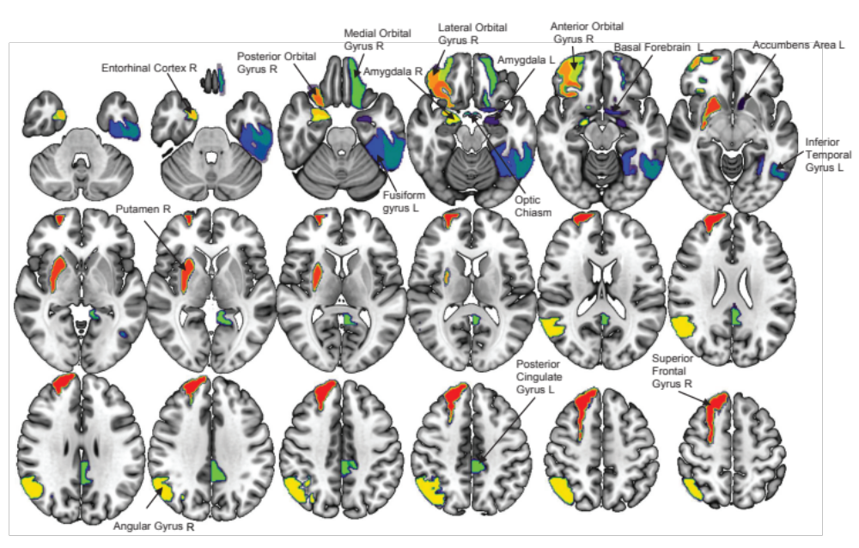
Supplementary Figure 5

Supplementary Figure 5: Map of brain regions significantly correlating with CSF parameters.
Map of the 16 brain regions with significant correlation values of GMV and clinical variables in the Neuro-COVID group after multiple comparison correction (FDR). These regions are represented in different colors on a T1-weighted template (in radiological convention).
Legend: L: left, R: right.

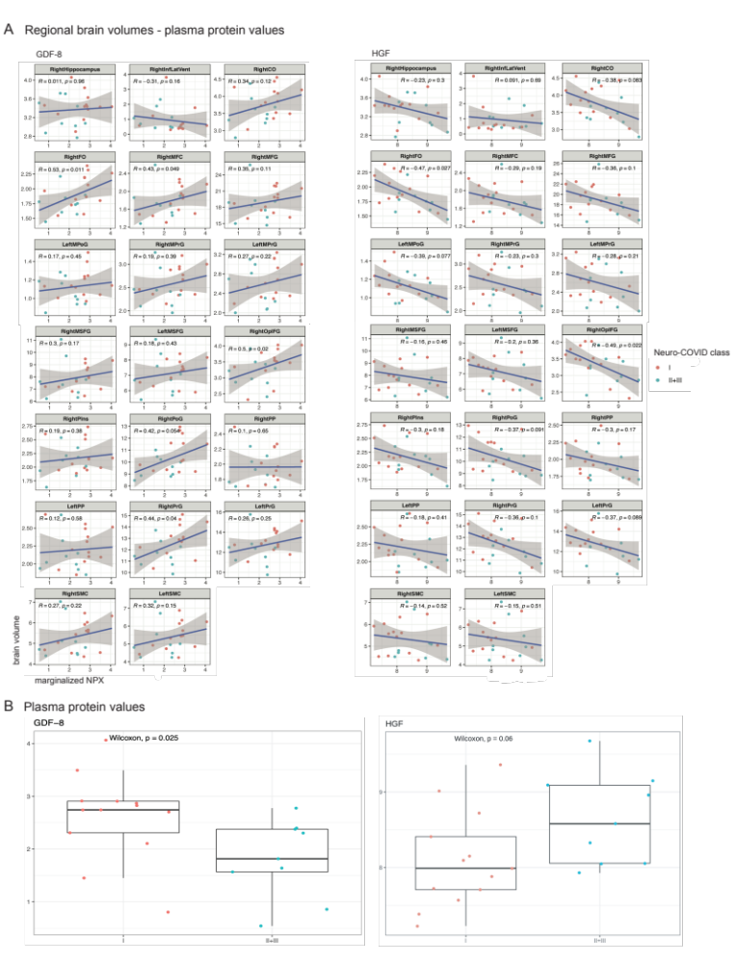
Supplementary Figure 6

Supplementary Figure 6: Elevated GDF-8 plasma levels in class I are associated with preserved regional brain volumes, whereas higher HGF plasma levels in class III are associated with decreased regional brain volumes.
a Correlation plots demonstrating the correlation of GDF-8 and different regional brain volumes in Neuro-COVID patients. The Y-axis represents the regional brain volume values. The X-axis represents the marginalized NPX of the respective protein. None of the adjusted p-values was significant after BH-procedure. b Boxplot representations of marginalized NPX of class I compared to merged class II+II plasma GDF-8 (Wilcoxon, p=0.025). c Correlation plots demonstrating the correlation of HGF and different regional brain volumes in Neuro-COVID patients. The Y-axis represents the regional brain volume values. The X-axis represents the marginalized NPX of the respective protein. None of the adjusted p-values was significant after BH-procedure. d Boxplot representations of marginalized NPX of class I compared to merged class II+II plasma HGF (Wilcoxon, p=0.06).
Legend: RightFO: right frontal operculum, LeftPrG: left precentral gyrus, RightOpIFG: right opercular part of the inferior frontal gyrus, RightInfLatVent: right inferior lateral ventricle, LeftPP: left planum polare, RightPIns: right posterior insula, RightCO: right central operculum.

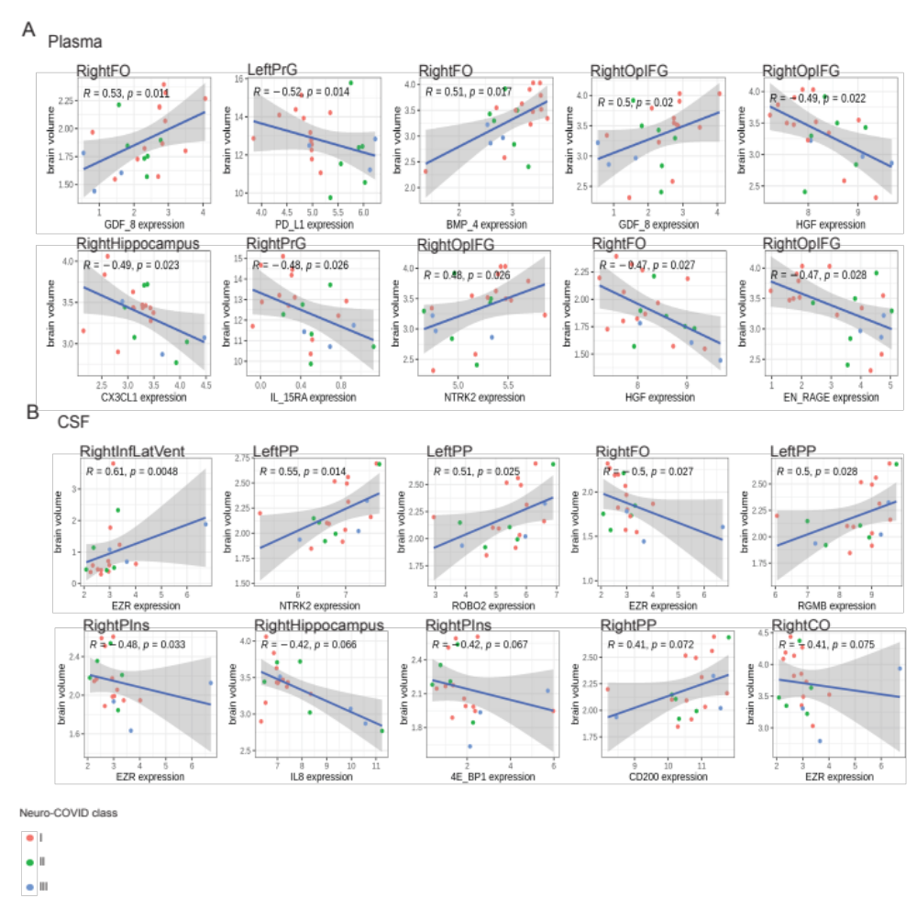
Supplementary Figure 7

Supplementary Figure 7: Correlation analysis of brain regions and proteins with most significant associations.
a Boxplot representations of marginalized NPX individual plasma analytes associated with decreased regional brain volumes: PD-L1, HGF, CX3CL1, IL-15RA, EN-RAGE; and plasma analytes associated with protective effects on regional brain volumes: GDF-8, BMP-4, NTRK2. Statistics: none of the p-values are significant after BH-procedure. b Boxplot representations of marginalized NPX individual CSF analytes associated with decreased regional brain volumes: EZR, IL-8, 4E-BP1; and CSF analytes associated with protective effects on regional brain volumes: EZR, NTRK2, ROBO2, RGMB, CD200. Statistics: none of the p-values are significant after BH-procedure.
Legend: RightFO: right frontal operculum, LeftPrG: left precentral gyrus, RightOpIFG: right opercular part of the inferior frontal gyrus, RightInfLatVent: right inferior lateral ventricle, LeftPP: left planum polare, RightPIns: right posterior insula, RightCO: right central operculum, R: correlation coefficient, p: p-value.

Supplementary tables

Supplementary Table 1: Detailed routine CSF parameters for each COVID-19 patient.
Detailed CSF parameters assessed during routine diagnostics are represented for each COVID-19 patient. Assessed parameters include glucose serum, lactate serum, CSF leukocytes, CSF erythrocytes, CSF lactate, CSF glucose, lactate and glucose ratio, protein total, CSF ferritin, Albumin CSF/plasma ratio, IgG index, IgG, IgA, IgM in the CSF, oligoclonal IgG bands in CSF vs serum and CSF-specific oligoclonal IgG bands.

Supplementary Table 2: PCA components.
PC0 and PC1 components for both sample sources and merged exploratory proteomic panels (inflammatory and neurological proteins).

Supplementary Table 3: Log₂ scaled CSF/plasma ratio for each individual analyte and differences across study cohorts.
Differences in the CSF/plasma ratio for each protein and group.

Supplementary Table 4: Nomenclature of relevant proteins in the study.
Naming of relevant study proteins according to the HUGO Gene Nomenclature Committee (HGNC, genenames.org).

Supplementary Table 5: ROC-AUC analysis of individual proteins in different Neuro-COVID classes.
ROC-AUC analysis of individual CSF and plasma proteins and different group comparisons for prediction of class III development (class I versus III, class II versus III, class I and II versus III).

Supplementary Table 6: Brain MRI and cranial CT results per Neuro-COVID class.
Detailed brain imaging analysis of structural brain imaging. Imaging analysis results are listed per Neuro-COVID class. CT scan results are described according to clinical standards.

Supplementary Table 7: Smaller regional brain volumes in COVID-19 patients compared to the volumetric imaging control group.

Twenty brain regions were constituted with a lesser volume in the Neuro-COVID group compared to healthy controls. Statistics: there were no significant differences after FDR correction.

Legend: std: standard deviation, uncorr: uncorrected, corr: corrected. Significant correlation values, p <0.05 (uncorrected), are represented in bold.

Supplementary Table 8: Significant associations of regional brain volumes and clinical variables.
The significant associations between regional brain volume and clinical variables in the SARS-CoV-2 group. All correlation values were negative. For each region is shown the partial correlation value and their corrected p-value (FDR).
Legend: In bold, significant FDR p-values corrected (p <0.05). CSF: Cerebrospinal fluid; pval: p values corrected by FDR; Corr: correlation.

Supplementary Table 9: Characteristics of patients with a non-MS inflammatory neurologic disorder and healthy controls.
Demographics of healthy individuals and non-MS inflammatory neurologic disorder patients. For non-MS inflammatory neurologic disorder patients, specific neurological conditions are depicted.
Legend: SD: standard deviation, VZV: varicella-zoster virus, CNS: central nervous system.

Supplementary Table 10: Marginalized individual protein values and contrasts between different groups.
Marginalized values of 192 analytes, including chemokines, soluble cell membrane proteins and cytokines, were measured in 85 paired plasma and CSF supernatant samples and 5 additional plasma samples (35 paired samples of COVID-19 patients, 5 plasma samples of COVID-19 patients, 25 paired samples of non-MS inflammatory neurological disorder controls and healthy controls, each). Individual NPX values and NPX values differences for each protein and group are represented.

Supplementary Table 11: Brain imaging questionnaire.
For standardization of MRI interpretation, an assessment protocol was created. Cranial CT scans were assessed according to clinical standards.

Supplementary Table 12: Main demographics and clinical variables of the COVID-19 imaging group and the volumetric imaging control group.
T-test for independence by group was used if the variable was normally distributed (Shapiro-Wilk, p <0.05). Non-parametric Mann-Whitney-U-test was applied whenever a variable for each group was not normally distributed, or there was no homogeneity of variances (Levene’s test); chi-square test for sex. Mean and standard deviation are shown for all variables except the categorical ones: sex, stroke, died in the hospital, Neuro-COVID state and MRI magnetic Field strength.
Legend: sd: standard deviation, CSF: Cerebrospinal fluid, TIV: Total Intracranial Volume, BPF: brain parenchymal fraction, na: not applicable. *p <0.05.

Supplementary Table 13: Regional brain volume values for the volumetric imaging COVID-19 group and control group.
Brain regional volume differences between SARS-CoV-2 patients and Control group. Legend: std: standard deviation, uncorr: uncorrected, corr: corrected. Significant correlations values, p<0.05 (uncorrected), are represented in bold.

