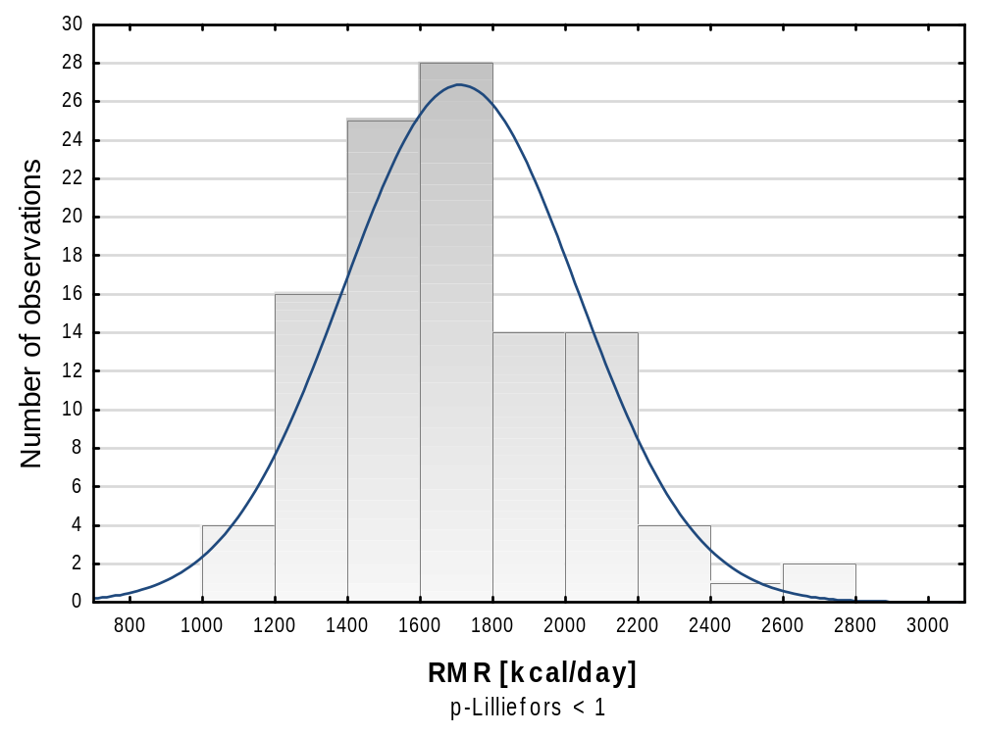

Figure S1 Frequency histograms with the results of Lilliefors test of normal distribution for different RMR estimates (continued)
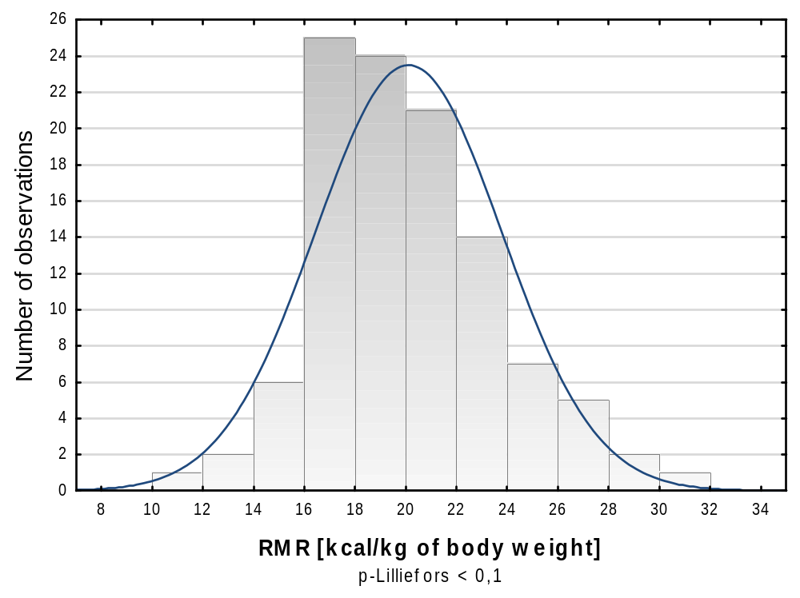

Figure S1 Frequency histograms with the results of Lilliefors test of normal distribution for different RMR estimates (continued)

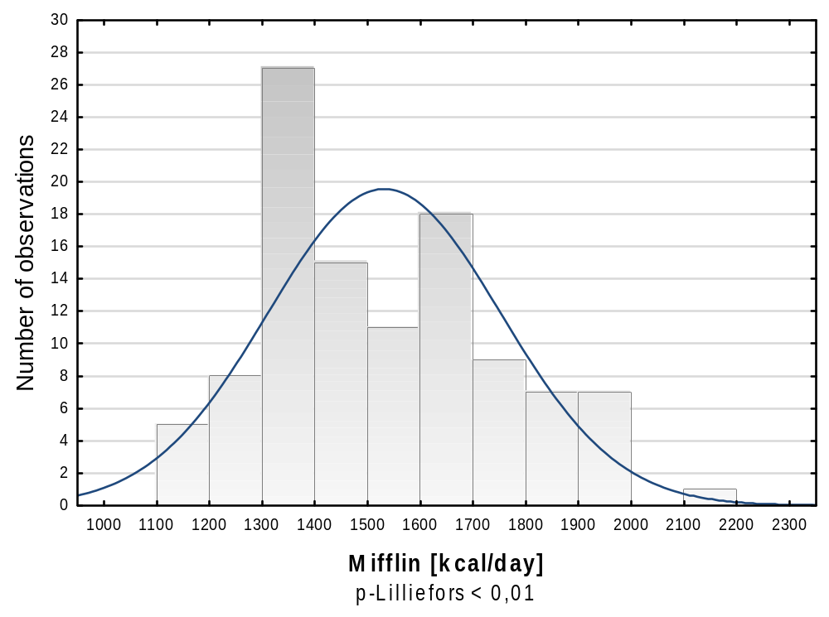

Figure S1 Frequency histograms with the results of Lilliefors test of normal distribution for different RMR estimates (continued)

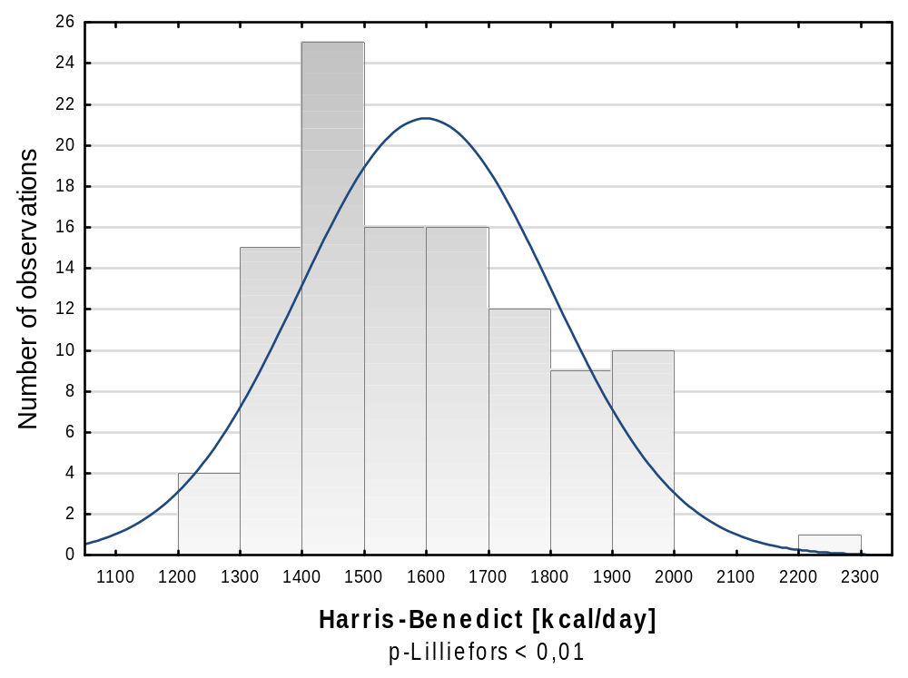

Figure S1 Frequency histograms with the results of Lilliefors test of normal distribution for different RMR estimates (continued)

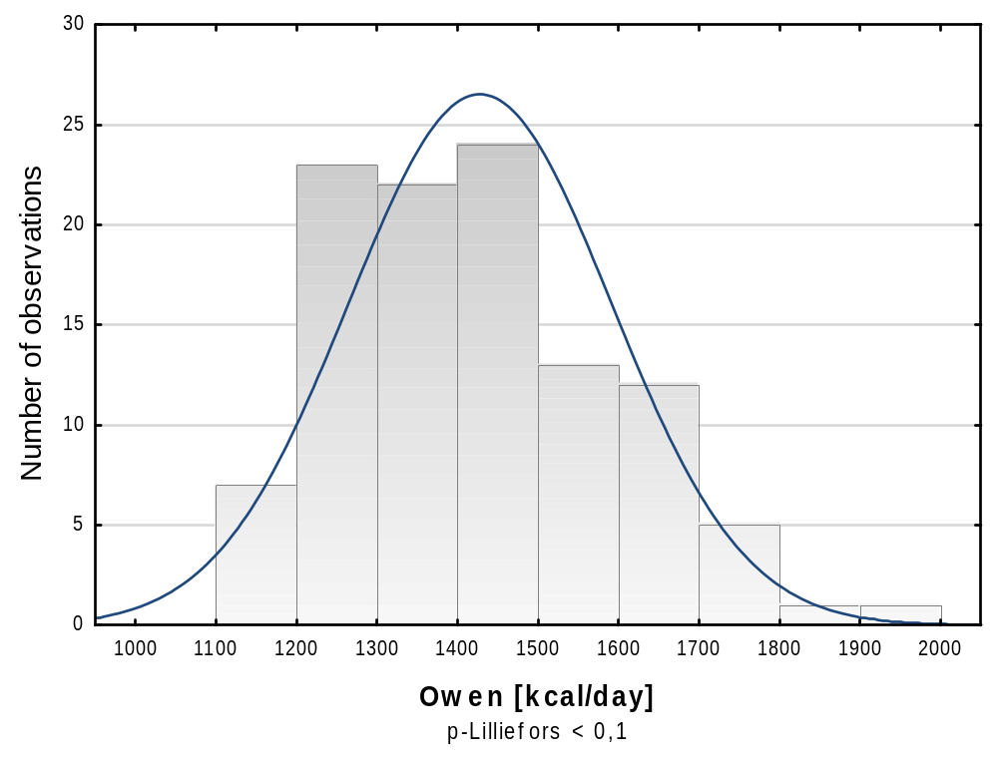

Figure S1 Frequency histograms with the results of Lilliefors test of normal distribution for different RMR estimates (continued)

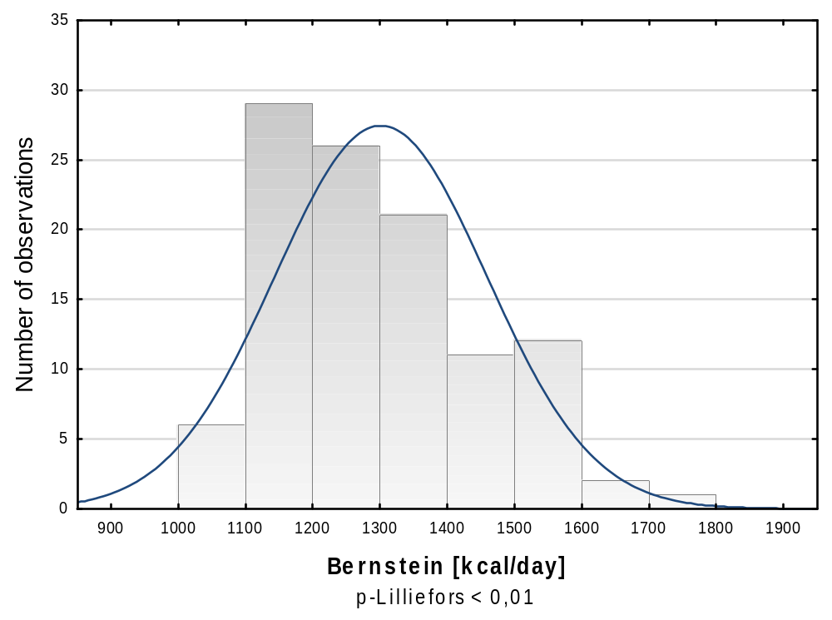

Figure S1 Frequency histograms with the results of Lilliefors test of normal distribution for different RMR estimates (continued)

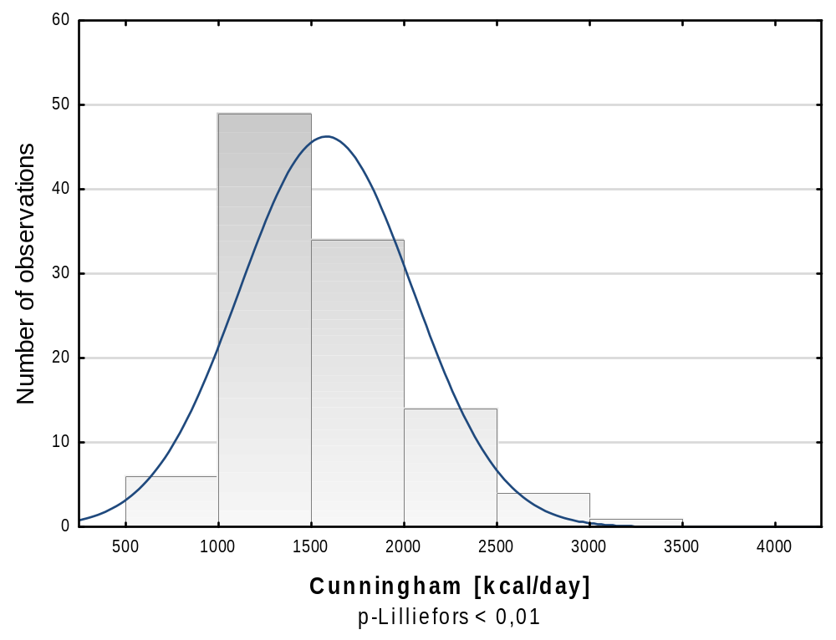

Figure S1 Frequency histograms with the results of Lilliefors test of normal distribution for different RMR estimates (continued)
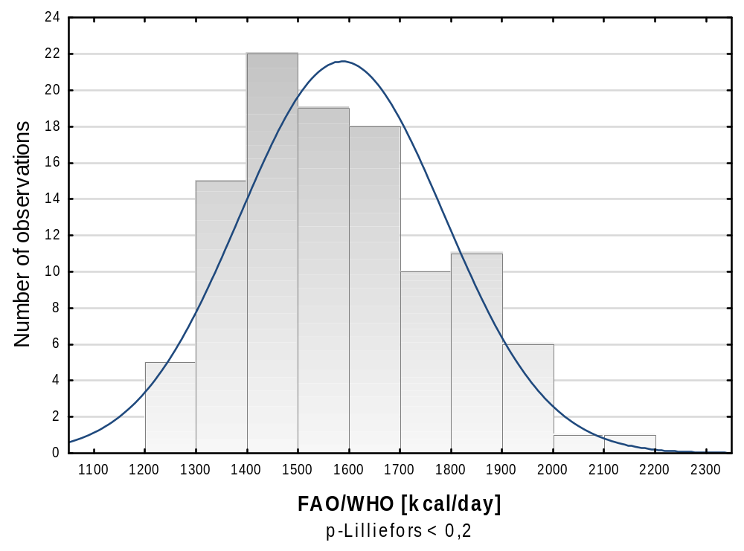

Figure S1 Frequency histograms with the results of Lilliefors test of normal distribution for different RMR estimates (continued)

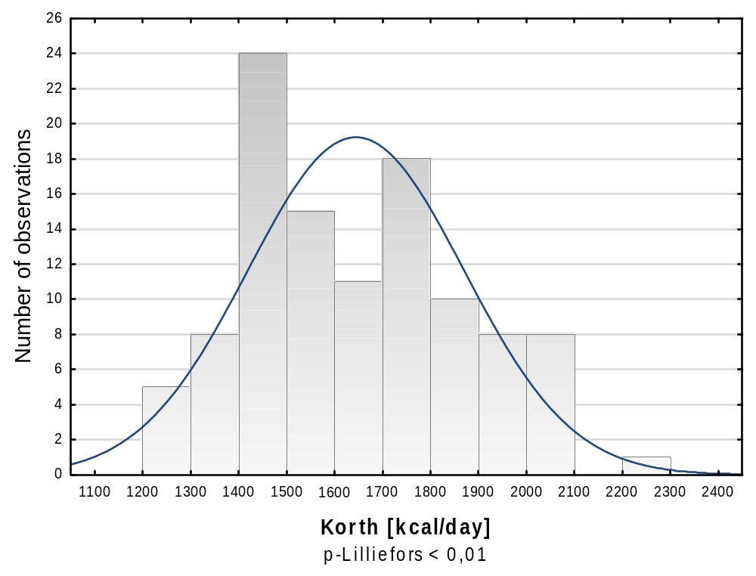

Figure S1 Frequency histograms with the results of Lilliefors test of normal distribution for different RMR estimates (continued)

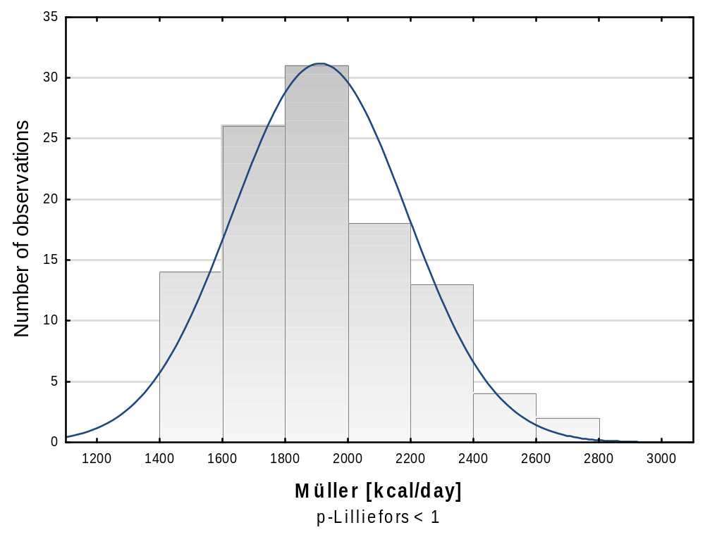

Figure S1 Frequency histograms with the results of Lilliefors test of normal distribution for different RMR estimates (continued)

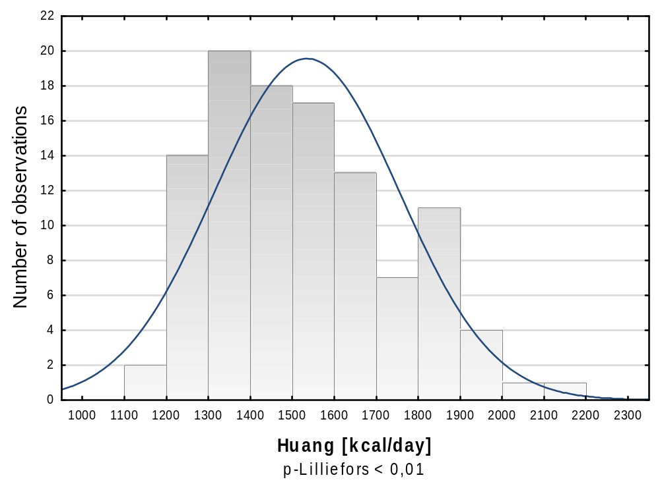

Figure S1 Frequency histograms with the results of Lilliefors test of normal distribution for different RMR estimates (continued)

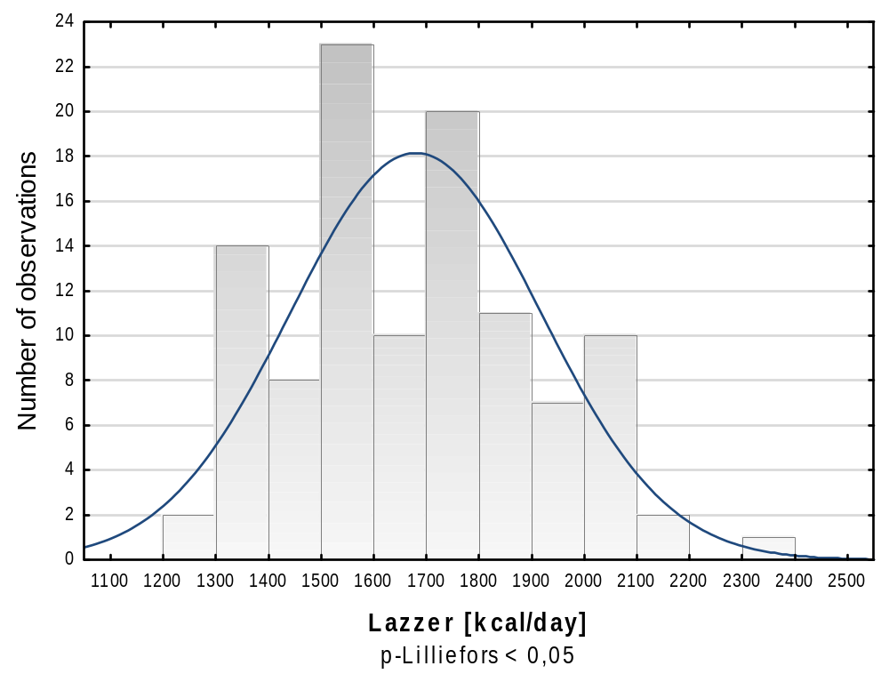

Figure S1 Frequency histograms with the results of Lilliefors test of normal distribution for different RMR estimates (continued)

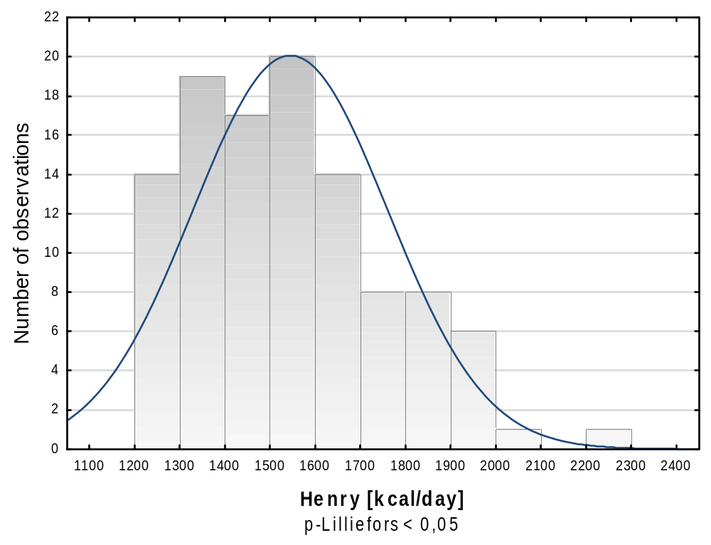

Figure S1 Frequency histograms with the results of Lilliefors test of normal distribution for different RMR estimates (continued)

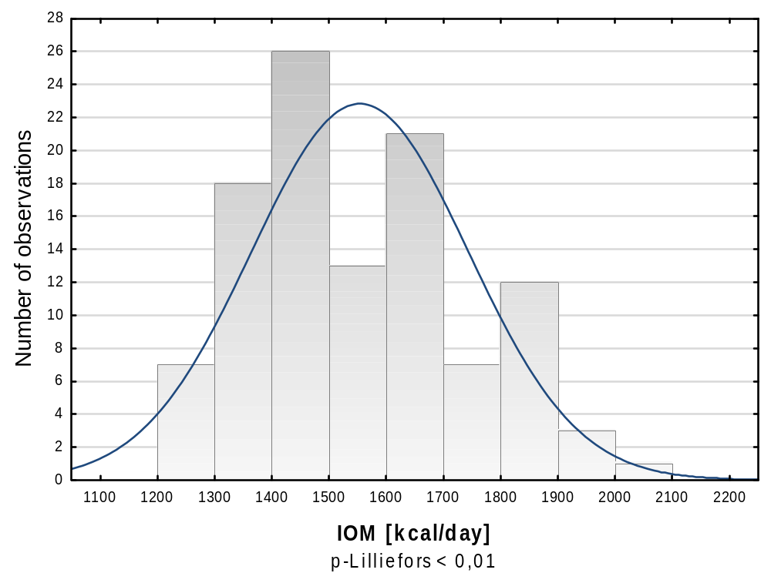

Figure S1 Frequency histograms with the results of Lilliefors test of normal distribution for different RMR estimates (continued)

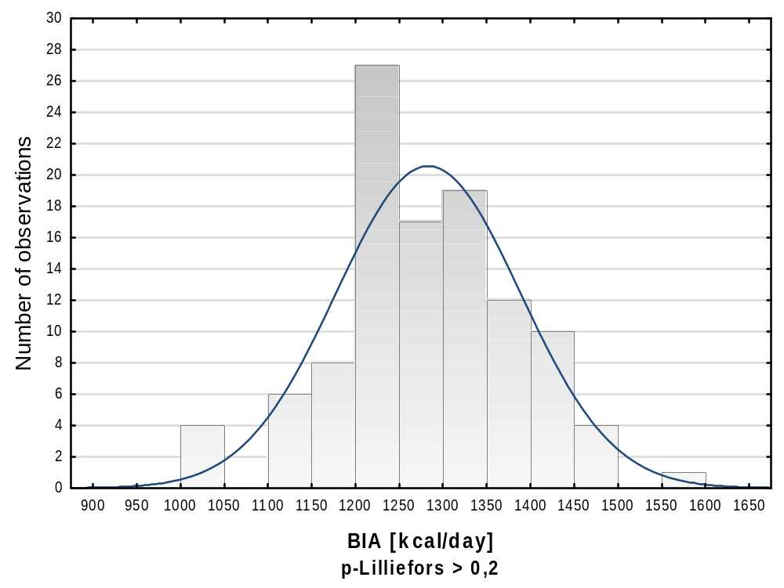

Figure S1 Frequency histograms with the results of Lilliefors test of normal distribution for different RMR estimates (continued)

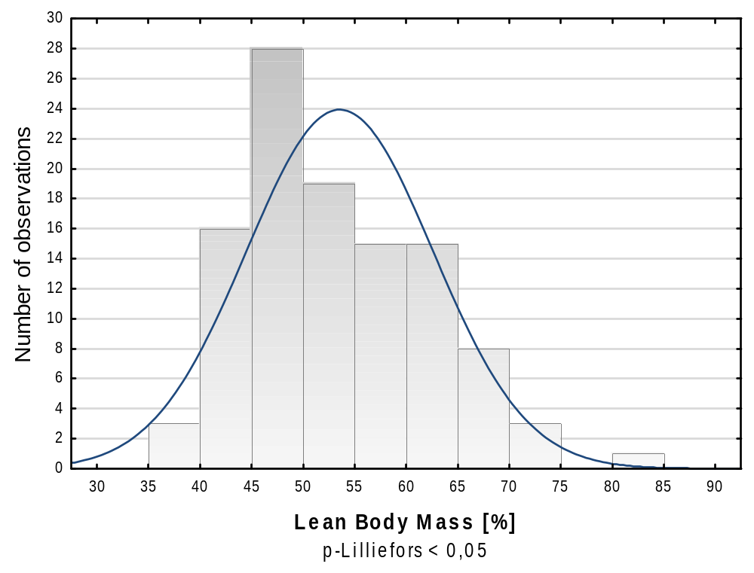

Figure S2 Frequency histograms with the results of Lilliefors test of normal distribution for anthropometric measurements and BMI (continued)

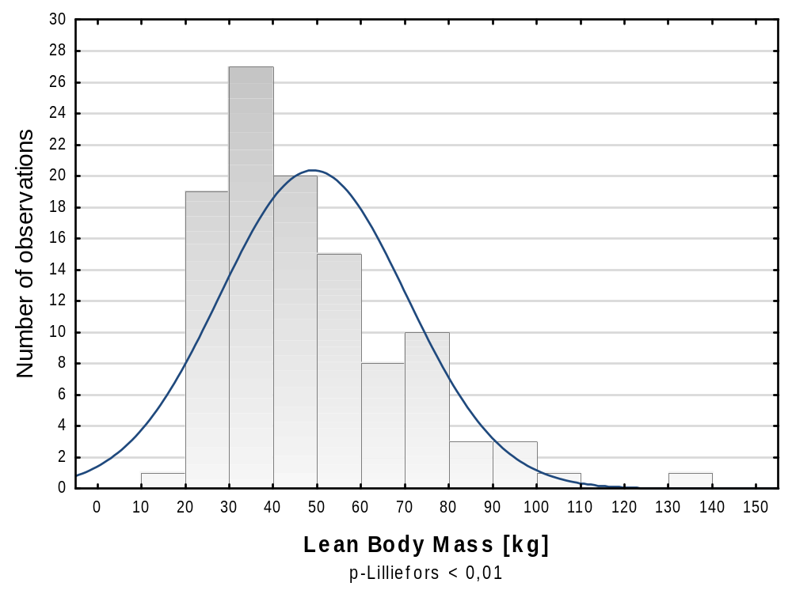

Figure S2 Frequency histograms with the results of Lilliefors test of normal distribution for anthropometric measurements and BMI (continued)

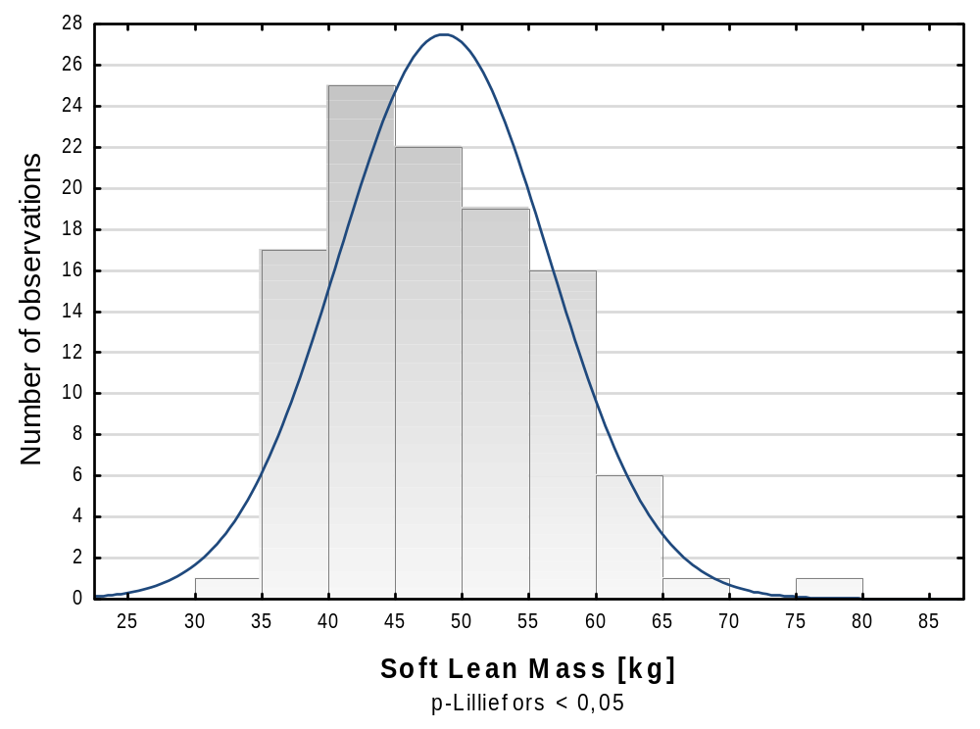

Figure S2 Frequency histograms with the results of Lilliefors test of normal distribution for anthropometric measurements and BMI (continued)

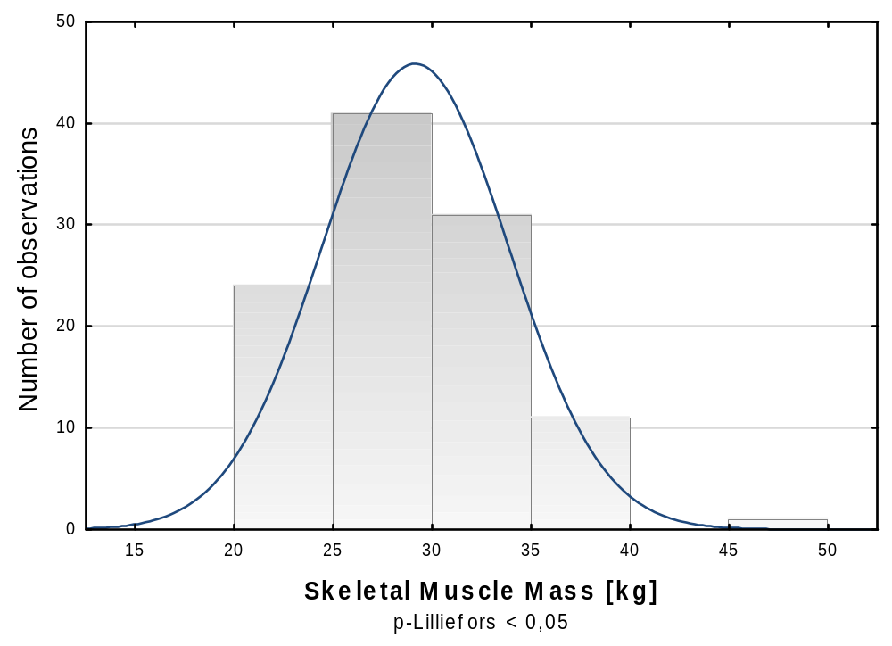

Figure S2 Frequency histograms with the results of Lilliefors test of normal distribution for anthropometric measurements and BMI (continued)

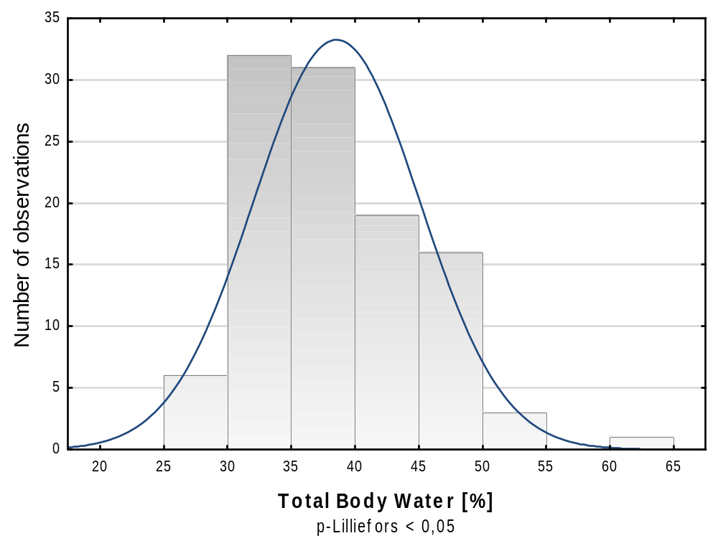

Figure S2 Frequency histograms with the results of Lilliefors test of normal distribution for anthropometric measurements and BMI (continued)

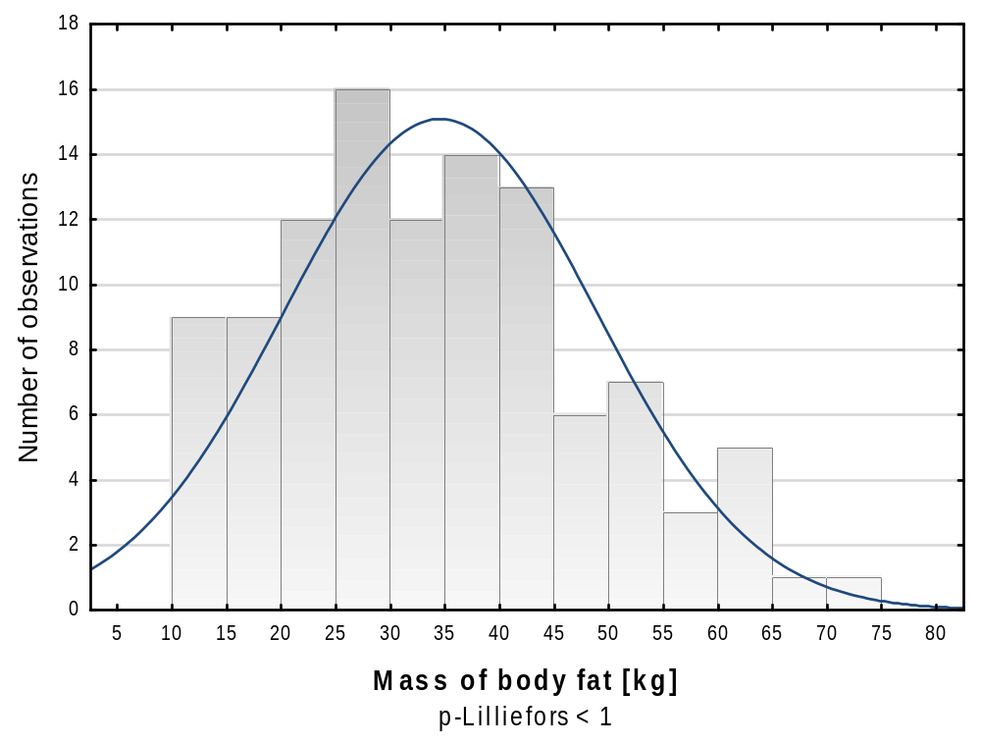

Figure S2 Frequency histograms with the results of Lilliefors test of normal distribution for anthropometric measurements and BMI (continued)

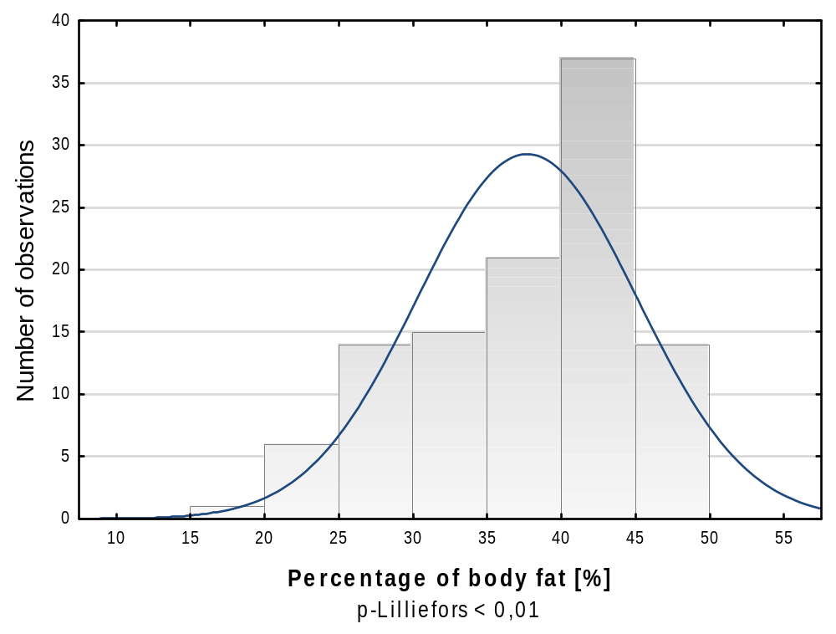

Figure S2 Frequency histograms with the results of Lilliefors test of normal distribution for anthropometric measurements and BMI (continued)

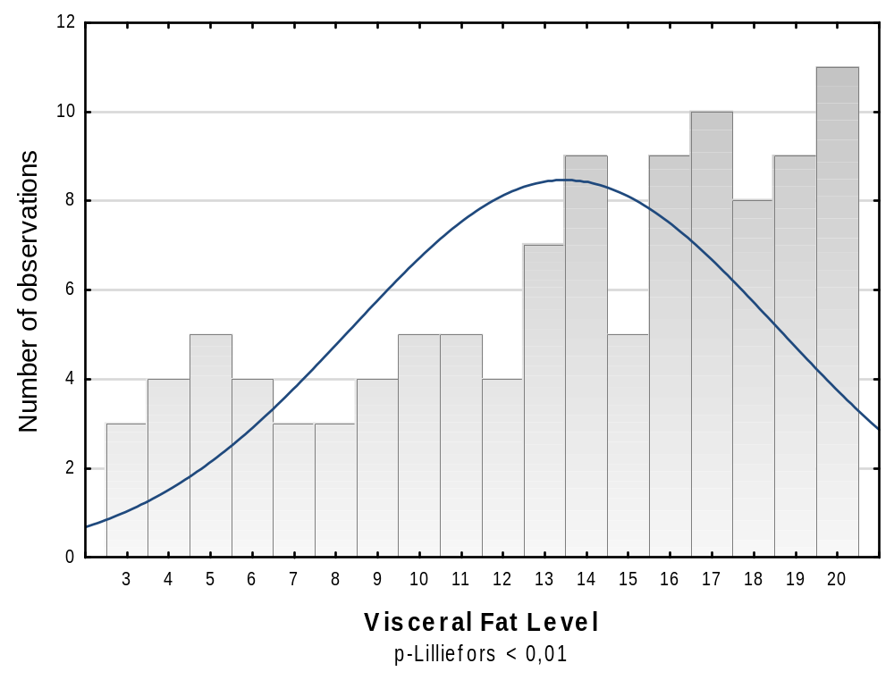

Figure S2 Frequency histograms with the results of Lilliefors test of normal distribution for anthropometric measurements and BMI (continued)

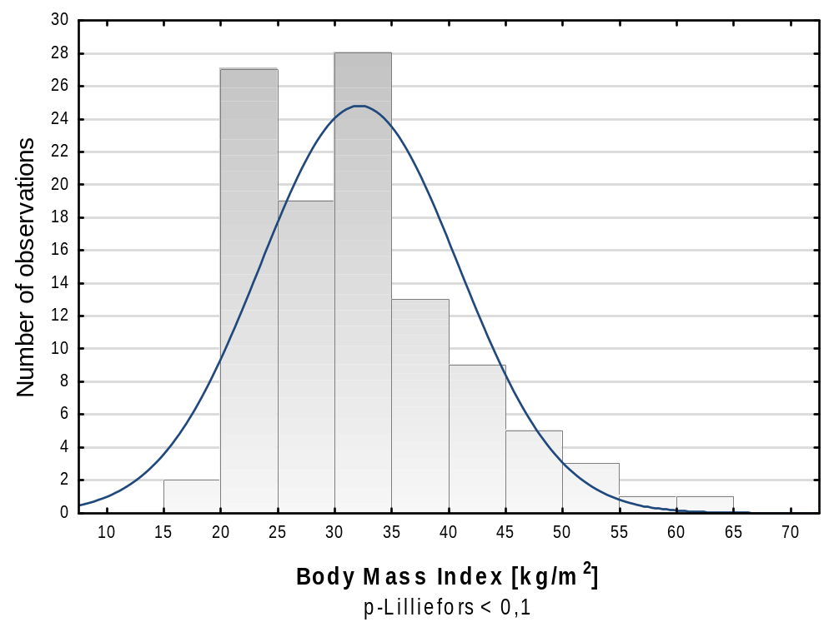

Figure S2 Frequency histograms with the results of Lilliefors test of normal distribution for anthropometric measurements and BMI (continued)

