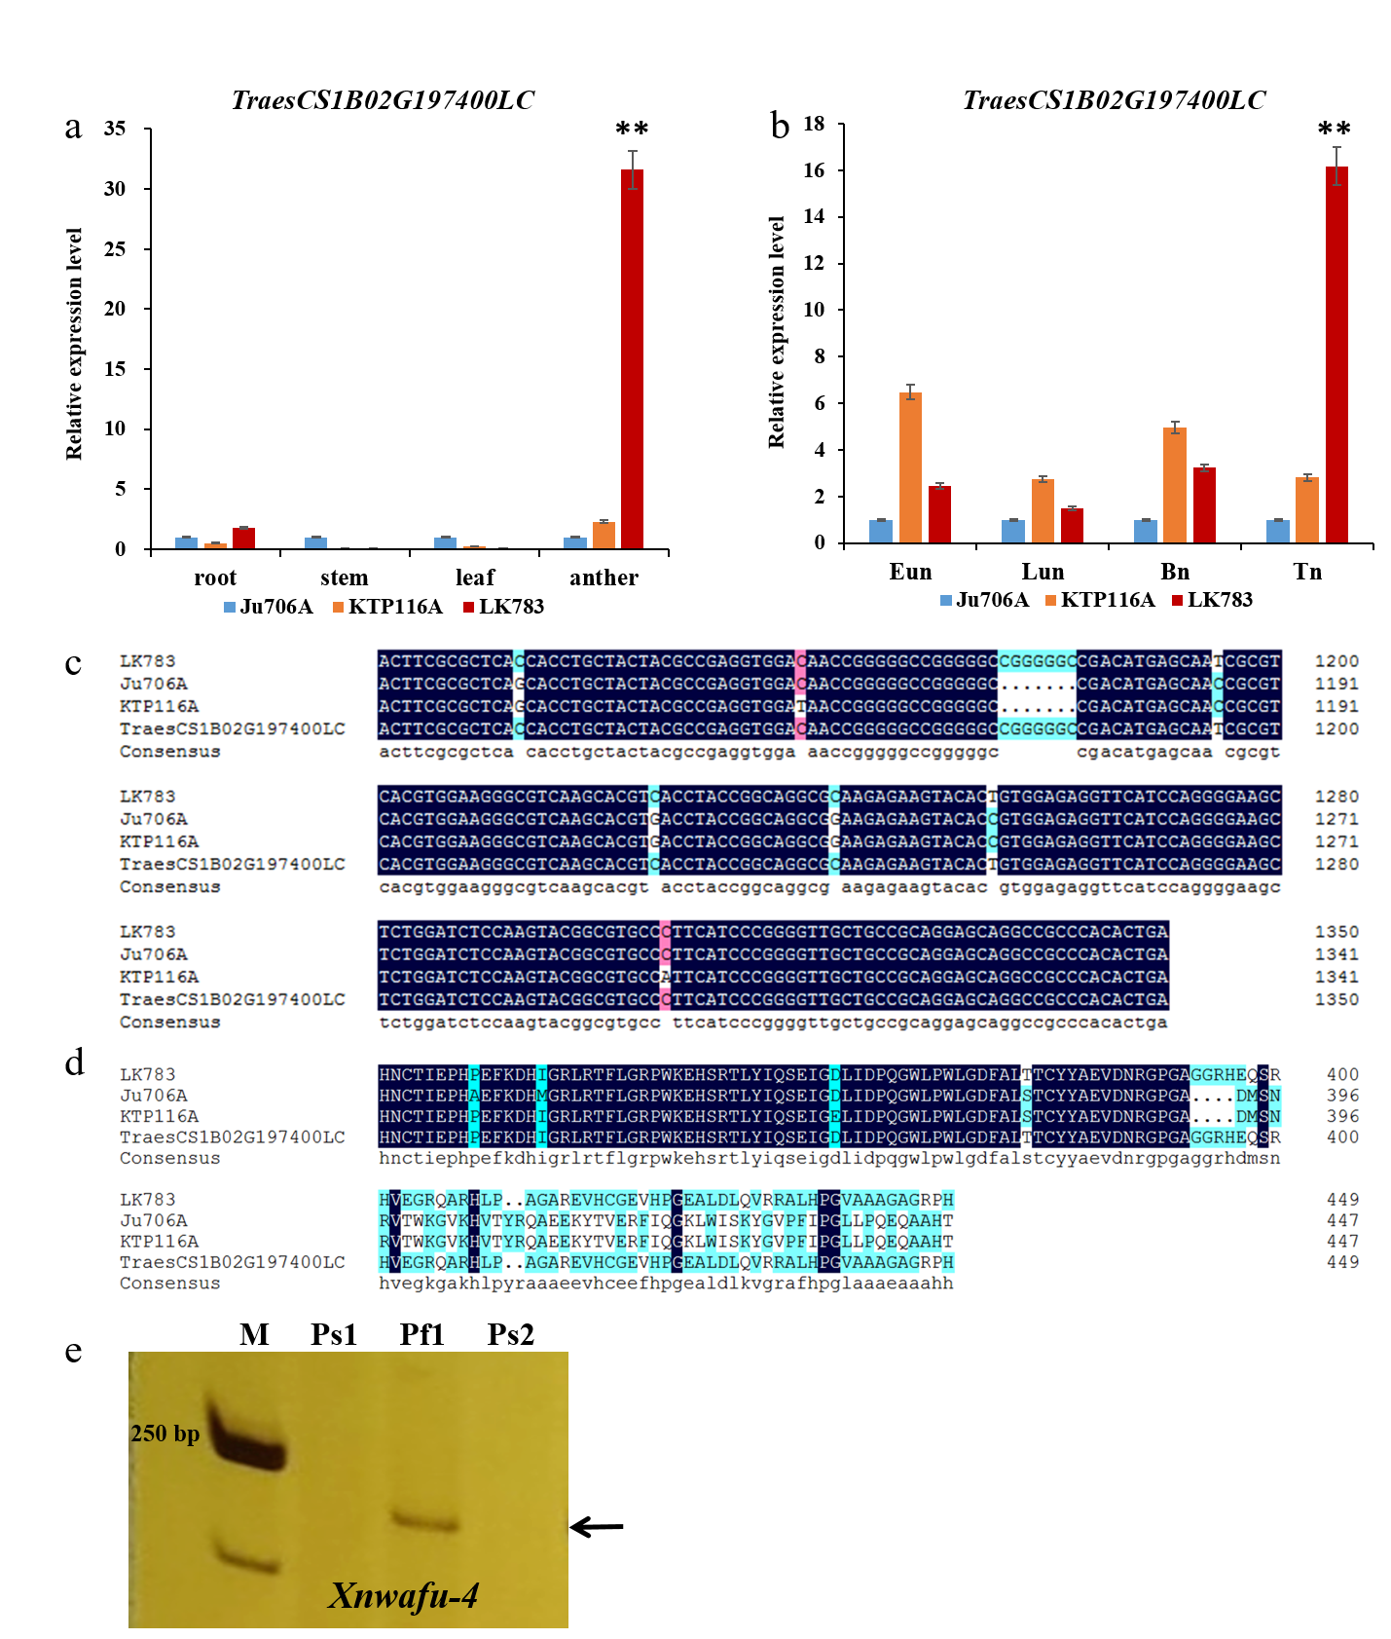Fig. S9 Expression analysis, sequence alignment analysis, PCR identification of Ju706A, KTP116A and LK783. a Expression analysis of TraesCS1B02G197400LC in different tissues; b Expression analysis of TraesCS1B02G197400LC in anthers at different stages; Eun: early uninucleate stage; Lun: late uninucleate stage; Bn: binucleate stage; Tn: trinucleate stage. The ordinate represents 2^{–ΔΔCT} values and the data obtained represent three replicates. Bars represent standard deviation and asterisks indicate significantly different data by T‐test, * P<0.05, ** P<0.01. c Nucleotide sequence alignment analysis of LK783, Ju706A, KTP116A and the reference genome sequence (IWGSC_v1.1_LC_gene). Nucleotide sequence alignment showed that both KTP116A and Ju706A had a 7 bp deletion; d Amino acid sequence alignment of Ju706A, KTP116A, LK783and the reference genome sequence (IWGSC_v1.1_LC_gene). Both KTP116A and Ju706A had frameshift mutation at the 393th amino acid caused by a 7-bp deletion; e PCR and polyacrylamide gel electrophoresis analysis results for Ju706A, KTP116A and LK783 using Xnwafu-4, which can also distinguish between LK783 and Ju706A; M, DNA marker 2000; Ps1, Ju706A; Ps2, KTP116A; Pf1, LK783; The black arrow indicates the target band.

