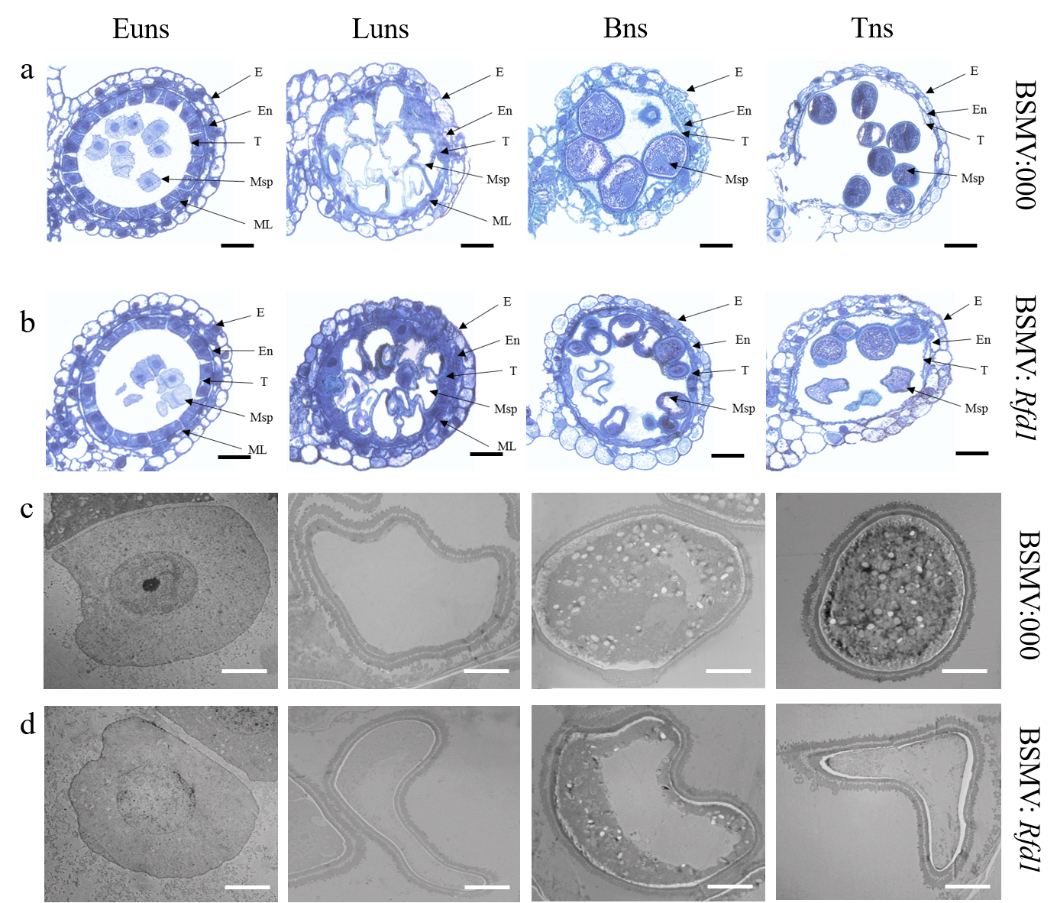
Fig. S6 Semi-thin section observation of anthers and TEM observation of microspores. a, b Semi-thin section observation of anthers; c, d TEM observation of microspores. E, En, ML, T, Msp represent Epidermis, Endothecium, Middle layer, Tapetum layer and Microspores, respectively; Scale bars = 50 µm (a, b); 3 µm (c, d).

