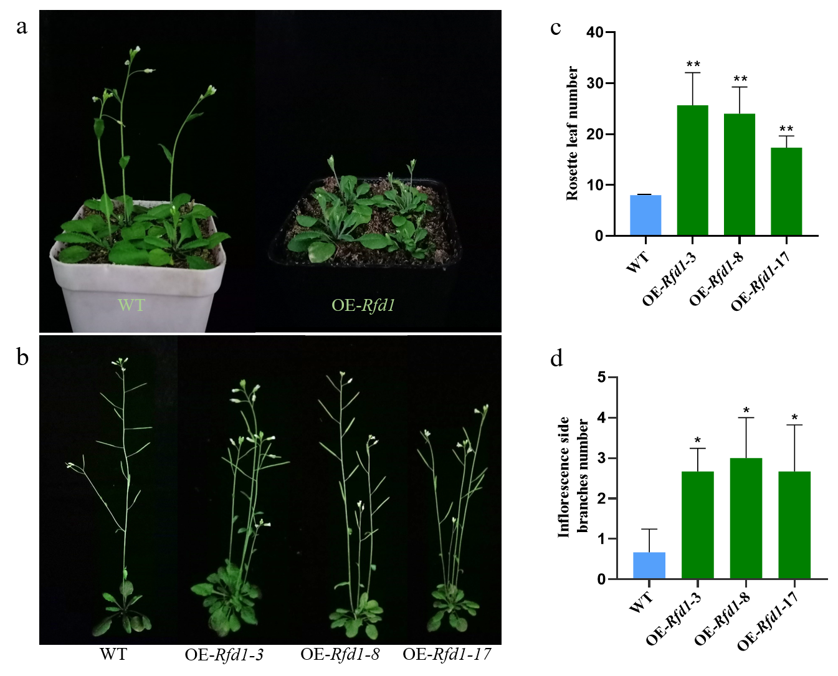Fig. S7 Phenotypic observation in wild type and transformants. a Observation on mosses, flowering and rosette leaves of Arabidopsis thaliana; b Observation on inflorescence side branches in wild type and overexpressed lines; c Rosette number statistics in wild type and overexpressed lines; d Inflorescence side branches number statistics in wild type and overexpressed lines. The data obtained represent three replicates and bars represent standard deviation. Asterisks indicate significantly different data by T‐test, * P<0.05, ** P<0.01.

