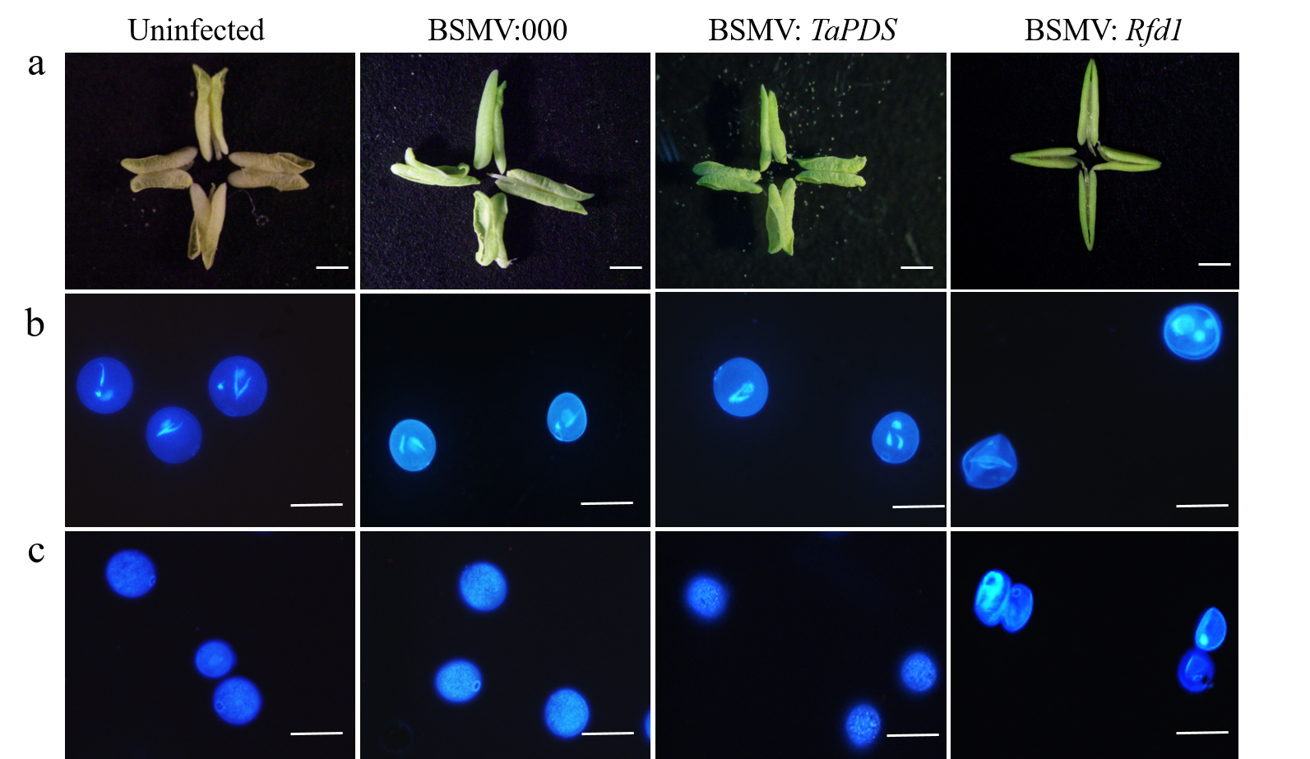
Fig. S4 Morphological observation of BSMV: Rfd1 plants. a Phenotypic observation of anther; b DAPI staining of pollen grains at the trinucleate stage; c Aniline blue staining of pollen grains at the trinucleate stage. Scale bars = 500µm (a); 100 µm (b, c).

