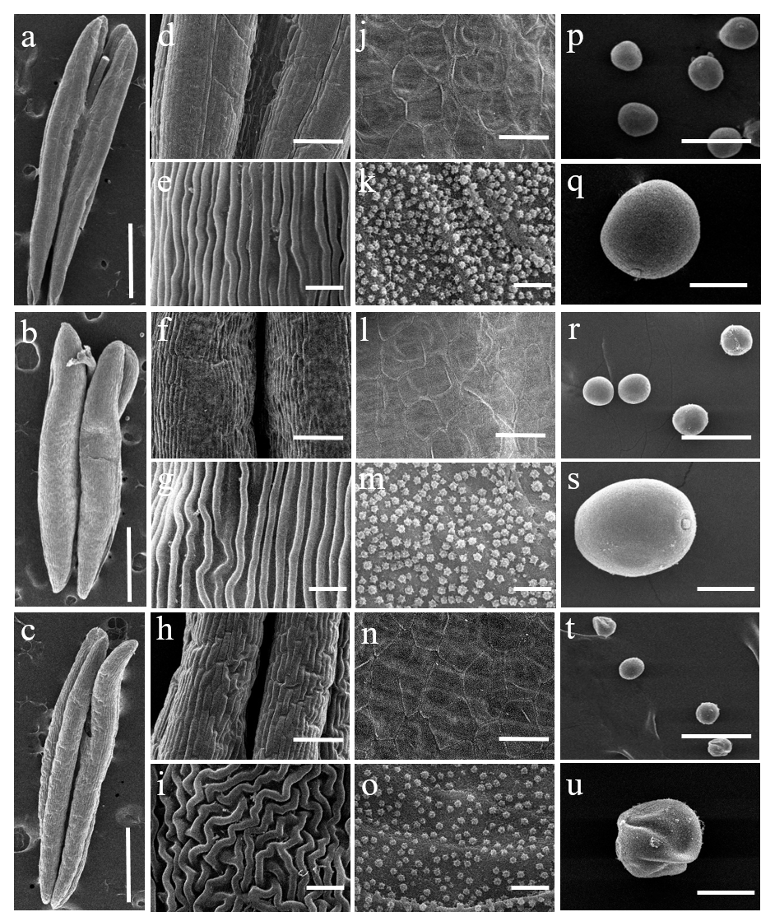Fig. S5 Scanning electron microscope observation of anthers in control plants (uninfected and BSMV: 000) and BSMV: Rfd1 plants. a, d, e, j, k, p, q Uninfected plant; b, f, g, l, m, r, s BSMV:000 plant; c, h, i, n, o, t, u BSMV: Rfd1 plant. a, b, c SEM observation of anther; d, e, f, g, h, i SEM observation of outer epidermis; j, k, l, m, n, o SEM observation of inner epidermis; p, q, r, s, t, u SEM observation of microspores. Scale bars = 1mm (a, b, c); 100 µm (d, f, h); 50 µm (j, l, n, p, r, t); 10 µm (e, g, i, k, m, o, q, s, u).

