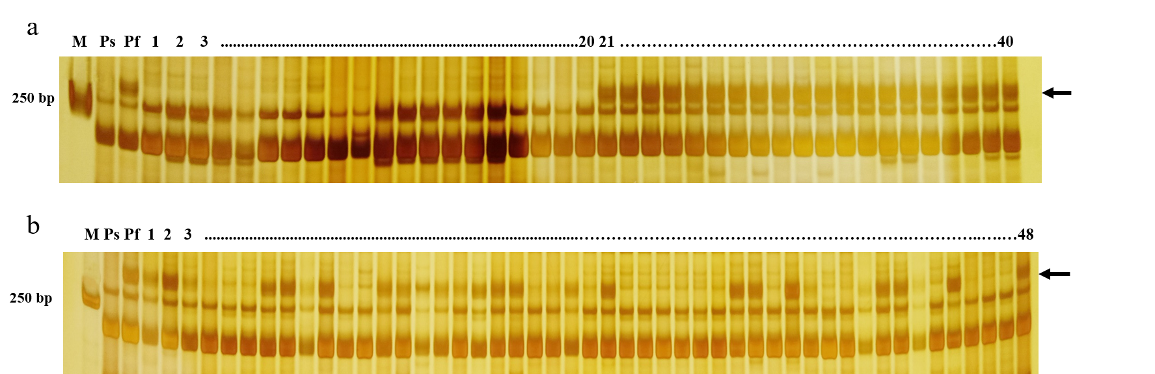Fig. S8 Identification of Xnwafu1 in different materials. a Identification of Xnwafu1 in maintainer and restorer lines. The Xnwafu1 can identify 40 maintainer lines (97.6%) and 190 restorer lines (93.4%); 1-20: sterile individuals; 21-40: fertile individuals; b Identification of Xnwafu1 in 293 materials from different regions of China. The Xnwafu1 can identify70.3% materials from different regions of China; 1-48: Individual plants from 293 materials. M, DNA marker 2000; Ps, Ju706A; Pf, LK783; The black arrow indicates the target band.

