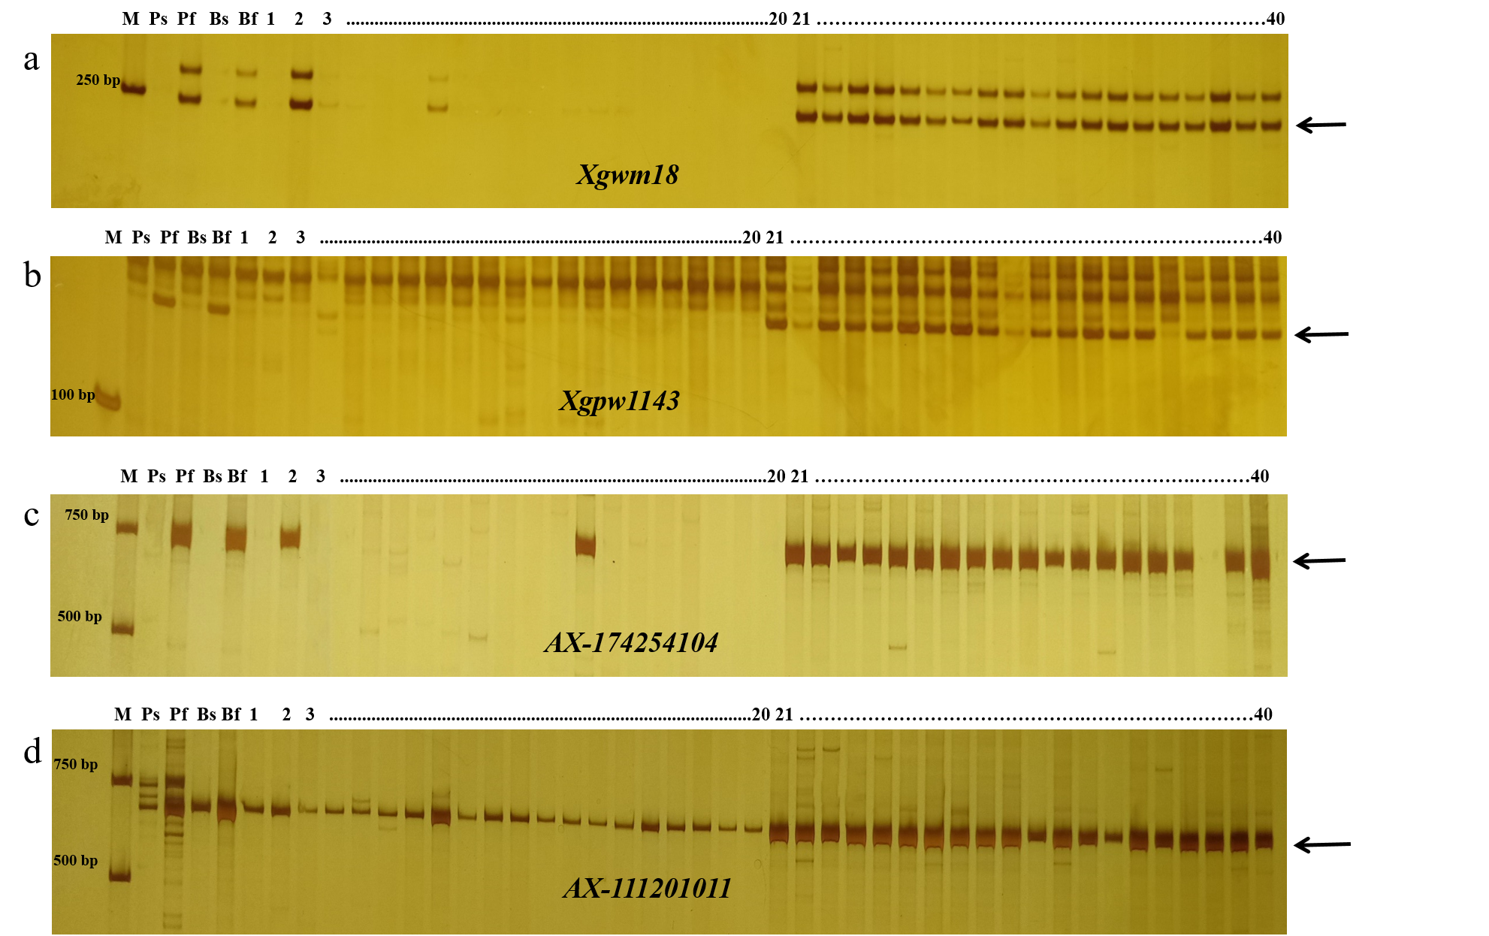Fig. S1 SSR and SNP analysis of individuals in BC₁F₁ with markers Xgwm18, Xgpw1143, AX-174254104 and AX-111201011. a SSR analysis of individuals in BC₁F₁ with marker Xgwm18; b SSR analysis of individuals in BC₁F₁ with marker Xgpw1143; c SNP analysis of individuals in BC₁F₁ with marker AX-174254104; d SNP analysis of individuals in BC₁F₁ with marker AX-111201011. M, DNA marker 2000; Ps, Ju706A; Pf, LK783; Bs, mixed pool of 20 sterile individuals with seed setting rate of 0%; Bf, mixed pool of 20 fertile individuals with seed setting rate higher than 85%. (1-20) denotes sterile individuals in BC₁F₁, (21-40) denotes fertile individuals in BC₁F₁. The black arrow indicates the target band.

