Sample | Species of Candida sp. | Oral Cavity Swab | Colony Characteristics
Elephant 1 (Ella) | C. albicans | + | Green
 | C. tropicalis | + | Bright purple surrounded with pale white, or dull blue diffused into purple edges.
 | Other species of Candida | - | Pale yellow, white
Elephant 2 (Sienna) | C. albicans | + | Green
 | C. tropicalis | + | Bright purple surrounded with pale white, or dull blue diffused into purple edges.
 | C. Parapsilosis | + | Light brown to yellow
 | Other species of Candida | + | Pale yellow, white
Elephant 3 (Mega) | C. albicans | + | Green
 | C. tropicalis | + | Bright purple surrounded with pale white, or dull blue diffused into purple edges.
 | C. glabrata | + | Light to dark brown
Elephant 4 (Septi) | C. albicans | + | Green
 | C. tropicalis | + | Bright purple surrounded with pale white, or dull blue diffused into purple edges
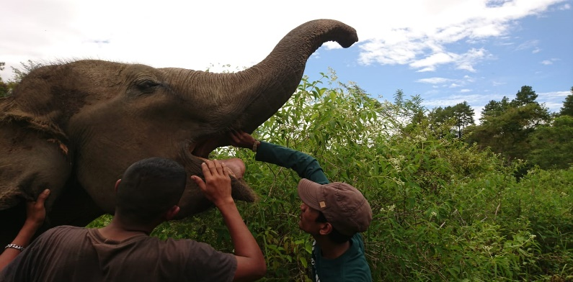
Figure 1. Profile of Sumatran elephant

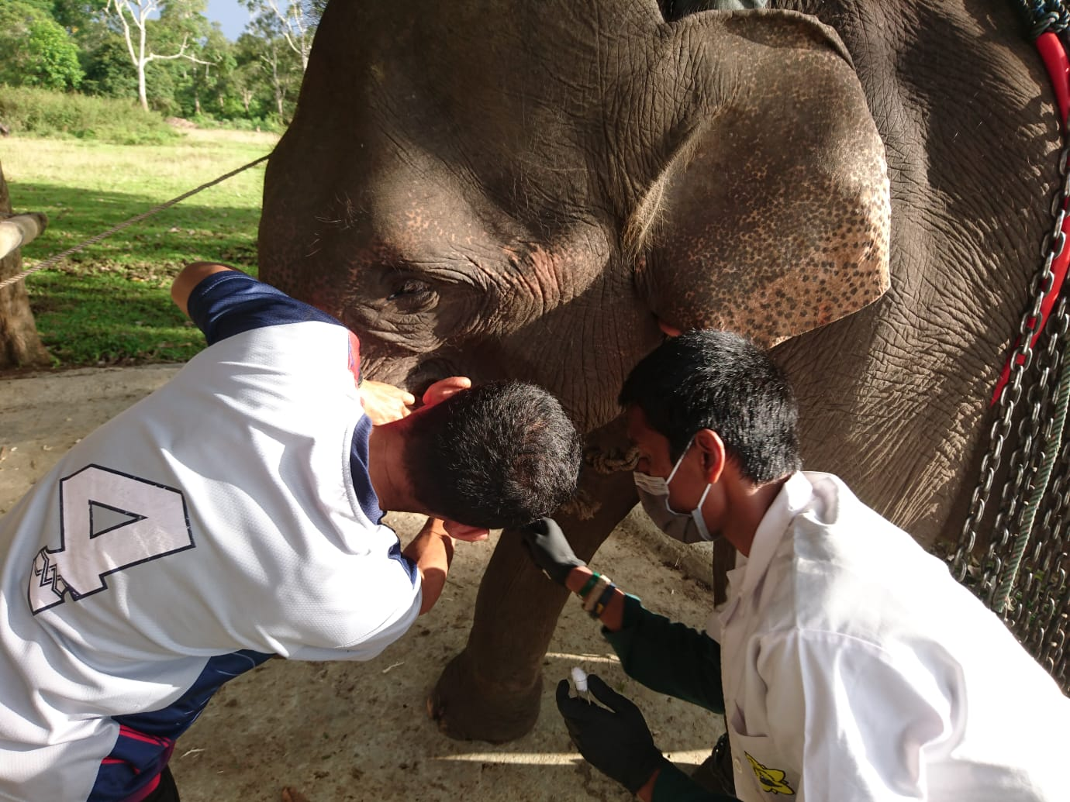
Figure 2. Process of sample collection in Sumatran elephant (Mega)

Table 1. Growth and colony characteristics of Candida sp. taken from Sumatran Elephants oral cavity

