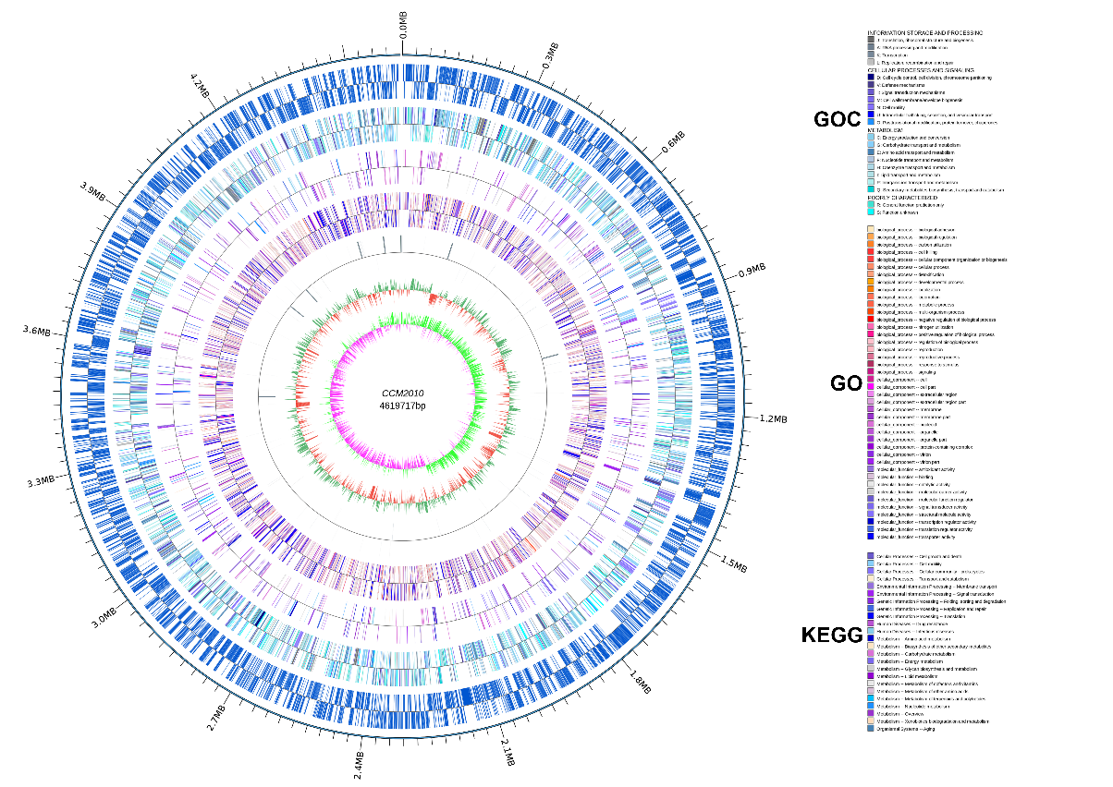
Figure S1 Circular map for the whole genome of E. hormaechei F2

