Synthesis of rice derived high surface area zinc oxide supported copper catalysts and its catalytic activity studies on cyclohexanol dehydrogenation
Kumara Swamy Koppadi^{a,}*, Nagaraju Nekkalaª,Ponnala Bhanuchanderª, SK Hussainª, Perupogu Vijayanandª ,Putrakumar Balla^{a,b,}*
Supplementary Information
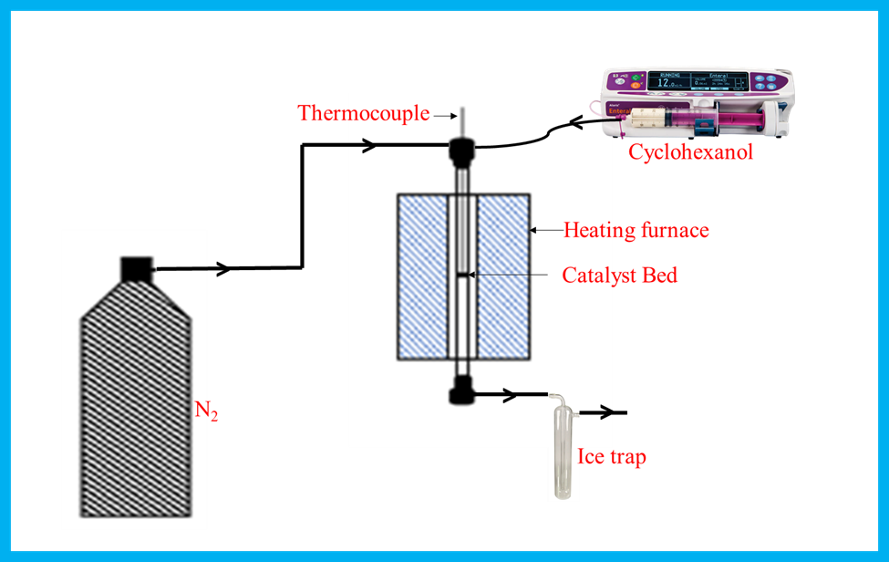
Figure S.1: Schematic diagram for vapour phase cyclohexanol dehydrogenation reaction.
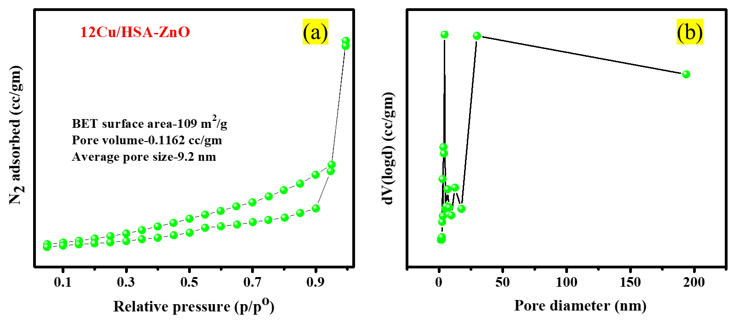
Figure S.2: (a) N₂ adsorption-desorption isotherm and (b) Pore size distribution curves of 12Cu/HSA-ZnO catalysts

Synthesis of 12Cu/ LSA-ZnO:
LSA-ZnO support was prepared by precipitation method. In a typical synthesis, required amount of Zinc nitrate trihydrate was dissolved in distilled water in 500 ml beaker. The aqueous solution of potassium carbonate added to the above solution drop by drop at constant P^{H}-9. After completion of precipitation process, the resultant precipitate mixture thoroughly washed with distilled water. The resultant obtained white solid was dried in a oven at 373 K for 12h. Later, this white colored solid was calcined at 723 K for 5 h. By using this support, 12Cu/LSA-ZnO catalyst was synthesized by impregnation method. In this typical synthesis, the required amount of Cu (NO₃₎₂ 3H₂O (Sigma-Aldrich, USA, 99.9%) were dissolved in 100 ml beaker. To this resultant solution, add the LSA-ZnO support. The resultant mixture was dried slowly on hot plate at 353 K up to completely removal of water. The dried solid was kept in a oven for 12 h at 373 K then the resultant solid was calcined at 623 K for 8 h under air flow.
Figure S.3: XRD pattern of calcined LSA-ZnO and 12Cu/LSA-ZnO catalysts
The XRD pattern of LSA-ZnO and calcined Cu/LSA-ZnO catalysts were shown in Fig.2., herein, the peaks at 2θ values 31.67º, 34.31º, 36.14º, 47.40º, 56.52º, 62.73º, 66.28º, 67.91º and 69.03º are corresponded to (100), (002), (101), (102), (110), (103), (200), (112) and (201) of ZnO, which indicating that the samples were polycrystalline wurzite structure (Zincite, JCPDS 5-0064) [A]. The rest of the well-resolved peaks were assigned to the CuO. Some of the ZnO intensity peaks are merged with the intensity of CuO peaks.
Table. S1: The BET and activity results of 12Cu/LSA-ZnO
Catalyst | Surface areaª  (m²/gm) | Conversion^{b}  (%) | Selectivity^{b}  (%)
LSA-ZnO | 46.4 | - | -
12Cu/LSA-ZnO | 29.7 | 28 | 91
12Cu/HSA-ZnO | 109 | 75 | 89
- From BET results
- Cyclohexanol dehydrogenation reaction results,
Reaction Conditions: Dehydrogenation Cyhol to Cyhon over 12Cu/LSA-ZnO catalyst; Reaction conditions: catalyst weight 0.5 g, Reaction temperature:513 K, N₂ flow: 25 mL min⁻¹, Liquid feed flow: 1 mL h⁻¹
From Table S1, It can be seen that 12Cu/LSA-ZnO catalyst showed 28% conversion of Cyhol and 91% selectivity to Cyhon at optimum reaction conditions. These results indicate that 12Cu/HSA-ZnO showed better activity than 12Cu/LSA-ZnO. It might be to the high specific surface area of 12Cu/HSA-ZnO.
Figure S.4: TPR profile of calcined 12Cu/LSA-ZnO catalyst
References:
[A] Sancheti S V., Yadav GD (2021) CuO-ZnO-MgO as sustainable and selective catalyst towards synthesis of cyclohexanone by dehydrogenation of cyclohexanol over monovalent copper. Mol Catal 506:111534. https://doi.org/10.1016/j.mcat.2021.111534

