In the supplement document we provided the title page and the information of supplementary as below
1.Title with author detail and institutions
Flavor Disorder Is Associated with Obstructive Sleep Apnea: A Nationwide Population-Based Cohort Study
* Hsin-Hsin Huang¹, *Yao-Min Hung^{2,3,4}, #Chien Han Tsao^{5,7}, #Yin-Tsan Hung ¹¹, #James Cheng-Chung Wei^{5,6,7,8}, Wei-Sheng Wen⁵, Yu-Hsun Wang⁹, Kuo-Shu Huang¹⁰
¹ Institute of Medicine, Chung Shan Medical University, Taichung, Taiwan;²Department of Emergency Medicine, Kaohsiung Veterans General Hospital, Kaohsiung, Taiwan; ³School of Medicine, National Yang Ming University, Taipei, Taiwan; ⁴Yuhing Junior College of Health Care and Management, Kaohsiung, Taiwan;⁵ Department of Otolaryngology, Chung Shan Medical University Hospital, Taichung, Taiwan;
⁶Division of Allergy, Immunology and Rheumatology, Chung Shan Medical University Hospital;⁷ School of Medicine, Chung Shan Medical University, Taichung, Taiwan;⁸Graduate Institute of Integrated Medicine, China Medical University, Taiwan;⁹ Department of Medical Research, Chung Shan Medical University Hospital, Taichung, Taiwan;¹⁰Department of Applied Foreign Languages, Chung Shan Medical University, Taichung, Taiwan;¹¹Department of Otolaryngology, Hung Yin Tsan BenQ Medical Center, The Affiliated BenQ Hospital of Nanjing Medical University, Nanjing, Jiangsu Province, China.
Correspondence to: Dr. Chien Han Tsao, No. 110, Sec. 1, Jianguo N. Rd., South District, Taichung City 40201, Taiwan. E-mail: Q1203738@gmail.com
Phone: +886-4-24739595 ext. 34718 FAX: +886-4-24734323
*Hsin-Hsin Huang¹ and, *Yao-Min Hung^{2,3,4} contributed equally to this work.
#Chien Han Tsao^{5,7} was corresponding authors
#Chien Han Tsao^{5,7}, #James Cheng-Chung wei^{5,6,7,8}, and #Hung Yin Tsan¹¹ contributed equally to this work.
Subtitle: OSA with risk of flavor disorder

2.Supplement figure 1. study design
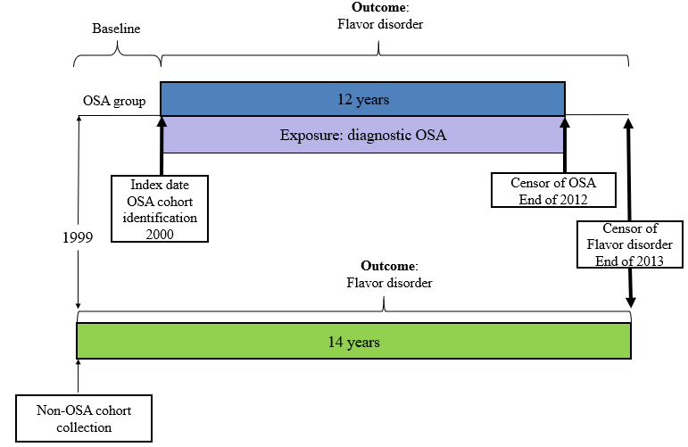
Patient with first diagnosed of OSA were identified since 1999 and the data must be clear for checking. Patient with first diagnosis of flavor disorder (FD) (ICD-9CM codes 781.1) before index date were excluded. The baseline period was set as 1 January1999 to 31 December 1999 and the OSA cohort were started. Only patients with ≧3 outpatient visits (including the index visit) or at least 1 inpatient admission after 1 January 2000 were included in the OSA group. The outcome was time to first flavor disorder occurring. Censoring of OSA cohort occurred at the end of 2012(31 December 2012).Censor of flavor disorder following were set on 31 December 2013 of both groups.

