Supplement figure 1. study design
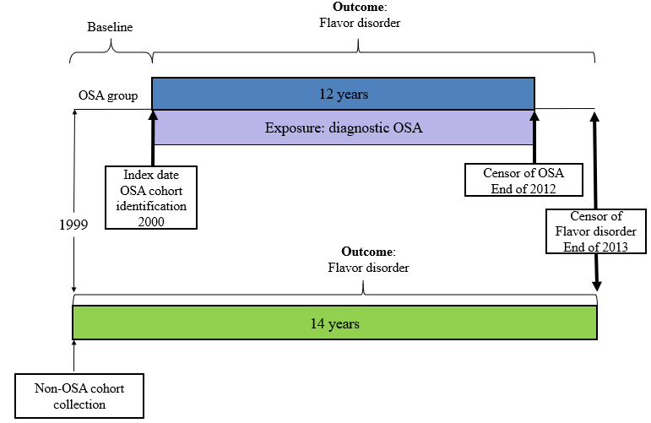
Patient with first diagnosed of OSA were identified since 1999 and the data must be clear for checking. Patient with first diagnosis of flavor disorder (FD) (ICD-9CM codes 781.1) before index date were excluded. The baseline period was set as 1 January1999 to 31 December 1999 and the OSA cohort were started. Only patients with ≧3 outpatient visits (including the index visit) or at least 1 inpatient admission after 1 January 2000 were included in the OSA group. The outcome was time to first flavor disorder occurring. Censoring of OSA cohort occurred at the end of 2012(31 December 2012).Censor of flavor disorder following were set on 31 December 2013 of both groups.

