Screen-Printed Biocompatible Ultrasensitive Electrochemical Sensor for Real-Time Detection of Reactive Oxygen Species in Sweat
Rui Liao,ª Xiaosong Du, ^{a,} Zhiqiang Zhai,ª Yang Wang,ª Jun Li, ^{b} Heng Zheng, ^{c} Yin Long^{a,*} and Yadong Jiangª
a. State Key Laboratory of Electronic Thin Films and Integrated Devices, University of Electronic Science and Technology of China, Chengdu, 610054, China
b. Department of Materials Science and Engineering, University of Wisconsin-Madison, Madison, Wisconsin 53706, United States
c. Sichuan Academy of Medical Sciences & Sichuan Provincial People's Hospital, Chengdu, 610072, China

Supporting Information
Experimental Section
Fabrication of CeO_{2-x}-CNTs modified electrodes
Glassy Carbon Electrodes (GCE) was polished successively by using 0.05$μm$Alumina powder on a polishing cloth and then cleaned in Deionized water. For the fabrication of CeO_{2-x}-CNTs / GCE, 5 mg CeO_{2-x}-CNTs were added to 0.5 mL Nafion solution, consisting of Deionized water (70 %), Absolute ethanol (26 %) and 5 %wt Nafion (4 %) PFSA polymer dispersions D520 procured from DUPONT, for sonicate 2 h. Using the micropipette to draw 5 uL CeO_{2-x}-CNTs / Nafion mixed solution and dropping coast on the GCE, which behaves 3 mm diameter, followed by drying at 60 °C for 20 min.
Preparation of CeO_{2-x}-CNTs paste
Acrylic resin procured from Saisi was fully dissolved into N-Methylpyrrolidone (NMP) at 120℃ for 4 h, which weight ratio is 3:7. 500mg CeO_{2-x}-CNTs and 100mg dispersant for carbon nanotubes NMP solutions were added into above NMP and Acrylic resin mixed solution for stirring 12 h to obtain the CeO_{2-x}-CNTs screen-printed paste.
Selectivity, stability and flexibility of the IFRS device
The IFRS was used to sensing the H₂O₂ in the presence of variety of biological interferences such as ascorbic acid (AA), dopamine (DA), glucose (GLU) and ethanol absolute (Et-OH) with 0.2 mM concentration for 60 s of each analyte. The repeatability was studied by 0.2 and 1 mM H₂O₂ at -0.7 V and testing i-t curve for continuous 7 days. Flexibility of the IFRS was tested by dynamic mechanical analyzer RSA III using a 3-point bending method.

Supporting Information
Figures
Figure S1. SEM images of 0.5, 1 and 1.5CeO_{2-x}-CNTs.

Figure S2. EDS results of the 1.5CeO_{2-x}-CNTs. (a) SEM of the scanned area. (b) EDS element mapping of (a). (c) EDS element analysis of (a).
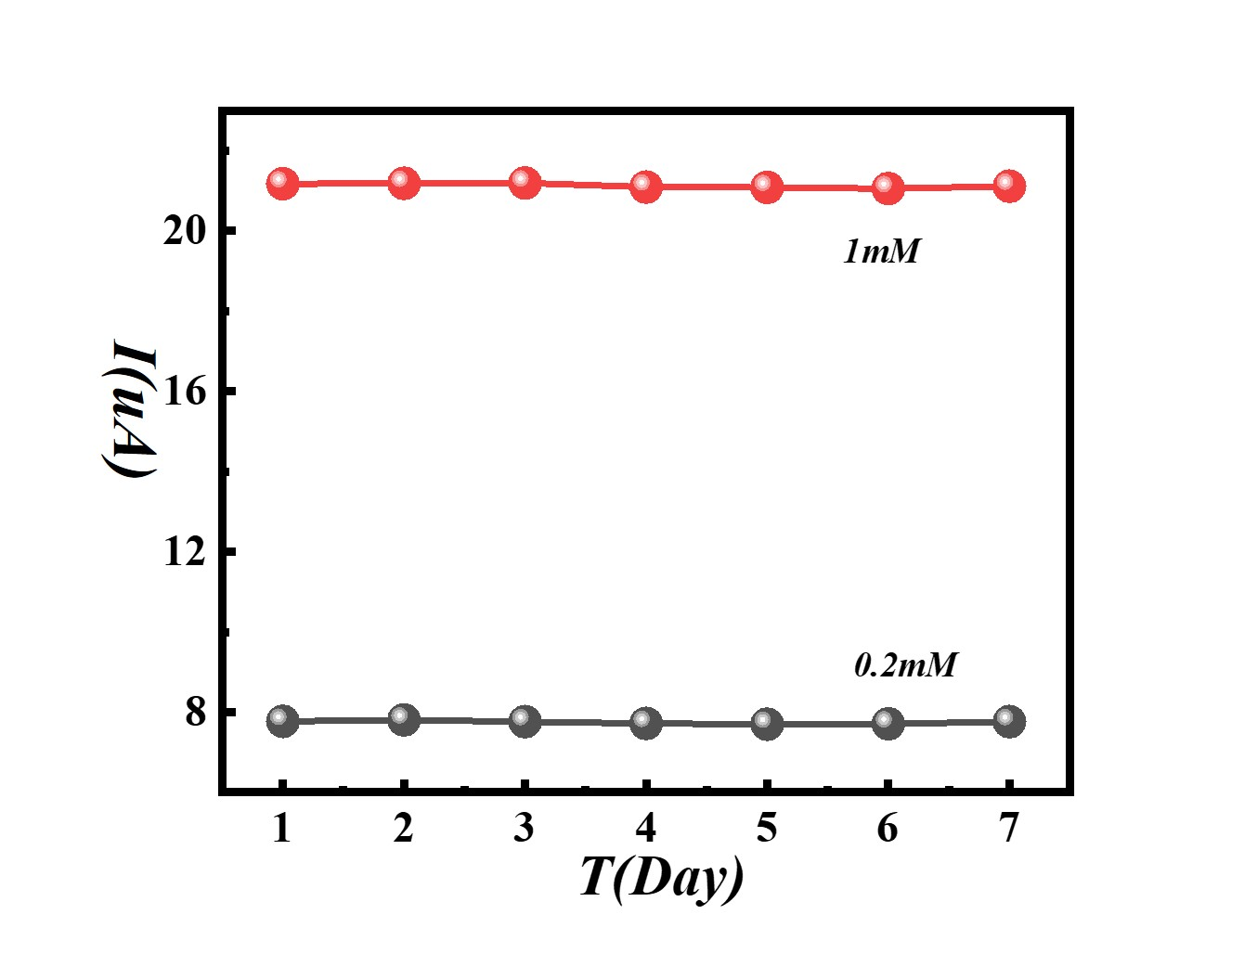
Figure S3. Repeatability of the CeO_{2-x}-CNTs modified electrodes within 7 days in 0.2- and 1-mM concentration of H₂O₂.

Figure S4. Optimization of the IFRS device. (a) Different configuration of the as-prepared IFRS devices. (b) Comparison of the sensing performance to H₂O₂ of the devices in (a).

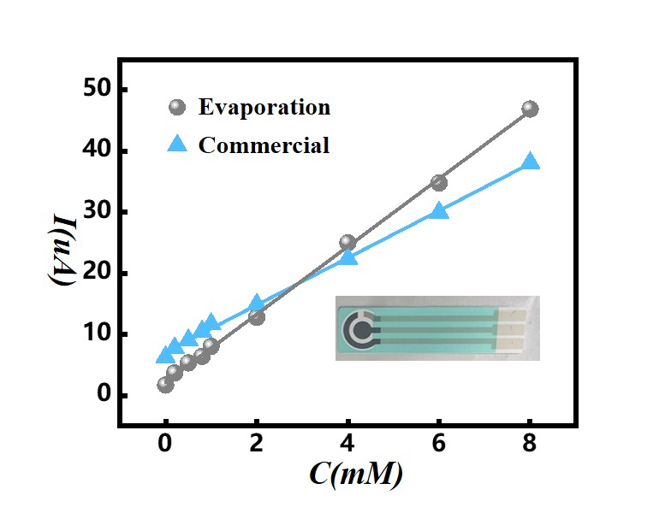
Figure S5. Sensitivity comparison of our evaporated sensor and commercial sensor.

Figure S6. EIS spectrum of directly printed CeO_{2-x}-CNTs paste and drop-casted CeO_{2-x}-CNTs on carbon black.
Supporting Information
Tables
Table S1. Atomic ratio of Ce, O and C of 1.5CeO_{2-x}-CNTs.
Element | Line Type | Apparent Concentration | k Ratio | Wt% | Atomic %
C | K series | 29.23 | 0.29226 | 22.47 | 58.51
O | K series | 55.79 | 0.18775 | 13.97 | 27.30
Ce | L series | 108.08 | 1.00581 | 63.56 | 14.18
Total: |  |  |  | 100.00 | 100.00
Table S2. Atomic ratio of Ce, O and C of 2CeO_{2-x}-CNTs.
Element | Line Type | Wt % Sigma | Wt% | Atomic %
C | K series | 0.30 | 22.28 | 55.79
O | K series | 0.13 | 16.54 | 31.09
Ce | L series | 0.31 | 61.17 | 13.13
Total: |  |  | 100.00 | 100.00

Table S3. Comparison of our CeO_{2-x}-CNTs and IFRS with recently reported results.
Electrode | Preparation | Sensitivity ($μA∙{mM}^{-1}∙{cm}^{-2}$) | LOD(μM) | Linear range(mM) | Ref
Pt-MWCNTs | screen-printing | 75.2 | 10 | 1 to 15 | [1]
MWCNTs-MnO₂/GCE | drop-casting | 13.9 | 6.97 | 0.1 to 20.7 | [2]
NiO-carbon foam | adsorption | 23.3 | 0.01 | 0.2 to 3.75 | [3]
Ag-MnO₂-MWCNTs/GCE | drop-casting | 82.5 | 1.7 | 0.001 to 10.4 | [4]
Au-CeO₂/GCE | drop-casting | 27.1 | 5 | 0.005 to 30 | [5]
CeO₂-HMTA/ITO | drop-casting | 21.13 | 0.6 | - | [6]
rGO-AuNPs/ITO-PET | electrodeposition | 0.064 | 6.55 | 0.1 to 0.5 | [7]
Pt-Au/silica | dipping | 46.7 | 5 | 0.1 to 6.8 | [8]
AgNPs@GNR/SPE | screen-printing | - | 20 | 0.05 to 5 | [9]
Au@Co₃O₄/CeO₂ /GCE | drop-casting | 35.67 | 0.002 | 0.005 to 5.4 | [10]
PVA-CNTs-PtNPs/GCE | drop-casting | 122.63 | 0.7 | 0.002 to 3.8 | [11]
CeO_{2-x}-CNTs/GCE | drop-casting | 229.58 | 0.52 | 0.01 to 8 | this work
CCSPS | screen-printing | 136.59 | 1.85 | 0.01 to 10 | this work

Reference
1. Chou T-C, Wu K-Y, Hsu FX, Lee C-K: Pt-MWCNT modified carbon electrode strip for rapid and quantitative detection of H2O2 in food. J Food Drug Anal 2018, 26:662-669.
2. Dinesh M, Revathi C, Haldorai Y, Kumar RTR: Birnessite MnO2 decorated MWCNTs composite as a nonenzymatic hydrogen peroxide sensor. Chem. Phys. Lett. 2019, 731.
3. Liu M, An M, Xu J, Liu T, Wang L, Liu Y, Zhang J: Three-dimensional carbon foam supported NiO nanosheets as non-enzymatic electrochemical H2O2 sensors. Appl. Surf. Sci. 2021, 542.
4. Han Y, Zheng J, Dong S: A novel nonenzymatic hydrogen peroxide sensor based on Ag-MnO2-MWCNTs nanocomposites. Electrochim. Acta 2013, 90:35-43.
5. Ampelli C, Leonardi SG, Bonavita A, Genovese C, Papanikolaou G, Perathoner S, Centi G, Neri G: Electrochemical H2O2 Sensors Based on Au/CeO2 Nanoparticles for Industrial Applications. In 12th International Conference on Chemical and Process Engineering (ICheaP); 2015 May 19-22; Milano, ITALY. 2015: 733-738.
6. Ujjain SK, Das A, Srivastava G, Ahuja P, Roy M, Arya A, Bhargava K, Sethy N, Singh SK, Sharma RK, Das M: Nanoceria based electrochemical sensor for hydrogen peroxide detection. Biointerphases 2014, 9.
7. Patella B, Buscetta M, Di Vincenzo S, Ferraro M, Aiello G, Sunseri C, Pace E, Inguanta R, Cipollina C: Electrochemical sensor based on rGO/Au nanoparticles for monitoring H2O2 released by human macrophages. Sens. Actuators B Chem. 2021, 327.
8. Liu W, Hiekel K, Huebner R, Sun H, Ferancova A, Sillanpaa M: Pt and Au bimetallic and monometallic nanostructured amperometric sensors for direct detection of hydrogen peroxide: Influences of bimetallic effect and silica support. Sens. Actuators B Chem. 2018, 255:1325-1334.
9. Stankovic V, Durdid S, Ognjanovic M, Mutic J, Kalcher K, Stankovic DM: A novel nonenzymatic hydrogen peroxide amperometric sensor based on AgNp@GNR nanocomposites modified screen-printed carbon electrode. J. Electroanal. Chem. 2020, 876.
10. Lei L, Zhang Y, Jiang Y, Xiong L, Liu Y, Li CM: Oxygen-vacancy-enhanced Catalytic Activity of Au@Co3O4/CeO2 Yolk-shell Nanocomposite to Electrochemically Detect Hydrogen Peroxide. Electroanalysis 2021, 33:2180-2186.
11. Fang Y, Zhang D, Qin X, Miao Z, Takahashi S, Anzai J-i, Chen Q: A non-enzymatic hydrogen peroxide sensor based on poly(vinyl alcohol)-multiwalled carbon nanotubes-platinum nanoparticles hybrids modified glassy carbon electrode. Electrochim. Acta 2012, 70:266-271.

