Fig. S1. ¹H NMR spectra of sensor 1
Fig. S2. ¹³C NMR spectra of sensor 1

Fig. S3. HRMS spectra of sensor 1
Fig. S4. FTIR spectra of sensor 1
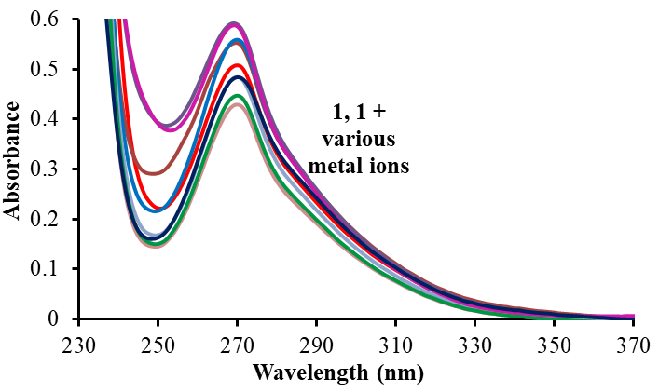
Fig. S5. UV-vis absorption preliminary studies of sensor 1 (20 μM) in CH₃CN with 100eq. of different metal ions.
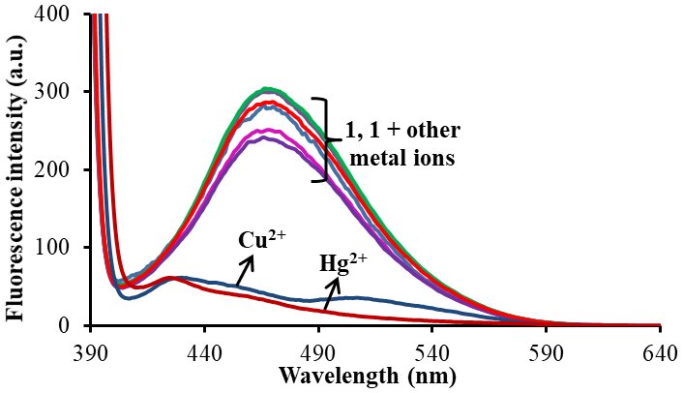
Fig. S6. Fluorescence preliminary studies of sensor 1 (10 μM) in CH₃CN with 100eq. of various metal ions.
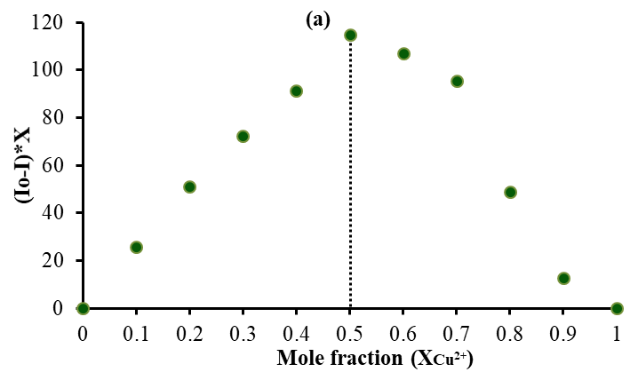 | 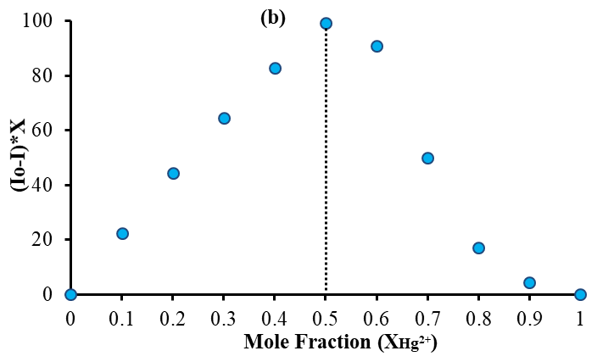
Fig. S7. Job’s plot of 1 for (a) Cu²⁺ and (b) Hg²⁺ ions by measuring fluorescence changes at 470 nm.
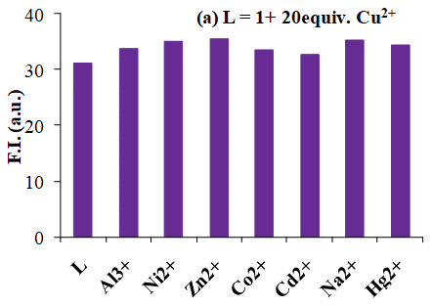 | 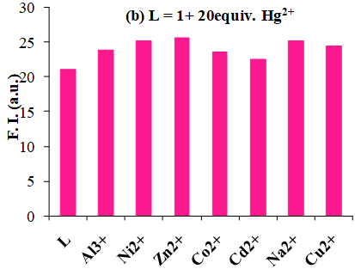
Fig. S8. Metal ion competitive profile of 1 (10 μM) via changes observed in fluorescence emission spectra with addition of 20 equiv. of (a) Cu²⁺ ion; (b) Hg²⁺ ion along with 100 equiv. of other interfering cations in CH₃CN.

