Supplementary Table 4. Before-after difference of qualified health service coverage in component level
 | Unexposed |  |  | Exposed
 | Before | After | Difference | Before | After | Difference
Family planning (n) | 1233 |  |  | 1116
Using modern contraceptive method = Yes (%) | - | 598 (48.5) | - | - | 438 (39.2) | -
Told about side effect = Yes (%) | - | 441 (35.8) | - | - | 299 (26.8) | -
Told how to deal with side effects = Yes (%) | - | 386 (31.3) | - | - | 270 (24.2) | -
Told about other method = Yes (%) | - | 369 (29.9) | - | - | 238 (21.4) | -
Antenatal care (n) | 479 | 864 |  | 484 | 980
First ANC visit in up to 12 weeks = Yes (%) | 158 (33.1) | 234 (27.1) | -6.0% | 151 (31.2) | 240 (24.5) | -6.7%
More than 4 times ANC visits = Yes (%) | 336 (70.6) | 560 (65.0) | -5.6% | 349 (72.4) | 635 (64.9) | -7.5%
Talked about the signs of complication = Yes (%) | 295 (62.2) | 512 (59.5) | -2.7% | 287 (59.5) | 585 (59.8) | 0.3%
Blood pressure taken during pregnancy = Yes (%) | 411 (86.3) | 750 (87.1) | 0.8% | 440 (91.3) | 838 (85.6) | -5.7%
Urine sample taken during pregnancy = Yes (%) | 352 (73.9) | 629 (73.1) | -0.8% | 378 (78.4) | 711 (72.6) | -5.8%
Blood sample taken during pregnancy = Yes (%) | 358 (75.2) | 644 (74.8) | -0.4% | 381 (79.0) | 710 (72.5) | -6.5%
Drugs for intestinal worms during pregnancy = Yes (%) | 82 (17.2) | 133 (15.4) | -1.8% | 92 (19.0) | 157 (16.0) | -3.0%
Iron tablet during pregnancy = Yes (%) | 353 (74.0) | 624 (72.2) | -1.8% | 386 (79.8) | 735 (75.0) | -4.8%
Delivery care (n) | 475 | 945 |  | 470 | 831
Mother checked after delivery (%) | 167 (35.2) | 284 (30.1) | -5.1% | 208 (44.3) | 355 (42.8) | -1.5%
Baby checked within 1 hour (%) | 29 (6.1) | 22 (2.3) | -3.8% | 33 (7.1) | 51 (6.1) | -1.0%
At least 24 hours facility stay (%) | 129 (27.2) | 196 (20.7) | -6.5% | 135 (28.9) | 263 (31.8) | 2.9%
Baby checked within 2 months (%) | 326 (68.6) | 544 (57.6) | -11.0% | 345 (73.7) | 532 (64.1) | -9.6%
Received Vitamin A (%) | 258 (54.3) | 414 (43.9) | -10.4% | 245 (52.2) | 384 (46.3) | -5.9%
Ever breastfeed (%) | 464 (97.7) | 932 (98.6) | 0.9% | 453 (96.4) | 803 (96.9) | 0.5%
Put baby to mother's breast within 60 mins (%) | 285 (61.7) | 660 (71.0) | 9.3% | 229 (50.7) | 501 (62.6) | 11.9%
Vaccination (n) | 474 | 583 |  | 466 | 512
BCG vaccine = Yes (%) | 419 (88.4) | 488 (84.1) | -4.30% | 395 (86.1) | 409 (81.3) | -4.80%
DPT vaccine 3 or more = Yes (%) | 363 (76.6) | 372 (64.1) | -12.50% | 313 (68.8) | 292 (57.9) | -10.90%
Polio vaccine 3 or more = Yes (%) | 333 (70.3) | 362 (62.4) | -7.90% | 291 (63.4) | 276 (54.7) | -8.70%
Measles vaccine = Yes (%) | 369 (78.5) | 402 (69.6) | -8.90% | 328 (71.8) | 266 (52.7) | -19.10%
Malaria prevention (n) | 1528 |  |  | 1406
Family slept under the treated net last night = Yes (%) | - | 252 (16.5) | - | - | 276 (19.6) | -
Mother slept under the mosquito net last night = Yes (%) | - | 274 (17.9) | - | - | 311 (22.1) | -
Child slept under the mosquito net last night = Yes (%) | - | 204 (13.4) | - | - | 249 (18.0) | -
Abbreviations: ANC: antenatal care; BCG: bacillus Calmette- Guérin; DPT: diphtheria, pertussis, and tetanus.

Supplementary Table 5. Results of additional analyses
 | Household damage |  | Regional damage |  | Short-term damage |  | Without birth within 10 months after the earthquake |  | Outcome as continuous variable
 | Odds ratio  (95% CI) | P-value | Odds ratio  (95% CI) | P-value | Odds ratio  (95% CI) | P-value | Odds ratio  (95% CI) | P-value | Coefficient  (95% CI) | P-value
Family planning | 0.93  (0.75-1.17) | 0.549 | 0.62  (0.38-1.00) | 0.052 | - |  | - |  | -0.05  (-0.24-0.13) | 0.590
Antenatal care | 1.03  (0.71-1.48) | 0.893 | 1.06  (0.72-1.55) | 0.762 | 0.80  (0.48-1.35) | 0.408 | 0.85  (0.58-1.25) | 0.413 | 0.14  (-0.19-0.46) | 0.408
Delivery care | 1.09  (0.77-1.54) | 0.616 | 1.35  (0.95-1.93) | 0.097 | 1.15  (0.69-1.90) | 0.601 | - |  | 0.15  (-0.06-0.37) | 0.161
Vaccination | 0.88  (0.60-1.28) | 0.500 | 0.93  (0.63-1.36) | 0.697 | 0.82  (0.50-1.34) | 0.428 | - |  | -0.15  (-0.38-0.09) | 0.226
Malaria prevention | 1.19  (0.95-1.49) | 0.125 | 1.25  (0.73-2.15) | 0.415 | - |  | - |  | -0.04  (-0.15-0.06) | 0.44

Household damage: mothers were defined as exposed if she experienced housing damage or loss of family member; Regional damage: mothers were defined as exposed if 50% of households in the region where mothers lived were exposed to the earthquake; Short-term damage: limited the earthquake exposed group to mothers who had the birth within 6 months after the earthquake; Without birth within 10 months after the earthquake: excluded mothers who had birth within 10 months since the earthquake; Outcome as continuous variable: d outcomes as continuous variables.
Supplementary Figure 2. Trend of access to qualified health services before and after the earthquake in

- Antenatal care

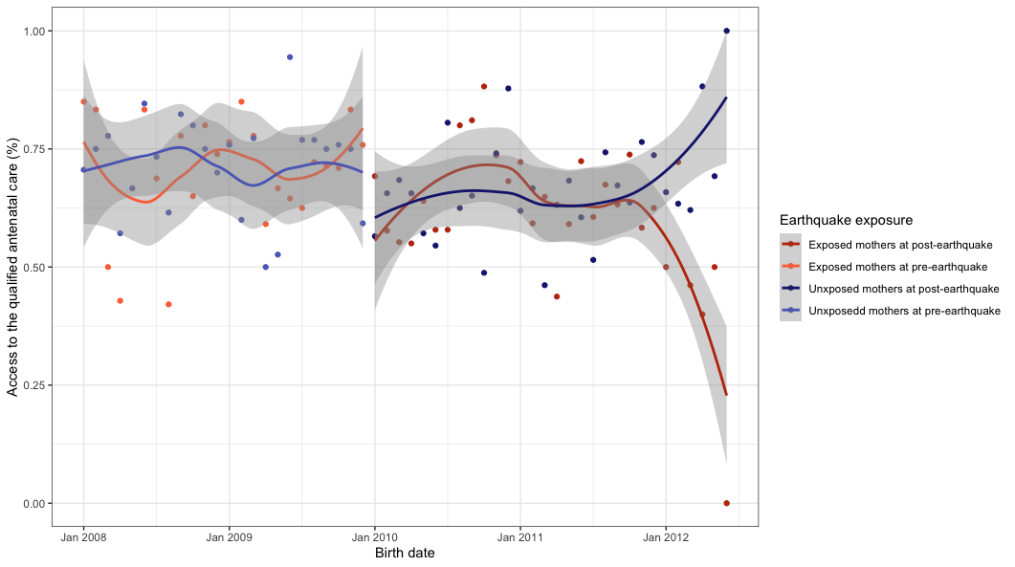

- delivery care

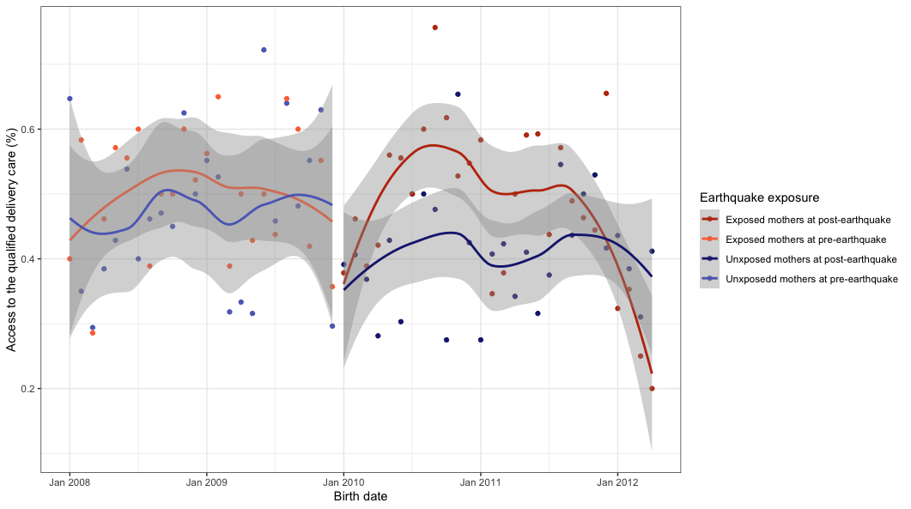

- Vaccination

