Supplementary Information

An Ingenious Strategy to Stereoscopically Enhance the Phosphorescence Properties of Guest–Host Materials: Addition of Metal Ions to Form Coordination with the Guest

Yan Guo,ª Kaijun Cheng,ª Zechen Hu,ª Yunxiang Lei,*ª Xiaoqing Liu,ª Miaochang Liu,ª Zhengxu Cai,*^{b} Huayue Wu,ª Xiaobo Huang,*ª and Yuping Dong^{b}

ª College of Chemistry and Materials Engineering, Wenzhou University, Wenzhou 325035, P. R. China
^{b} School of Materials Science & Engineering, Beijing Institute of Technology, Beijing, 10081, P. R. China

E-mail addresses: yunxianglei@wzu.edu.cn (Y. Lei), caizx@bit.edu.cn (Z. Cai) xiaobhuang@wzu.edu.cn (X. Huang)

1. Materials and characterization
¹H and ¹³C NMR spectra were carried out by a Bruker ARX500 spectrometer with DMSO-d₆ as the solvent. UV-vis absorption spectra were measured by a Persee TU-1901 spectroscopy. Fluorescence spectra were measured by a Hitachi F-7000 spectrophotometer. Phosphorescence spectra were measured by a FLS920 lifetime and steady state spectrometer. X-Ray crystal structure analyses were conducted on a Bruker-AXS SMART APEX2 CCD diffractometer. Solid-state emission quantum yields were collected on a FluoroMax-4 (Horiba Jobin Yvon) fluorimeter equipped with integrated sphere. The theoretical ground-state geometry and electronic structure were performed using the density functional theory (DFT) with B3LYP hybrid functional at the basis set level of 6-31+G (d, p).¹ All the theoretical calculations were optimized using Gaussian 09 package. All the host and guest molecules were purified twice by column chromatography and then recrystallized using dichloromethane and methanol.

2. Synthesis of seven guests
Figure 1. Synthetic routes of seven guest compounds.

The mixture of bromoquinoline (10.0 mmol), boronic acid (12.0 or 24.0 mmol), Pd(PPh₃)₄ (5.0 mol%), and K₂CO₃ (5.0 mol%) were dissolved in THF (10.0 mL) and water (1.0 mL). The mixture was stirred for 12 h at 80°C under nitrogen atmosphere. The solvent was removed under reduced pressure and the residue were purified by column chromatography (petroleum ether: ethyl acetate = 100:1, v:v) to afford the pure seven compounds.
2-Phenylquinoline (2-QL): White solid (1.74 g, 85%). ¹H NMR (500 MHz, DMSO-d₆) δ: 8.47 (d, J = 8.6 Hz, 1H), 8.28 (d, J = 7.4 Hz, 2H), 8.16 (d, J = 8.6 Hz, 1H), 8.08 (d, J = 8.4 Hz, 1H), 8.01 (d, J = 8.0 Hz, 1H), 7.79 (t, J = 7.4 Hz, 1H), 7.57 (dd, J = 7.3 Hz, 4H). ¹³C NMR (126 MHz, DMSO-d₆) δ: 156.41, 147.88, 138.98, 137.52, 130.25, 129.92, 129.43, 129.18, 128.13, 127.54, 127.31, 126.78, 119.06.
3-Phenylquinoline (3-QL): White solid (1.80 g, 88%). ¹H NMR (500 MHz, DMSO-d₆) δ: 9.26 (s, 1H), 8.65 (s, 1H), 8.06 (d, J = 8.4 Hz, 2H), 7.89 (d, J = 7.7 Hz, 2H), 7.78 (t, J = 7.6 Hz, 1H), 7.65 (t, J = 7.5 Hz, 1H), 7.56 (t, J = 7.6 Hz, 2H), 7.47 (t, J = 7.3 Hz, 1H). ¹³C NMR (126 MHz, DMSO-d₆) δ: 149.92, 147.30, 137.52, 133.26, 129.96, 129.65, 129.12, 128.85, 128.61, 128.13, 127.63, 127.44.
4-Phenylquinoline (4-QL): White solid (1.68 g, 82%). ¹H NMR (500 MHz, DMSO-d₆) δ: 8.95 (d, J = 4.3 Hz, 1H), 8.12 (d, J = 8.4 Hz, 1H), 7.91 – 7.75 (m, 2H), 7.66 – 7.50 (m, 6H), 7.47 (d, J = 4.3 Hz, 1H). ¹³C NMR (126 MHz, DMSO-d₆) δ: 150.39, 148.49, 147.64, 137.59, 129.86, 129.66, 128.97, 128.80, 127.16, 126.18, 125.64, 121.71.
5-Phenylquinoline (5-QL): White solid (1.76 g, 86%). ¹H NMR (500 MHz, DMSO-d₆) δ: 8.94 (s, 1H), 8.19 (d, J = 8.2 Hz, 1H), 8.07 (d, J = 8.4 Hz, 1H), 7.83 (t, J = 7.7 Hz, 1H), 7.62 – 7.34 (m, 7H). ¹³C NMR (126 MHz, DMSO-d₆) δ: 150.83, 148.44, 140.36, 139.10, 133.93, 130.20, 129.44, 129.01, 128.15, 127.57, 126.24, 122.07.
6-Phenylquinoline (6-QL): White solid (1.74 g, 85%).¹H NMR (500 MHz, DMSO-d₆) δ: 8.91 (d, J = 2.8 Hz, 1H), 8.43 (d, J = 8.1 Hz, 1H), 8.29 (s, 1H), 8.10 (s, 2H), 7.84 (d, J = 7.5 Hz, 2H), 7.61 – 7.48 (m, 3H), 7.43 (t, J = 7.3 Hz, 1H). ¹³C NMR (126 MHz, DMSO-d₆) δ: 151.07, 147.62, 139.79, 138.49, 136.77, 129.99, 129.55, 129.09, 128.64, 128.34 127.56, 125.91, 122.31.
7-Phenylquinoline (7-QL): White solid (1.70 g, 83%).¹H NMR (500 MHz, DMSO-d₆) δ: 8.94 (d, J = 4.0 Hz, 1H), 8.40 (d, J = 8.2 Hz, 1H), 8.27 (s, 1H), 8.08 (d, J = 8.5 Hz, 1H), 7.96 (d, J = 9.8 Hz, 1H), 7.86 (d, J = 7.5 Hz, 2H), 7.55 (d, J = 7.6 Hz, 3H), 7.44 (t, J = 7.3 Hz, 1H). ¹³C NMR (126 MHz, DMSO-d₆) δ: 151.54, 148.55, 141.59, 139.84, 136.19, 129.60, 129.22, 128.52, 127.63, 126.56, 126.21, 121.94.
8-Phenylquinoline (8-QL): White solid (1.66 g, 81%). ¹H NMR (500 MHz, DMSO-d₆) δ: 8.90 (s, 1H), 8.43 (d, J = 8.3 Hz, 1H), 8.00 (d, J = 8.1 Hz, 1H), 7.76 (d, J = 7.0 Hz, 1H), 7.67 (dd, J = 21.4, 7.5 Hz, 3H), 7.57 (dd, J = 8.3, 4.1 Hz, 1H), 7.44 (dt, J = 7.4 Hz, 3H). ¹³C NMR (126 MHz, DMSO-d₆) δ: 150.71, 145.66, 140.38, 139.73, 136.92, 131.09, 130.53, 128.85, 128.36, 128.16, 127.50, 126.90, 121.90.

3. Experimental data
Figure 2. (a), Absorption spectra of seven guests in THF solvents. Concentration: 1.0×10⁻⁵ mol/L. (b), Absorption spectra of seven guests in solid state.

Figure 3. Delayed emission spectra of seven guests in solution state (a) and solid state (b) (Delayed time: o.5 ms, Ex.: 380 nm).

Figure 4. Delayed emission spectra of 5-QL/BPO guest-host materials with different amounts of Py. (Delayed time: o.5 ms, Ex.: 380 nm).

Figure 5. (a) Phosphorescence spectra of the solution state guests at 77 K (Ex: 360 nm; Delayed time: 0.5 ms).

Figure 6. Proposed transfer path between the guest and host.
Figure 7. Delayed emission spectra of 5-QL/BPO/CdI₂ (a) and 5-QL/BPO/InCl₃ (b) doped materials with different molar ratios. (Delayed time: 0.5 ms, Ex.: 380 nm).

Figure 8. (a) Prompt and delayed emission spectra of 5-QL/BPO/CF₃CO₂Ag. (b) Prompt and delayed emission spectra of 5-QL/BPO/CdI₂. (Delayed time: 0.5 ms, Ex.: 380 nm).
Figure 9. (a) Time-resolved prompt emission decay curves of 5-QL/BPO/CF₃CO₂Ag. (b) Time-resolved prompt emission decay curves of 5-QL/BPO/CdI₂. (Delayed time: 0.5 ms, Ex.: 380 nm).
Figure 10. Delayed emission spectra of 5-QL/BPO/AlCl₃, 5-QL/BPO/GaCl₃, and 5-QL/BPO/InCl₃. (Delayed time: 0.5 ms, Ex.: 380 nm).

Figure 11. Phosphorescence decay curves of 5-QL/BPO/AlCl₃, 5-QL/BPO/GaCl₃, and 5-QL/BPO/InCl₃. Ex.: 380 nm.
Figure 12. Delayed emission spectra of 5-QL/M. (Delayed time: 0.5 ms, Ex.: 380 nm).
Figure 13. Delayed emission spectra of 2-QL/BPO/M (a) and 8-QL/BPO/M (b). (Delayed time: 0.5 ms, Ex.: 380 nm).

Figure 14. Configurations of 5-QL-AlCl₃ and 5-QL-CdI₂ obtained from theoretical simulations.
4. NMR spectra
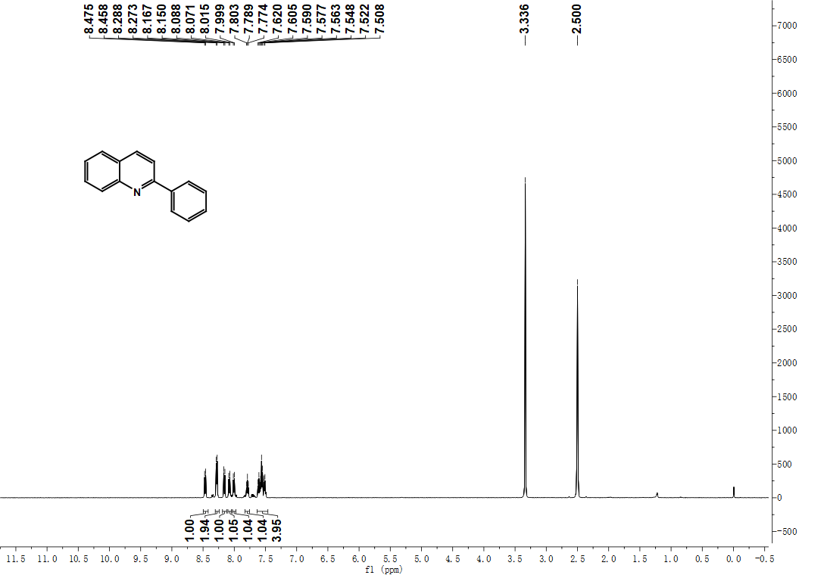
Figure 15. ¹H NMR of 2-QL (DMSO-d₆, 500 MHz)
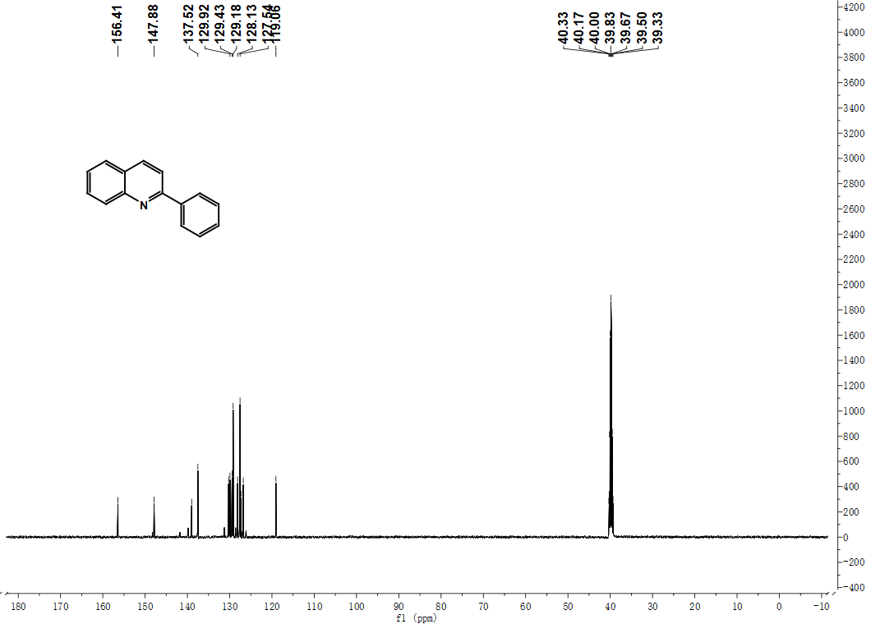
Figure 16. ¹³C NMR of 2-QL (DMSO-d₆, 126 MHz).

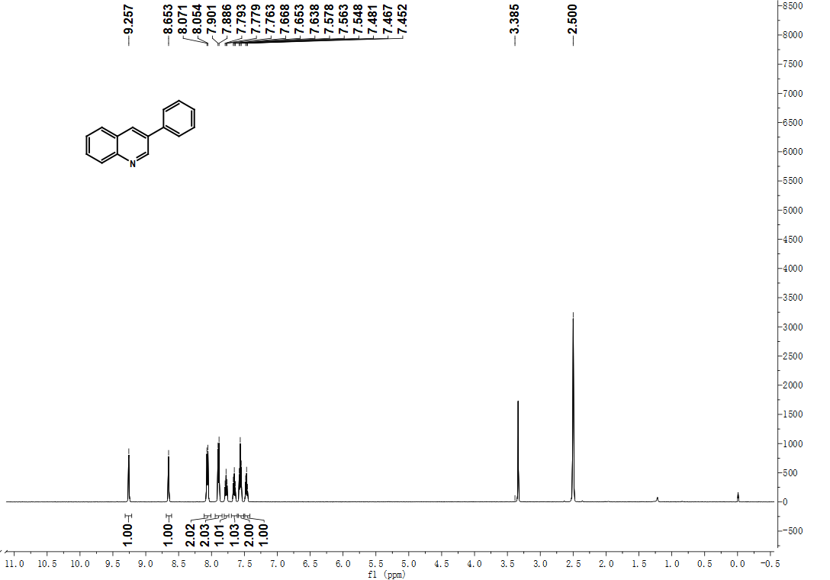
Figure 17. ¹H NMR of 3-QL (DMSO-d₆, 500 MHz)
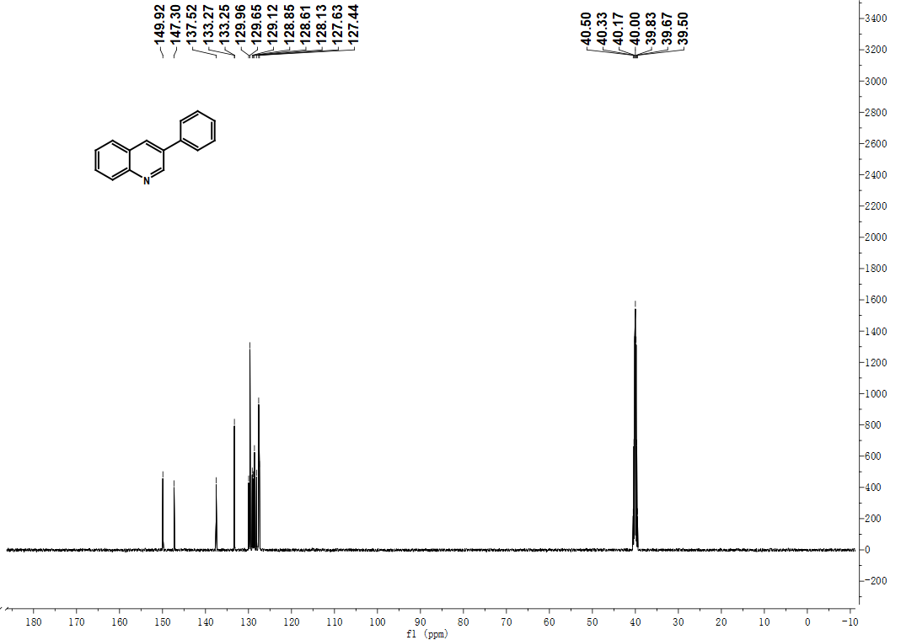
Figure 18. ¹³C NMR of 3-QL (DMSO-d₆, 126 MHz).

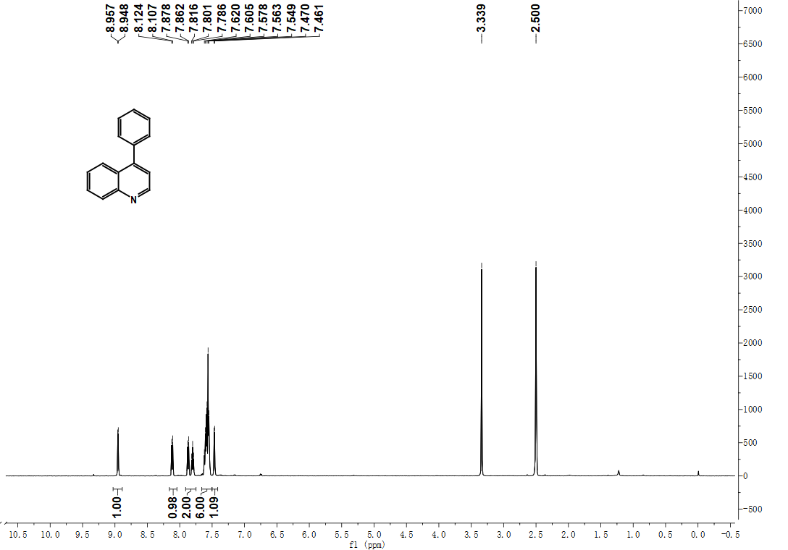
Figure 19. ¹H NMR of 4-QL (DMSO-d₆, 500 MHz)
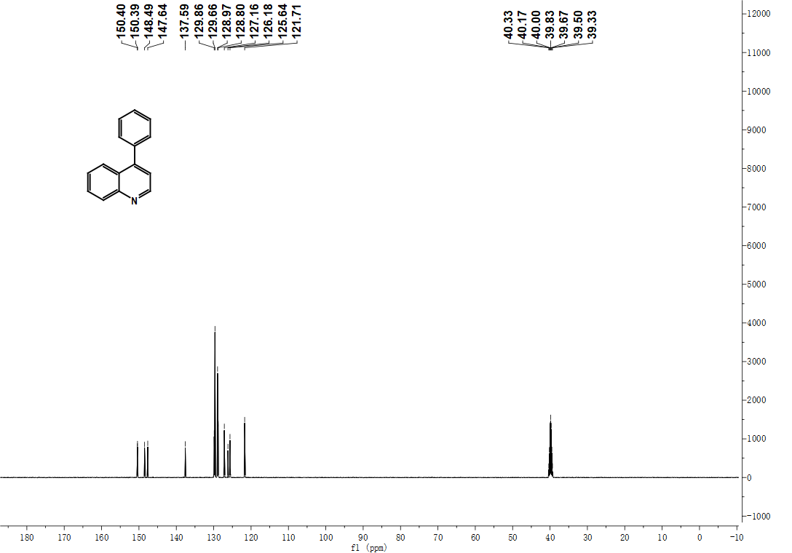
Figure 20. ¹³C NMR of 4-QL (DMSO-d₆, 126 MHz).

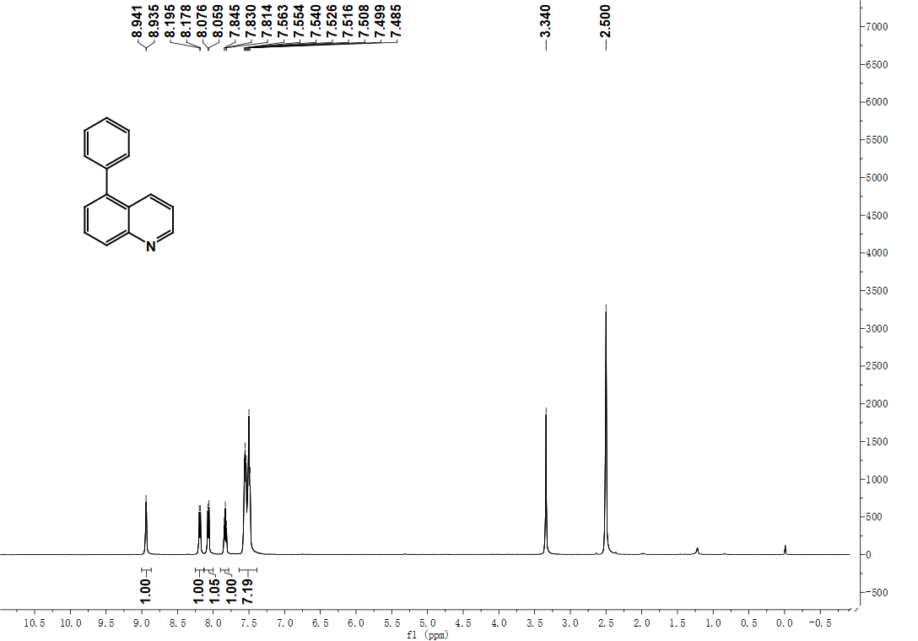
Figure 21. ¹H NMR of 5-QL (DMSO-d₆, 500 MHz)
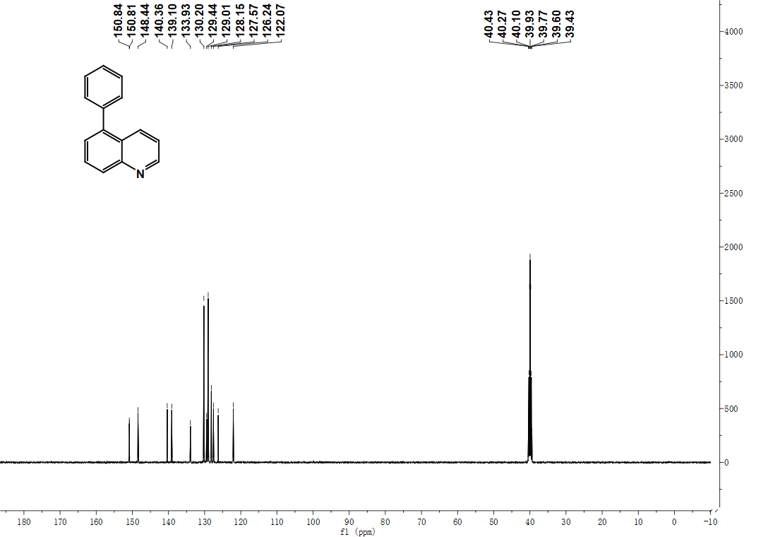
Figure 22. ¹³C NMR of 5-QL (DMSO-d₆, 126 MHz)

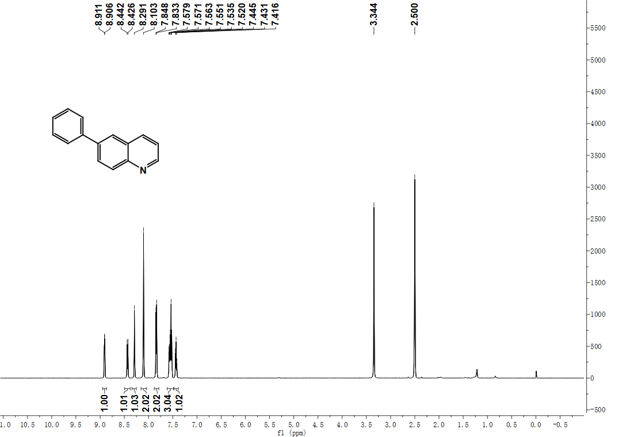
Figure 23. ¹H NMR of 6-QL (DMSO-d₆, 500 MHz)
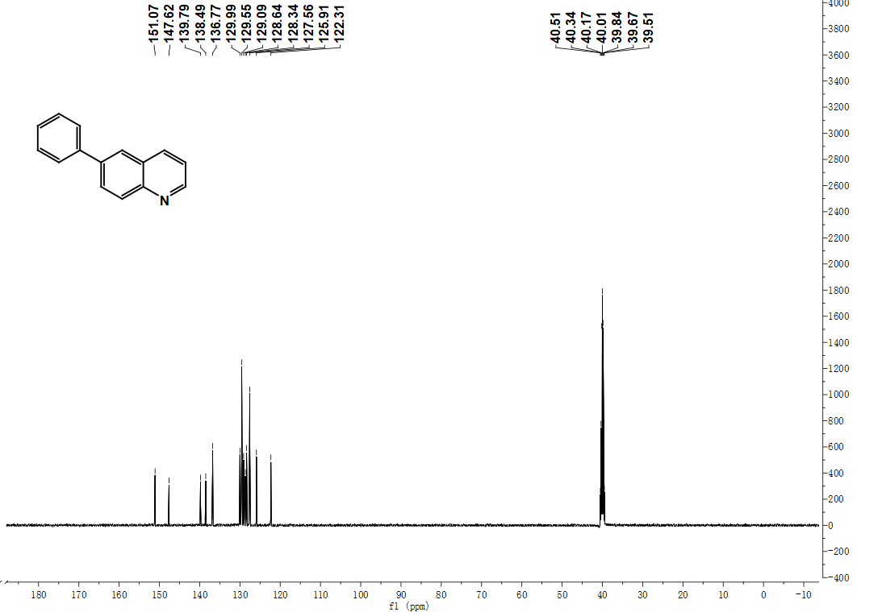
Figure 24. ¹³C NMR of 6-QL (DMSO-d₆, 126 MHz)

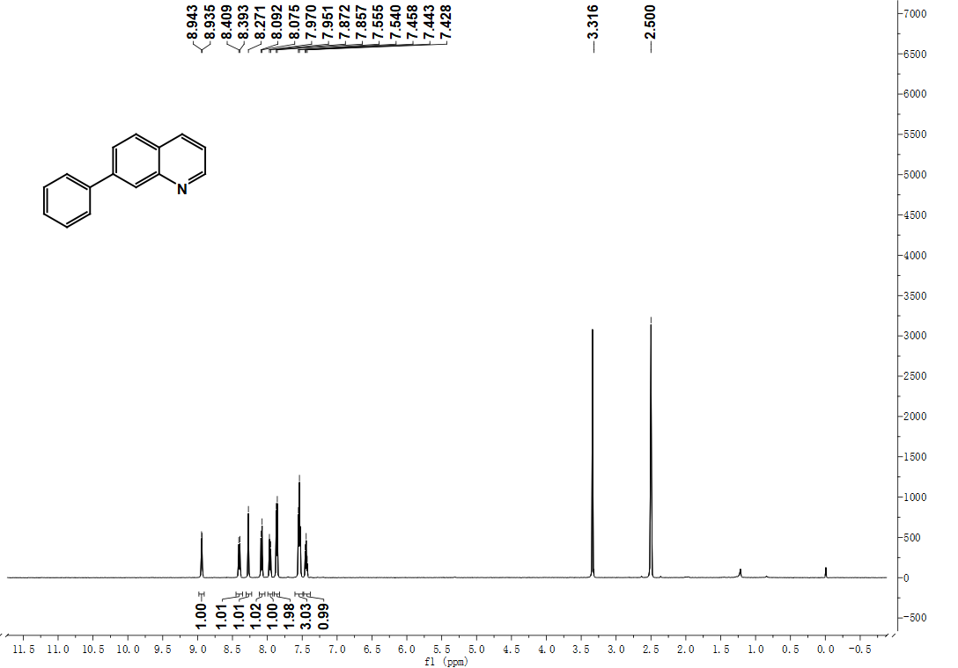
Figure 25. ¹H NMR of 7-QL (DMSO-d₆, 500 MHz)
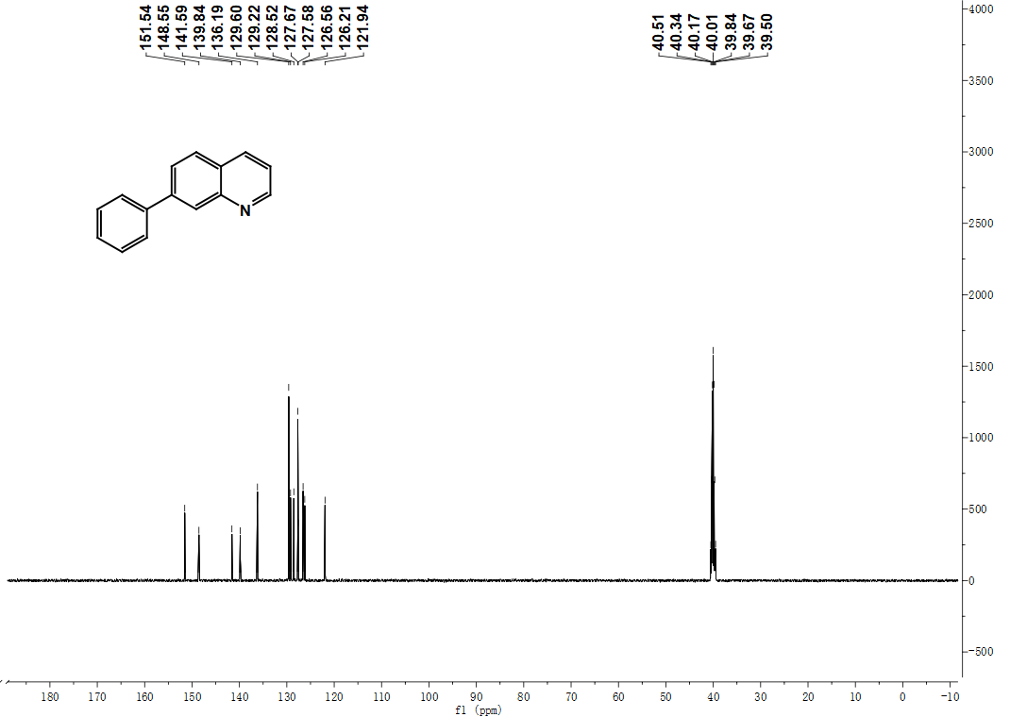
Figure 26. ¹³C NMR of 7-QL (DMSO-d₆, 126 MHz)

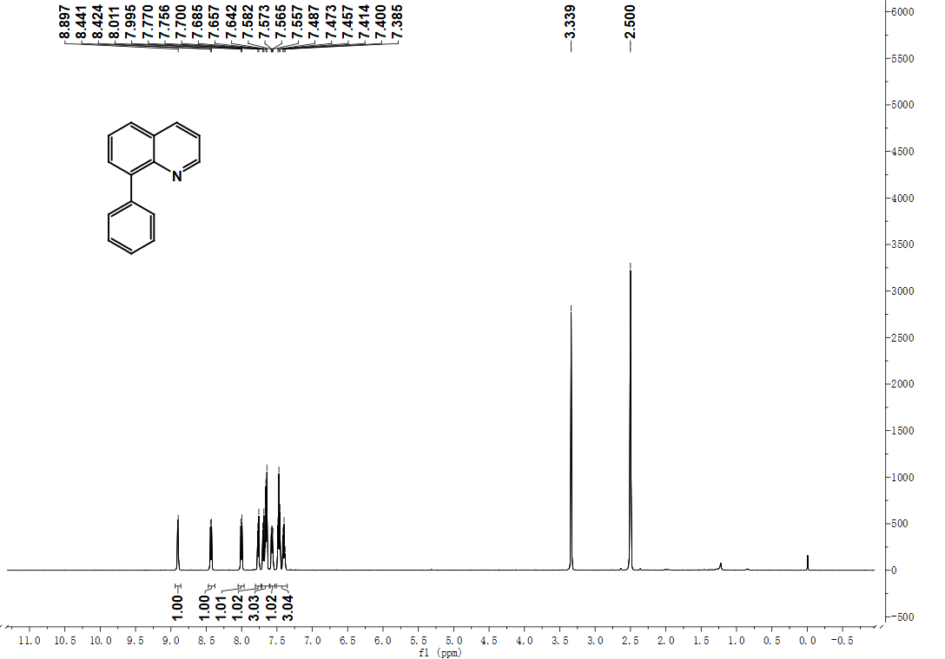
Figure 27. ¹H NMR of 8-QL (DMSO-d₆, 500 MHz)
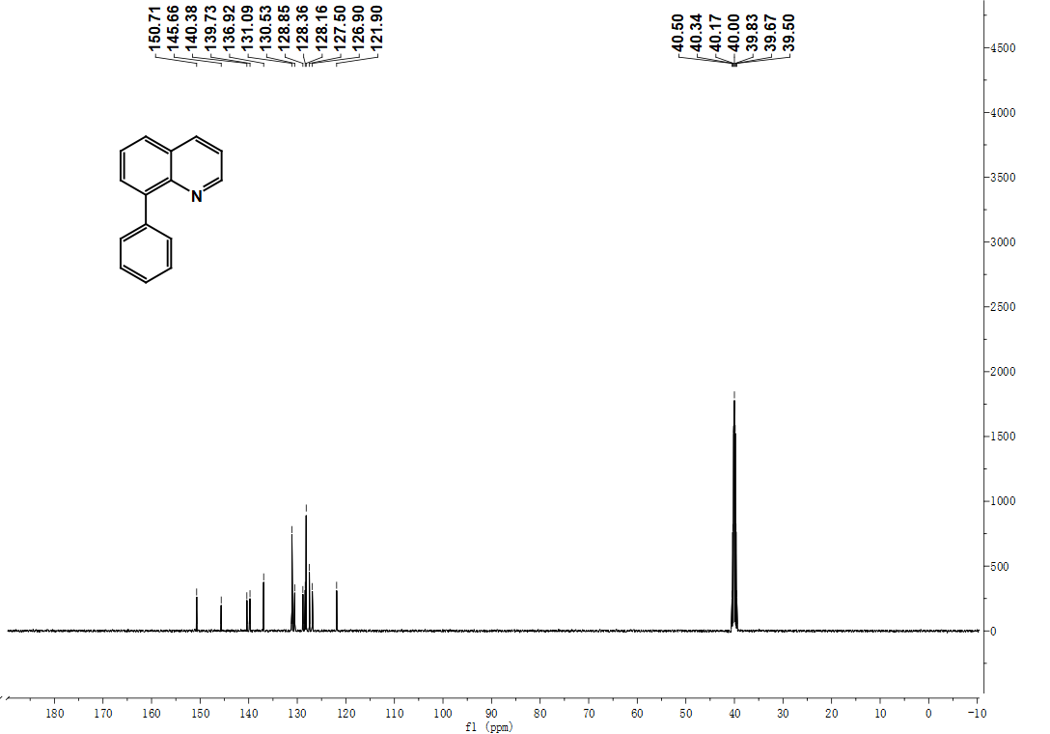
Figure 28. ¹³C NMR of 8-QL (DMSO-d₆, 126 MHz)

