Supporting Information

Plastic and low-cost zero thermal expansion alloy by a natural dual-phase composite

Chengyi Yu,¹ Kun Lin,^{1,}* Suihe Jiang,¹ Yili Cao,¹ Wenjie Li,¹ Yilin Wang,¹ Yan Chen,² Ke An,² Li You,¹ Kenichi Kato,³ Qiang Li,¹ Jinxia Deng,¹ Xianran Xing,^{1,}*

1. Beijing Advanced Innovation Center for Materials Genome Engineering, Institute of Solid State Chemistry, Department of Physical Chemistry, University of Science and Technology Beijing, Beijing 100083, China
2. Neutron Scattering Division, Oak Ridge National Laboratory, Oak Ridge, TN 37831, USA.
3. RIKEN SPring-8 Center, Hyogo 679-5148, Japan.
*Corresponding author: xing@ustb.edu.cn; kunlin@ustb.edu.cn

This PDF file includes:
- Supplementary Figure S1-10.
- Supplementary Table S1-2.

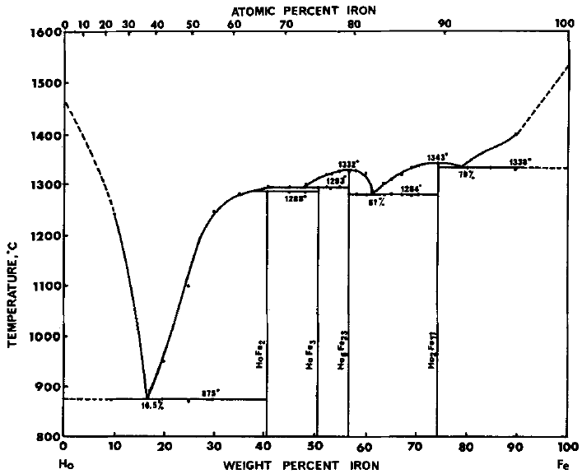

Fig. S1. The Fe-Ho phase diagram²⁶.

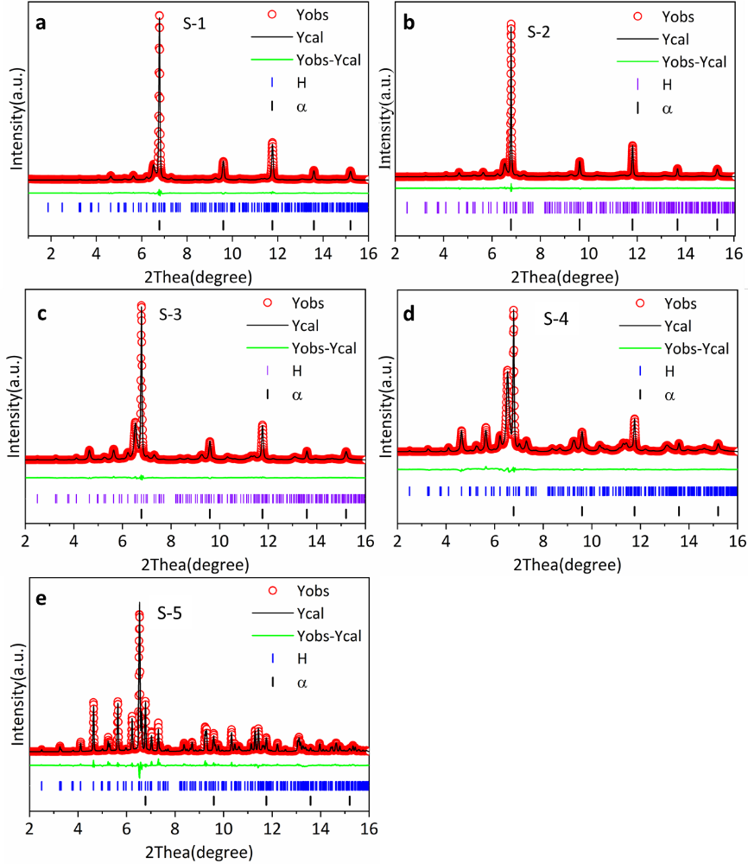
Fig. S2. The Rietveld refinements of SXRD data from S-1 to S-5.

Fig. S3. Variable temperature synchrotron X-ray diffraction patterns of S-2.

Fig. S4. Schematic illustration of the real-time in-situ neutron diffraction experimental set-up on VULCAN, where the loading direction (LD) is parallel to the Z₀ direction. The loading axis is horizontal and positioned at 45° from the incident beam such that Bank 1 probes the strain component along the loading direction (LD), while Bank 2 simultaneously probes the strain component in the transverse direction (TD), as shown in two insets.

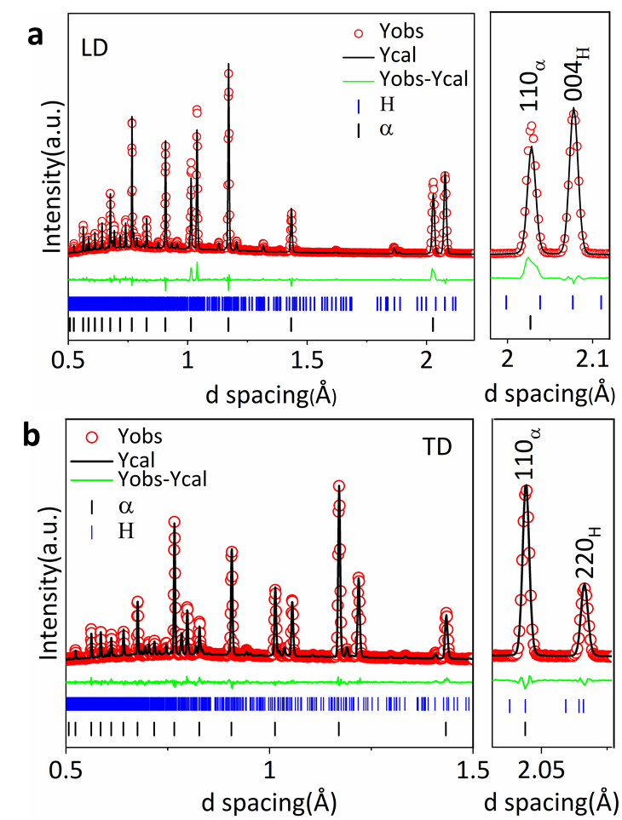
Fig. S5. The Rietveld refinements of in situ neutron diffraction profiles of S-2 alloy. a Along the loading direction (LD). b Along the transverse direction (TD). It shows that (004)_{H} reflections are significantly strong in LD but almost absent in TD. In contrast, (600)_{H} reflections are significantly strong in TD, which indicated the S-2 alloy is of high texture along the Z₀ direction.

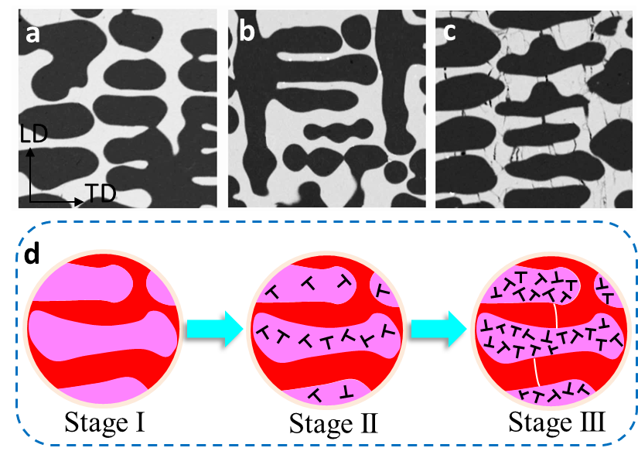
Fig. S6. a-c Ex-situ EPMA at ε=0%, 2%, 12%. d Schematic illustration of the mechanism of the dual-phase alloys during deformation.

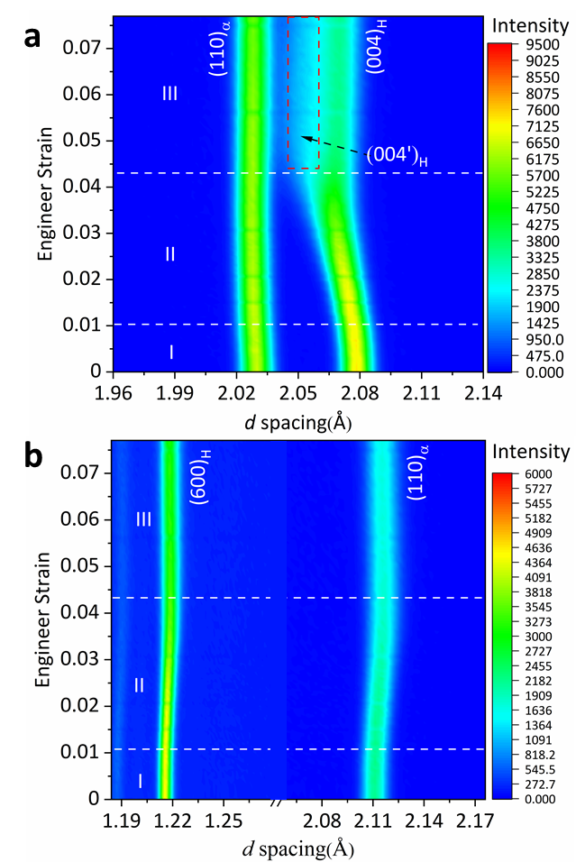
Fig. S7. In-situ neutron diffraction profiles of S2 along (a) LD and (b)TD.

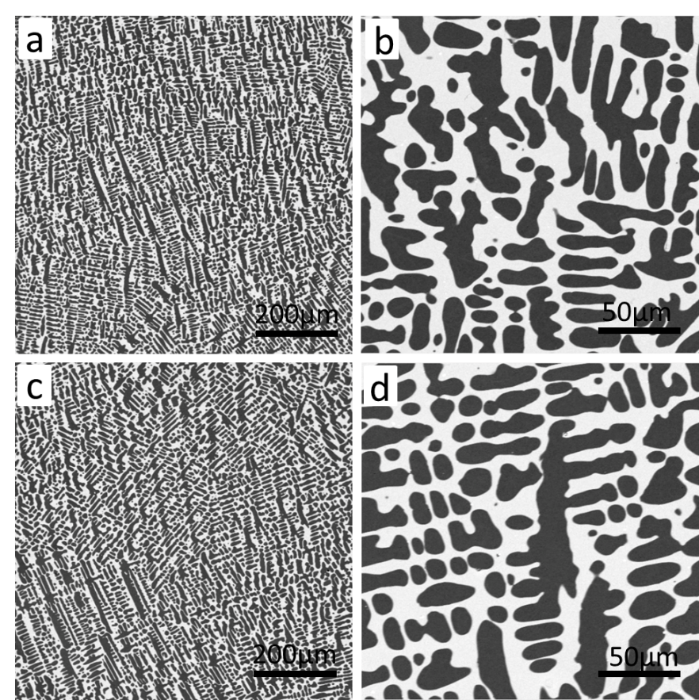
Fig. S8. The comparison of microstructures of the as-cast S2 alloy before and after thermal cycling tests. a, b The microstructures of the as-cast S2 alloy before thermal circling tests determined by EPMA in different magnifications. c, d The microstructures of the as-cast S2 alloy after 100 thermal cycling tests (77 K and 335 K) in different magnifications, which shows the alloy maintained perfect integrity and high thermo-stability. The special transition layers at the phase interface are important to improve thermal stability.

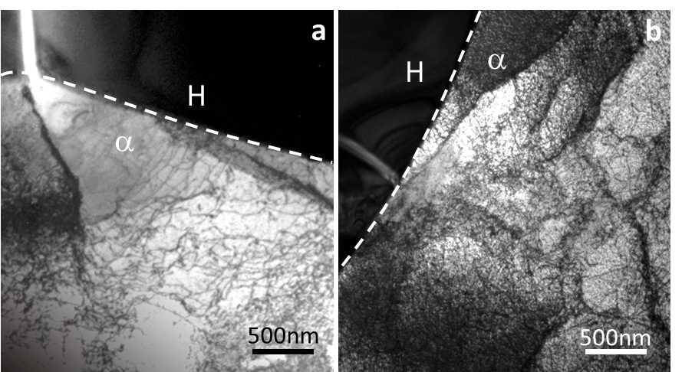
Fig. S9. a,b Ex-situ TEM at 12% compressive strain at the dual-phase interface, respectively.

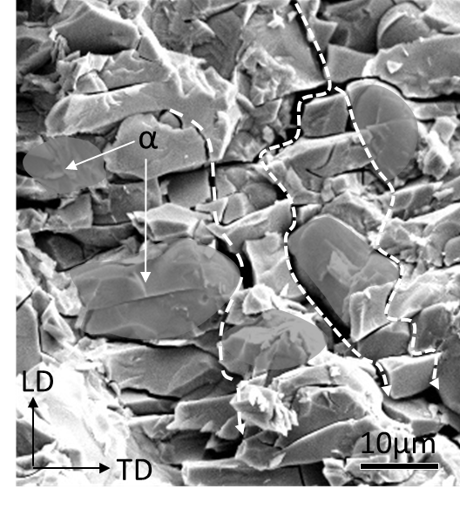
Fig. S10. Typical SEM image of the fracture microstructure, multiple microcracks mainly propagate along with dual-phase interface.

Table S1. Lattice parameters and structure information of Ho₂Fe₁₇ and α - Fe compounds at 300 K determined by SXRD patterns.
Lattice parameter a c V alpha beta gamma
Ho₂Fe₁₇ 8.45670 8.31858 515.20 90.0000 90.0000 120.0000
α - Fe 2.93150 2.93150 25.19 90.0000 90.0000 90.0000

Structure parameter |  |  |  | x | y | z | Occ. | U | Site | Sym.
Ho₂Fe₁₇ | 1 | Ho | Ho2 | 0.33333 | 0.66667 | 0.75000 | 1.000 | 0.019 | 2d | -6m2
 | 2 | Ho | Ho1 | 0.00000 | 0.00000 | 0.25000 | 0.824 | 0.019 | 2b | -6m2
 | 3 | Ho | Ho3 | 0.33333 | 0.66667 | 0.25000 | 0.112 | 0.019 | 2c | -6m2
 | 4 | Fe | Fe1 | 0.33333 | 0.66667 | 0.10676 | 0.887 | 0.005 | 4f | 3m.
 | 5 | Fe | Fe2 | 0.50000 | 0.00000 | 0.00000 | 1.000 | 0.005 | 6g | .2/m.
 | 6 | Fe | Fe3 | 0.33415 | 0.95614 | 0.25000 | 0.757 | 0.005 | 12j | m..
 | 7 | Fe | Fe6 | 0.29823 | 0.98286 | 0.25000 | 0.243 | 0.005 | 12j | m..
 | 8 | Fe | Fe4 | 0.16667 | 0.33296 | 0.97899 | 0.757 | 0.005 | 24l | 1
 | 9 | Fe | Fe7 | 0.16667 | 0.33296 | 1.00328 | 0.243 | 0.005 | 24l | 1
 | 10 | Fe | Fe5 | 0.00000 | 0.00000 | 0.10676 | 0.177 | 0.005 | 4e | 3m.
α - Fe | 1 | Fe | Fe1 | 0.00000 | 0.00000 | 0.00000 | 1.000 |  | 2a | m3m

Table S2. Lattice parameters of sample S2 obtained from SXRD Rietveld refinement.
Temperature(K) | a(Å) | c(Å)
107 | 8.3333 | 2.86279
131 | 8.33287 | 2.86324
154 | 8.33156 | 2.86377
177 | 8.33072 | 2.86442
200 | 8.32867 | 2.86502
223 | 8.32768 | 2.86567
246 | 8.32692 | 2.86624
270 | 8.32569 | 2.86696
292 | 8.32478 | 2.8675
306 | 8.32396 | 2.86807
315 | 8.32333 | 2.86836
325 | 8.32235 | 2.86864
334 | 8.32212 | 2.8689
343 | 8.32145 | 2.86925
362 | 8.32016 | 2.86983
385 | 8.31962 | 2.87057
408 | 8.32017 | 2.87138
431 | 8.3212 | 2.87222
450 | 8.32233 | 2.87288

