Supplement Table 1. Immunohistochemistry antibodies
No. | Antibody name | Clonality Species | Company | Product  No. | Diluted | Identified cells
1 | Anti-LAG-3 antibody | Monoclone; Rb | Abcam | Ab209236 | 1:500 | LAG-3⁺ cells

Supplement Table 2. Flow cytometry antibodies
No. | Antibody name | Company | Product  No. | Dye | Marker
1 | APC-Cy7 Mouse Anti-Human CD45 | BD Biosciences | 557833 | APC-Cy7 | CD45
2 | BB515 Mouse Anti-Human CD8 | BD Biosciences | 564526 | BB515 | CD8
3 | APC anti-human TIGIT (VSTM3) Antibody | BioLegend | 372706 | APC | TIGIT
4 | Brilliant Violet 421 Mouse Anti-Human TIGIT | R&D | FAB7898N | BV421 | TIGIT
5 | PE Mouse anti-Human CD279 (PD-1) | BD Biosciences | 560795 | PE | PD-1
6 | PE/Cy7 anti-human CD107a (LAMP-1) Antibody | BioLegend | 328618 | PE/Cy7 | CD107a
7 | Alexa Fluor 700 anti-human Perforin Antibody | BioLegend | 353323 | AF700 | PRF-1
8 | Brilliant Violet 421 anti-human TNF-α Antibody | BioLegend | 502931 | BV421 | TNF-α
9 | APC anti-human CD152 (CTLA-4) Antibody | BioLegend | 369611 | APC | CTLA-4
10 | PE-Cy 7 Mouse Anti-Human IFN-γ | BD Biosciences | 557643 | PE-Cy7 | IFN-γ
11 | PE Mouse Anti-Human Granzyme B | BD Biosciences | 561142 | PE | GZMB
12 | Brilliant Violet 605 anti-human Ki-67 Antibody | BioLegend | 350522 | BV605 | Ki-67
13 | Brilliant Violet 785 anti-human CD223 (LAG-3) | BioLegend | 369322 | BV785 | LAG-3

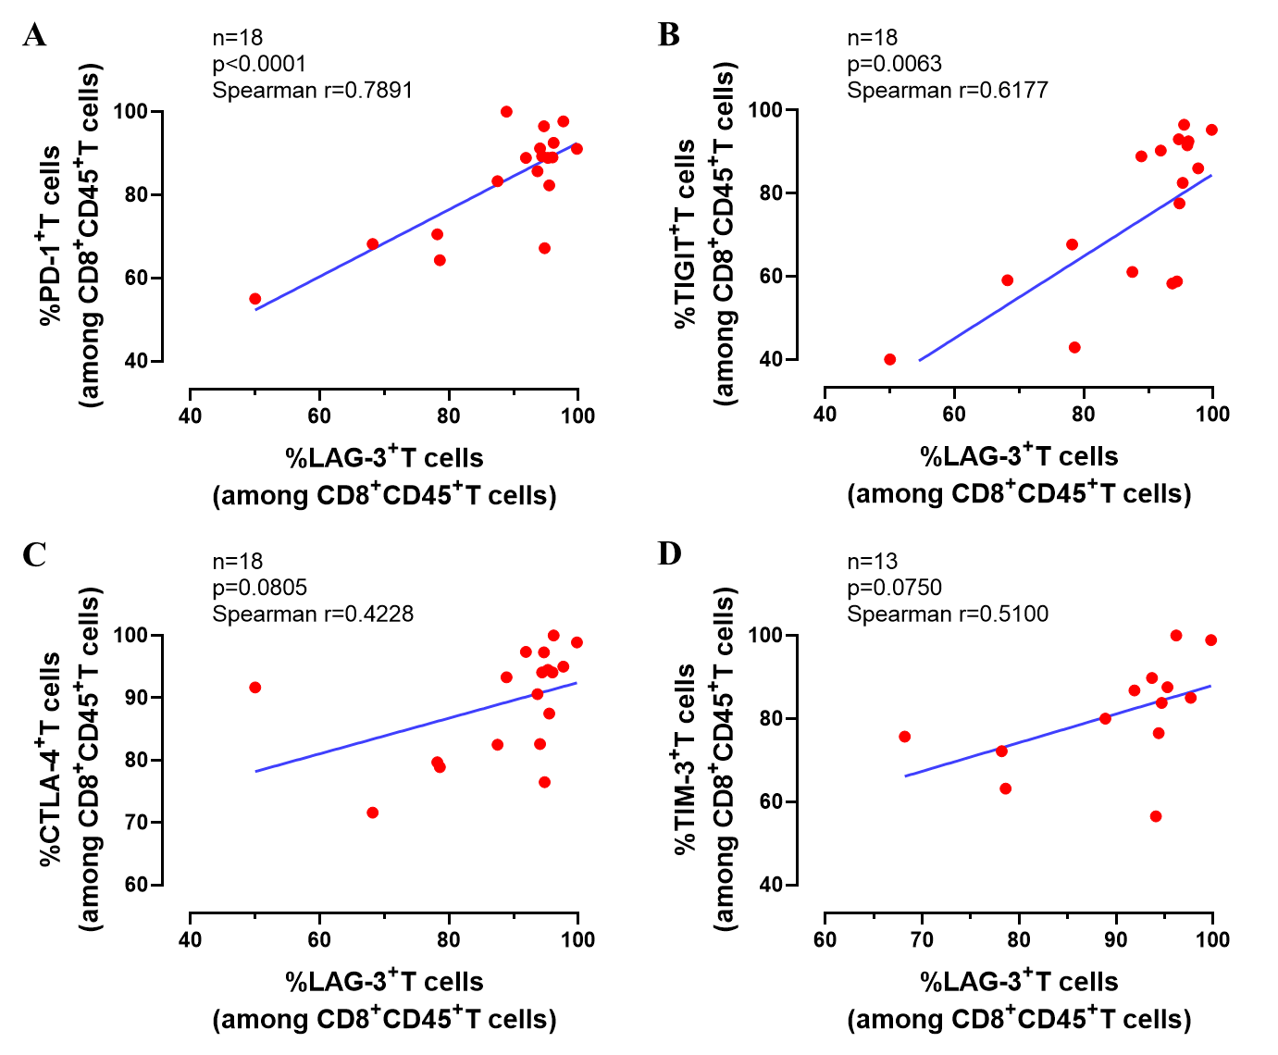
Supplement Figure 1. Relationship of LAG-3+ T-cells proportion and other immune checkpoint markers of CD8+ T-cells (PD-1, TIGIT, CTLA-4 and TIM-3) via FCM analyses.
Relationship of LAG-3⁺ T-cells proportion and other immune checkpoint markers of CD8⁺ T-cells (PD-1, TIGIT, CTLA-4 and TIM-3) via FCM analyses. Correlation was assessed by Spearman’s correlation analysis and linear regression analysis.

