Supplementary Information for
Group interaction field for learning and explaining pedestrian anticipation

Xueyang Wang^{1,2,3,†}, Xuecheng Chen^{3,†}, Puhua Jiang^{3,†}, Xiaoyun Yuan^{1,2,4}, Mengqi Ji⁵, Ruqi Huang³, Lu Fang^{1,2,4,*}
¹ Sigma Laboratory, Department of Electronic Engineering, Tsinghua University, Beijing, China.
² Beijing National Research Center for Information Science and Technology (BNRist), Beijing, China.
³ Tsinghua Shenzhen International Graduate School, Shenzhen, China.
⁴ Institute for Brain and Cognitive Science, Tsinghua University (THUIBCS), Beijing, China.
⁵ Institute of Artificial Intelligence, Beihang University (BUAA), Beijing, China
† These authors contributed equally to this work.
* Corresponding author. Email: fanglu@tsinghua.edu.cn.

Outline
Supplementary Fig. S1. GIF for crowd-aware robot navigation.
Supplementary Fig. S2. Statistics of the groups and interactions in the PANDA dataset.
Supplementary Fig. S3. Influence of grouping and interaction on the spatial structure of pedestrian pairs.
Supplementary Fig. S4. Experimental results on the proxemics field and the attention field.
Supplementary Fig. S5. Ablation analysis of the network.
Supplementary Fig. S6. Analysis of the proxemics field.
Supplementary Fig. S7. Visualization of the proxemics field.
Supplementary Fig. S8. Visualization of the attention field.
Supplementary Fig. S9. Visualization of neighbour weights.
Supplementary Table S1. Simulation parameters of the canvas and the universal law policy.
Supplementary Table S2. Quantitative results of the path efficiency of agents of our experiments.
Supplementary Table S3. Quantitative results of the attention irregularity of agents of our experiments.
Supplementary Note 1. Supplementary description for GIF-based robot navigation.
Supplementary References

Supplementary Figures
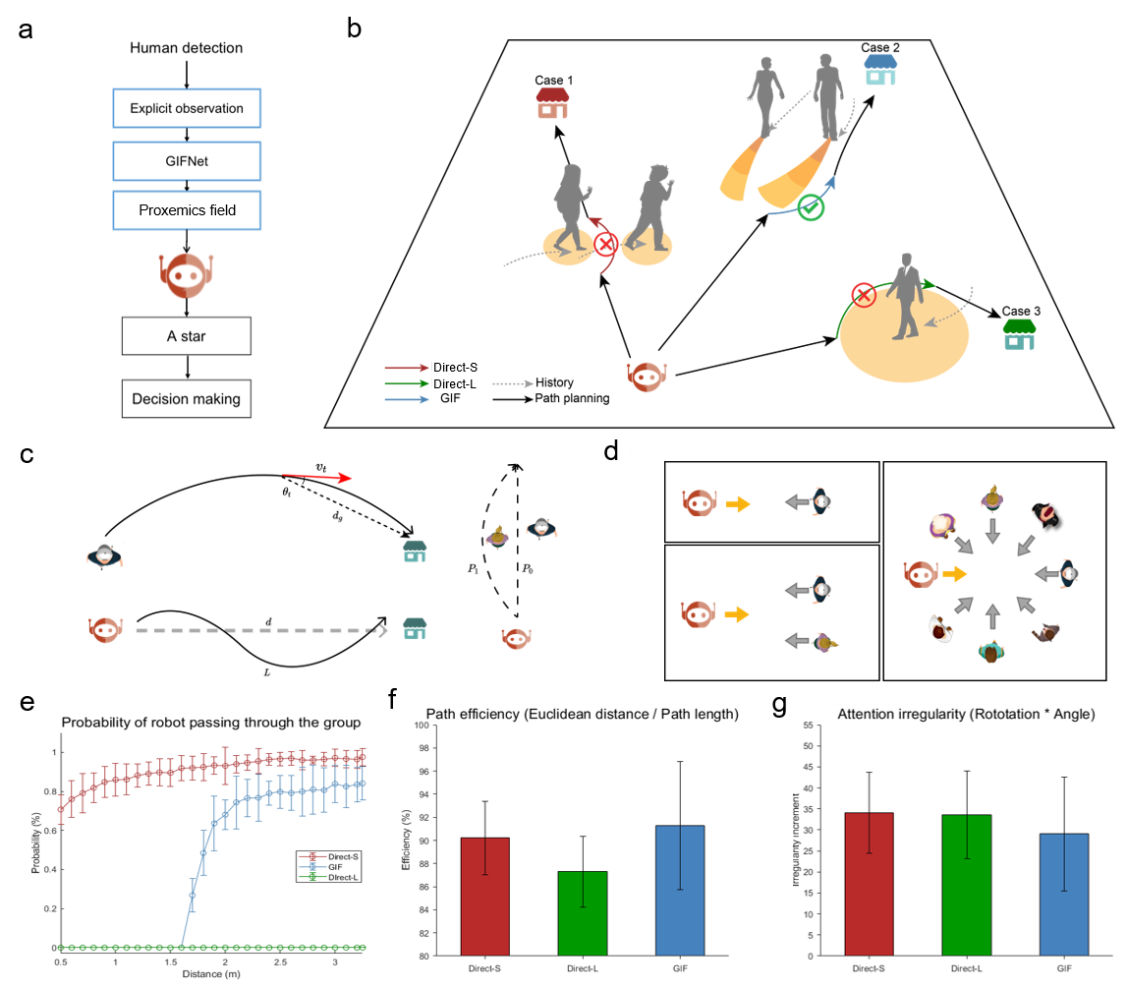 Figure S1 | GIF for crowd-aware robot navigation. a. Illustration of the pipeline of the GIF-based robot navigation. Our method uses the GIF to guide robot path planning. b. Illustration of three different path planning methods in our experiments. The ‘Direct-S’ and the ‘Direct-L’ method are widely used robot-navigation approaches which treat pedestrians as simple circular obstacles¹. The ‘Direct-S’ method treats pedestrians as small circular obstacles and often cause robots to disturb pedestrians. The ‘Direct-L’ method treats pedestrians as large circular obstacles, resulting in sacrifices in navigation efficiency and a longer path. The ‘GIF’ method treats the range of the predicted proxemics field as an obstacle. To ensure a fair comparison, we adopt the classic A-star path planning method to evaluate the performance of three methods (See the Supplementary Note 1). c. Three metrics are used for evaluation. The robot path efficiency¹ is the ratio between the robot’s Euclidean distance $d$ to the goal and the actual travelled distance $L$, which measures the robot navigation efficiency. The attention irregularity is the sum of the pedestrians’ unnecessary rotation angle ($θ_{t}$, the inner angle the direction of destination$d_{g}$ and direction of current speed $v_{t}$) caused by the robot, which measures the robot's disturbance to pedestrians. The probability of the robot passing through the group $P_{0}$ is used to measure the disturbance of the robot to the pedestrian group. d. Illustration of the layout of our experiments. We evaluate three methods under three different scenarios: one robot with one person, one robot with two persons, and one robot with multiple persons. e. The probability of the robot passing through a two-person group v.s. the distance between the two-person group. Our group-aware method can accurately identify groups (whose inner distance is usually less than 1.5 m) and avoid robots passing through them. fg. A comparison of the path efficiency and attention irregularity. Our GIF-based method has the highest path efficiency and the lowest attention irregularity, which suggests that our method effectively avoids robots disturbing pedestrians while maintaining the robot's driving efficiency. The error bars represent the s.d.. See the Supplementary Note 1 for more details on the robot simulation experiments. The parameters used in the experiment are presented in Tables S1-3.

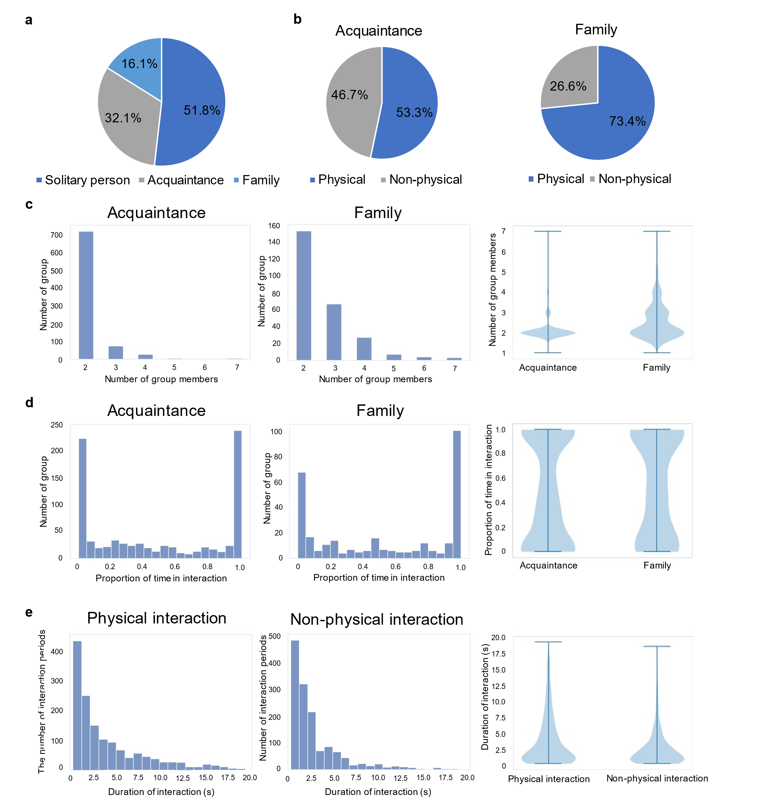
Figure S2 | Statistics of the groups and interactions in the PANDA dataset². a. Distribution of the group status of all pedestrians in the dataset. Nearly half of all pedestrians are in groups. b. Distribution of categories of interactions that occur in the acquaintance group and the family group. The proportion of physical interaction is higher in the family groups. c. Distribution of the number of members in acquaintance groups and family groups. The violin plot shows that the acquaintance groups are mostly made up of two people, while the family groups are more likely to have more members. d. Distribution of the proportion of interaction time in the total time for the acquaintance group and the family group. The violin plot shows that the proportion of no interaction or little interaction (interacting time is less than 40%) in the family group is lower than that in the acquaintance group. e. Distribution of durations of physical and non-physical interactions. The violin plot shows that the proportion of long interaction (longer than 7 s) in physical interaction is higher than that in non-physical interaction.

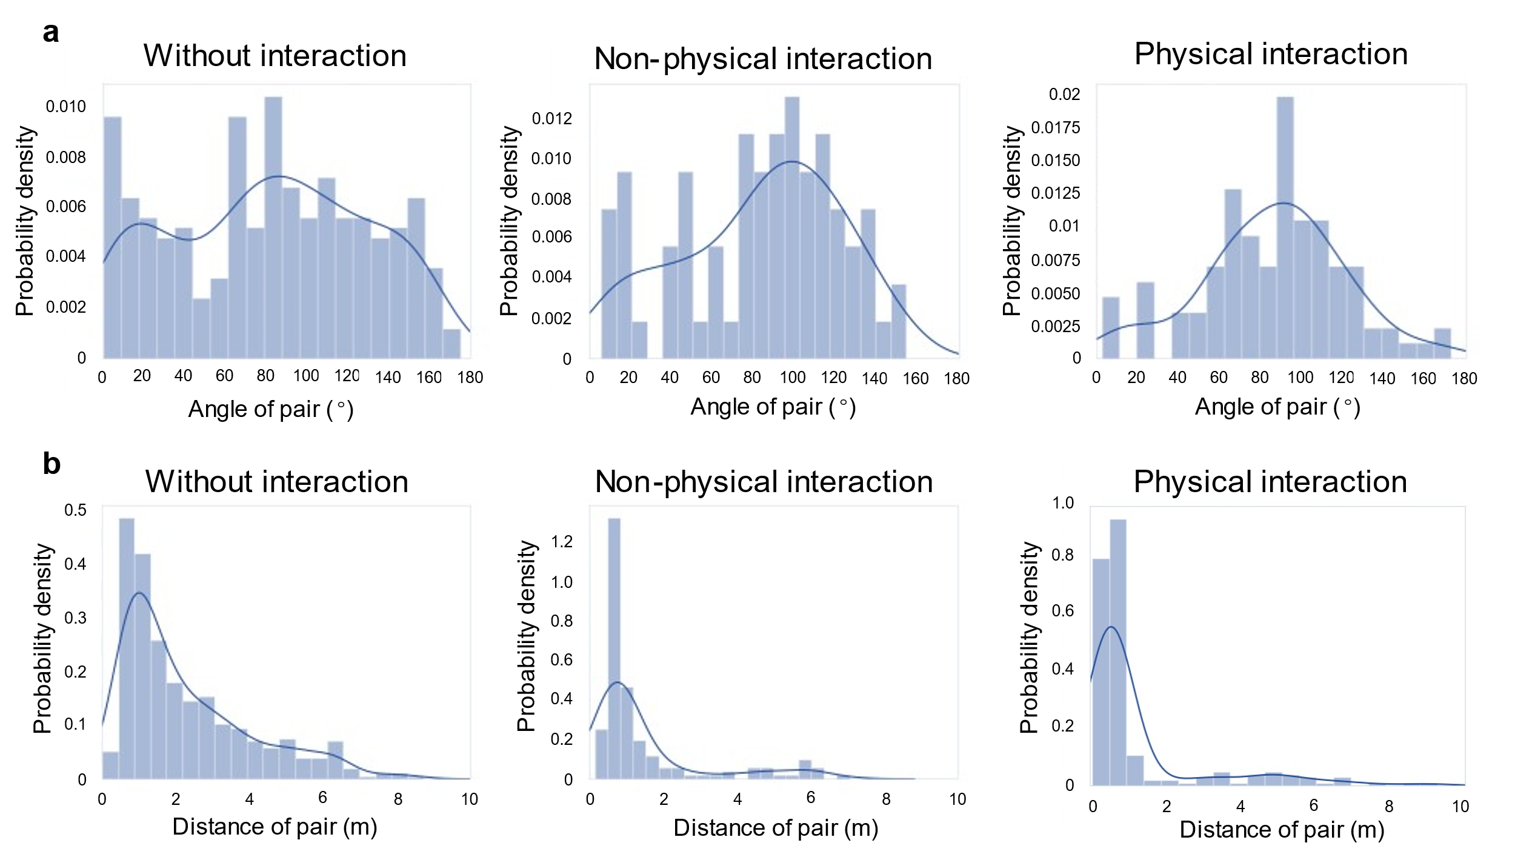
Figure S3 | Influence of grouping and interaction on the spatial structure of pedestrian pairs. a. Distribution of the inner angle between the group neighbour direction and forward direction ($θ_{p}$ in Fig.3f) for pedestrian pairs with no, non-physical, and physical interaction. The angles of pedestrian pairs with physical and non-physical interactions are clustered at ~90°, while the angles of pedestrian pairs without interactions are significantly smaller (p < 0.001, N = 3668, single-side Mann–Whitney U test) and more scattered, showing that pedestrian pairs in interaction tend to walk in parallel. Deep blue curves are kernel density estimations, showing the continuous distributions of probability. b. Distribution of the spatial distance between pedestrian pairs under the same three interaction conditions. The distances between pedestrian pairs with physical interaction, non-physical interaction, and no interaction increase significantly (both p < 0.001, N = 3668, single-side Mann–Whitney U test), showing that the pedestrian pairs with interactions are more concentrated than those without interaction, and compared with pairs with non-physical interaction, pairs with physical interaction are closer.

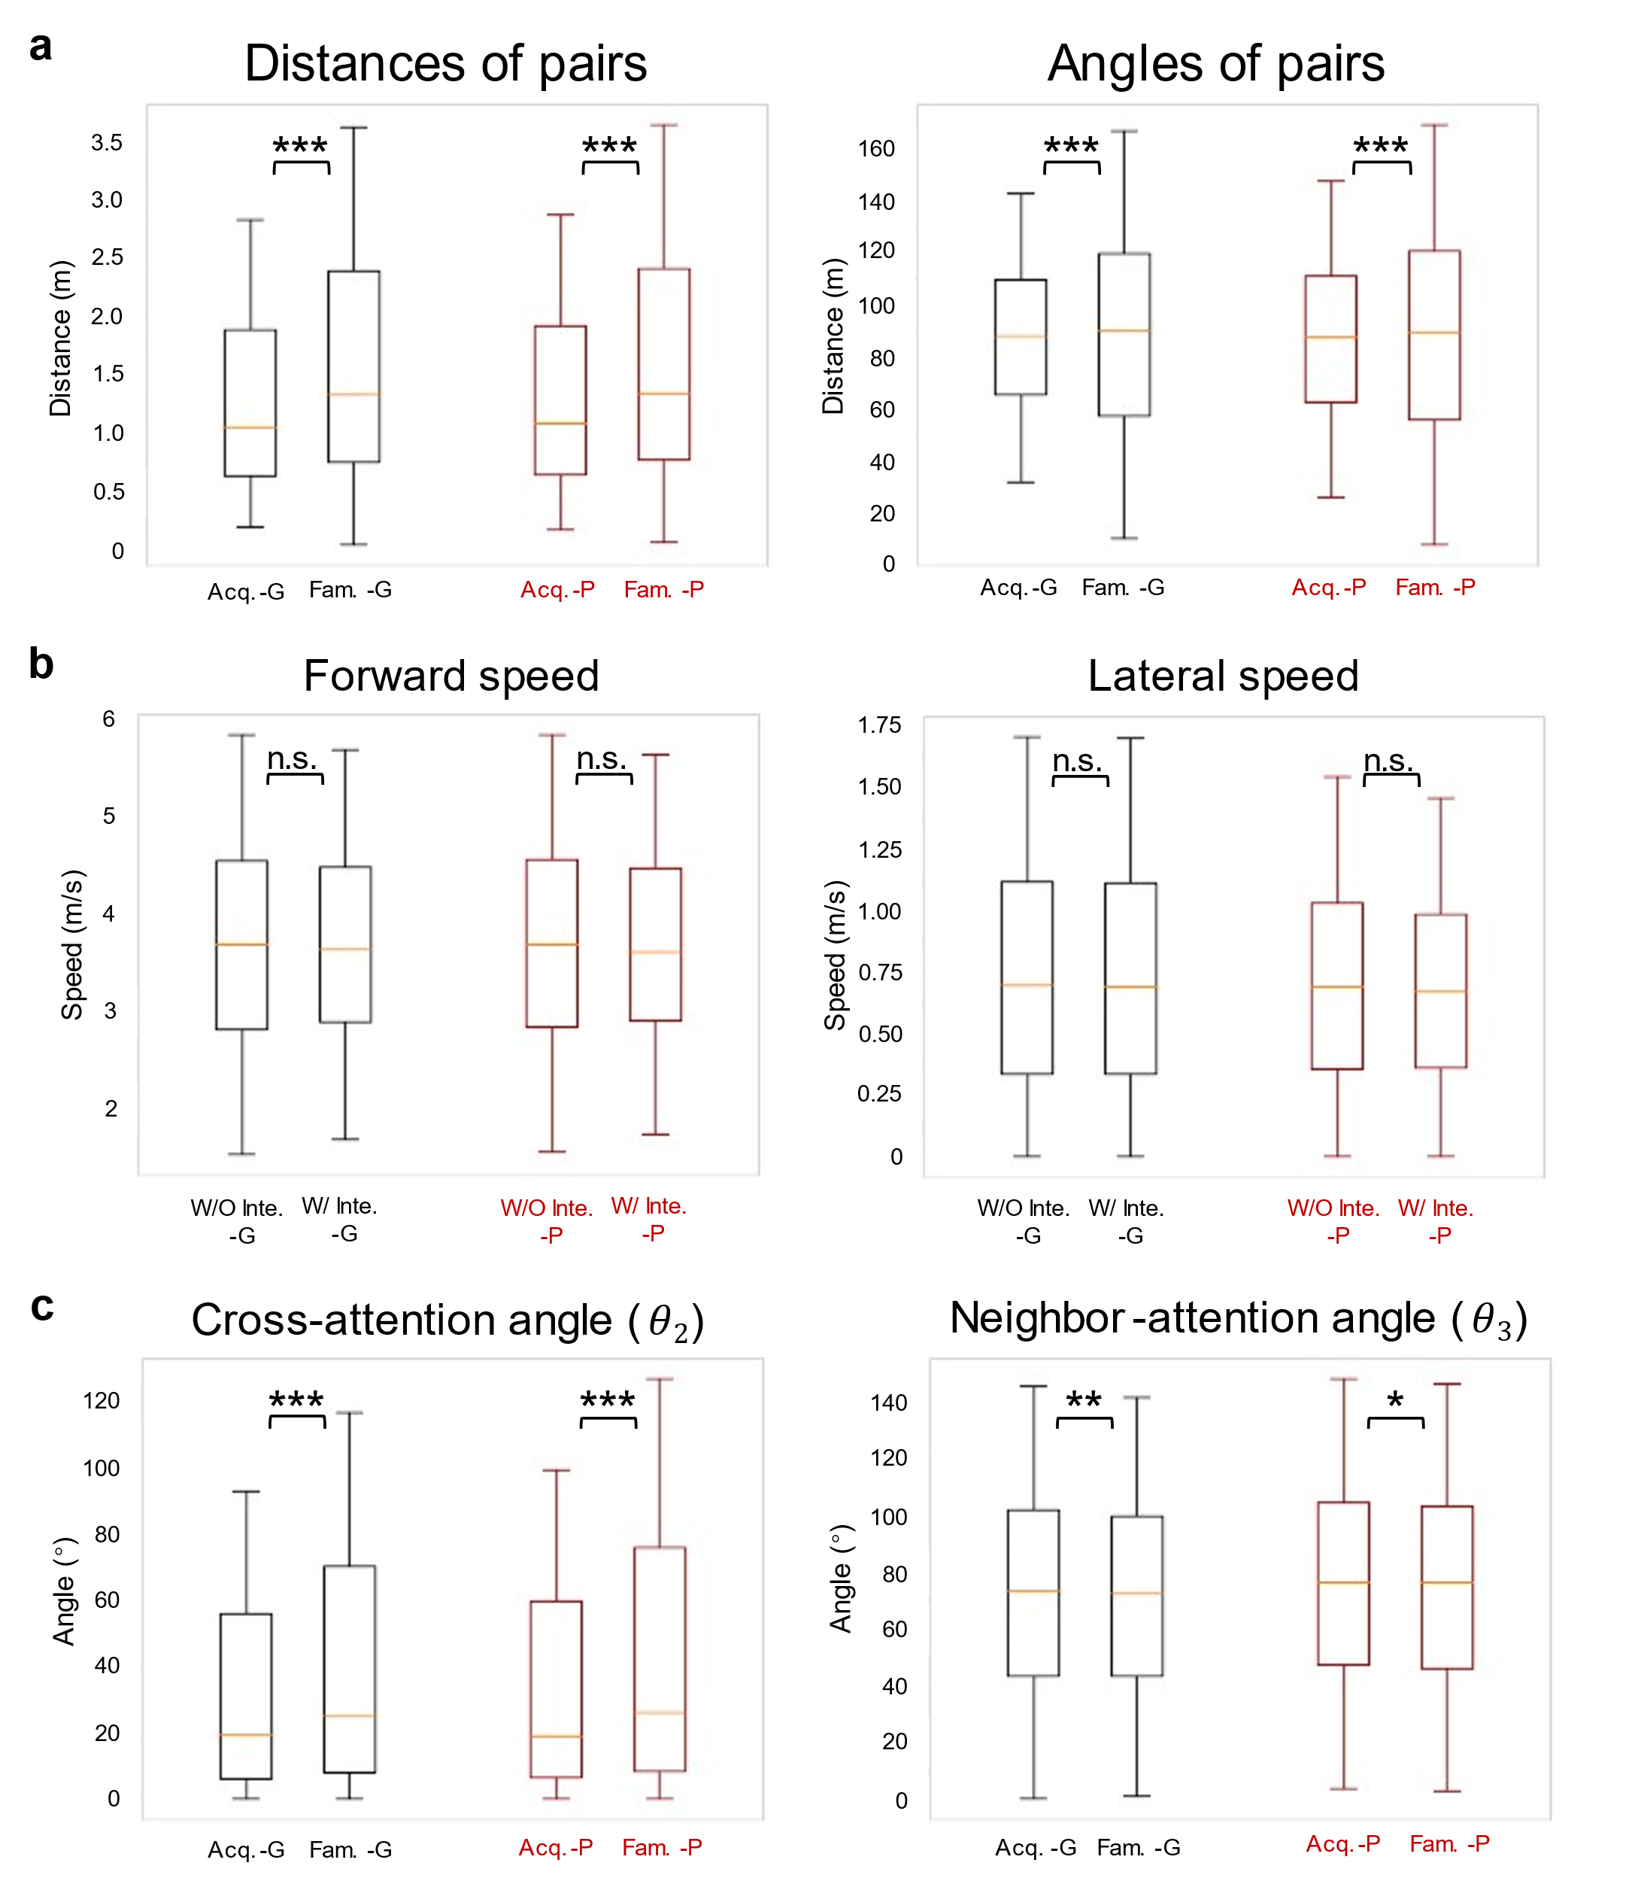
Figure S4 | Experimental results on the proxemics field and the attention field. a. Boxplot of the pair-wise distance and angle ($θ_{p}$ in Fig. 3f) of pedestrians in the acquaintance group and the family group. The distances between pedestrian pairs in the acquaintance group are significantly less than those in the family group (p < 0.001, N = 21112). The angles of pedestrian pairs in the acquaintance group and the family group are clustered at ~90°, and the angles of pedestrian pairs in the acquaintance group are also significantly less than those in the family group (p < 0.001, N = 21112). b, Boxplot of the forward and lateral speeds of pedestrians with or without interaction; there is no significant difference (p > 0.05, N = 7778). c. Distribution of the ground-truth and predicted cross-attention angle ($θ_{2}$ in Fig. 4c) and neighbour-attention angle ($θ_{3}$ in Fig. 4c) for the acquaintance group and the family group. The cross-attention angle of pedestrian pairs in the acquaintance group is significantly smaller than that in the family group (p < 0.001, N = 12946), and the neighbour-attention angle of pedestrian pairs in the acquaintance group is larger than that in the family group (p < 0.05 for both the ground truth and the prediction, N = 12946). The above results indicate that the pedestrian in the acquaintance groups tends to focus on the direction forward (cross-attention angles close to 0° and neighbour-attention angles close to 90°), while the pedestrian in the family groups is more likely to look at each other. This is consistent with Fig. 4de because family members are more likely to interact with each other physically, while acquaintances are almost equally likely to interact with each other physically and non-physically (Fig. S2b). ***, p < 0.001; **, p < 0.005; *, p < 0.05; n.s., no significance, single-sided Mann–Whitney U test. Fam., family. Acq., acquaintance. Inte., interaction. W/, With. W/O, Without. G, ground truth. P, prediction.

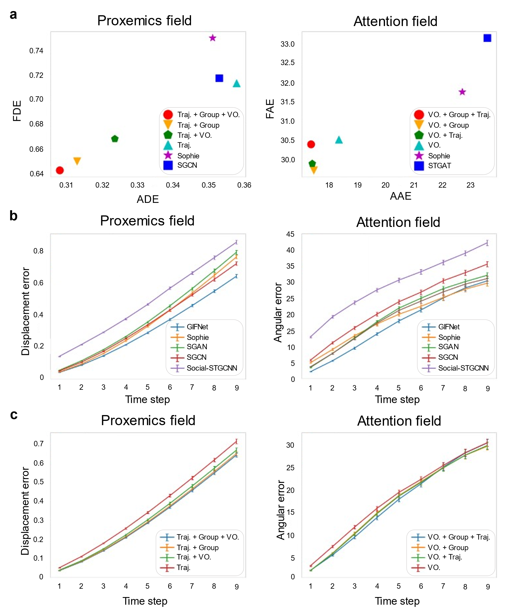
Figure S5 | Ablation analysis of the network. a. Left: Comparison of GIFNet with no visual orientation information, no group interaction information, and neither on the prediction of the proxemics field. In addition, the two best-performing baseline methods, Sophie and SGCN, are compared. The ADE and FDE are adopted as evaluation metrics. Right: Comparison of GIFNet with no trajectory information, no group interaction information, and neither on the prediction of the attention field. In addition, the two best-performing baseline methods, Sophie and STGAT, are compared. The AAE and FAE are adopted as evaluation metrics. b. Comparison of the error of the GIFNet and other baseline methods on each time step to predict (time span $T = 3 s$ and temporal resolution $R = 1/3 s$, 9 time steps in total). For proxemics field prediction, GIFNet performs best at every time step. For the prediction of attention field, GIFNet performed best in the first 6 time steps, and was slightly worse than Sophie in the last 3 time steps. c. Ablative comparison of GIFNet on each time step to predict (time span $T = 3 s$ and temporal resolution $R = 1/3 s$, 9 time steps in total). Left: Comparison of GIFNet with no visual orientation information, no group interaction information, and neither on the proxemics field prediction. Right: Comparison of GIFNet with no trajectory information, no group interaction information, and neither on the attention field prediction. For the proxemics field prediction, the visual orientation information input and the group interaction information input improve the performance at every time step. For the attention field prediction, the trajectory information input and the group interaction information input improve the performance in the first 6 time steps. The error bars represent the s.e.m.. Traj., trajectory. VO., visual orientation.

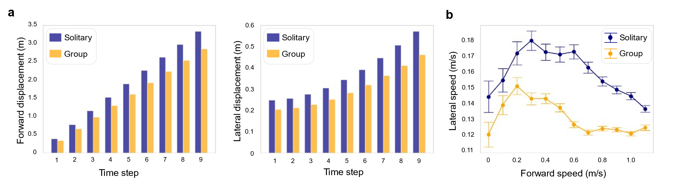
Figure S6 | Analysis of the proxemics field. a. Statistical analysis of the proxemics field of solitary pedestrians and group members. Bars show the average displacement in the forward direction and lateral direction at each time step (time span $T = 3 s$ and temporal resolution $R = 1/3 s$, 9 time steps in total). In both the forward direction and the lateral direction, the solitary persons walk farther than the group members at each time step, which is consistent with Fig.3bc. b. For solitary persons and group members, when the forward speed is the same, we compare the value of the lateral speed. The lateral speed of the solitary person is greater than that of the group members, indicating that the proxemics fields of solitary pedestrians are more dispersed than those of grouped pedestrians, i.e., the movement of solitary pedestrians has higher uncertainty. The error bars represent the s.e.m..

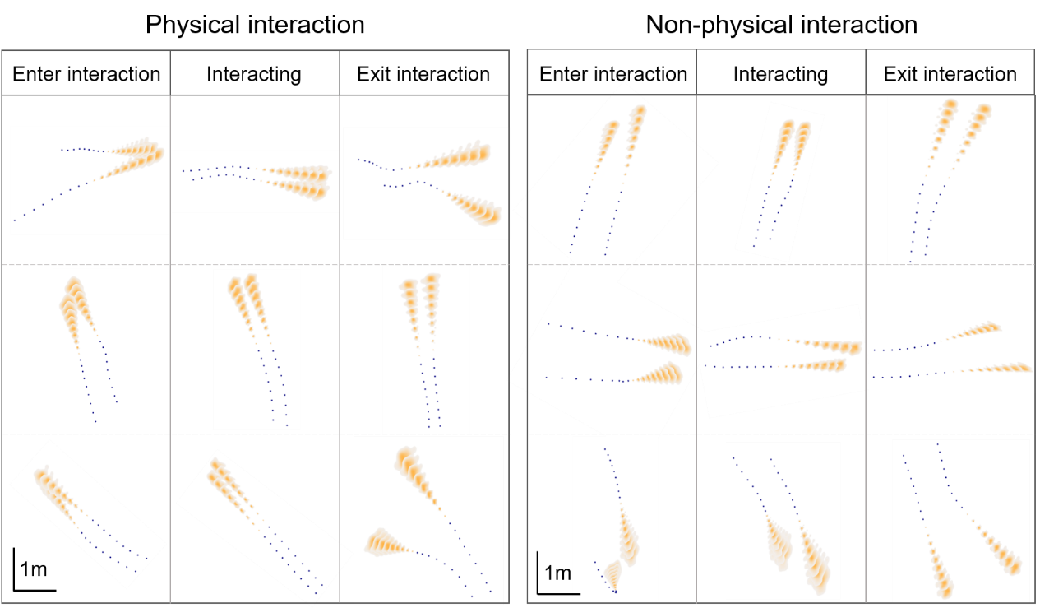
Fig. S7 | Visualization of the proxemics field. Visualization of the proxemics field when initiating the interaction, interacting, and ceasing interaction. Blue points are input observations, and orange fields are the predicted probability density of the future location at each time step (time span $T = 3 s$ and temporal resolution $R = 1/3 s$, 9 time steps in total). Representative fields show similar behaviour patterns: when the pedestrians start to interact, they move closer to each other; during the interaction, the distance remains stable; when ceasing interaction, the pair tends to separate. It is worth pointing out that for the last example of non-physical interaction, GIFNet accurately predicted when the interaction started that the pedestrian originally in front turned around and had an interaction with the companion. Compared with non-physical interaction, pedestrian pairs with physical interaction have smaller pair-wise distances.

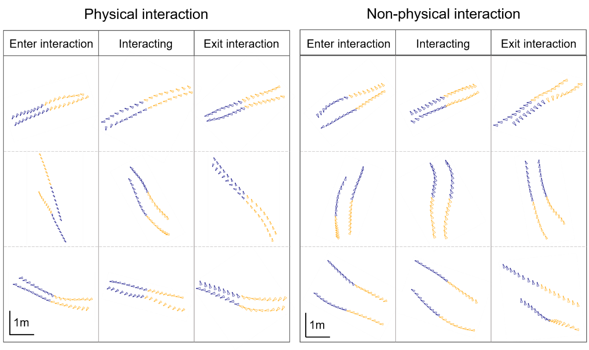
Fig. S8 | Visualization of the attention field. Visualization of the attention field when initiating interaction, interacting, and ceasing interaction. Blue fans are input observations, and their centre is the spatial position of pedestrians and their direction towards attention orientation. The orange fans are predictions for future time steps (time span $T = 3 s$ and temporal resolution $R = 1/3 s$, 9 time steps in total). As can be seen from the attention fields, when the pedestrian pairs start to interact, they tend to look at each other; during the interaction, both look forward, sometimes look at each other (more often during non-physical interactions); when ceasing interaction, they look at each other again and then turn to forward orientations.

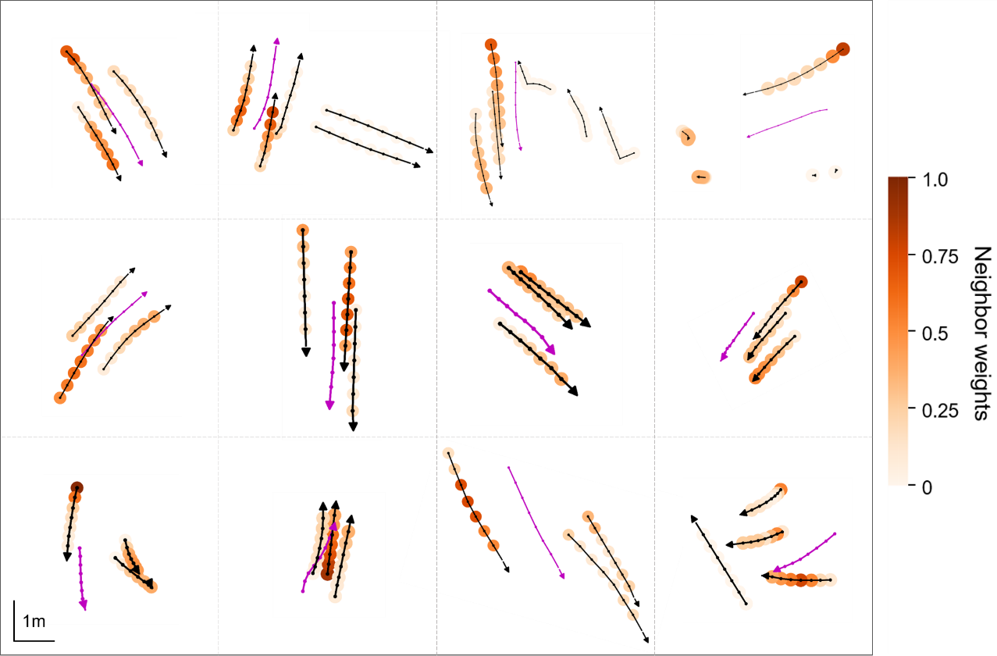
Fig. S9 | Visualization of neighbour weights. Visualization of neighbour weights output by GIFNet. Magenta arrows are the trajectories of the pedestrians of interest, which point in the forward direction. Each small magenta circle denotes the position of the pedestrian at that time point. Black arrows are the trajectory of group neighbours. The colour of the small circle represents the weight of each neighbour at each time step. From the figure above, GIFNet reasonably assigns weights to different neighbours and dynamically adjusts the assignment at every time step based on the relative distance between pedestrians and the group interaction state. High weights are assigned to neighbours that the network believes are more likely to have an impact on pedestrians of interest. For example, in the upper-left example, the high weight is assigned to the leftmost neighbour rather than the nearest neighbour because the pedestrian of interest starts interacting with the leftmost pedestrian; in the lower-right example, as the pedestrian of interest and the neighbour below approach each other, the weight assigned to that neighbour increases dynamically.

Parameter Name | Parameter Value
Map Length (m) | 60
Map Width (m) | 40
Timestep (s) | 0.25
Proportional Scale | 20
Robot velocity (p/s) | 7
Neighbour search range (m) | 10
Goal velocity speed (per step) | 0.7275
Max force | 5
Single person radius (m) | 0.5
End threshold (m) | 0.5
Neighbour angle (degree) | 60
View angle (degree) | 120
Table S1: Simulation parameters of the canvas and the universal law policy

 | 1 vs. 1 |  | 1 vs. 2 |  | 1 vs. 7
 | robot | pedestrian | robot | pedestrian | robot | pedestrian
No robot | 1.000 | 0.961 | 1.000 | 0.945 | 1.000 | 0.872
Naive-S | 0.954 | 0.883 | 0.987 | 0.890 | 1.000 | 0.833
Naive-L | 0.797 | 0.968 | 0.856 | 0.955 | 0.880 | 0.852
GIF | 0.898 | 0.970 | 0.913 | 0.955 | 0.943 | 0.867
Table S2: Quantitative results of the path efficiency of agents of our experiments.

 | 1 vs. 1 |  | 1 vs. 2 |  | 1 vs. 7
 | robot | pedestrian | robot | pedestrian | robot | pedestrian
No robot | 0.000 | 160.221 | 0.000 | 111.526 | 0.000 | 145.304
Naive-S | 37.699 | 238.973 | 62.831 | 137.432 | 4.712 | 158.584
Naive-L | 50.687 | 212.539 | 85.927 | 125.634 | 38.026 | 152.490
GIF | 41.239 | 210.470 | 74.367 | 125.634 | 33.391 | 150.019
Table S3: Quantitative results of the attention irregularity of agents of our experiments.

Supplementary Notes
Supplementary Note 1 Supplementary description for GIF-based robot navigation
Crowd-aware robot-navigation experimental design. To simulate the moving process of robots and humans, we first initialize a blank map M as the scene. Then, the initial birth location $P=\left(x_{p},y_{p}\right)$ and the destination location $D=\left(x_{d},y_{d}\right)$ of robots and humans are generated in M. Locations P and D are designed to allow robots and humans to have the chance to collide during walking. P and D are specific locations. In our repeat experiments, we will randomly modify the P and D to ensure generalizability.
The simulation step $Δt$ is set to 0.25 s. People move according to the universal power law model³, and the robot follows the path generated by A-star. The velocity of the robots is 1.4 m/s, which is the preferred walking speed of humans.
In the universal power law model, a pedestrian’s motion is influenced by their goals and other pedestrians. For each pedestrian, there is a driving force $F_{D}$ from the destination:
$$F_{D}=\frac{v_{g}-v_{t}}{2}$$
where $v_{g}$ is a constant parameter representing the goal velocity and $v_{t}$ is the velocity at the current time.
The interaction force between the pedestrians is:
$$F_{U}=-∇_{r}\left(\frac{k}{τ^{2}}e^{-τ/τ_{0}}\right)$$
where $∇_{r}$ is the spatial gradient, k is a constant that sets the units for the energy, and $τ$ is the time-to-collision, which is the duration of time for which two agents could continue walking at their current velocities before colliding.
Then, for each step, we can compute the total force of a pedestrian as:
$$F=F_{D}+F_{U}$$
and we can compute the acceleration of the pedestrian from the force and update the velocity $v_{t}$ and location $p_{t}$ of pedestrians:
$$v_{t+1}=v_{t}+F∙Δt$$
$$p_{t+1}=p_{t}+v_{t+1}Δt$$
We assume that the robot's influence on pedestrians obeys the same rule. The parameters of the Universal Power Law are shown in Table S1.
Robot motion model. The robot first rasterizes the entire map 20 times into coordinate system C with a length of 1200 and 800. For each step, the robot considers pedestrians as the obstacles in the map and uses A-star to find the optimal path to the destination.
To let A-star generate the appropriate path, we need to tell robots where the obstacles are and what shape they like. In the direct method, the obstacle is a circle centred in the location of pedestrian. In our method, we use a sector with the same radius as Direct-L to represent the GIF's proxemics field.
Experimental settings. In the experiment of Fig. S1e, we generate a robot and two pedestrians on the map and let them walk towards each other. In each experiment, two pedestrians are generated on a circle of radius $R$, and the distance between them is the diameter of the circle. In the experiment of Fig. S1f and S1g, the initial locations of the people and robots generated by us can be divided into three situations according to the number of people. Please refer to the supplementary materials for details.
Path metrics. The path efficiency $E$ is the ratio between the Euclidean distance d to the goal and the actual travelled distance L:
$$E=\frac{d}{L}×100\%$$
The attention irregularity $I$ is the sum of the angles of unnecessary rotation $θ_{t}$:
$$I=\sum_{t}{θ_{t}}$$
$$θ_{t}=<d_{D},v_{t}>$$
where $θ_{t}$ is the angle between the velocity $v_{t}$ and the destination direction $d_{D}$.

Supplementary References
1. Gul, F., Rahiman, W. & Nazli Alhady, S. S. A comprehensive study for robot navigation techniques. Cogent Eng. 6, (2019).
2. Wang, X. et al. PANDA: A Gigapixel-Level Human-Centric Video Dataset. 3265–3275 (2020) doi:10.1109/cvpr42600.2020.00333.
3. Karamouzas, I., Skinner, B. & Guy, S. J. Universal power law governing pedestrian interactions. Phys. Rev. Lett. 113, 1–5 (2014).

