Supplementary information

Ionospheric elves powered by corona discharges in overshooting thunderclouds

Feifan Liu¹, Torsten Neubert², Olivier Chanrion², Baoyou Zhu¹, Gaopeng Lu¹, Fanchao Lyu³, Christoph Köhn², Krystallia Dimitriadou², Jiuhou Lei^{1,4,5*}, Nikolai Østgaard⁶, and Victor Reglero⁷

1. CAS Key Laboratory of Geospace Environment, School of Earth and Space Sciences, University of Science and Technology of China, Hefei, China.
2. National Space Institute, Technical University of Denmark (DTU Space), Kongens Lyngby, Denmark.
3. Nanjing Joint Institute for Atmospheric Sciences, Nanjing, Jiangsu, China.
4. Mengcheng National Geophysical Observatory, University of Science and Technology of China, Hefei, China.
5. CAS Center for Excellence in Comparative Planetology, Hefei, China.
6. Birkeland Centre for Space Science, Department of Physics and Technology, University of Bergen, Norway.
7. Image Processing Laboratory, University of Valencia, Valencia, Spain.

Corresponding author: Jiuhou Lei (leijh@ustc.edu.cn)
Figures and notes
This supporting information shows the radio signals of the negative NBEs recorded by four stations (Fig S1). Figures S2-S5 present the optical and radio signals for the two negative NBEs associated with elves, not presented in the main text.
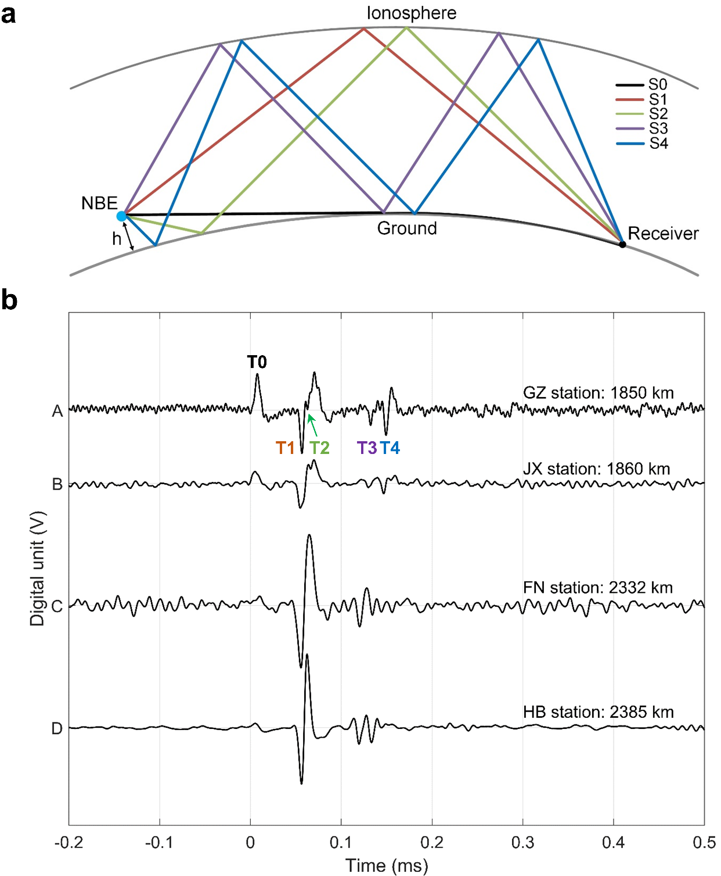
Supplementary Figure 1 | Propagation path of radio signals observed by the ground-based receiver. a The black line represents the ground-wave path of radio signals. Other colors present the ionospheric 1st-4st reflected waves. b The radio signals of negative NBEs were observed by four VLF/LF stations at 17:13:11.152780 UTC on August 28, 2020.
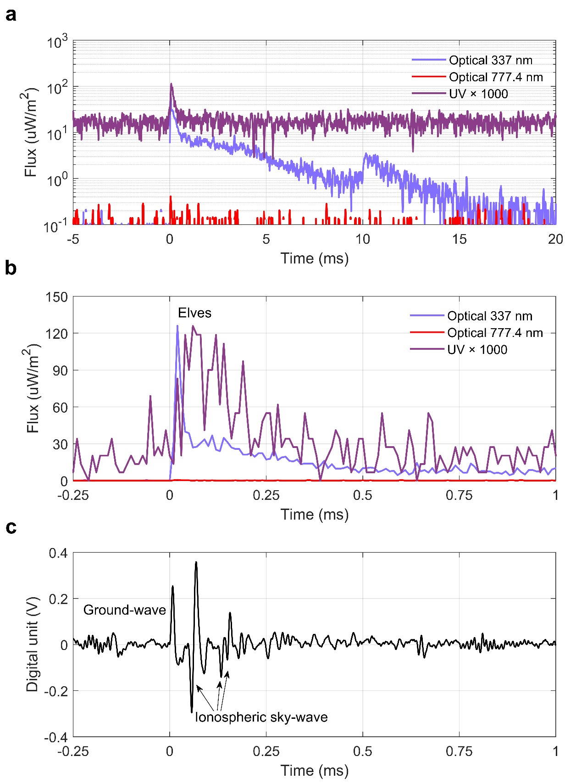
Supplementary Figure 2 | Light curves and radio signals of negative NBEs associated with elves at 17:13:53.881240 UTC on August 28, 2020. a The photometer signal on a logarithmic scale. b The same data zoomed-in view. c The associated radio waveforms of negative NBEs recorded by the GZ station.
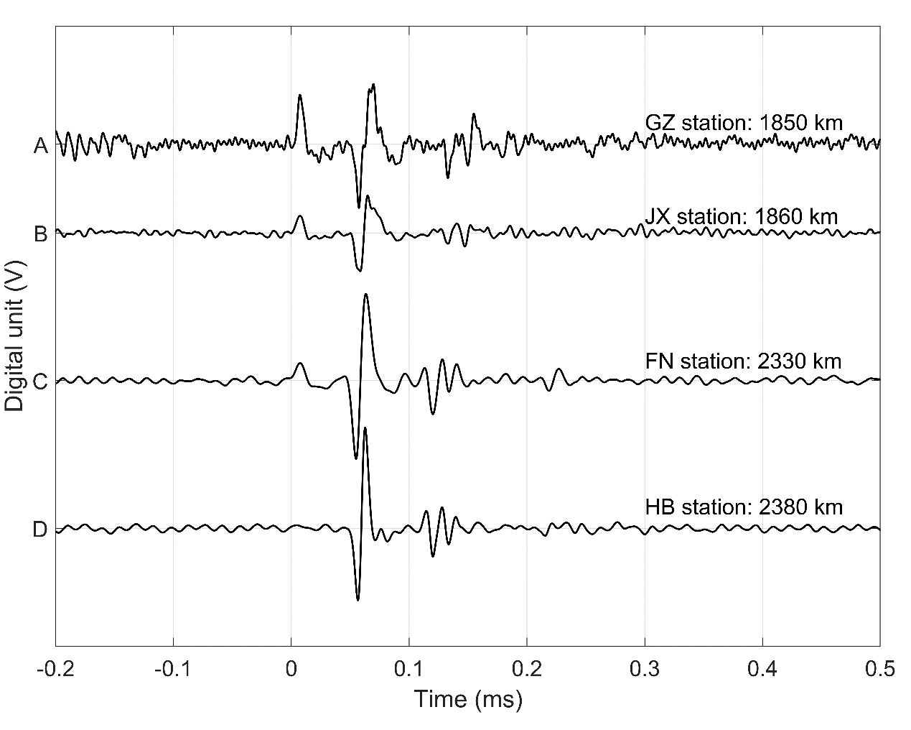
Supplementary Figure 3 | The radio signals of negative NBEs observed by four VLF/LF stations at 17:13:53.881240 UTC on August 28, 2020.
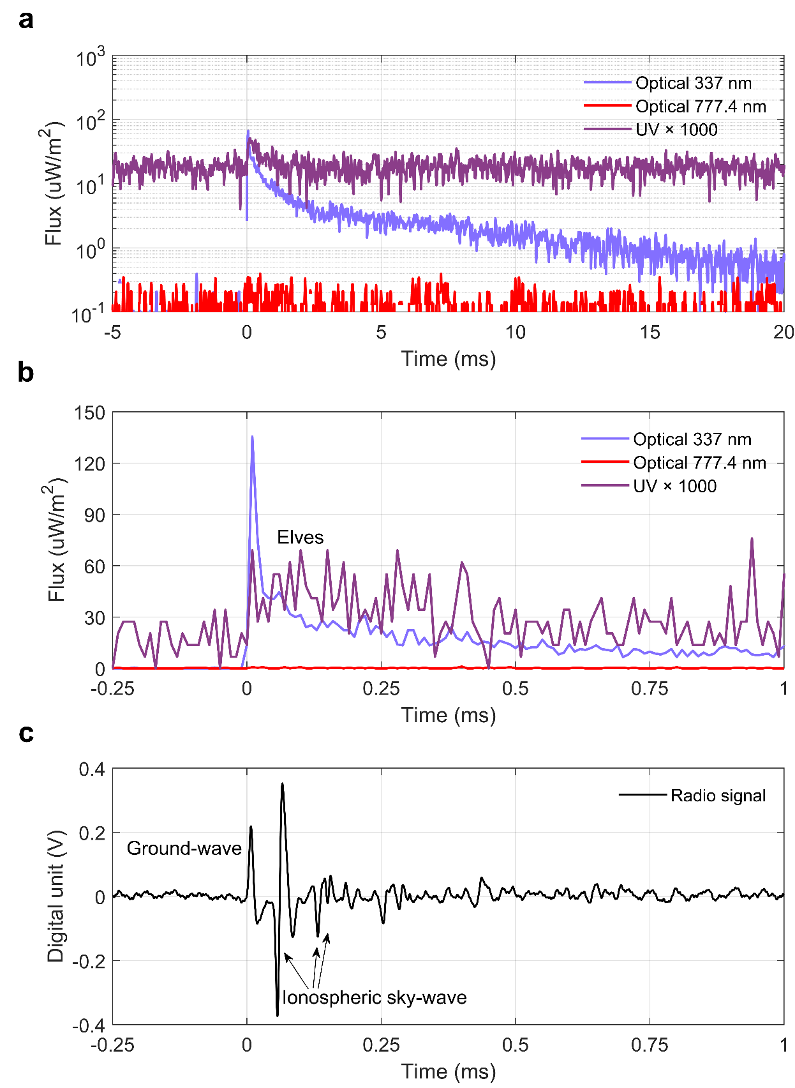
Supplementary Figure 4 | Light curves and radio signals of negative NBEs associated with elves at 17:12:59.355460 UTC on August 28, 2020. a The photometer signal on a logarithmic scale. b The same data zoomed-in view. c The associated radio waveforms of negative NBEs recorded by the GZ station.
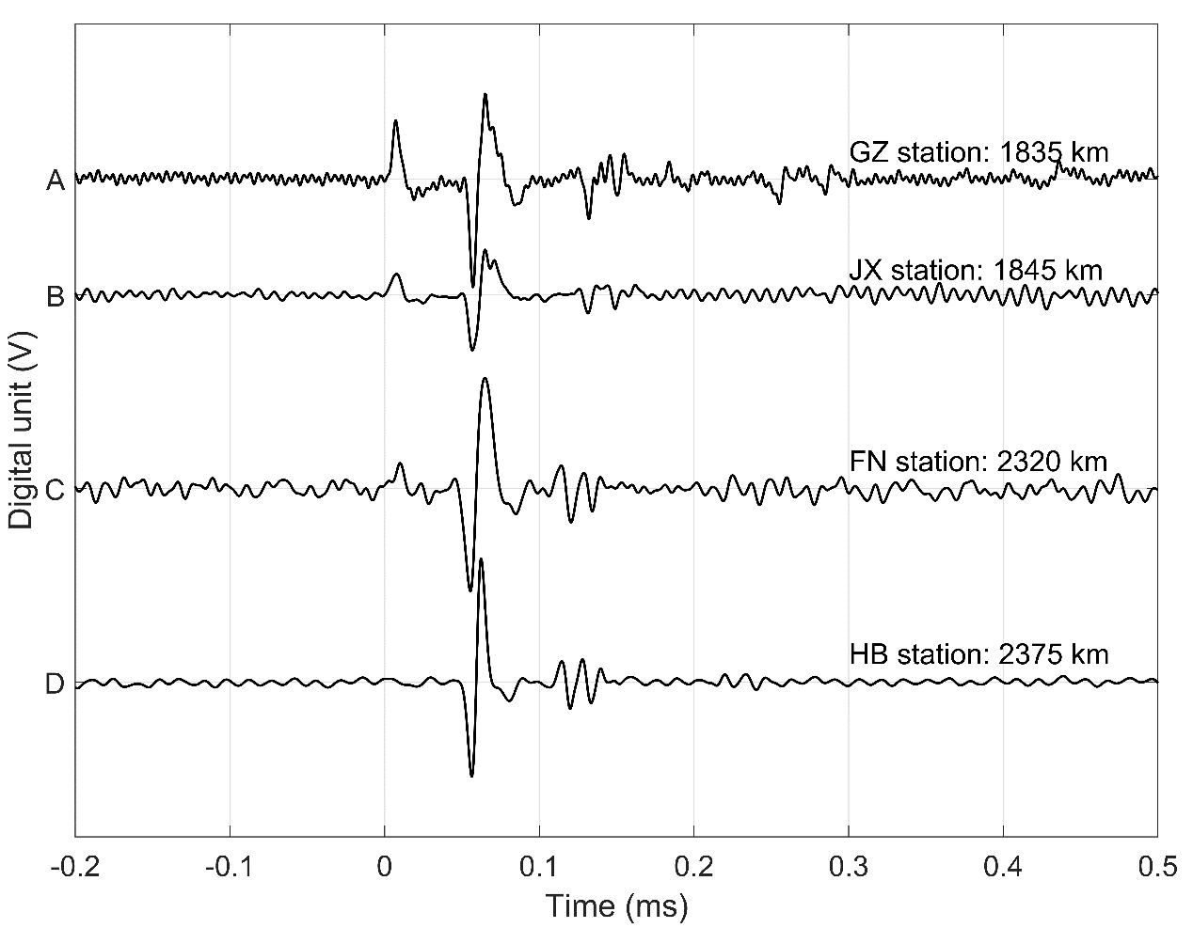
Supplementary Figure 5 | The radio signals of negative NBEs observed by four VLF/LF stations at 17:12:59.355460 UTC on August 28, 2020.

