Supplemental Figures:

Figure 1s (supplemental): Threshold-free Maps Showing Correlation Between ScreenQ Scores and Cortical Thickness
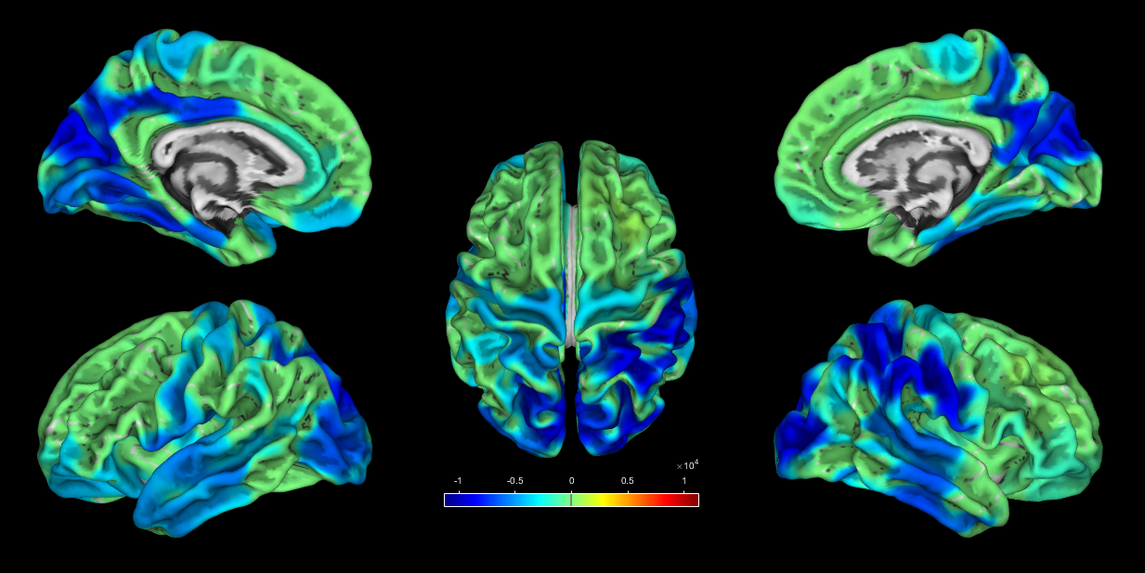
Figure 1s (supplemental): Map of the Threshold Free Cluster Enhancement (TFCE) statistic of association between cortical thickness (CT) and total ScreenQ score, with no significance threshold applied. Upper views are medial, lower views are lateral and central view is superior with frontal lobe facing upward.

Figure 2s (supplemental): Threshold-free Maps Showing Correlation Between ScreenQ Scores and Sulcal Depth
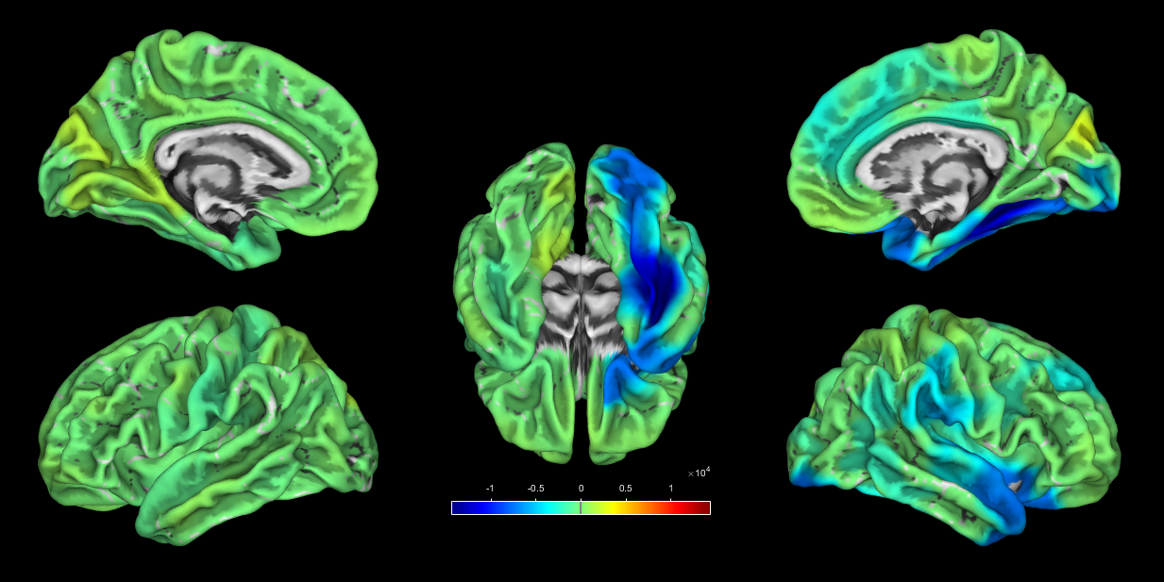
Figure 2s (supplemental): Map of the Threshold Free Cluster Enhancement (TFCE) statistic of association between sulcal depth (SD) and total ScreenQ score, with no significance threshold applied. Upper views are medial, lower views are lateral and central view is inferior with occipital lobe facing upward.

