Table S1 Phenotype of F₂ population and corresponding F_{2:3} families used for genetic analysis.
ID | Phenotype |  |  | ID | Phenotype |  |  | ID | Phenotype
ID | F₂ | F_{2:3} |  | ID | F₂ | F_{2:3} |  | ID | F₂ | F_{2:3}
1 | 0.31 | H |  | 91 | 0.22 | H |  | 181 | 0.67 | H
2 | 0.00 | non-PS |  | 92 | 0.67 | H |  | 182 | 0.67 | H
3 | 0.72 | PS |  | 93 | 0.82 | H |  | 183 | 0.00 | non-PS
4 | 0.88 | H |  | 94 | 0.65 | H |  | 184 | 0.00 | non-PS
5 | 1.00 | PS |  | 95 | 0.00 | non-PS |  | 185 | 0.65 | H
6 | 0.00 | non-PS |  | 96 | 0.61 | PS |  | 186 | 0.63 | H
7 | 0.50 | H |  | 97 | 0.76 | H |  | 187 | 0.88 | PS
8 | 0.00 | non-PS |  | 98 | 0.00 | non-PS |  | 188 | 0.00 | non-PS
9 | 0.47 | H |  | 99 | 0.28 | H |  | 189 | 0.00 | non-PS
10 | 0.00 | non-PS |  | 100 | 0.00 | non-PS |  | 190 | 0.46 | H
11 | 0.63 | PS |  | 101 | 0.00 | non-PS |  | 191 | 0.59 | PS
12 | 0.35 | H |  | 102 | 0.44 | PS |  | 192 | 0.76 | H
13 | 1.00 | PS |  | 103 | 0.88 | H |  | 193 | 0.00 | non-PS
14 | 0.86 | H |  | 104 | 0.92 | H |  | 194 | 0.67 | H
15 | 0.75 | PS |  | 105 | 0.78 | H |  | 195 | 0.83 | H
16 | 0.47 | H |  | 106 | 0.00 | non-PS |  | 196 | 0.91 | PS
17 | 0.00 | non-PS |  | 107 | 0.78 | PS |  | 197 | 0.91 | H
18 | 0.26 | H |  | 108 | 0.79 | H |  | 198 | 0.74 | H
19 | 0.00 | non-PS |  | 109 | 0.80 | PS |  | 199 | 0.75 | PS
20 | 0.44 | H |  | 110 | 0.86 | H |  | 200 | 0.80 | H
21 | 0.82 | PS |  | 111 | 0.87 | H |  | 201 | 0.60 | H
22 | 0.00 | non-PS |  | 112 | 0.87 | H |  | 202 | 0.78 | H
23 | 0.60 | PS |  | 113 | 0.00 | non-PS |  | 203 | 0.69 | H
24 | 0.80 | H |  | 114 | 0.82 | H |  | 204 | 0.00 | non-PS
25 | 0.81 | H |  | 115 | 0.47 | PS |  | 205 | 0.65 | H
26 | 0.67 | H |  | 116 | 0.89 | H |  | 206 | 0.67 | H
27 | 0.00 | non-PS |  | 117 | 0.94 | PS |  | 207 | 0.29 | H
28 | 0.79 | H |  | 118 | 0.81 | PS |  | 208 | 0.80 | H
29 | 0.00 | non-PS |  | 119 | 0.63 | H |  | 209 | 0.75 | PS
30 | 0.50 | H |  | 120 | 0.90 | H |  | 210 | 0.71 | H
31 | 0.50 | H |  | 121 | 0.82 | PS |  | 211 | 0.29 | H
32 | 0.63 | H |  | 122 | 0.69 | H |  | 212 | 0.84 | H
33 | 1.00 | H |  | 123 | 0.00 | non-PS |  | 213 | 0.00 | non-PS
34 | 0.00 | non-PS |  | 124 | 0.85 | H |  | 214 | 0.22 | H
35 | 0.74 | H |  | 125 | 0.00 | non-PS |  | 215 | 0.30 | H
36 | 0.00 | non-PS |  | 126 | 0.00 | non-PS |  | 216 | 0.00 | non-PS
37 | 0.00 | non-PS |  | 127 | 0.76 | H |  | 217 | 0.76 | H
38 | 0.00 | non-PS |  | 128 | 0.87 | PS |  | 218 | 0.00 | non-PS
39 | 0.71 | H |  | 129 | 0.86 | H |  | 219 | 0.00 | non-PS
40 | 0.44 | PS |  | 130 | 0.00 | non-PS |  | 220 | 0.46 | H
41 | 0.71 | H |  | 131 | 0.00 | non-PS |  | 221 | 0.00 | non-PS
42 | 0.87 | H |  | 132 | 0.73 | H |  | 222 | 0.00 | non-PS
43 | 0.30 | H |  | 133 | 0.00 | non-PS |  | 223 | 0.76 | PS
44 | 0.83 | H |  | 134 | 0.00 | non-PS |  | 224 | 0.00 | non-PS
45 | 0.71 | PS |  | 135 | 0.88 | H |  | 225 | 0.60 | PS
46 | 0.00 | non-PS |  | 136 | 0.77 | H |  | 226 | 0.00 | non-PS
47 | 0.61 | PS |  | 137 | 0.00 | non-PS |  | 227 | 0.71 | H
48 | 0.00 | non-PS |  | 138 | 0.81 | H |  | 228 | 0.79 | H
49 | 0.58 | PS |  | 139 | 0.87 | H |  | 229 | 0.00 | non-PS
50 | 0.00 | non-PS |  | 140 | 0.82 | H |  | 230 | 0.82 | H
51 | 0.67 | H |  | 141 | 0.94 | PS |  | 231 | 0.76 | PS
52 | 0.87 | PS |  | 142 | 0.77 | H |  | 232 | 0.83 | PS
53 | 0.60 | H |  | 143 | 0.76 | H |  | 233 | 0.20 | H
54 | 0.00 | non-PS |  | 144 | 0.00 | non-PS |  | 234 | 0.63 | H
55 | 0.82 | H |  | 145 | 0.81 | H |  | 235 | 0.82 | H
56 | 0.82 | H |  | 146 | 0.67 | PS |  | 236 | 0.33 | H
57 | 0.00 | non-PS |  | 147 | 0.56 | H |  | 237 | 0.75 | PS
58 | 0.80 | H |  | 148 | 0.00 | non-PS |  | 238 | 0.85 | PS
59 | 0.76 | PS |  | 149 | 0.76 | PS |  | 239 | 0.86 | H
60 | 0.87 | H |  | 150 | 0.92 | PS |  | 240 | 0.00 | non-PS
61 | 0.72 | H |  | 151 | 0.79 | H |  | 241 | 0.90 | H
62 | 0.85 | H |  | 152 | 0.81 | PS |  | 242 | 0.80 | PS
63 | 0.88 | H |  | 153 | 0.00 | non-PS |  | 243 | 0.88 | H
64 | 0.93 | H |  | 154 | 0.81 | H |  | 244 | 0.00 | non-PS
65 | 0.67 | H |  | 155 | 0.89 | H |  | 245 | 0.88 | H
66 | 0.69 | H |  | 156 | 0.87 | H |  | 246 | 0.00 | non-PS
67 | 0.83 | H |  | 157 | 0.76 | PS |  | 247 | 0.83 | H
68 | 0.93 | H |  | 158 | 0.80 | PS |  | 248 | 0.83 | PS
69 | 0.00 | non-PS |  | 159 | 0.67 | PS |  | 249 | 0.92 | PS
70 | 0.83 | H |  | 160 | 1.00 | H |  | 250 | 0.93 | H
71 | 1.00 | H |  | 161 | 0.00 | non-PS |  | 251 | 0.85 | H
72 | 0.85 | PS |  | 162 | 0.75 | H |  | 252 | 0.00 | non-PS
73 | 0.71 | PS |  | 163 | 0.75 | PS |  | 253 | 0.67 | H
74 | 0.81 | PS |  | 164 | 0.79 | H |  | 254 | 0.82 | H
75 | 0.94 | H |  | 165 | 0.00 | non-PS |  | 255 | 0.90 | H
76 | 0.82 | PS |  | 166 | 0.00 | non-PS |  | 256 | 0.00 | non-PS
77 | 0.87 | H |  | 167 | 0.85 | PS |  | 257 | 0.00 | non-PS
78 | 0.00 | non-PS |  | 168 | 0.86 | H |  | 258 | 0.00 | non-PS
79 | 0.75 | H |  | 169 | 0.87 | H |  | 259 | 0.92 | H
80 | 0.82 | PS |  | 170 | 0.67 | H |  | 260 | 0.00 | non-PS
81 | 0.64 | H |  | 171 | 0.00 | non-PS |  | 261 | 0.76 | H
82 | 0.00 | non-PS |  | 172 | 0.55 | PS |  | 262 | 0.69 | H
83 | 0.79 | H |  | 173 | 0.00 | non-PS |  | 263 | 0.00 | non-PS
84 | 0.53 | PS |  | 174 | 0.00 | non-PS |  | 264 | 0.73 | H
85 | 0.60 | H |  | 175 | 0.00 | non-PS |  | 265 | 0.80 | H
86 | 0.82 | H |  | 176 | 0.93 | H |  | 266 | 0.81 | PS
87 | 0.00 | non-PS |  | 177 | 0.72 | PS |  | 267 | 0.80 | PS
88 | 0.83 | H |  | 178 | 0.81 | H |  | 268 | 0.80 | H
89 | 0.57 | H |  | 179 | 0.00 | non-PS |  | 269 | 0.75 | PS
90 | 0.00 | non-PS |  | 180 | 0.00 | non-PS |  | 270 | 0.00 | non-PS
Note: The phenotypes of F₂ individuals were indicated by paired spikelet frequencies. To phenotype F_{2:3}, eight seeds from each F₂ individual were planted in greenhouse, and their genotypes were recorded as PS (all plants contain PS), non-PS (all plants had no PS), and H (heterozygous, PS and non-PS individuals were present simultaneously).

Table S2 Primer sequences of markers used in this study.
Marker type | Marker ID | SNP | Position | Forward (5'-3') | Reverse (5'-3')
Sanger sequencing | M1 | C/T | 75790397 | CTCGCGTCATCTCCTCTTCC | TGAGTGCCTACGTGCAAGTT
Sanger sequencing | M4 | G/A | 216401544 | GCAGCTGAACCCGTAGCTTA | AGCCGAACTTTGCCGAATTT
Sanger sequencing | M9 | G/A | 202563678 | GCCAGGAAATTTGTGGTGTTGT | CTCTGTCTCAAAACGAAGGTGT
Sanger sequencing | M10 | G/A | 208360759 | GGTCATTGGAGAACGAGGCA | CCCGGTCTTATTCACCTCGG
Sanger sequencing | M11 | T/C | 220916760 | AAAGCCGTTTAATCTCCAATAA | GCCCTGTGTCTTAAATGCCG
Sanger sequencing | M12 | C/G | 224141734 | TGAGCGATTGGGTTTACGGA | TGGCCAGACATTTTACCGGA
CAPS | M2 | G/A (HpaII) | 101095751 | AGAGGAGGGGTTGAGTTGGT | AATTGTTCCTGCGTCTCCCC
CAPS | M5 | G/A (RsaI) | 283569126 | CCAGCATAGTTTCCCTCCCC | GTTCGCTTGCATTTCCACCA
CAPS | M7 | G/A (TaqI) | 335579895 | TTTCTCTGCGACTGGGGAAC | GATGGGGAGCTCTGGGTTTC
 |  |  |  | Allele specific primers (5'-3') | Common primer (5'-3')
KASP | M3 | G/A | 141643252 | TCTATAGTCTCCTGCCAACGC | ACTTGAAGATGTTTTGGGCCG
 |  |  |  | TCTATAGTCTCCTGCCAACGT
KASP | M6 | G/A | 320398322 | AACGATGAGCCGACGTAACG | ACAAGGCAAAGGTACAGGTGA
 |  |  |  | AACGATGAGCCGACGTAACA
KASP | M8 | C/T | 181629145 | GGATTGCCTACCCTTTCCATTAA | AGTCGGTCATCAAGGTCCCA
 |  |  |  | GGATTGCCTACCCTTTCCATTAG
KASP | M13 | G/A | 274253786 | CGTCACAGCCATGCCCAG | CACACTTGATAACCGGCAGC
 |  |  |  | CGTCACAGCCATGCCCAA

Table S3 Phenotypes and genotypes of recombinants (F₂).
Type | Phenotype | No. of plants | Genoptypes
Type | Phenotype | No. of plants | M3 | M8 | M9 | M10 | M4 | M11 | M12 | M13 | M5
1 | PS | 2 | A | H | H | H | H | H | H | H | H
2 | PS | 3 | A | A | H | H | H | H | H | H | H
3 | PS | 3 | A | A | A | A | H | H | H | H | H
4 | WT | 3 | A | A | A | A | A | H | H | H | H
5 | WT | 2 | A | A | A | A | A | A | A | H | H
6 | WT | 1 | H | H | A | A | A | A | A | A | A
7 | PS | 5 | H | H | H | H | H | H | H | A | A
8 | PS | 2 | H | H | H | H | B | B | B | B | B
9 | PS | 3 | B | B | B | B | H | H | H | H | H
Note: A, homozygous recessive genotype; B, homozygous dominant genotype; H, heterozygous genotype.

Table S4 Statistics of RNA-seq data for each sample.
Samples | Clean reads | Clean bases | GC content | % ≥Q30 |  | Mapping rate
K1-S1-1 | 24335780 | 7240794074 | 54.21% | 94.68% |  | 92.82%
K1-S1-2 | 24648240 | 7333897312 | 54.01% | 94.86% |  | 93.39%
K1-S1-3 | 24821404 | 7392692496 | 54.46% | 94.67% |  | 93.16%
K1-S2-1 | 20805594 | 6209588234 | 54.23% | 94.58% |  | 93.04%
K1-S2-2 | 24779648 | 7377859176 | 54.48% | 94.25% |  | 92.47%
K1-S2-3 | 27275158 | 8127979100 | 54.05% | 94.68% |  | 92.12%
wps1-S1-1 | 27489801 | 8182951162 | 54.08% | 94.51% |  | 92.92%
wps1-S1-2 | 28384322 | 8440291850 | 53.98% | 94.59% |  | 93.07%
wps1-S1-3 | 24241737 | 7216152180 | 54.29% | 94.20% |  | 88.91%
wps1-S2-1 | 27322868 | 8145322712 | 53.83% | 94.52% |  | 93.11%
wps1-S2-2 | 27082080 | 8070058250 | 54.43% | 93.97% |  | 84.30%
wps1-S2-3 | 25291999 | 7531145454 | 54.41% | 94.46% |  | 92.01%

Table S5 IDs and values of expression levels of genes present in Fig. S3b.
Encoded protein | Gene ID | Mean of expression level (FPKM)
Encoded protein | Gene ID | K1-S1 | K1-S2 | wps1-S1 | wps1-S2
GH3 | TraesCS1A02G320200 | 4.14 | 2.41 | 8.68 | 5.57
GH3 | TraesCS1B02G332400 | 4.86 | 1.94 | 10.69 | 4.20
GH3 | TraesCS1D02G320000 | 3.12 | 1.74 | 7.66 | 3.80
GH3 | TraesCS3A02G324100 | 1.44 | 1.21 | 2.65 | 2.13
GH3 | TraesCS3B02G353200 | 1.10 | 1.12 | 2.27 | 1.58
GH3 | TraesCS3D02G317600 | 0.21 | 0.15 | 1.00 | 0.72
IAA2 | TraesCS3B02G127400 | 2.35 | 1.58 | 4.53 | 3.80
IAA2 | TraesCS3A02G108400 | 3.40 | 2.64 | 4.87 | 3.71
PIN | TraesCS4B02G130100 | 9.71 | 8.10 | 13.36 | 10.83
PIN | TraesCS4D02G125300 | 12.44 | 9.96 | 14.88 | 13.59
PIN | TraesCS7B02G095500 | 12.47 | 14.85 | 13.77 | 14.83
ARF | TraesCS2B02G519200 | 5.79 | 5.14 | 6.92 | 5.60
ARF | TraesCS2B02G578500 | 5.34 | 5.05 | 6.99 | 6.89
ARF | TraesCS2D02G491200 | 8.02 | 6.40 | 10.70 | 7.61
ARF | TraesCS3A02G292400 | 10.68 | 8.25 | 14.91 | 10.99
ARF | TraesCS7A02G416400 | 4.67 | 3.41 | 6.32 | 4.41
UGT | TraesCS2B02G624400 | 5.27 | 8.11 | 9.29 | 8.67
UGT | TraesCS3B02G034700 | 1.31 | 2.57 | 2.02 | 2.91
UGT | TraesCS3B02G034800 | 2.62 | 5.31 | 3.60 | 5.19
DAO | TraesCS6B02G225200 | 0.65 | 0.97 | 2.10 | 1.98

Fig. S1 BSR analysis by ED method. Fitted: ED4 fit using a Loess curve. Unfitted : ED4.

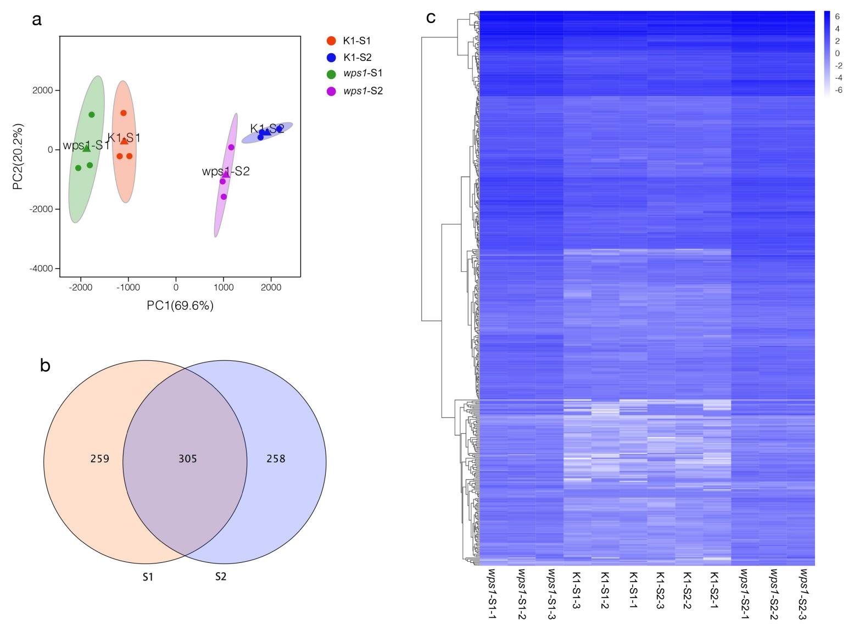
Fig. S2 RNA-seq analysis of young inflorescence of wps1 and K1. (a) PCA analysis of RNA-seq data. Group 1 and group 2 consist of three biological replicates of K1 at stage 1 (S1) and stage 2 (S2), and group 3 and group 4 consist of three biological replicates of wps1 at S1 and S2, respectively. (b) Number of DEGs between wps1 and K1 at two stages. (c) Expression level based clustering of DEGs. Scale bar showed log2 values of fold changes.

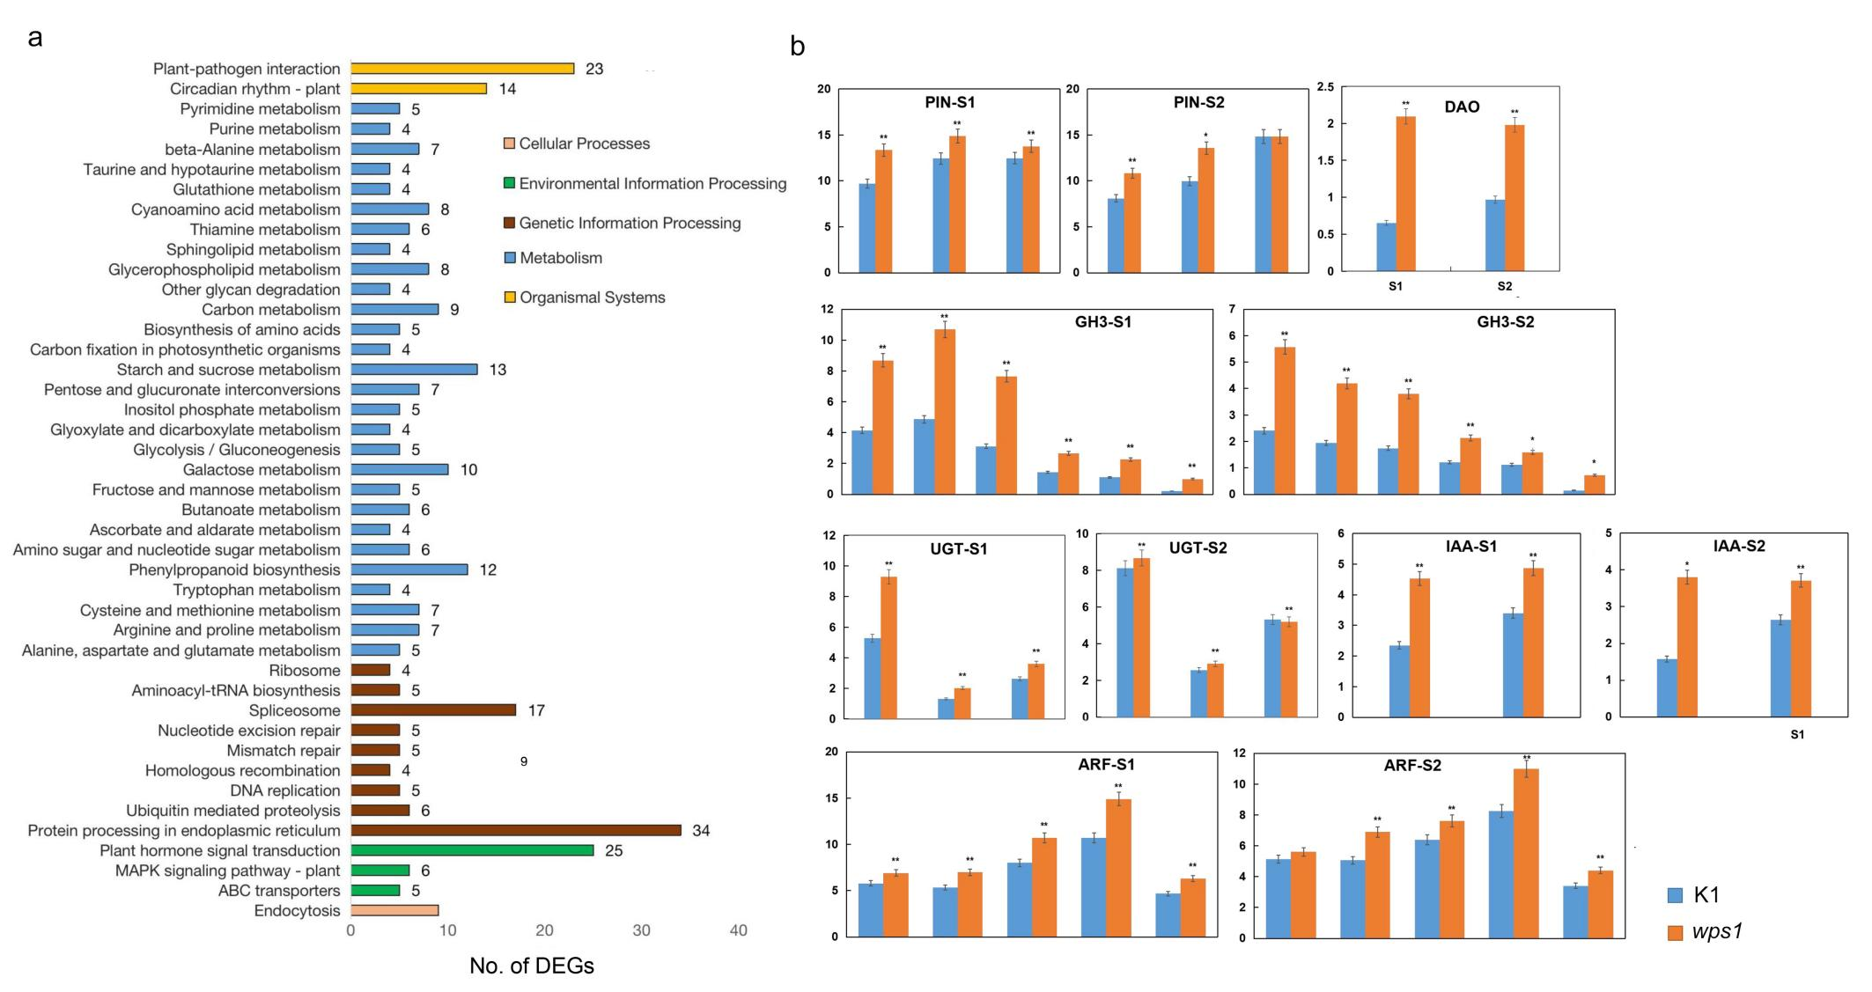

Fig. S3 Comparative transcriptome analysis of developing young inflorescence of wps1 and K1. (a) KEGG classification of DEGs. The KEGG pathways consisting of at least four DEGs were shown. (b) RNA-seq based identification of auxin (IAA) -related genes showing significantly different transcript abundance between wps1 and K1 (The gene IDs were list in Table S5). * and ** indicated significance at P < 0.05 and P <0.01, respectively. The expression levels representing by means of FPKM (Y-axis) were showed as solid bars. The error bars represented the standard deviation (SD).

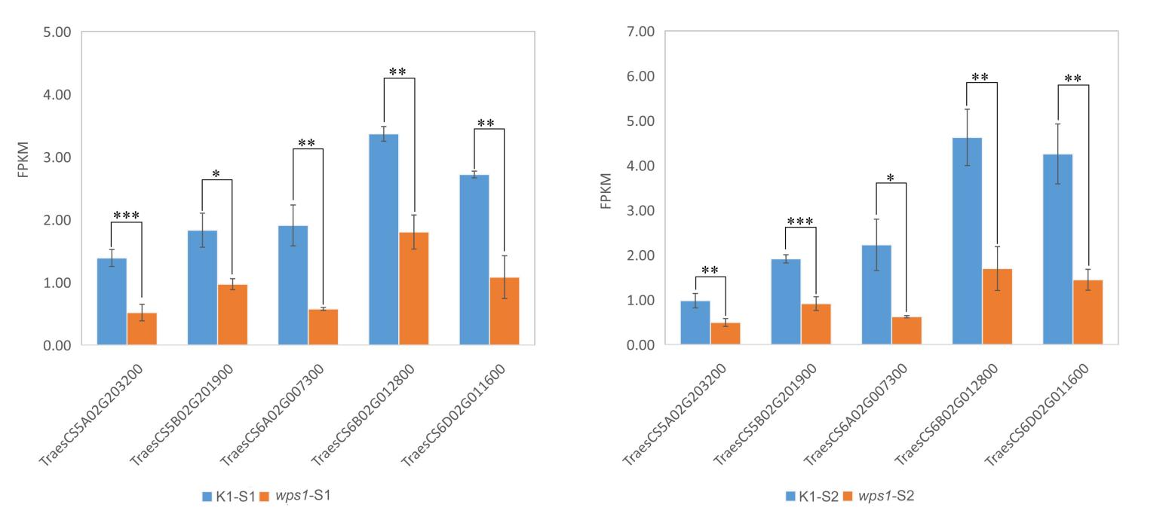
Fig. S4 Expression levels of five genes encoding type-B ARABIDOPSIS RESPONSE REGULATORS (B-ARR). Expression levels were based on RNA-seq data and represented by FPKM values. *, **, and *** indicated significant difference at P<0.05, P <0.01 and P <0.001, respectively. The error bars represented the standard deviation (SD) between biological replicates.

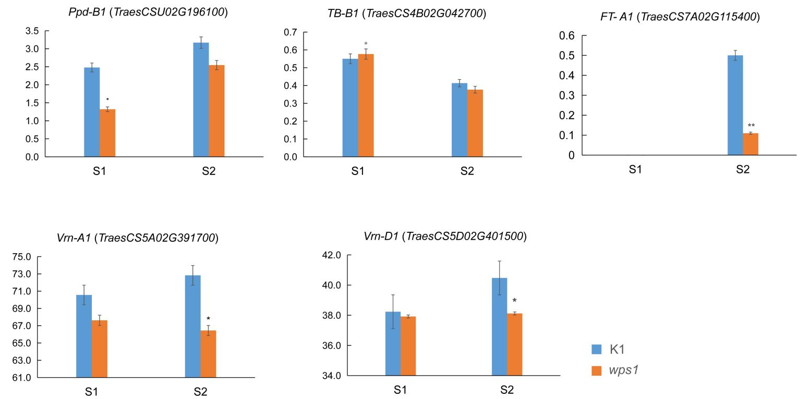
Fig. S5 Expression levels of the genes known to be involved in PS formation at two investigated stages. Expression levels were based on RNA-seq data and represented by FPKM values (Y-axis). * and ** indicated significant difference at P<0.05 and P<0.01, respectively. The error bars represent the standard deviation (SD).

Fig. S6 Expression levels of LHYs. Expression levels were based on RNA-seq data and represented by FPKM values (Y-axis). The error bars represented the standard deviation (SD). **, P<0.01.
Fig. S7 Expression levels of MADS-box genes at two stages. Expression levels were based on RNA-seq data and represented by FPKM values (Y-axis). The error bars represented the standard deviation (SD). * P<0.05; **, P<0.01.

