Supplementary information for Large-area flexible Visible-Short wavelength Infrared Photodetection based on III-V compound semiconductor membrane photodetector with high performance
Xuanzhang Li^{1,2}, Junyang Zhang^{1,2}, Chen Yue^{1,2}, Xiansheng Tang³, Zhendong Gao^{1,2}, Yang Jiang^{1,4}, Chunhua Du^{1,4,5}, Zhen Deng^{1,4,5,} *, Haiqiang Jia^{1,4,6}, Wenxin Wang^{1,4,6}S and Hong Chen^{1,4,5,6}
¹ Key Laboratory for Renewable Energy, Beijing Key Laboratory for New Energy Materials and Devices, Beijing National Laboratory for Condensed Matter Physics, Institute of Physics, Chinese Academy of Sciences, Beijing 100190
² University of Chinese Academy of Sciences, Beijing 100049, China
³ Laser Institute, Qilu University of Technology (Shandong Academy of Sciences), Jinan 250014, China
⁴ Center of Materials and Optoelectronics Engineering, University of Chinese Academy of Sciences, Beijing 100049, China
⁵ The Yangtze River Delta Physics Research Center, Liyang 213000, China
⁶ Songshan Lake Materials Laboratory, Dongguan 523808, China
*zhen.deng@iphy.ac.cn

- Material growth of InGaAs PIN PD on InP substrate
The material for InGaAs PIN photodetector was grown on a n-type (10¹⁷ cm⁻³) InP wafer in a metal organic chemical vapor deposition reactor. First, a n-InP buffer layer (~10¹⁸ cm⁻³, thickness >200 nm) was grown to stabilize the wafer surface, followed by a 500nm lattice-matched n-type(~10¹⁸ cm⁻³) In_{0.53}Ga_{0.47}As, a 500 nm n-type(~10¹⁸ cm⁻³) InP layer, 2.2 μm i- In_{0.53}Ga_{0.47}As layer (~10¹⁶ cm⁻³), a 600 nm n-type(~10¹⁶ cm⁻³) InP layer and a 50 nm n-type(~10¹⁶ cm⁻³) In_{0.53}Ga_{0.47}As layer, respectively. After the epitaxy, the p-type InGaAs layer and InP layer were achieved by single MOCVD diffusion of zinc. The concentrations of p-InGaAs and p-InP layer were about 10¹⁹ cm⁻³ and 2×10¹⁸ cm⁻³, respectively. Figure S1 shows the InGaAs PIN photodetector based on InP substrate.
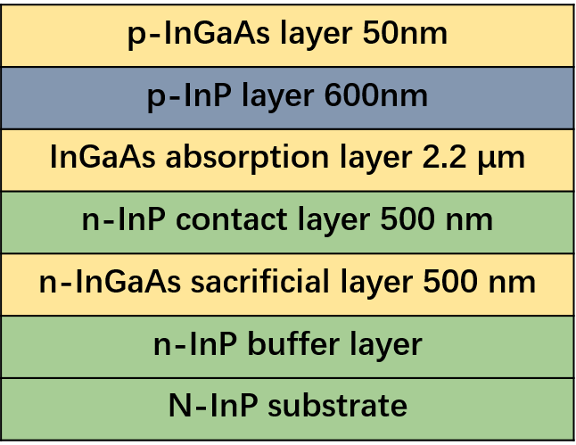
Figure S1. The InGaAs PIN photodetector based on InP substrate

- Material Characterization
After the epitaxial growth, the material quality was assessed by using atomic force microscopy (AFM), high resolution X-ray diffraction (HR-XRD) and photoluminescence (PL). AFM image showed that the sample exhibited a good surface morphology with clear atomic steps and small roughness of 1.66 Å over a 5 × 5 μm² area Fig.10(a). Furthermore, as shown in Figure S2(b) and (c), the HR-XRD and PL results showed that the Indium composition is very close to 0.53, which means that the InGaAs layer is well fitted to the design composition. In addition, the full width at half maximum (FWHM) value of the InGaAs epilayer was 126 arcsec. All the results reveals that the high-quality materials were obtained.
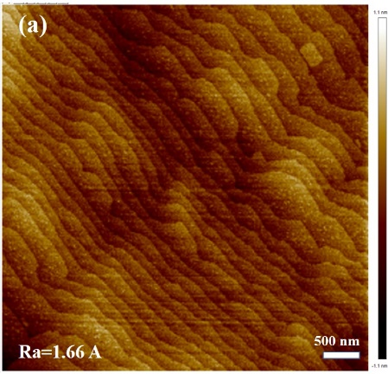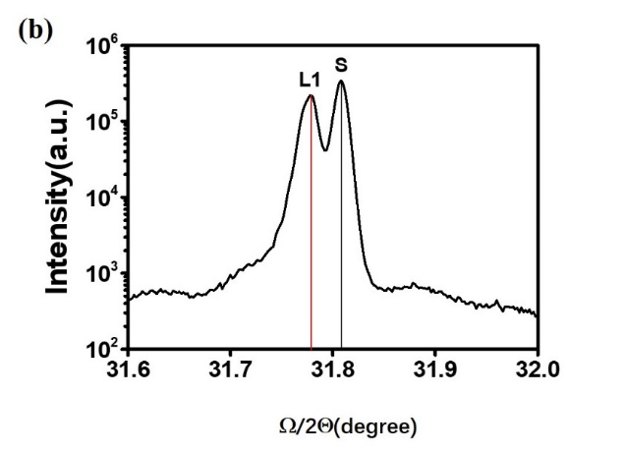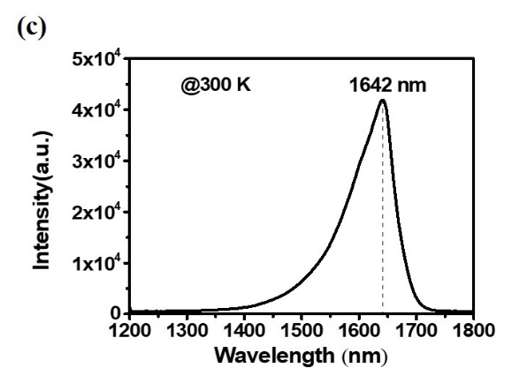
Figure S2. (a) The AFM image of a 5 μm × 5 μm surface area of the as-grown material, with rms roughness value of 1.66 Å. (b) the HR-XRD ω/2θ curve of the InGaAs PIN photodetector structure. L1 represents the epitaxy InGaAs layer, and S represents the InP substrate. (c) PL spectra of InGaAs PIN photodetector structure at room temperature. The peak of curve is 1642 nm (~ 0.755 eV), which is close to the band gap of lattice-matched InGaAs on InP substrate.

