Supplementary information
Atomic-scale understanding of the Na and Cl remotion from seawater promoted by Mo_{1.33}C(OH)₂-MXene

J. Guerrero-Sanchez¹, Dalia M. Muñoz-Pizza^{2,3}, Ma Guadalupe Moreno-Armenta¹, Noboru Takeuchi¹
¹Centro de Nanociencias y Nanotecnología, Universidad Nacional Autónoma de México, km.107, Apdo. Postal 14. Carretera Tijuana-Ensenada, Ensenada, Baja California, México.
²Colegio de la Frontera Norte, Departamento de Estudios Urbanos y del Medio Ambiente, Tijuana, Baja California, Mexico
³Facultad de Ciencias Marinas, Universidad Autónoma de Baja California, Ensenada, Baja California, Mexico.

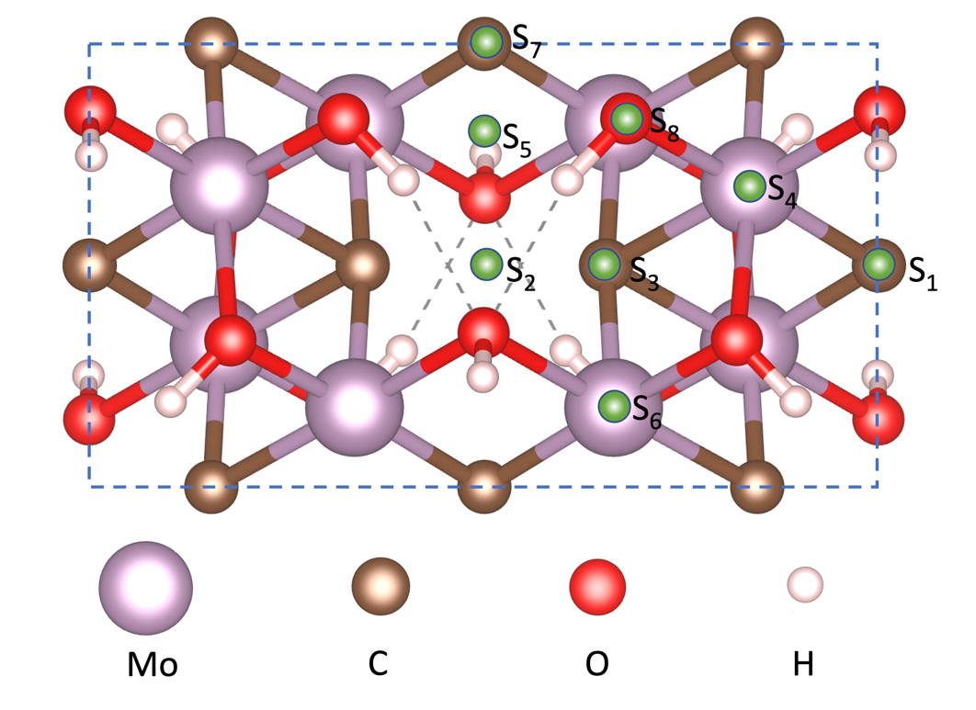
Figure S1. High-symmetry adsorption sites for the Cl and Na atoms on the Mo_{1.33}C(OH)₂ sheet.

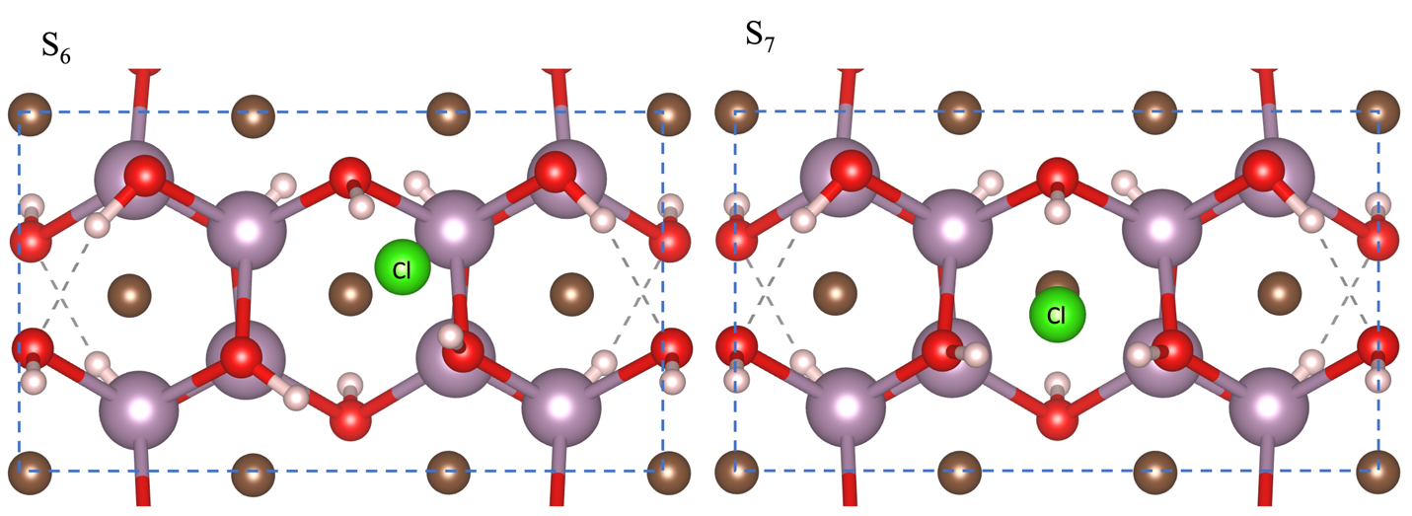

Figure S2. Stable adsorption sites for Cl atoms on the Mo_{1.33}C(OH)₂ sheet.

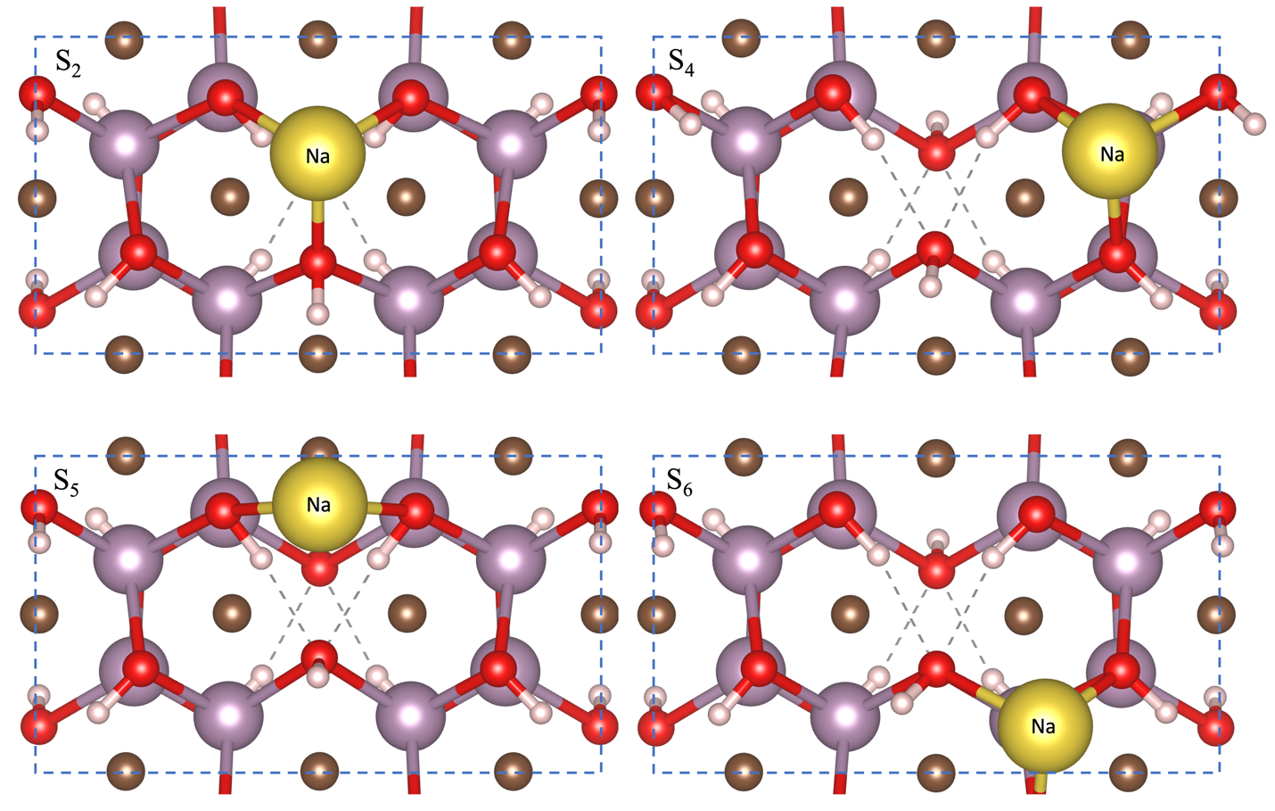

Figure S3. Stable adsorption sites for Na atoms on the Mo_{1.33}C(OH)₂ monolayer.

