Supplementary material for
Antiviral efficacy of cerium oxide nanoparticles
Alexandra Nefedova^{1*}, Kai Rausalu^{2*}, Eva Zusinaite², Alexander Vanetsev¹, Merilin Rosenberg^{3,4}, Kairi Koppel³, Stevin Lilla¹, Meeri Visnapuu¹, Krišjānis Šmits⁵, Vambola Kisand¹, Tanel Tätte¹, Angela Ivask^{3**}

¹ Institute of Physics, University of Tartu, W. Ostwaldi Street 1, 50411, Tartu, Estonia
² Institute of Technology, University of Tartu, Nooruse Street 1, 50411, Tartu, Estonia
³ Institute of Molecular and Cell Biology, University of Tartu, Riia Street 23, 51010, Tartu, Estonia
⁴ Department of Chemistry and Biotechnology, Tallinn University of Technology, Akadeemia Street 15, 12618, Tallinn, Estonia
⁵ Institute Solid State Physics, University of Latvia, Kengaraga Street 8, LV-1063, Riga, Latvia

*Shared first authorship
** Corresponding author: angela.ivask@ut.ee

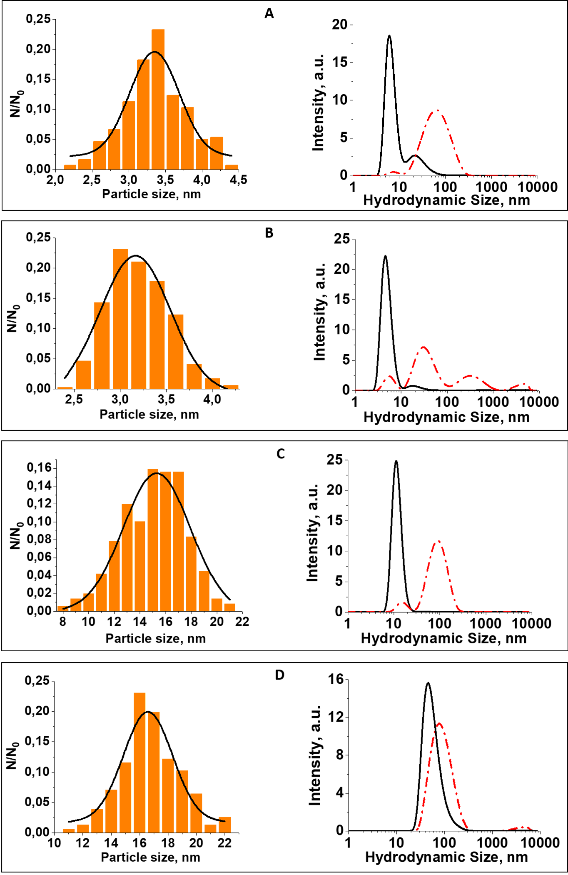
Figure S1. Particle size distribution as calculated from HRTEM images (left column) and from DLS data (right column). A: nano-CeO₂(+), B: nano-CeO₂(-), С: nano-Ag, D: nano-SiO₂. On DLS graphs the solid line is a distribution by the number of particles and dashed line by intensity of scattering. HRTEM data is based on measuring the diameter of >300 particles except for SiO₂ (under 200 was measured due to complications with image analysis).

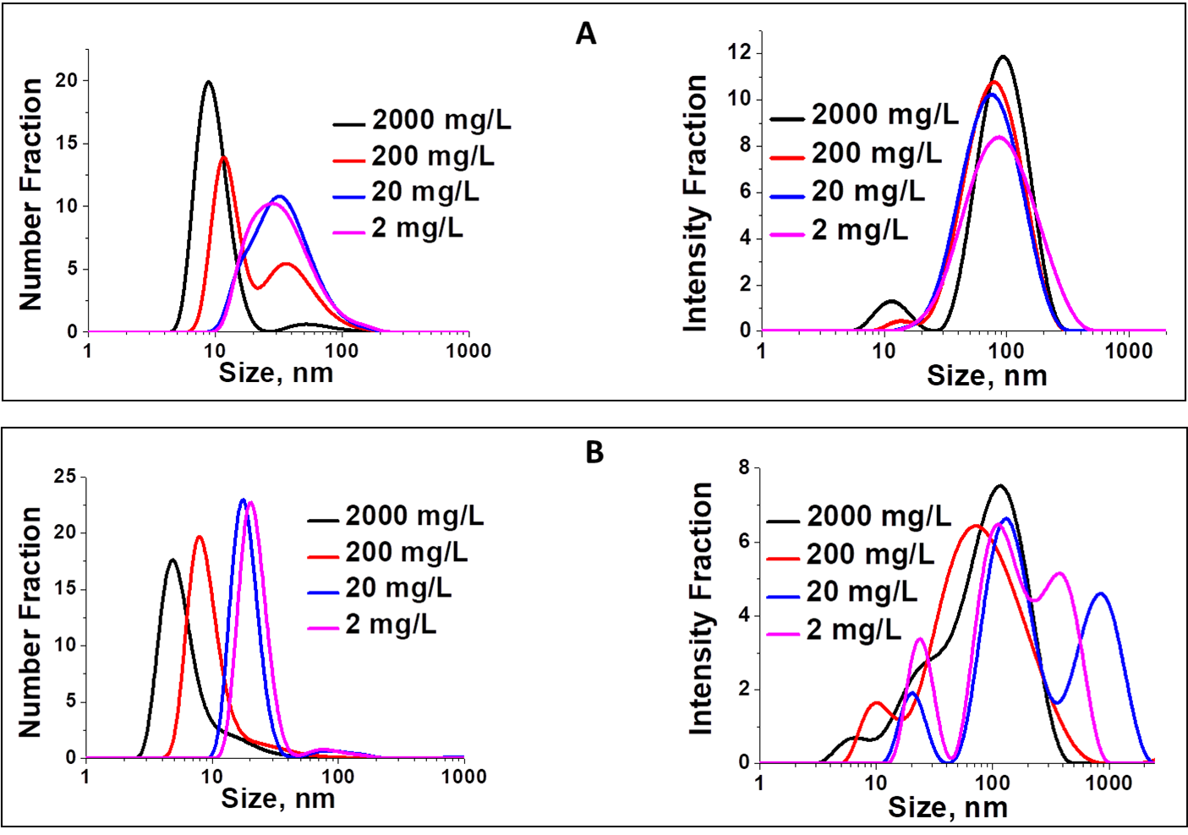
Figure S2. Evolution of hydrodynamic particle size with changing concentration of nano-CeO₂(+) and (-) according to number fraction (left side) and intensity fraction (right side). The dilution of both nano-CeO₂(+) and nano-CeO₂(-) colloids leads to aggregation of individual particles and disappearance of single nanoparticles. The aggregation is monotonous in case of nano-CeO₂(+) but in case of nano-CeO₂(-) the particles behavior is more complex. While individual particles also tend to aggregate monotonously with the dilution, the size distribution of the final aggregates in these colloids is broad and multiband and changes in a non-linear manner.

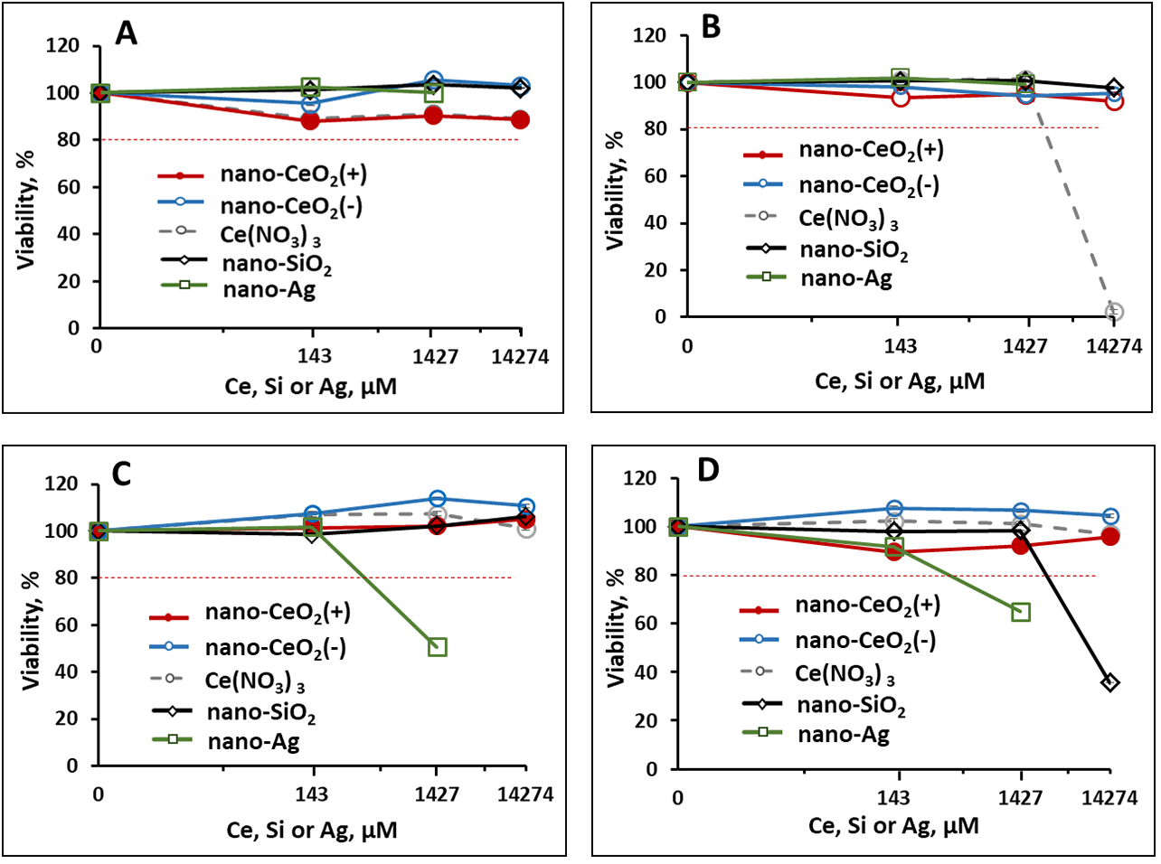
Figure S3. The effect of tested nanoparticles and chemicals on viability of host cells of mammalian viruses. A: BHK-21 cells used as hosts for EMCV virus, B: Vero-E6 cells used as host for SARS-CoV-2 virus, C: MDCK-2 cells used as a host for A/WSN/1933 influenza virus, D: ST cells used as a host for TGEV virus. Average cell viability results (% viability compared with non-exposed cells) of three experiments with standard deviation are shown. Decrease of cellular viability to less than 80% (red dotted line) was considered cytotoxic. The highest concentration of nano-Ag was not analyzed as the highest concentration (14,270 μM) of the synthesized particles was 4400 μM.
During antiviral testing, the concentration of nanoparticles and Ce(NO₃)₃ that was exposed to viral host cells in infection procedure was 10-fold lower compared with the concentrations in virus and nanoparticle/chemical mixtures. Therefore, if 14,270 μM Ce(NO₃)₃ was exposed to SARS-CoV-2, the concentration of Ce(NO₃)₃ to be exposed to Vero-E6 cells in infection mixture was 1420 μM.

