Supporting Information
Self-synergistic effect of Prussian blue nanoparticles for cancer therapy: driving photothermal therapy and reducing hyperthermia-induced side effects

Xue Xie ^{1,2†}, Wei Gao^{1†}, Junnian Hao¹, Jianrong Wu^{1*}, Xiaojun Cai^{1*}, Yuanyi Zheng^{1*}

*Correspondence: wujr_028@126.com; c1x2j34@163.com; zhengyuanyi@sjtu.edu.cn
† Xue Xie and Wei Gao contributed equally to this work
1. Shanghai Institute of Ultrasound in Medicine, Shanghai Jiao Tong University Affiliated Sixth People's Hospital, Shanghai 200233, P.R. China.
2. Chongqing Key Laboratory of Ultrasound Molecular Imaging, Ultrasound Department of the Second Affiliated Hospital of Chongqing Medical University. Chongqing 400010, People’s Republic of China

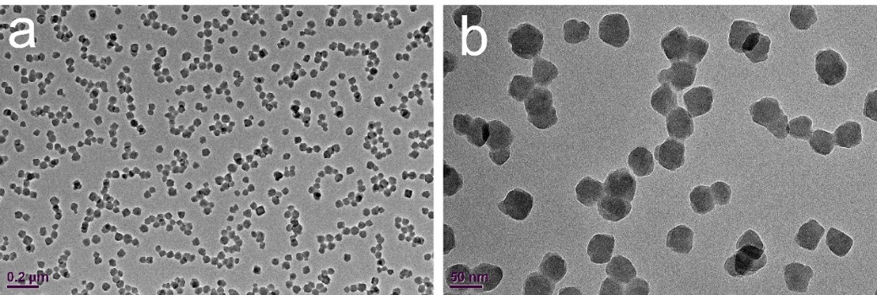

Figure S1.TEM images of PBs with different magnification.

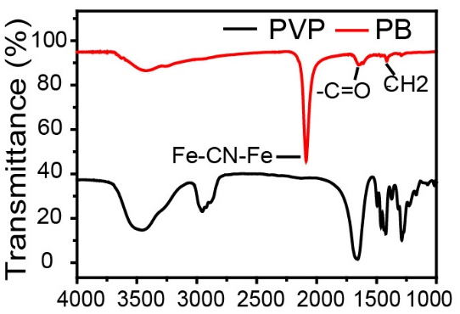
Figure S2. FTIR spectra of PBs. FTIR displays a characteristic peak around 2085 cm⁻¹ of Fe²⁺-CN-Fe³⁺, the absorption peak at 1670 cm⁻¹ is characteristic of the C=O group of PVP.
Figure S3. Photothermal-heating curves of PBs at elevated concentrations under 808 nm laser irradiation. (a) 0.2 W cm⁻². (b) 0.4 W cm⁻² and (c) 0.8 W cm⁻².

Figure S4. Photothermal-heating curves of PBs dispersed in aqueous solution irradiated at different power intensity (0.2, 0.4, 0.8 and 1.0 W cm⁻²). (a) PB concentration (100 μg mL⁻¹). (b) PB concentration (200 μg mL⁻¹).
Figure S5. In vitro photothermal performance of PBs. (a) Photothermal performance of the PBs under irradiation by a NIR laser( 808 nm, 0.8 W cm⁻²) .(b) Time constant for heat transfer from the system was determined to be 133.22 s by applying the linear time data from the cooling period versus negative natural logarithm of driving force temperature, which was originated from the cooling stage.
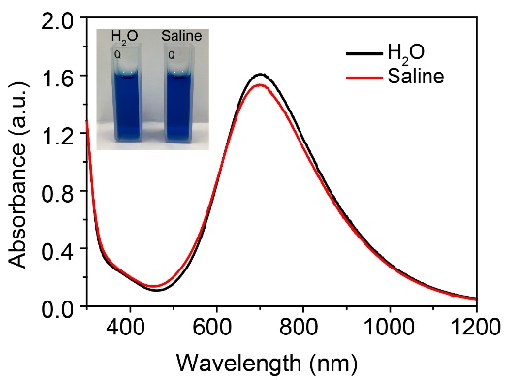
Figure S6. Digital photographs and the UV-vis-NIR absorbance of PBs dispersed in pure water and saline.
Figure S7. UV-vis-NIR absorbance spectra of PB dispersions before and after irradiation for 10 min and 30 min by 808 nm laser, respectively.

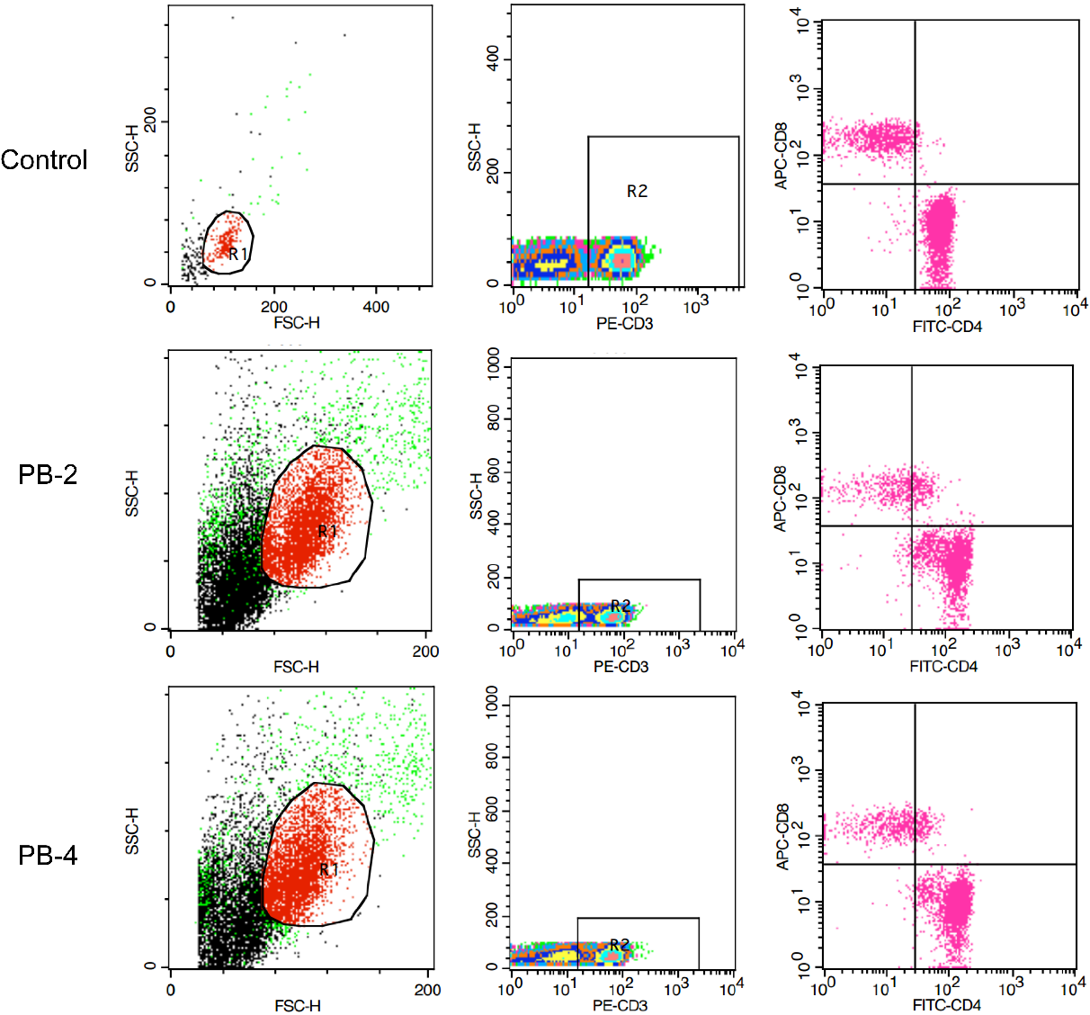
Figure S8. Flow cytometry analysis of CD3⁺, CD3⁺CD8⁺, and CD3⁺CD4⁺ T cells in the blood.

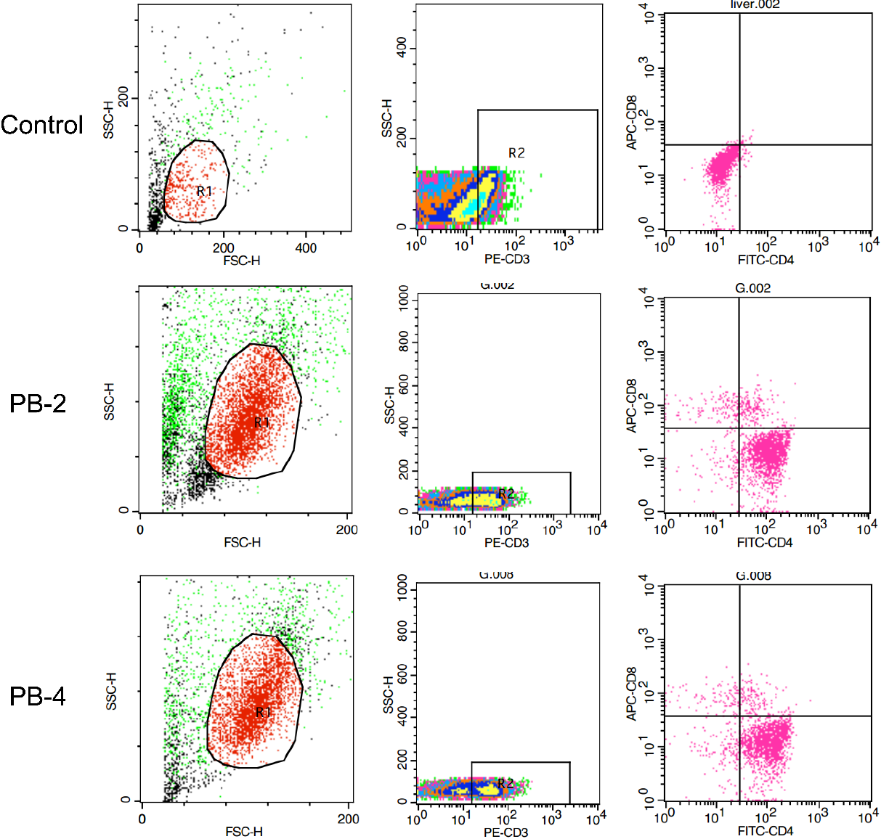
Figure S9. Flow cytometry analysis of CD3⁺, CD3⁺CD8⁺, and CD3⁺CD4⁺ T cells in the liver.

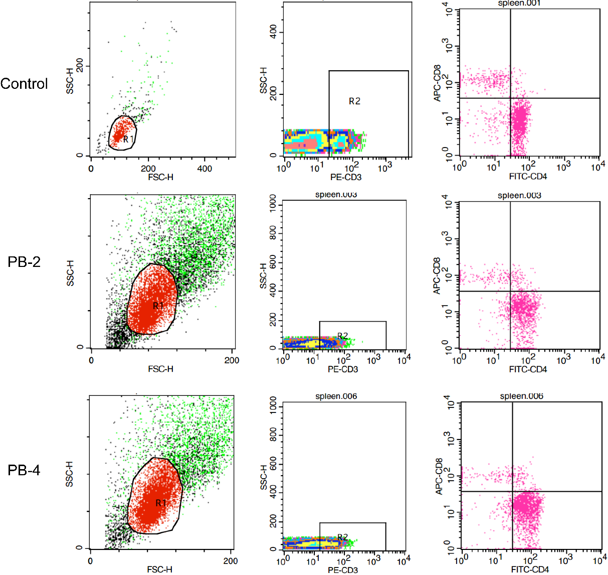
Figure S10. Flow cytometry analysis of CD3⁺, CD3⁺CD8⁺, and CD3⁺CD4⁺ T cells in the spleen.

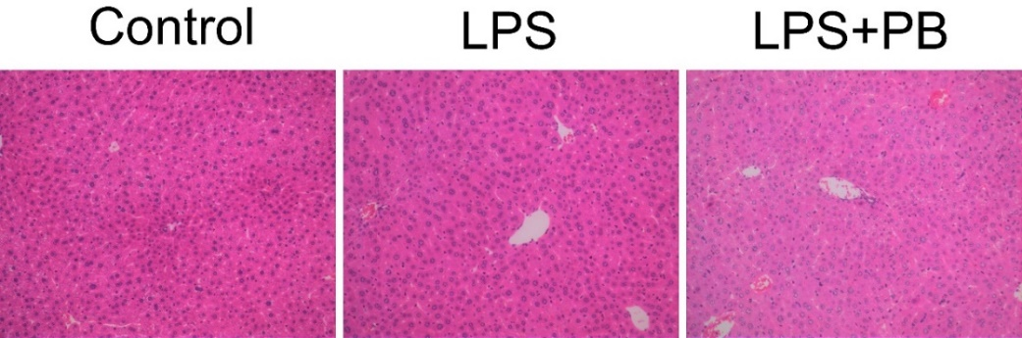
Figure S11. The hematoxylin and eosin staining of liver in various groups. The focal nuclear pyknosis, inflammatory cell infiltration, and even bile stasis could be observed in the livers of mice treated with LPS. While with PBs treatment, the livers display markedly decreased histological alterations.
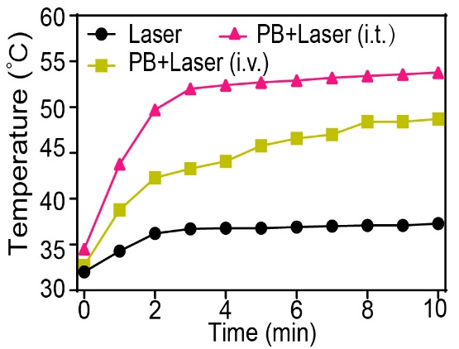
Figure S12. Temperature curves at the tumor region of 4T1-tumor-bearing nude mice in different groups under 808 nm laser irradiation (The laser density=1.0 W cm⁻²) for 10 min.

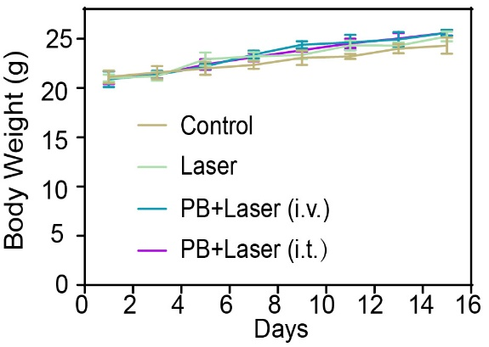
Figure S13. Time-dependent body-weight curves of 4T1 tumor-bearing nude mice.
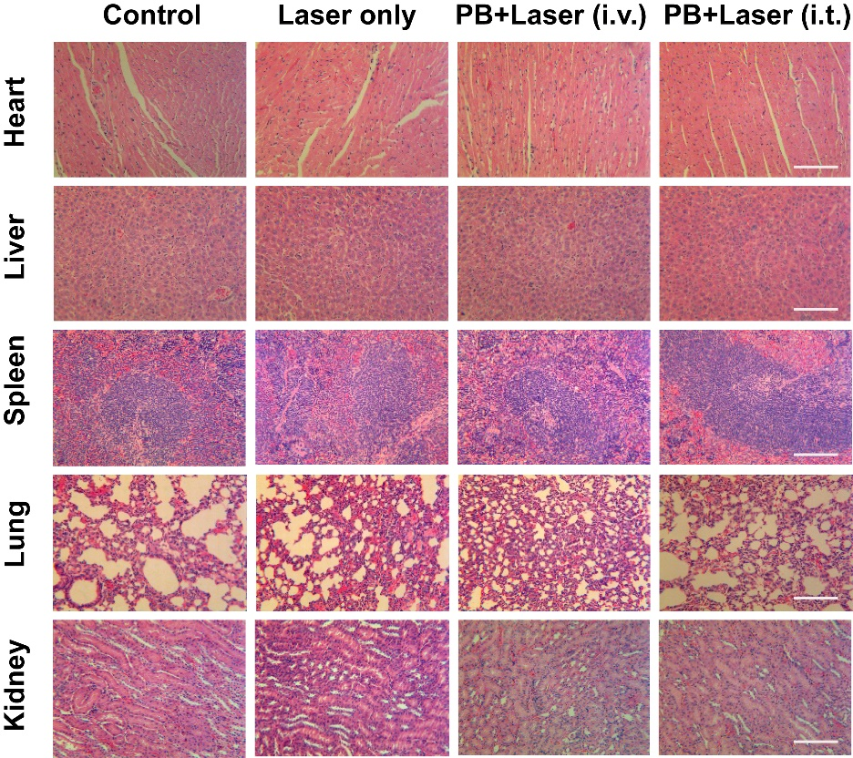
Figure S14. H&E-staining tissue of major organs from 4T1-bearing nude mice after various treatments. All the scale bars are 50 μm.

