SUPPLEMENTARY INFORMATION
Noise self-cancelling metrology using twisted light
Pooja Munjal, Komal Chaudhary, and Kamal P. Singh
Department of Physical Sciences, IISER Mohali, Sector-81, Manauli 140306, India.

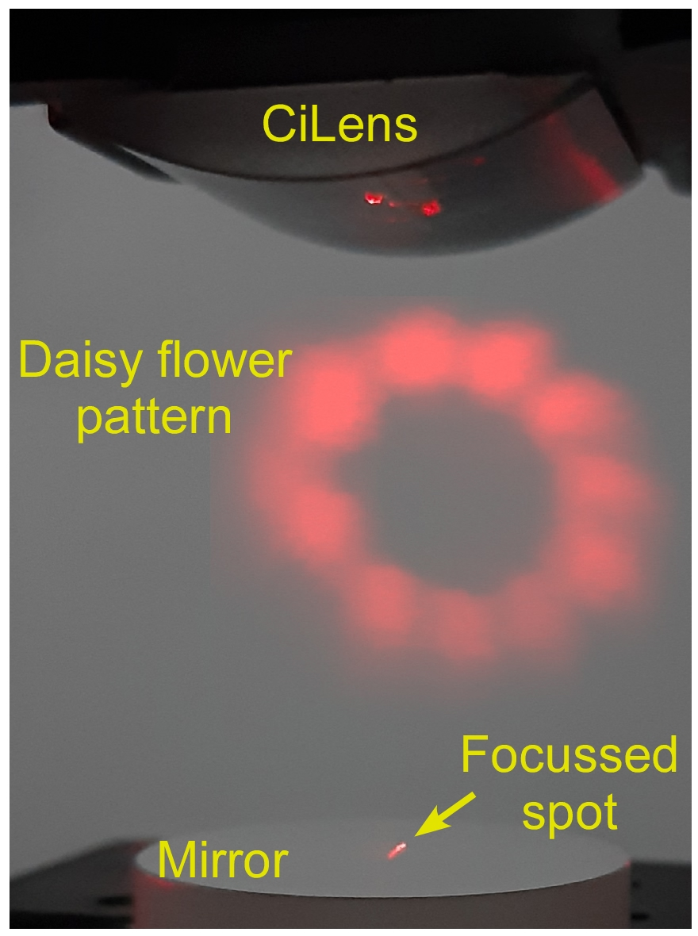

Figure S1: Experimental setup. Picture of the single cylindrical iLens ultra-stable spiral interferometer. Various components are labelled.

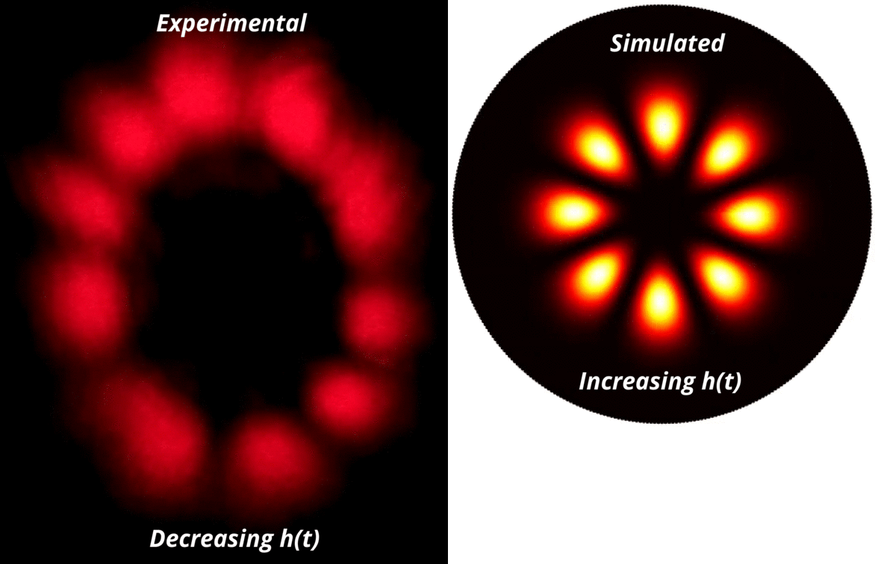

Figure S2: Rotation of the daisy flower-like interference pattern upon linearly displacing the mirror. The left video shows the anti-clockwise rotation of the experimentally obtained flower pattern upon decreasing the cavity length. The right video shows the clockwise rotation of simulated flower pattern when the mirror is displaced away from the CiLens, i.e. the cavity length is increasing.

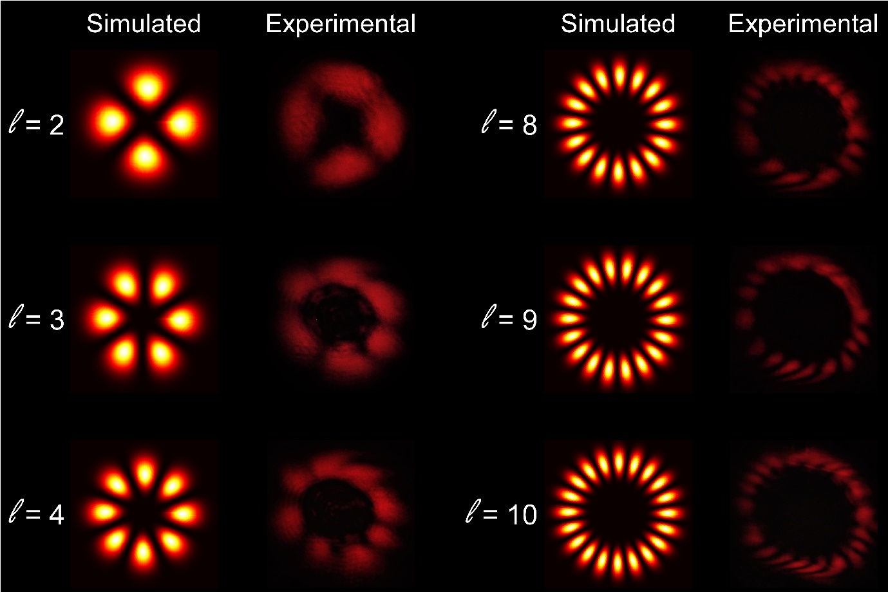

Figure S3: Demonstration of daisy flower pattern with different l values. The left and right column shows the snapshots of simulated and experimentally obtained daisy flower pattern respectively for l = 2, 3, 4, 8, 9, 10.

