Impacts of Ecological Water Supplement on Survival of Aquatic Organisms: A Case Study of Cyprinus Carpio in Baiyangdian, China
Yi-fei Ma, Xue-yi You*
Tianjin Engineering Center of Urban River Eco-purification Technology
School of Environmental Science and Engineering, Tianjin University
Jinnan District, Tianjin 300350, China
*Corresponding author XY You, xyyou@tju.edu.cn

Table S1. The coordinate pairs of Cyprinus carpio in Baiyangdian Wetland

Coordinate pairs | longitude | latitude
1 | 115.971 | 38.807
2 | 116.024 | 38.858
3 | 116.035 | 38.902
4 | 116.035 | 38.824
5 | 115.986 | 38.845
6 | 115.960 | 38.912
7 | 116.015 | 38.801
8 | 115.875 | 38.923
9 | 115.960 | 38.908
10 | 115.960 | 38.914
11 | 115.982 | 38.946
12 | 115.977 | 38.952
13 | 115.979 | 38.957
14 | 115.994 | 38.957
15 | 116.001 | 38.946
16 | 116.003 | 38.951
17 | 115.900 | 38.819
18 | 115.990 | 38.848
19 | 115.901 | 38.827
20 | 115.944 | 38.897
21 | 116.046 | 38.868
22 | 116.030 | 38.855
23 | 116.003 | 38.864
24 | 115.954 | 38.845
25 | 115.943 | 38.844
26 | 115.966 | 38.809
27 | 115.884 | 38.833
28 | 115.980 | 38.868
29 | 116.019 | 38.799
30 | 116.032 | 38.825
31 | 116.038 | 38.897
32 | 116.029 | 38.862
33 | 116.009 | 38.870
34 | 115.998 | 38.951
35 | 116.041 | 38.822
36 | 116.002 | 38.959
37 | 116.046 | 38.860
38 | 116.054 | 38.854
39 | 115.984 | 38.939
40 | 116.055 | 38.858
41 | 116.026 | 38.810
42 | 115.939 | 38.845
43 | 115.903 | 38.814
44 | 115.898 | 38.812
45 | 116.040 | 38.868
46 | 115.898 | 38.833
47 | 116.018 | 38.804
48 | 115.876 | 38.819
49 | 115.976 | 38.809
50 | 115.951 | 38.843
51 | 115.946 | 38.896
52 | 116.032 | 38.820
53 | 115.983 | 38.868
54 | 116.031 | 38.896
55 | 115.994 | 38.851
56 | 115.945 | 38.839
57 | 116.044 | 38.864
58 | 116.016 | 38.794

S1 Model validation
S1.1 Grid independence
The flow field is discretized by unstructured triangular meshes. The allowable minimum angle of mesh is 30°. The denser mesh is near the entrance and boundary. Two kinds of mesh distribution are used to study the grid independent: (1) The flow field is divided into 40125 grids, the maximum grid of the denser area is 10000 m², and the maximum grid is 25000 m²; (2) The flow field is divided into 52012 grids, the maximum grid of the denser area is 7000 m², and the maximum grid is 25000 m². Ten represent points are selected in the flow field, and the velocity and temperature of each point at typical time are computed. The sum of relative error of velocity and temperature of each point under two grid numbers are calculated respectively. The results show that the relative errors of velocity and temperature are less than 5% and 0.5% respectively at every typical time under two grid numbers. Therefore, the mesh of 40125 grids is selected to simulate the flow velocity, water depth and temperature of Baiyangdian Wetland.
S1.2 Verification of hydrodynamic model
The monitoring data from December 1, 2017 to June 30, 2018 are selected for hydrodynamic model validation. When the scheme of ‘Diverting the Yellow River into the wetland’ and ‘South to North Water Diversion Project’ are in action, the relative error of the simulation results and the monitoring water level is less than 3%. The results show that the hydrodynamic model could simulate the hydrodynamic process accurately.
S1.3 Verification of water quality model
According to the water quality monitoring data of Baiyangdian Wetland from December 2017 to July 2018 in the national and provincial water control environmental quality monthly report, Zaolinzhuang, Wangjiazhai and Duancun stations with comprehensive data are selected to verify the rationality of the water quality model. The categories of the monitored and simulated water quality are shown in Table S2.
Table S2. Comparison of the monitored and simulated water quality category at three stations
Station name  Month | Zaolinzhuang |  | Wangjiazhai |  | Duancun
Station name  Month | Measured | Simulation | Measured | Simulation | Measured | Simulation
2017.12 | \ | Ⅴ | Ⅴ | Ⅴ | PoorⅤ | PoorⅤ
2018.01 | \ | Ⅴ | \ | Ⅴ | \ | Ⅴ
2018.02 | \ | Ⅴ | \ | Ⅴ | PoorⅤ | Ⅴ
2018.03 | \ | Ⅴ | \ | Ⅴ | \ | Ⅴ
2018.04 | Ⅴ | Ⅴ | Ⅴ | Ⅴ | Ⅴ | Ⅴ
2018.05 | Ⅳ | Ⅴ | Ⅳ | Ⅴ | Ⅴ | Ⅴ
2018.06 | Ⅳ | Ⅴ | Ⅴ | Ⅴ | Ⅴ | Ⅴ
2018.07 | Ⅴ | Ⅴ | Ⅳ | Ⅴ | Ⅴ | Ⅴ
(Note: The water class is classified by Environmental Quality Standards for Surface Water (GB 3838-2002))
According to Table S2, it is found that the simulated water quality category at the stations are roughly in line with the monitored water quality category during the simulation period. The monitored data of NH₄⁺-N and TP fluctuate are within the concentration range of class IV and V of surface water. Only a small deviation between the monitored and simulated results occur in the water quality category in a few months. Therefore, the simulation error of water quality is within a reasonable error range and the water quality model is validated to be useful.
S2 Results of MIKE 21 in case of environmental flow regulation
S2.1 Hydrodynamic result
The variation of flows in Baiyangdian Wetland is shown in Fig. S1. Fig. S1 (a) shows the flow filed distribution on Feb.11, 2018. At this time, the wetland is in the period of freezing, and the ice blocks the influence of the wind field on the flow velocity field. So the velocity of the flow field is low, and the flow velocity of most water area is within the range of 0-0.025 m/s. The area with high flow velocity only appears near the discharge point of domestic sewage, and the maximum velocity is 0.125 m/s.
Fig. S1 (b) shows that due to the melting of ice in the wetland, the wind speed filed plays a leading role in the flow filed velocity. Therefore, compared with the freezing period, the area with high flow field velocity in the wetland increases. The water flow direction is opposite to the wind direction, and the maximum flow velocity is 0.192 m/s. Meanwhile, April 2018 is in the environmental flow regulation period of ‘South to North Water Diversion Project’ and ‘Reservoir supply of Western Ocean and Wangkuai’. So the flow velocity of the downstream areas of Baohe River, Fuhe River, Zhulong River and Baigouyin River increased compare to Fig. S1 (a), and the flow velocity is in the range of 0-0.075 m/s.
Figs. S1 (c-d) show the variation of flow field distribution in the wetland from May 2018 to June 2018. At these two moments, the wind speed filed also plays a leading role in the flow filed velocity, and flow velocity of most water bodies in the wetland is low. Due to the continuous water supplement, the area with high flow velocity appears in the downstream of Baohe and Fuhe River, with the maximum flow velocity of 0.189 m/s and 0.207 m/s, respectively.
Fig. S2 (a) shows the temperature distribution in the wetland on Feb.11, 2018. At this time, the wetland is in the period of freezing, and the ice isolates the heat exchange between the atmosphere and water, so the water temperature difference in the wetland is small.
Figs. S2 (b-d) show the variation of temperature from April 2018 to June 2018. On April 6, 2018, with the increase of air temperature, the water temperature also increases. The water temperature in the wetland is generally between 11℃ and 13.5℃, and the maximum water temperature is 13.52℃. On May 22, 2018 and June 30, 2018, the water temperature in the wetland further increased, with the water temperature generally above 20℃, and the maximum water temperature is 29℃ and 32℃, respectively.
Compared with the freezing period on Feb.11, 2018, the temperature difference of water body in the wetland is larger on April 6, May 22 and June 30, 2018. This is due to the melting of the ice cover and resumption of heat exchange between the atmosphere and water. At the same time, under the influence of wind field and topography, the difference of water flow velocity in the wetland becomes larger. Some areas with smaller velocity and larger water depth are easier to accumulate heat, leading to the increase of water temperature difference in the wetland.
Maiztegui et al. (2016) pointed out that water depth is a major environmental factor affecting the survival of Cyprinus carpio. Here, the distribution of water depth on June 30, 2018 is shown in Fig. S3, and the deepest water depth of Baiyangdian Wetland is about 4 m.
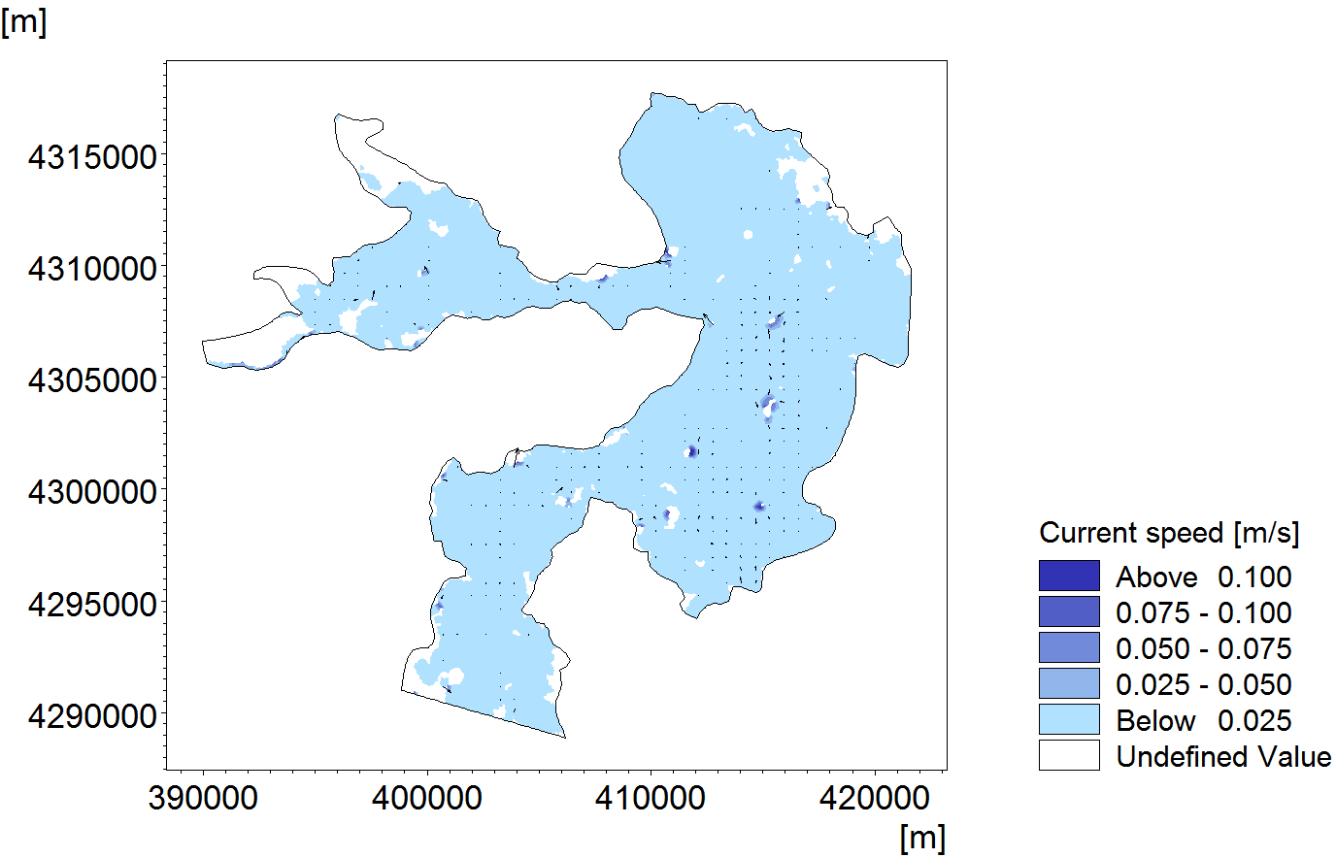
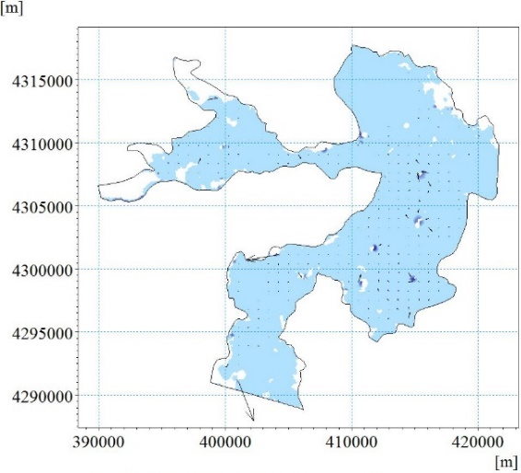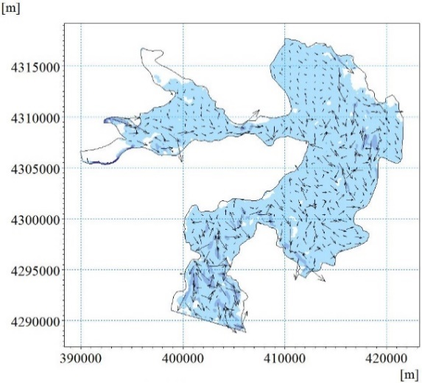
(a) on Feb.11, 2018 (b) on April 6, 2018
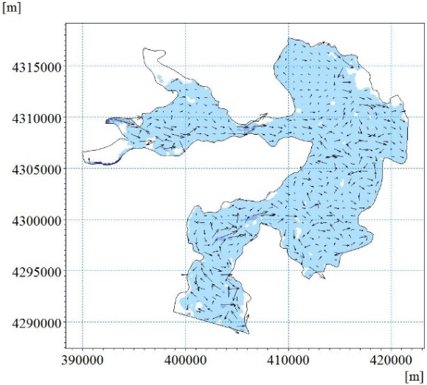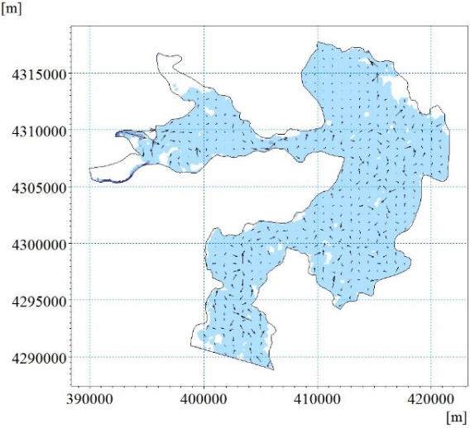
(c) on May 22, 2018 (d) on June 30, 2018
Fig. S1. The distribution of flow field at the typical times.
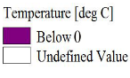
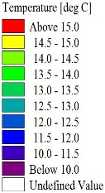
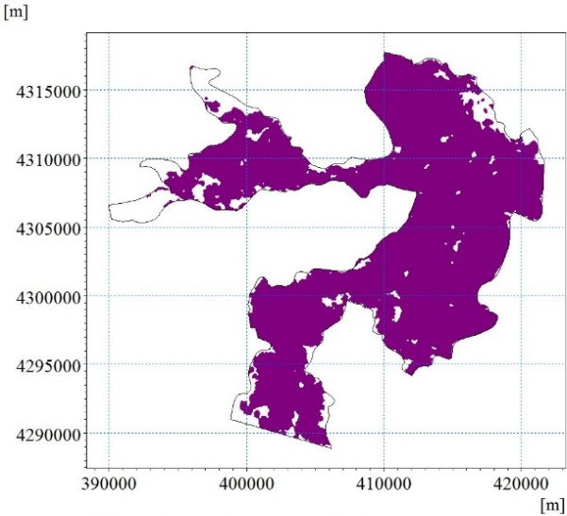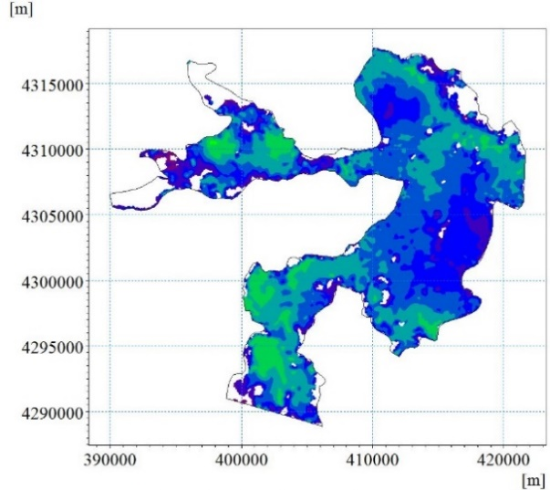
(a) on Feb.11, 2018 (b) on April 6, 2018
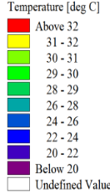
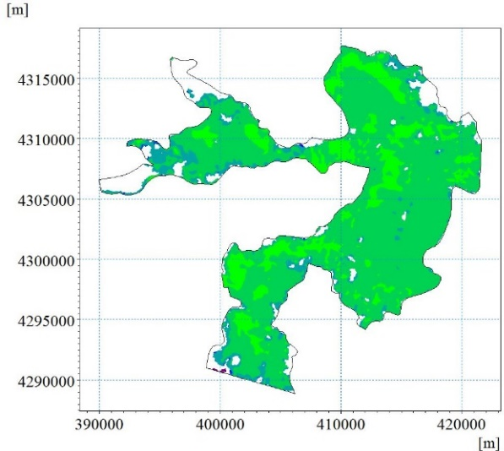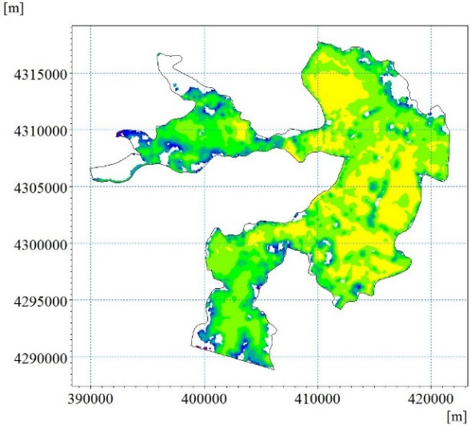
(c) on May 22, 2018 (d) on June 30, 2018
Fig. S2. The distribution of water temperature at the typical times.
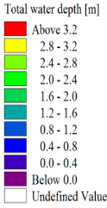
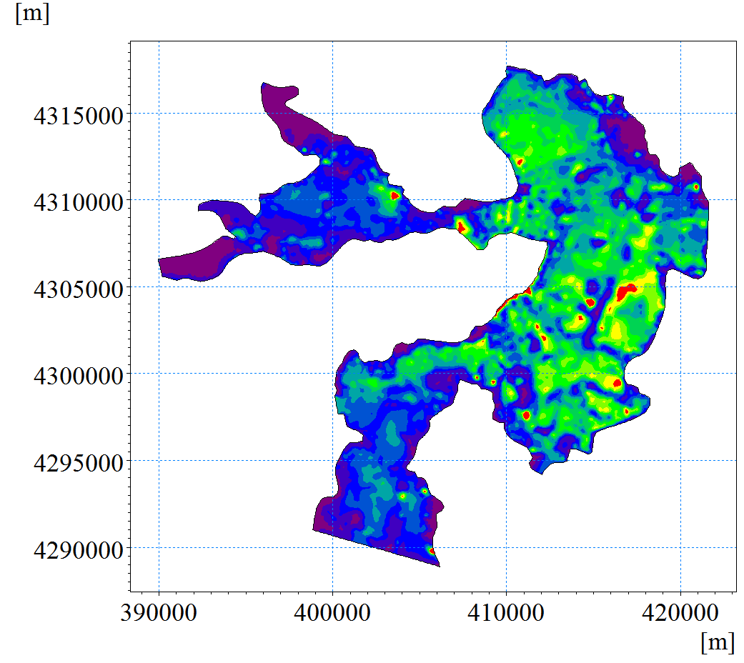
Fig. S3. The distribution of water depth on June 30, 2018.
S2.2 The variation of water quality
Some major water quality variables, such as BOD, NH₄⁺-N, Chla and DO, and their interactions are modeled in aquatic environments (Lushchak 2011; Hu et al., 2014; Taze et al., 2015). The results of ENMTML package show in the text indicates that the main water quality variables affecting the survival environment of Cyprinus carpio are DO NH₄⁺-N and Chla. Therefore, the spatial distribution of these variables at typical times is shown in the Figs. S4, S5 and S6, respectively.
Figs. S4 (a-b) show that from December 2017 to March 2018, due to the good water quality of the water diversion from Yellow River to the wetland flow, the value of DO increases obviously in the whole wetland. However, Figs. S4 (c-d) show that from April 2018 to June 2018, the wetland adopts the ‘South to North Water Diversion Project’ and ‘Reservoir supply of Western Ocean and Wangkuai’ for water supplement, due to the decline of the water quality of water supplement, the value of DO decreases slightly.
Fig. S5 and Fig. S6 shows the variation of NH₄⁺-N and Chla concentration in Baiyangdian Wetland, respectively. According to the results of hydrodynamic simulation, the overall water depth is shallow, the water velocity and the water exchange are low, which result in the concentration of pollutants in the wetland is blocked after the diversion.
The change of average eutrophication index with respect to time is shown in Fig. S7. It is found that the eutrophication in the wetland is serious before water supplement, because it is in the state of extreme eutrophication. During December 2017 and March 2018, the discharge of the water diversion from Yellow River to the wetland is used for water supplement and the good input water quality to the wetland flow increases the overall water quality of wetland, and the extreme eutrophication water body is reduced.
During April 2018 and June 2018, the wetland adopts the "South to North Water Diversion Project" and ‘Reservoir supply of Western Ocean and Wangkuai’ for water supplement. Due to the decline of the input water quality and the increase release of plant decay and sediment, the water quality of wetland is becoming worse and relatively increasing the degree of eutrophication in the wetland.
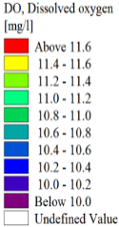
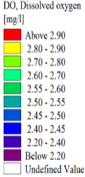
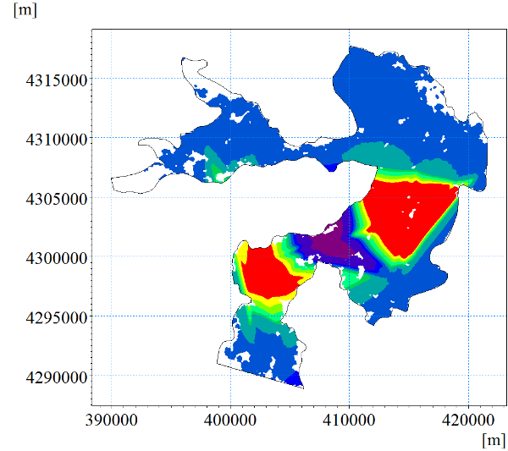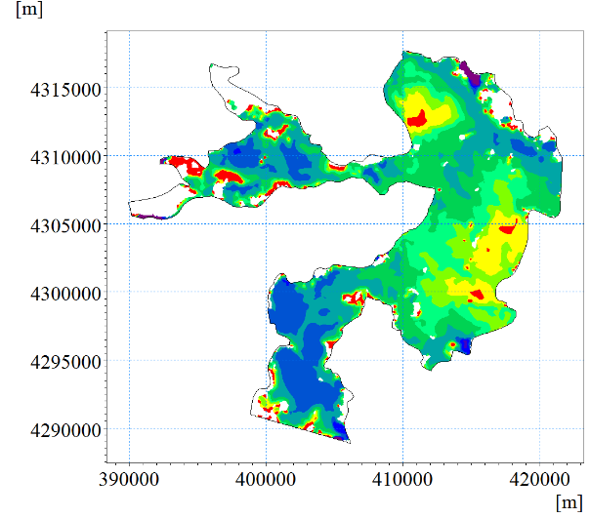
(a) on Dec.1, 2017 (b) on April 6, 2018
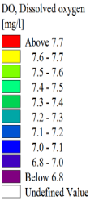
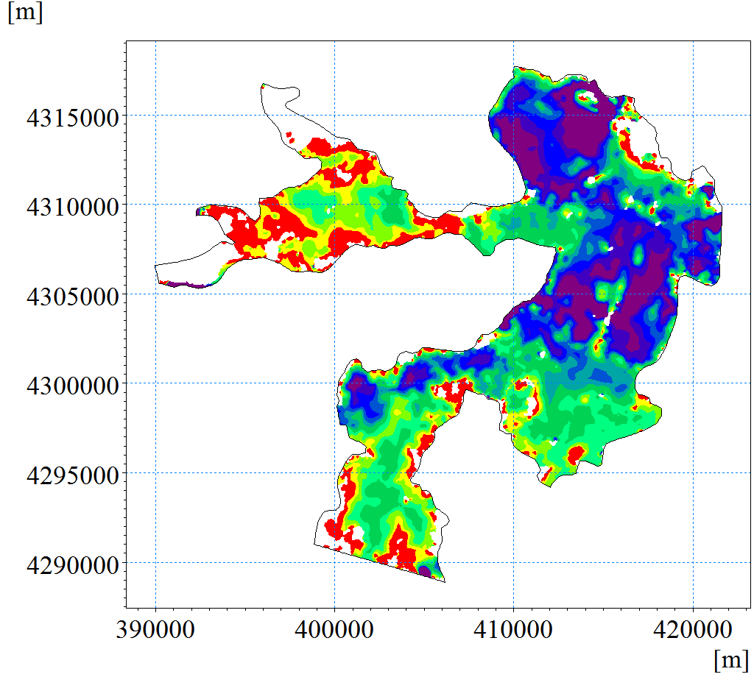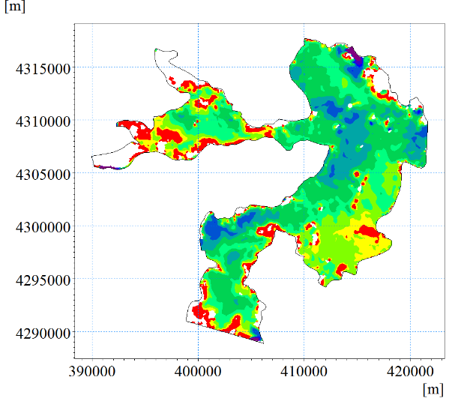
(c) on May 22, 2018 (d) on June 30, 2018
Fig. S4. The distribution of DO at the typical times.
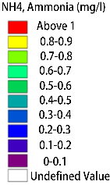
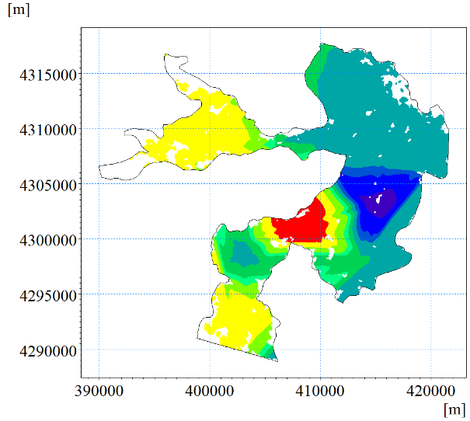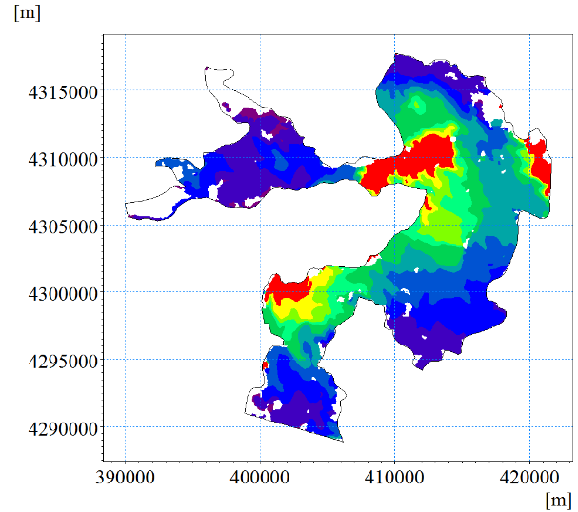
- on Dec.1, 2017 (b) on April 6, 2018
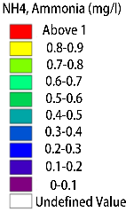
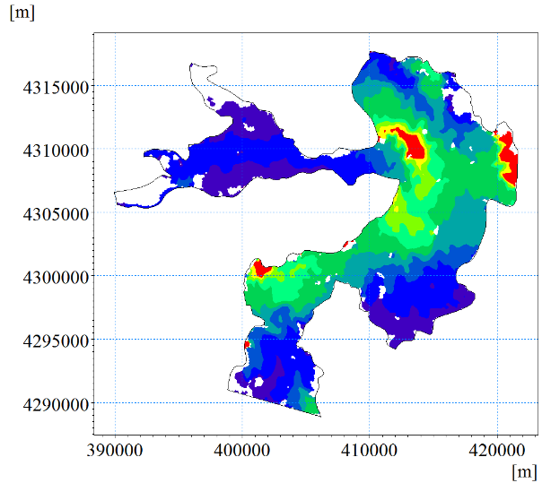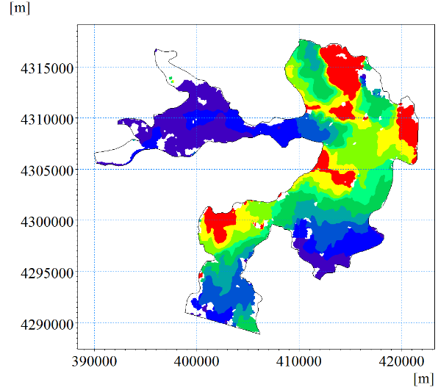
(c) on May 22, 2018 (d) on June 30, 2018
Fig. S5. The distribution of NH₄⁺-N at the typical times.
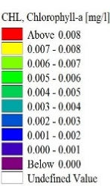
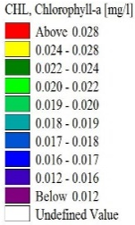
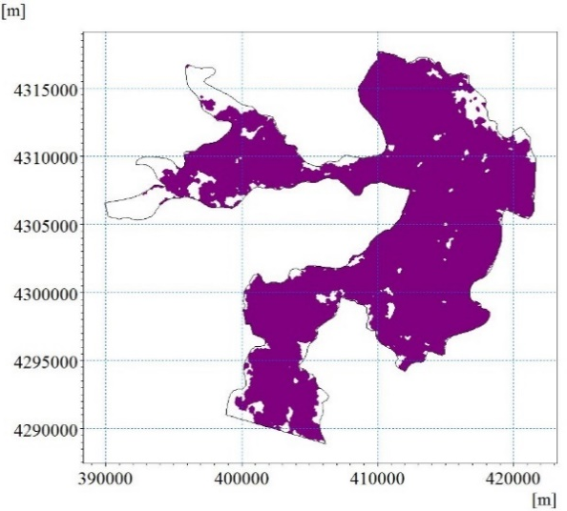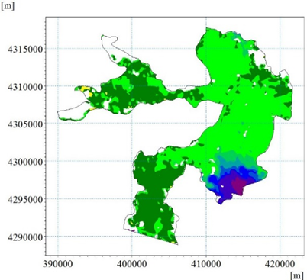
(a) on Dec.1, 2017 (b) on April 6, 2018
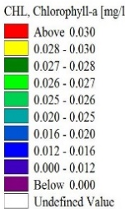
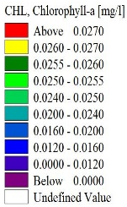
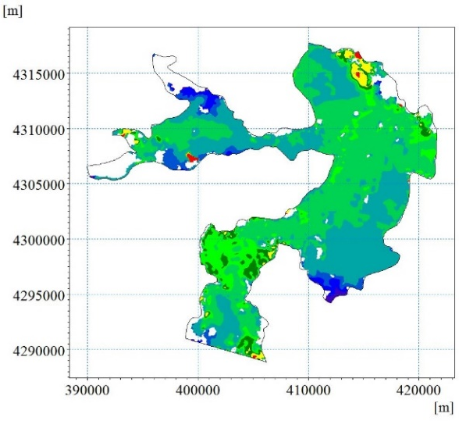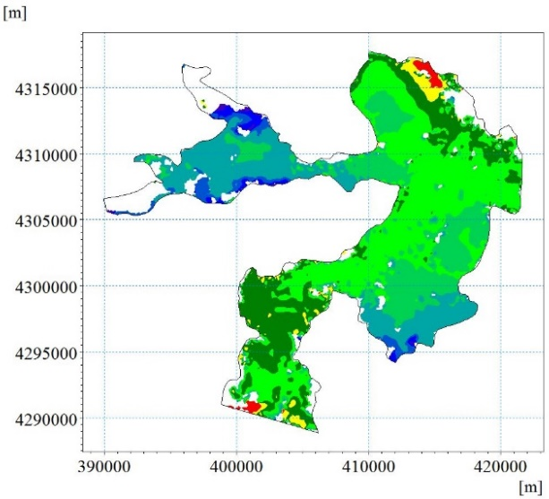
(c) on May 22, 2018 (d) on June 30, 2018
Fig. S6. The distribution of Chla at the typical times. 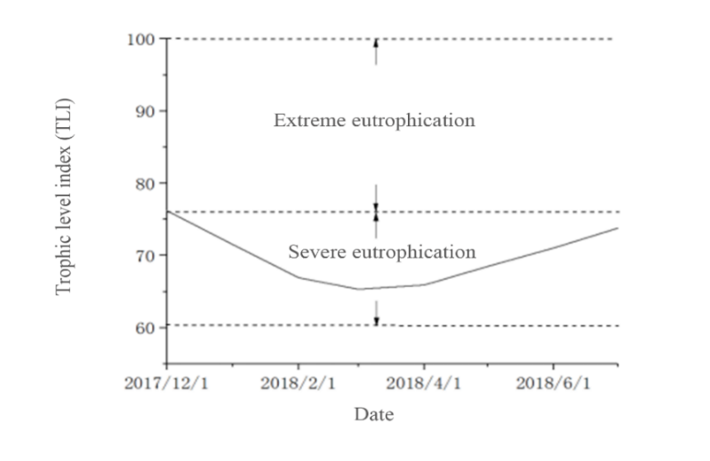
Fig. S7. The change of eutrophication index with respect to time.
S3 Results of MIKE 21 in case of no environmental flow regulation
In the no environmental flow regulation cases, the same hydrodynamic and water quality parameter in environmental flow regulation cases is adopted, except setting the inlet flow boundaries of Dashuliu, Baohe River, Baigouyin River, Zhulong River as 0, and setting the inlet flow boundaries of Fuhe River and Xiaoyi River as 1.1574 m³/s, 0.2315 m³/s, respectively..
S3.1 Hydrodynamic result
Fig. S8 shows the variation of flow filed from February 2018 to June 2018. It can be seen that the flow velocity in the wetland is low compared to water supplement case. The areas with high flow velocity are only distributed near Fuhe and Xiaoyi River with continuous flow or near domestic sewage discharge points.
Fig. S9 (a) shows the temperature distribution in the wetland on Feb.11, 2018. Due to the wetland is in the period of freezing, the water temperature is below 0 ℃. Figs. S9 (b-d) show the variation of temperature from April 2018 to June 2018, which show that with the increase of air temperature, the water temperature increases. Meanwhile, due to the lack of water supplement, the flow velocity in the wetland is low, which makes it easier to store heat in the areas with large water depth, leading to the higher water temperature difference in the wetland.
The distribution of water depth is shown in Fig. S10. It is found that compare to environmental flow regulation cases, water depth in no environmental flow regulation cases is shallow.
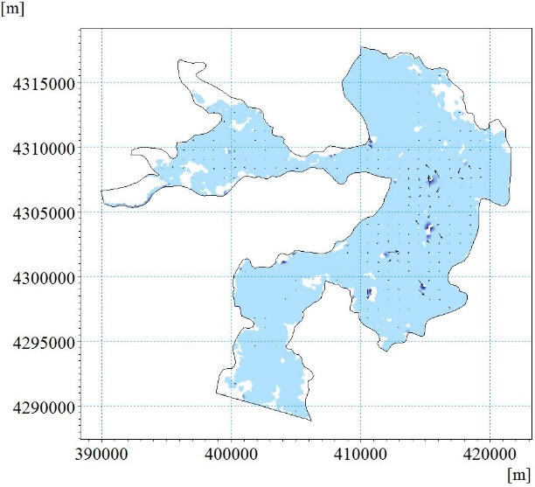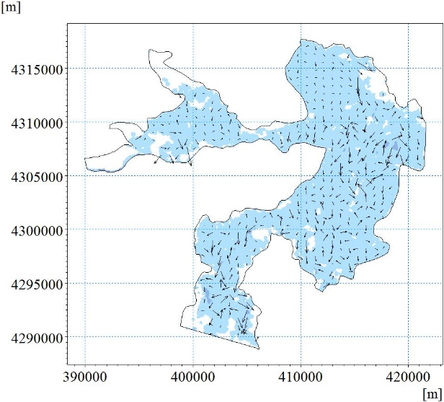
(a) on Feb.11, 2018 (b) on April 6, 2018
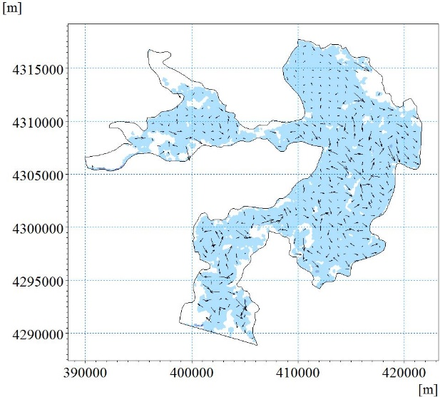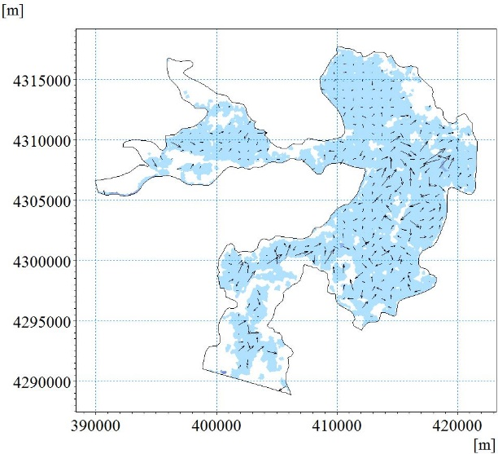
(c) on May 22, 2018 (d) on June 30, 2018
Fig. S8. The distribution of flow field at the typical times.
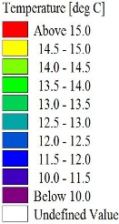
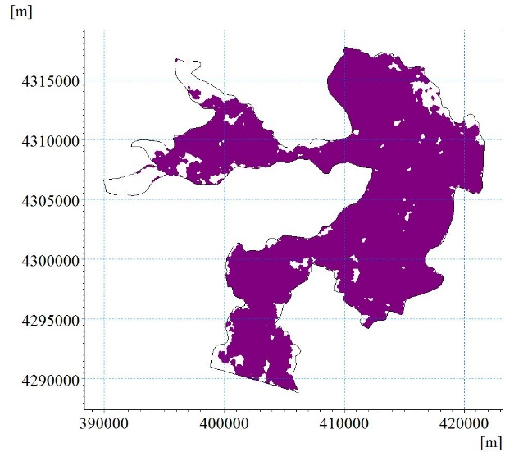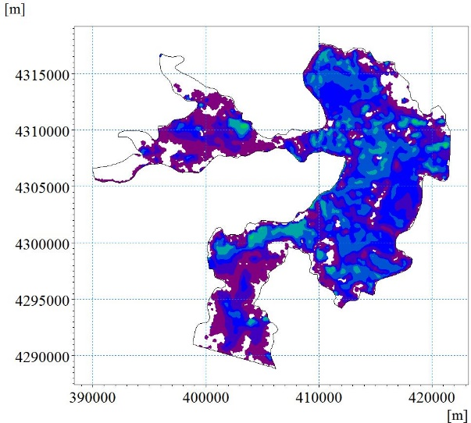
(a) on Feb.11, 2018 (b) on April 6, 2018

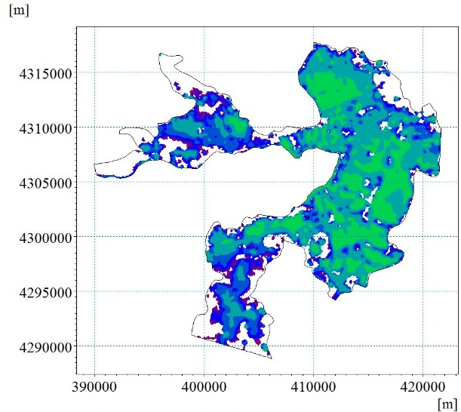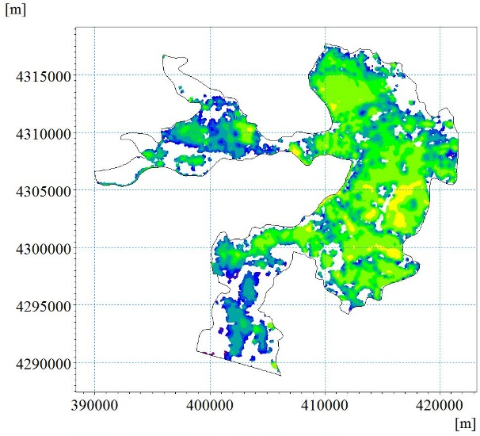
(c) on May 22, 2018 (d) on June 30, 2018
Fig. S9. The distribution of water temperature at the typical times.
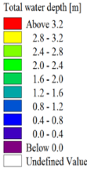
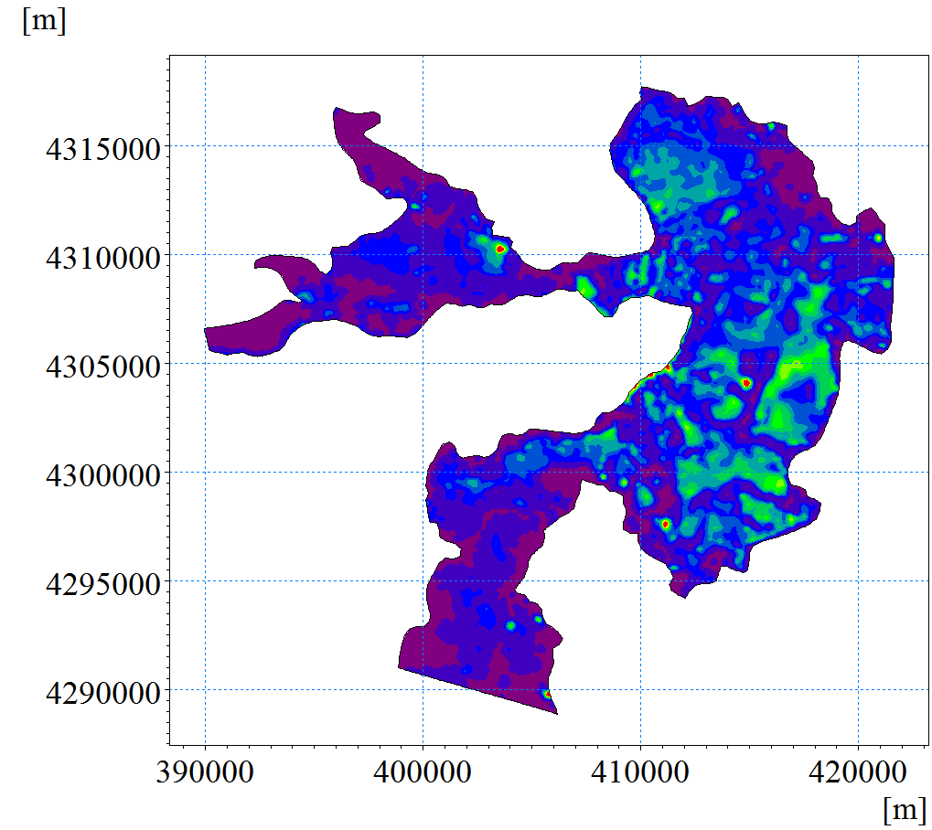
Fig. S10. The distribution of water depth on June 30, 2018.
S3.2 The variation of water quality
Figs. S11 shows the spatial distribution of DO and at typical times. Figs. S11 (a-b) show that as the ice melts and the water temperature increases, the photosynthesis of plants in the water gradually recover and increase the concentration of DO in the water. However, the increase degree of DO is not as large as that of environmental flow regulation cases, since the process of atmospheric reoxygenation in environmental flow regulation cases is stronger. With the water temperature increases, the concentration of DO declines slightly (Figs. S11 (b-d)) because of the growth of algae.
Fig. S12 and Fig. S13 shows the variation of Chla and NH₄⁺-N concentration in Baiyangdian Wetland, respectively. Compare to environmental flow regulation cases (Fig. S5 and Fig. S6), the concentration of NH₄⁺-N and Chla increase significantly. Due to the increase of NH₄⁺-N and Chla concentration, the eutrophication in Baiyangdian Wetland has aggravated. It is found that Baiyangdian Wetland is basically in a state of extreme eutrophication in no environmental flow regulation cases (Fig. S14). What’s more, with the increase of water temperature, the rapid propagation of algae and other plankton aggravates eutrophication.
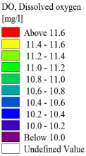
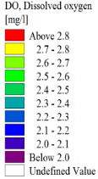
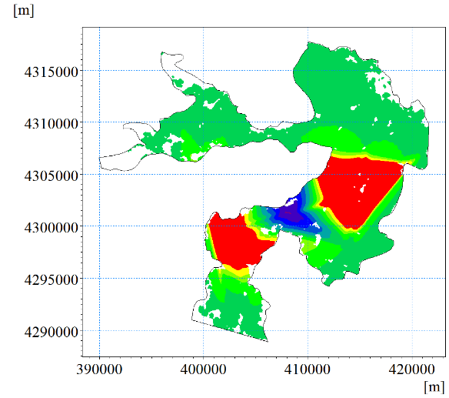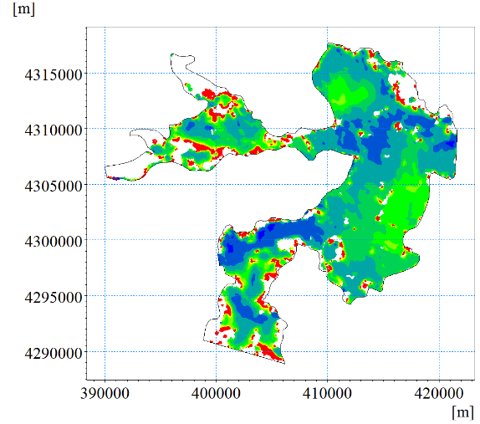
- on Dec.1, 2017 (b) on April 6, 2018
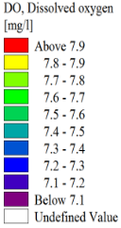
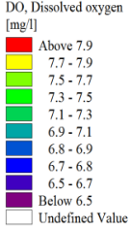
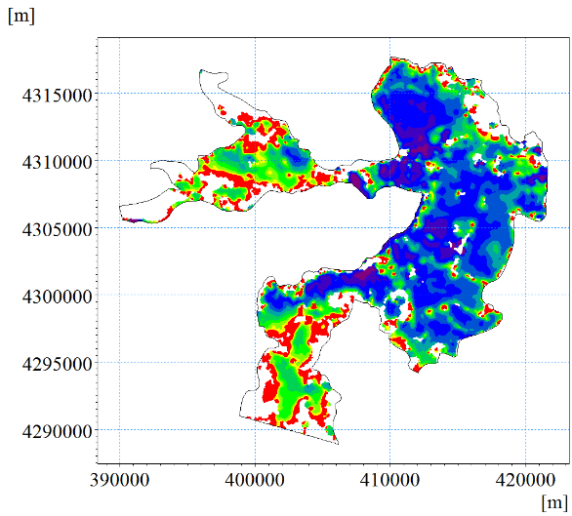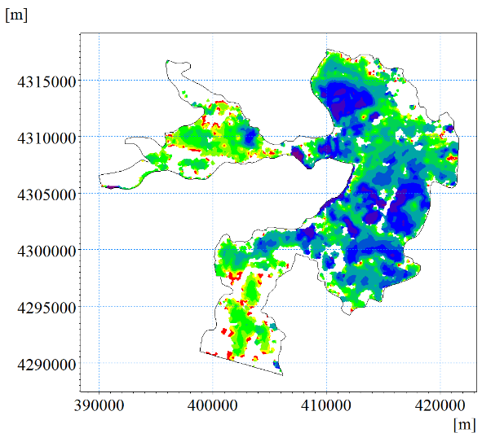
(c) on May 22, 2018 (d) on June 30, 2018
Fig. S11. The distribution of DO.
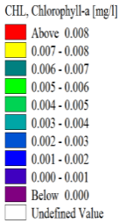
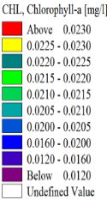
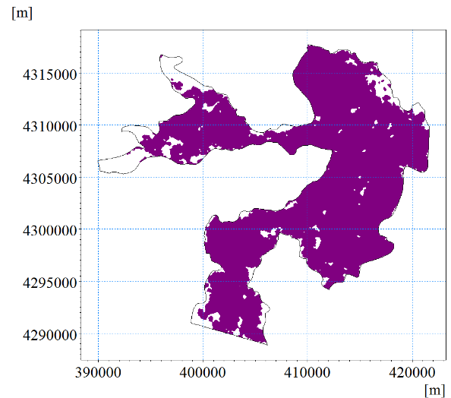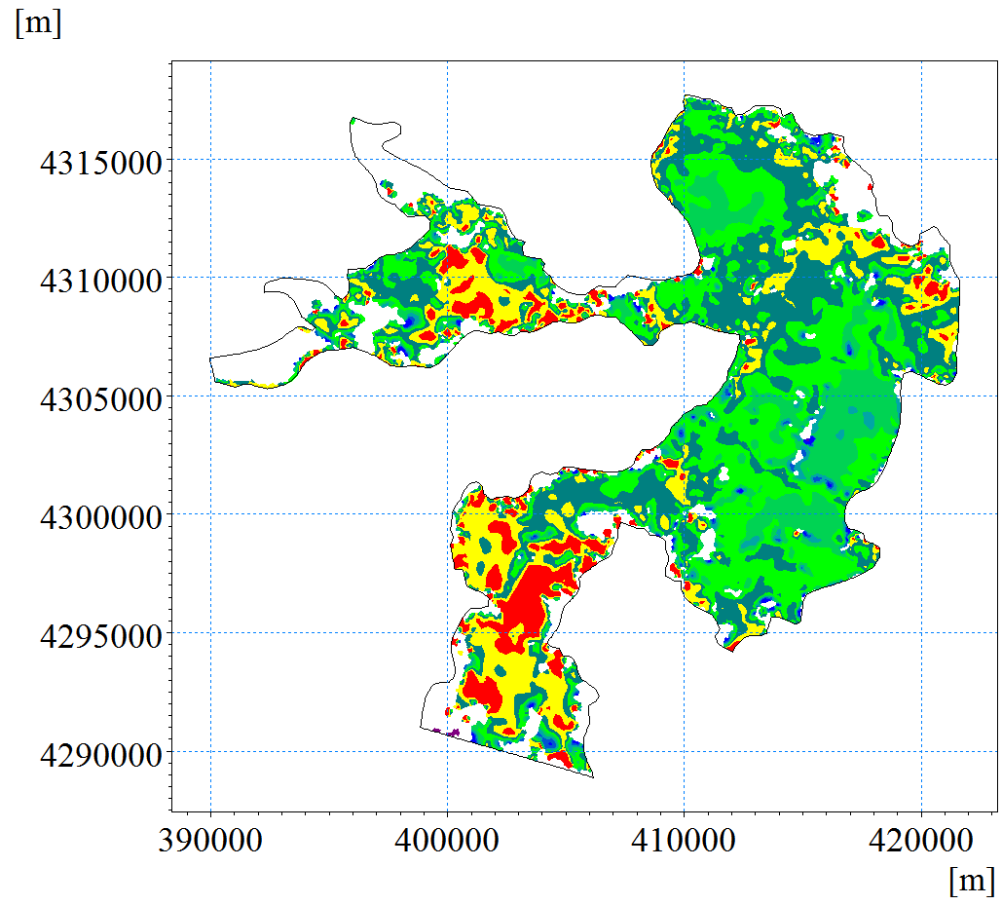
(a) on Dec.1, 2017 (b) on April 6, 2018
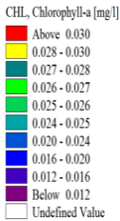
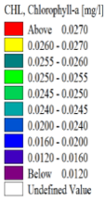
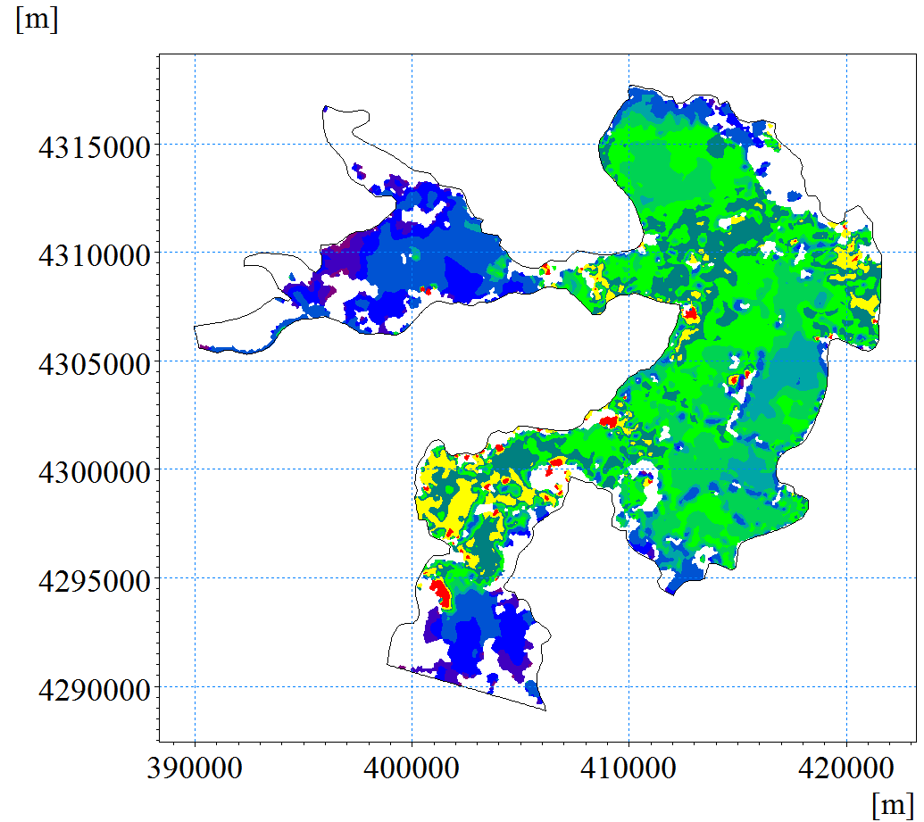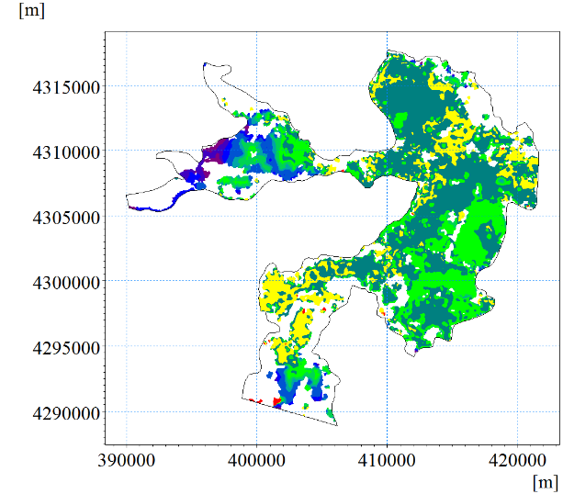
(c) on May 22, 2018 (d) on June 30, 2018
Fig. S12. The distribution of Chla.
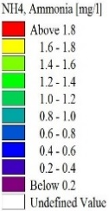
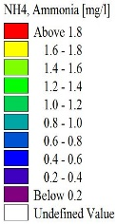
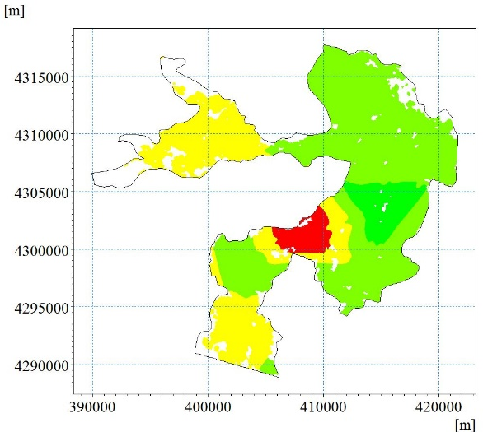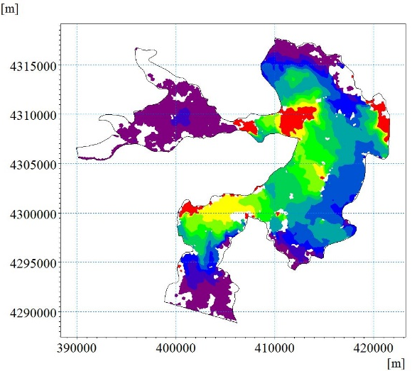
(a) on Dec.1, 2017 (b) on April 6, 2018
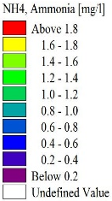
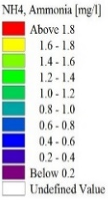
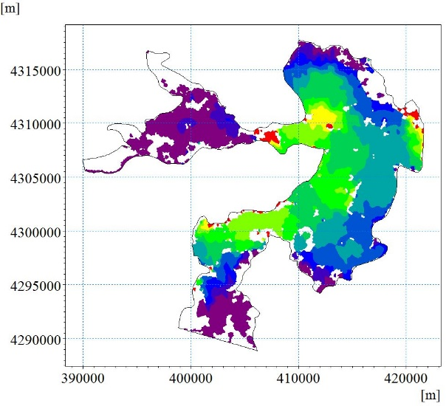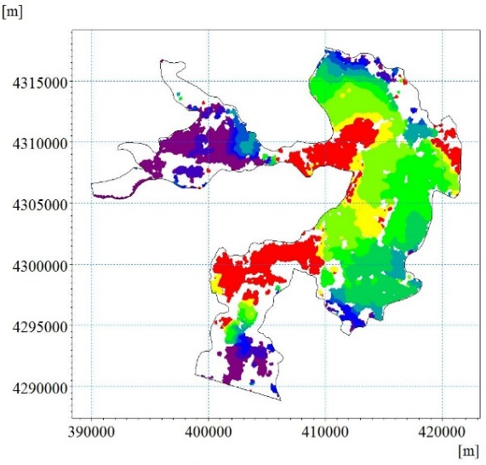
(c) on May 22, 2018 (d) on June 30, 2018
Fig. S13. The distribution of NH₄⁺-N.
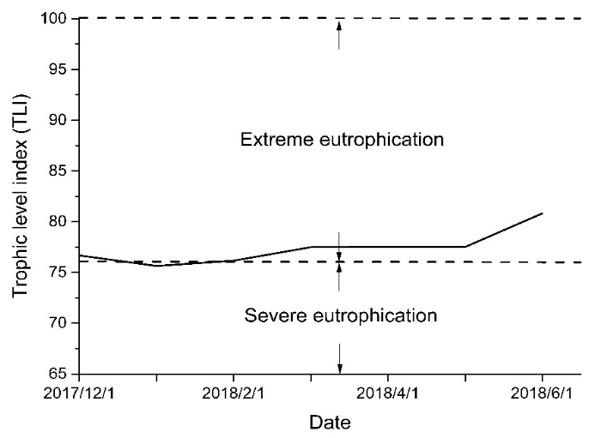
Fig. S14. The eutrophication index with respect to time.

