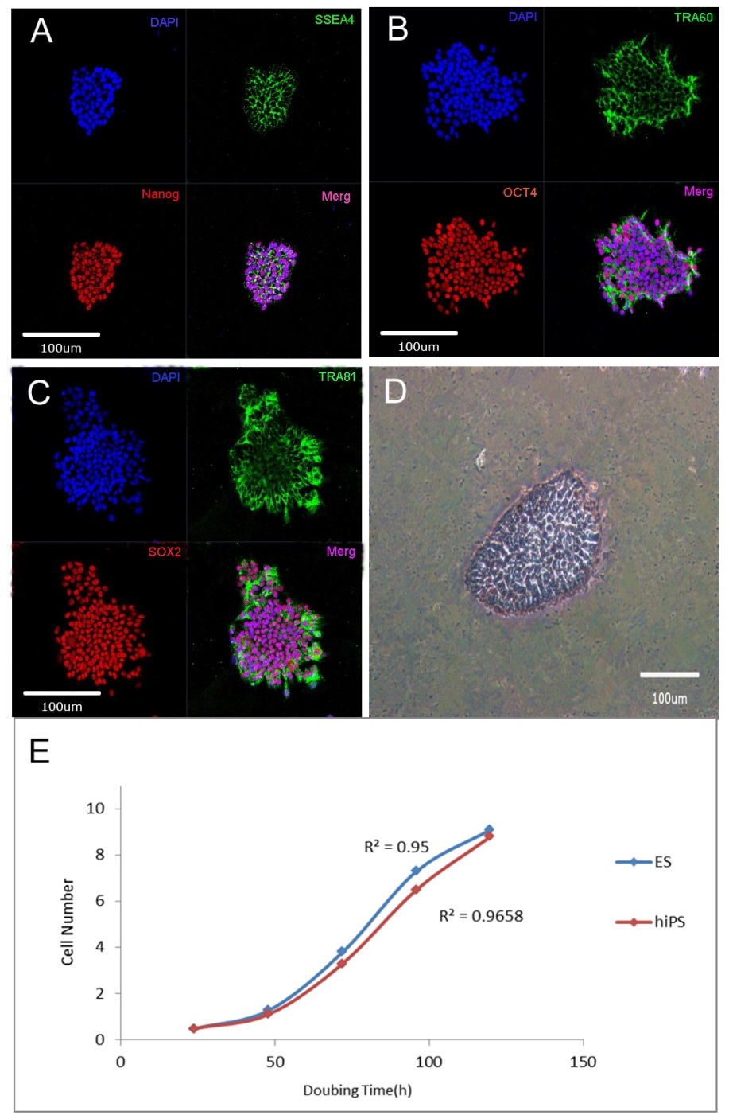

Fig. S1 Physiochemical and biological properties of hiPS cells.
The hiPS cells were derived from human skin cells and were provided by Beijing Cellapy Biotechnology company. The stem cell properties were identified by specific staining of stem cell biomarkers. Nanog (A， red) , Oct4 (B, red）and Sox2(C, red) are the nucleus protein, so the immunohistochemically results only in the nuclei coloring positioning with DAPI (A、B、C, blue) obviously. SSEA4 (A, green) is membrane proteins, showed green fluorescence surround the nucleus DAPI staining. TRA60 (B, green) and TRA81(C, green) are cell cytoplasm protein, showed green fluorescence discontinuous, located near the nucleus. The hiPS cells were cultured in the PSCeasy medium (Beijing Cellapy Biotechnology, China), contains a large amount of Alkaline Phosphatase (AP), with a strong activity (D). During the first 24-48 hours after iPS cells were dissociated, they showed a slow proliferation speed, is the best time window for electrical stimulation experiments (E). Scale bar,100um.

