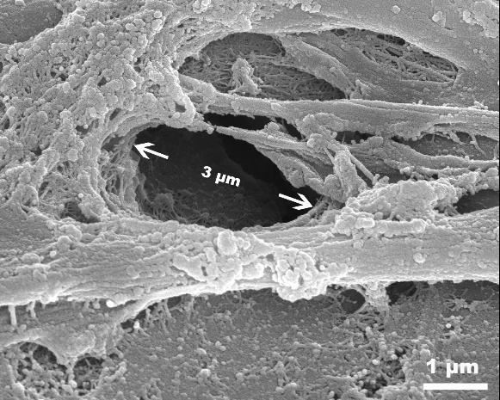
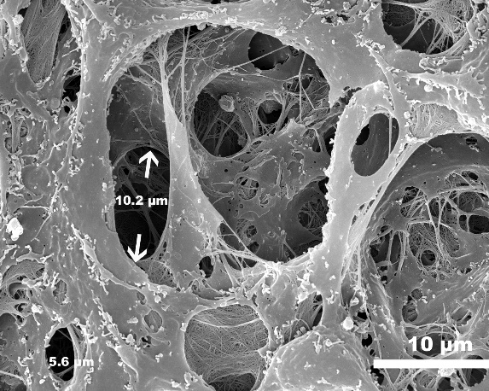
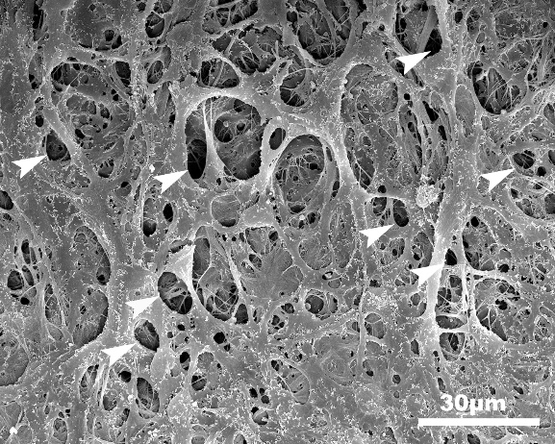
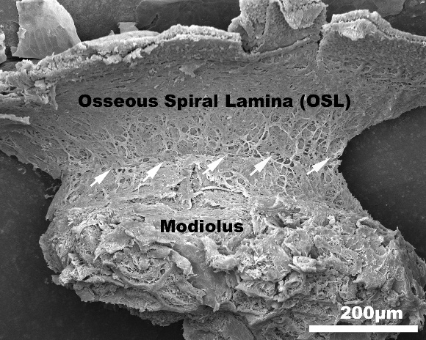
D
C
B
A
Fig. S3 Innate pores of cochlear partition in pig. (A) Scanning electron micrograph showing openings on the surface of the osseous spiral lamina (OSL) which faces the scala tympani (ST), most dense in the area where the OSL and modiolus meet (arrows). (B) The diameter of pores varied from 1μm to 20μm in the mucosa. (C) The diameter of large pores is about 10μm. (D) The diameter of small pores is 3μm.

