Nitric oxide biosensor uncovers diminished ferrous iron-dependency of cultured cells adapted to physiological oxygen

Gulsah Sevimli^{1,#}, Matthew J. Smith^{2,#}, Tuba Akgul Caglar^{1,3,#}, Şükriye Bilir^{3,#}, Melike Secilmis¹, Hamza Y. Altun^{1,}, Esra N. Yigit^{3,4}, Fan Yang², Roland Malli^{5,6}, Gürkan Öztürk^{3,7}, Giovanni E. Mann^{2,¶,}* and Emrah Eroglu^{1,3,¶,}*

Correspondence: giovanni.mann@kcl.ac.uk and emrah.eroglu@sabanciuniv.edu

Supplementary Figures 1-6
Supplementary Table 1

Supplementary Figures

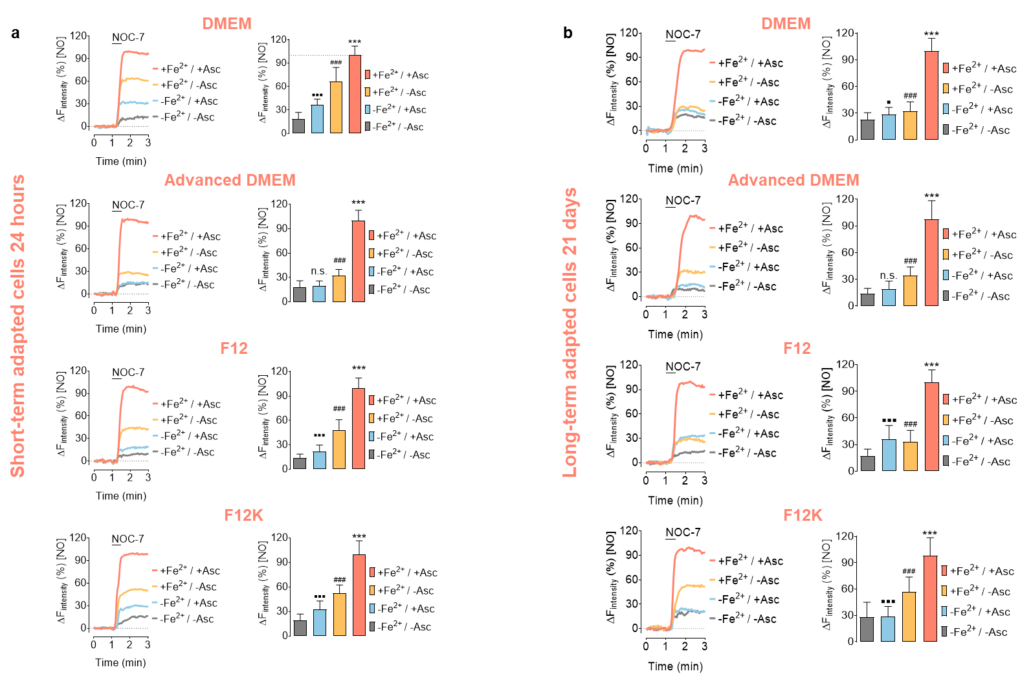
Supplementary Fig. 1: Short or long-term adaptation of HEK293T cells in different culture media under 18 kPa O₂. a, Figures in this panel show NO responses of cultured cells in different culture media (DMEM, Advanced DMEM, F12, or F12K) and different iron (II) supplementation. Cells were maintained in the indicated culture media for 24 h. b, Figures in this panel show the same procedure as in panel a, but cell treatments were continued for 21 days. After adaptation, either 24 h (a) or 21 days (b) cells were tested for geNOps functionality either without any other iron (II) treatment (light grey curves or bars), or 1 mM ascorbate (blue curves or bars), or 1 mM FeSO₄ (orange curves or bars), or the combination of 1 mM FeSO₄ and 1 mM ascorbate (pink curves or bars) for 20 min before imaging. All experiments were repeated in triplicate, and 50-120 individual cells were analyzed for each condition. Dunnett's Multiple Comparison Test was applied to compare all columns with the control column. All values denote mean ± S.D., P-value summary: P<0.0001 (■■■Control vs -Fe²⁺/ +Asc; ###Control vs +Fe²⁺/ -Asc; ***Control vs +Fe²⁺/ +Asc.

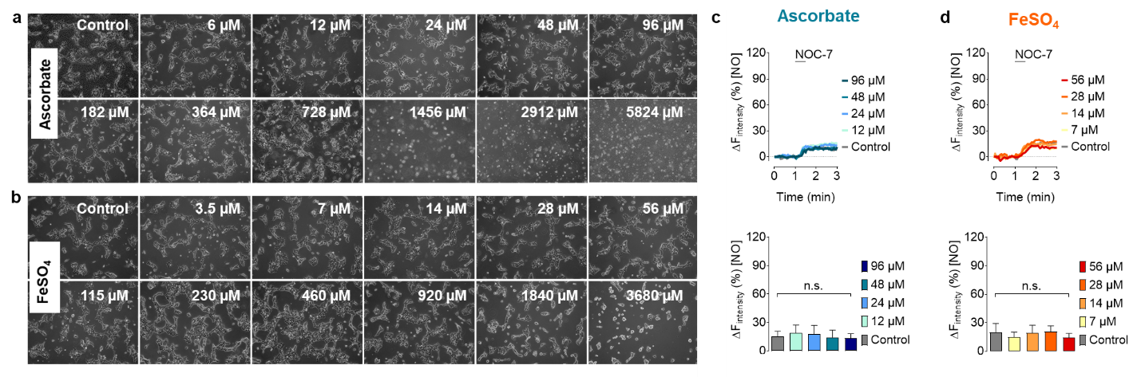
Supplementary Fig. 2: Long-term adaptation of HEK293T cells to FeSO₄ or ascorbate under 18 kPa O₂. Representative phase-contrast images of cells expressing O-geNOp-NES treated with different concentrations of a, ascorbate or b, FeSO₄ as indicated. Representative real-time NO traces in cells expressing O-geNOp-NES adapted for 14 days to increasing concentrations of c, ascorbate or d, FeSO₄ as indicated in the legends. All experiments were repeated in triplicates, and 27-111 individual cells were analyzed for each condition. All values are given as mean ± S.D., and Dunnett's Multiple Comparison Test was applied to compare all columns to the control column.

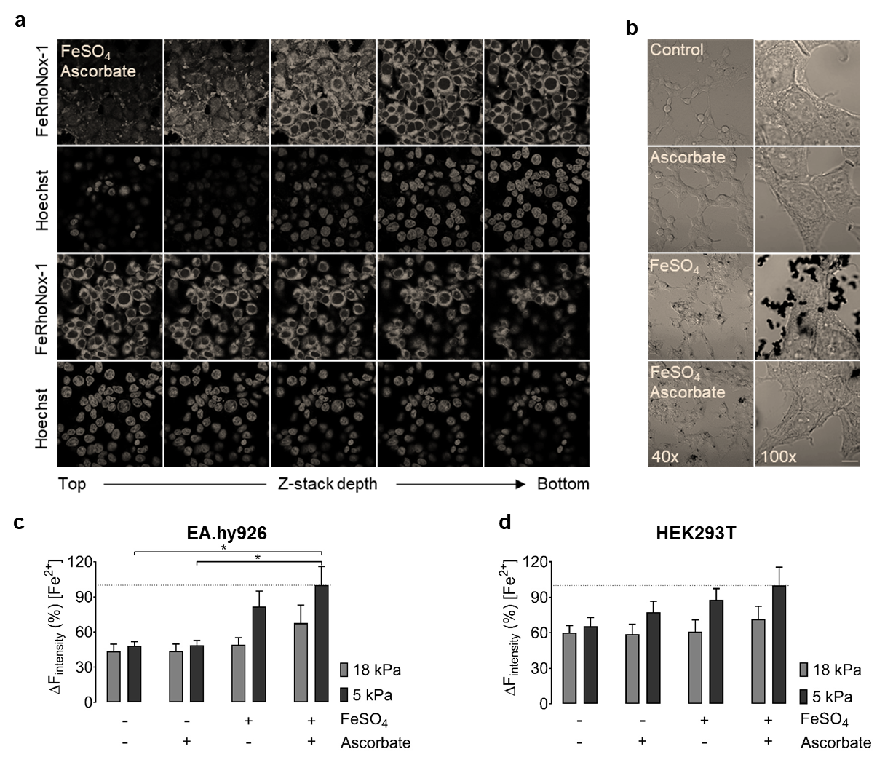

Supplementary Fig.3: Live-cell imaging unveils intracellular distribution and iron (II) uptake in EA.hy926 and HEK293T cells following long-term adaptation to 18 or 5 kPa O₂. a, High-resolution confocal images show Z-stacks of HEK293T cells treated with 1 mM FeSO₄ and 1 mM ascorbate for 20 min and co-stained with Hoechst and FeRhoNox-1. b, Phase-contrast images of Perls/DAB stained HEK293T cells under control condition or following treatment with 1 mM ascorbate, or 1 mM FeSO₄, or 1 mM FeSO₄ + 1 mM ascorbate for 20 min. Normalized FeRhoNox-1 fluorescent intensities in EA.hy926 (c) and HEK293T (d) cells following long-term adaption to 18 kPa (light grey bars) or 5 kPa O₂ (dark grey bars) under non-treated conditions, 1mM FeSO_{4,} 1 mM ascorbate and 1 mM FeSO₄ + 1 mM ascorbate for 20 min. Data denote mean ± S.E.M., n=6 different cell cultures, Tukey's Multiple Comparison Test, P-value summary: *P<0.05.

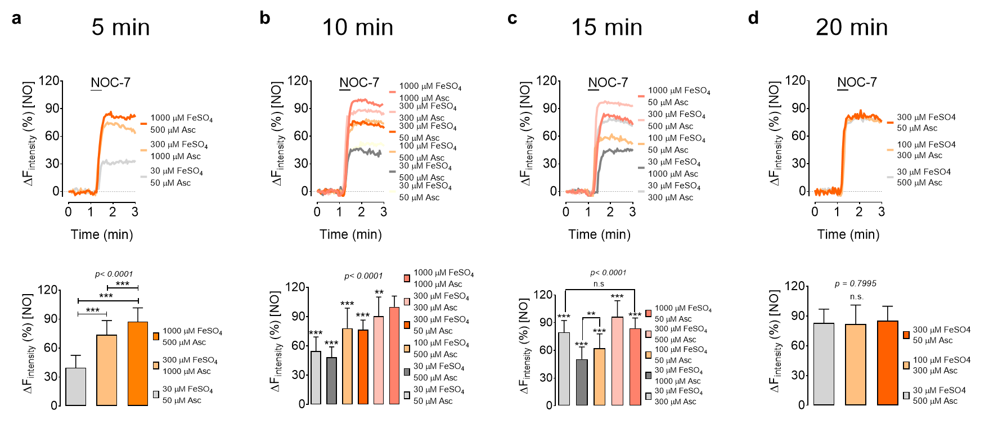

Supplementary Fig. 4: Optimization of iron (II) loading process using Taguchi experimental design. Curves in this figure show real-time traces of NO responses in HEK293T cells under 18 kPa O₂ and pretreated with different iron(II) and ascorbate concentrations for 5 min (a), 10 min (b), 15 min (c), or 20 min (d). Bars show mean ± S.D. of experiments conducted in duplicate in accordance with Taguchi design of experiments, with the number of individual cells ranging between 25 to 105 cells. For statistical analysis, 1 mM FeSO₄ + 1 mM ascorbate for 10 min has been used as the control for comparison with other treatments Tukey's Multiple Comparison Test (panel b, right panel), in all other panels, Bonferroni's Multiple Comparison Test was performed. P-values are indicated, respectively.
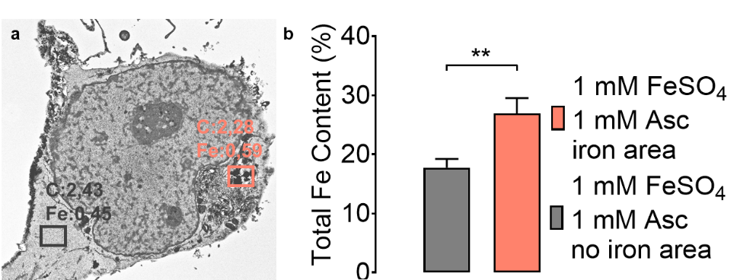

Supplementary Fig. 5: SEM/EDX method for total Fe determination. a, Representative SEM/EDX micrograph shows the cross-section of an individual HEK293T cell under 18 kPa O₂ and pretreated with 1 mM FeSO₄ and 1 mM ascorbate for 20 min. The pink square indicates the accumulation of iron particles. The grey square shows a cell region without iron accumulation. b, Bars represent the maximum iron levels in cells detected in iron-containing (pink bar, n=3) and non-iron-containing regions (grey bar, n=3). Total iron levels were normalized against the total carbon content in the respective region of interest. Student's t-test was applied, P<0.01.

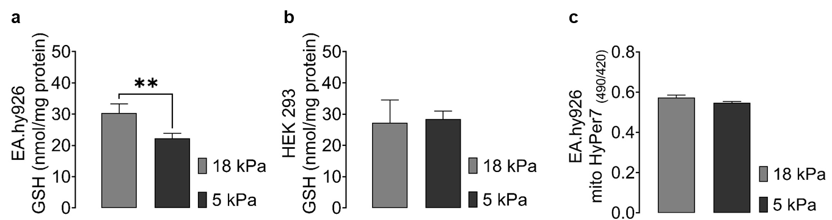
Supplementary Fig. 6: Basal intracellular GSH and H₂O₂ levels in EA.hy926 and HEK293T cells adapted to 18 or 5 kPa O₂. Bars show total intracellular glutathione levels in EA.hy926 (a) and HEK293T (b) cells adapted for five days to either 18 kPa (light grey bars) or 5 kPa (dark grey bars) O₂. c, Bars indicate the statistical analysis of basal H₂O₂ levels in the mitochondria of EA.hy926 cells adapted for five days to either 18 kPa (light grey bars) or 5 kPa (dark grey bars) O₂. Data denote mean ± S.E.M., n = 4 independent cultures, Student's unpaired t-test, **P<0.01.

Supplementary Table 1: Experimental design for iron (II) loading optimization
