Supplementary Information
Starfish-inspired Ultrasound Ciliary Bands for Microrobotic Systems
Cornel Dillinger¹, Nitesh Nama², and Daniel Ahmed^{1*}
¹Acoustic Robotics Systems Lab, Department of Mechanical and Process Engineering, ETH Zurich, Switzerland
²Department of Surgery, University of Michigan, Ann Arbor, Michigan, USA
*Correspondence and requests for materials should be addressed to D.A. (e-mail: dahmed@ethz.ch)

This PDF file includes:
Supplementary text
Figures S1 to S8
Legends for Movies S1 to S7
SI References

Other supplementary materials for this manuscript include the following:
Movies S1 to S7

Supplementary Information Text
Theory
Here, we describe the theoretical formulation employed in the current work to investigate the flow patterns around microswimmer. The fluid response is governed by the standard Navier-Stokes equations for a linear, viscous compressible fluid:
$\frac{∂ρ}{∂t}+∇·\left(ρv\right)=0$ , (eq. S1)

$ρ\frac{∂v}{∂t}+ρ\left(v·∇\right)v=-∇p+μ∇^{2}v+{(μ}_{b}+\frac{1}{3}μ)∇(∇·v),$ (eq. S2)
where ρ is the mass density of the fluid, p is the fluid pressure, and µ and µ_{b} are the shear and the bulk dynamic viscosities, respectively. Eq. (S1) and (S2) need to be supplemented with a constitutive relation linking the pressure to the fluid density. Following our prior work ^{1,2}, we assume a linear relation between pressure and density as:

$$p=c_{0}^{2}ρ,$$

where $c_{0}$ is the speed of sound in the fluid under quiescent conditions. Direct simulations of this system of equations (with appropriate boundary conditions) poses significant numerical challenges due to the widely separated time scales of the acoustic actuation and the consequent acoustic streaming. Therefore, we follow a perturbation approach to split the flow variables into their first- and second-order components as:

$v= v_{0}+ εv_{1}+ ε^{2}v_{2}+O\left(ε^{3}\right)+…$,

$p= p_{0}+ εp_{1}+ ε^{2}p_{2}+O\left(ε^{3}\right)+…$,

$ρ= ρ_{0}+ ερ_{1}+ ε^{2}ρ_{2}+O\left(ε^{3}\right)+… ,$ (eq. S3)

where $ε$ is a non-dimensional smallness parameter. Substitution of (S3) in (S1) and (S2), and segregation of first-order terms yields a first-order system of equations:
$\frac{∂ρ_{1}}{∂t}+ρ_{0}\left(∇·v_{1}\right)=0,$ (eq. S4)

$ρ_{0}\frac{∂v_{1}}{∂t}=-∇p_{1}+μ∇^{2}v_{1}+{(μ}_{b}+\frac{1}{3}μ)∇\left(∇·v_{1}\right).$ (eq. S5)

Following the same procedure for the second-order terms, and a subsequent time-averaging over a period of oscillation, yields the second-order system of equations:

$〈\frac{∂ρ_{2}}{∂t}〉+ρ_{0}∇·〈v_{2}〉=-∇·〈ρ_{1}v_{1}〉,$ (eq. S6)

$ρ_{0}〈\frac{∂v_{2}}{∂t}〉+〈ρ_{1}\frac{∂v_{1}}{∂t}〉+ρ_{0}〈\left(v_{1}·∇\right)v_{1}〉=-∇p_{2}+μ∇^{2}v_{2}+{(μ}_{b}+\frac{1}{3}μ)∇(∇·v_{2}).$ (eq. S7)

We have retained the terms associated with the bulk viscosity in our analysis to fully account for viscous attenuation both within and outside the boundary layer. The above system of equations, with appropriate boundary conditions, yields the Eulerian descriptions of fluid velocity and pressure at the first- and second-order. However, for a direct correspondence with the particle velocity observed in the experiments, these descriptions need to be subsequently augmented with the definition of Stokes drift to obtain the Lagrangian fluid velocity. Alternatively, as discussed in², a similar system of equation as above can be derived directly in terms of the Lagrangian fluid velocity to avoid the need to employ the notion of Stokes drag. We refer the reader to our prior work ³ for further discussion of the governing equations and boundary conditions.

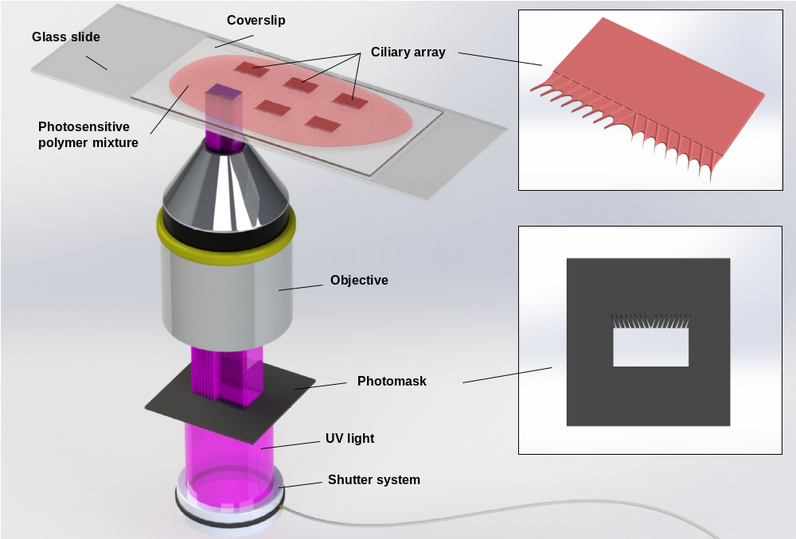

Fig. S1 | UV-photopolymerization setup. Ciliary bands were fabricated using a custom-built microscope projection UV photolithography process. A UV lamp (NIKON, Intensilight C-HGFI) was mounted onto an inverted epi-fluorescence microscope (NIKON, Eclipse Ti) and used to irradiate a high-resolution photomask (CAD/Art Services, Inc.) inserted into the field stop of the microscope. UV light passed through the mask, became focused through a 20x objective, and polymerized the photosensitive polymer mixture (see Materials) on a glass slide downsized by a factor of $\sim 16.3$. In exposed regions, the negative photoresistor polymerized according to the photomask pattern. The UV exposure time was controlled by an electric shutter system (Vincent Associates, VCM-D1) to fully polymerize the ciliary band and varied between $500 - 3000 ms$ at different UV-intensity levels $(12.5 - 100.0\%)$ selected on the UV lamp.

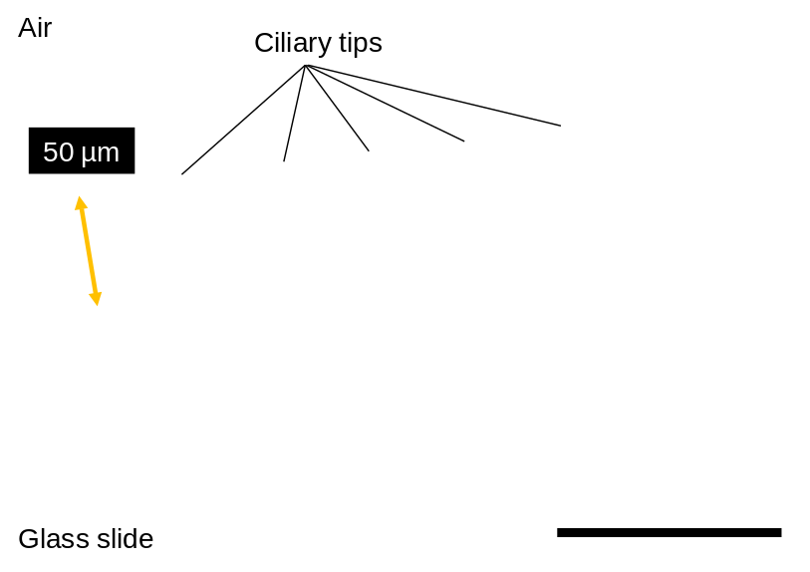

Fig. S2 | The micrograph shows the cross-sectional view of the ciliary band of thickness $\sim 50μm$. Scale bar, $100 µm$.

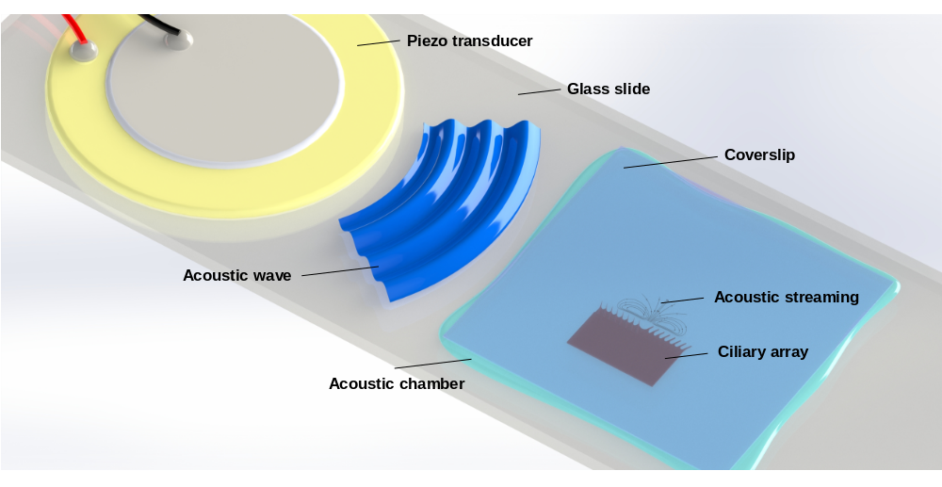

Fig. S3 | Acoustic setup. The acoustic system was built on a $25 mm x 75 mm x 1 mm$ glass slide (Menzel) whereon a transducer disc (Murata, 7BB-27-4L0) was attached with epoxy resin (2-K-Epoxidkleber, UHU Schnellfest). Once the ciliary band and other microarchitectures were fabricated and cleaned (IPA, Sigma-Aldrich) on the acoustic device, they were transferred onto the microscope stage. A solution consisting of $10:1$ by volume DI water and tracer $5.7 µm$ particles (Polysciences) was placed on top of the microstructures. A confined “liquid manipulation chamber” was developed by applying a coverslip $(22 mm x 22 mm)$ to the droplet $(\sim 150 µl)$ containing microstructures and tracer particles. The piezo transducer was then connected to the function generator (AFG 3011C, Tektronix) via an amplifier (Thurlby Thandar Instruments, WA301) to generate acoustic fields with adjustable frequencies and voltages within the liquid. The whole setup was mounted on an inverted microscope.

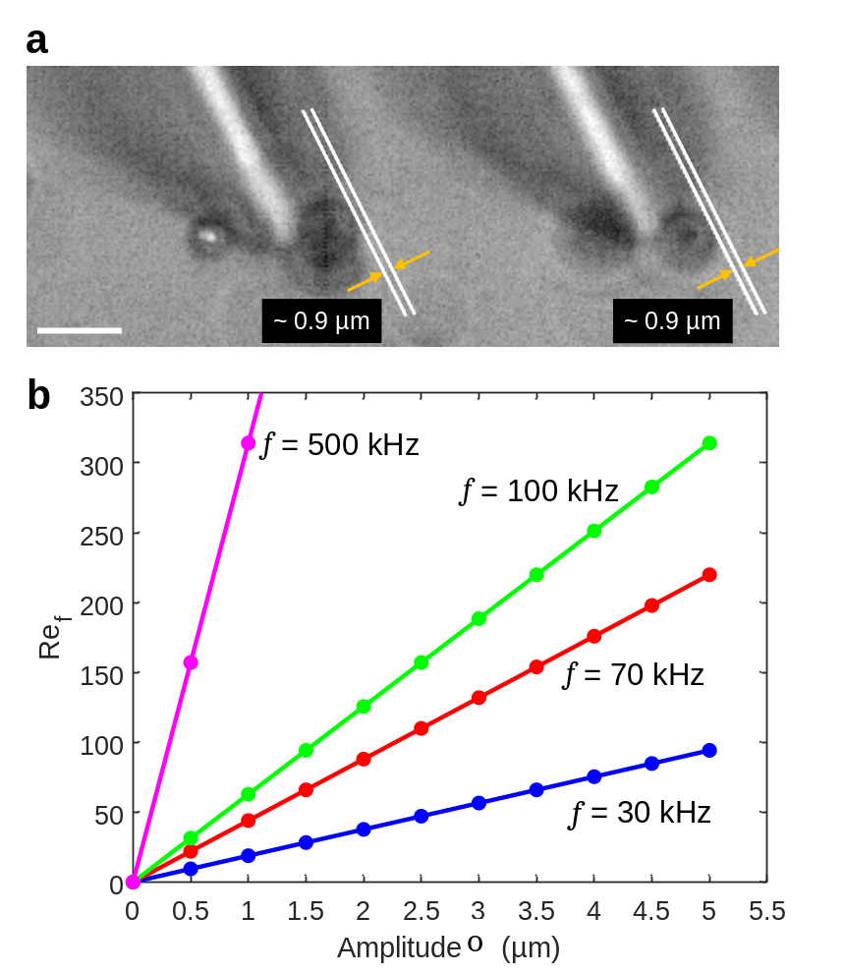
Fig. S4 | a. Optical image demonstrates the small-amplitude oscillation of the ciliary bands in ultrasound. The image shows the oscillation amplitude, $∆s ≈ 0.9 μm,$ of the ciliary band at $68.5 kHz$ and $20$ $V_{PP}$(see also Movie S6). Scale bar,$10 µm$. b. Measured Reynolds number $({Re}_{f}=2πf∆sL/ν)$ versus oscillation amplitude $∆s$ of the cilia tip at $30$ (blue), $70$ (red), $100$ (green), and $500 kHz$ (magenta).

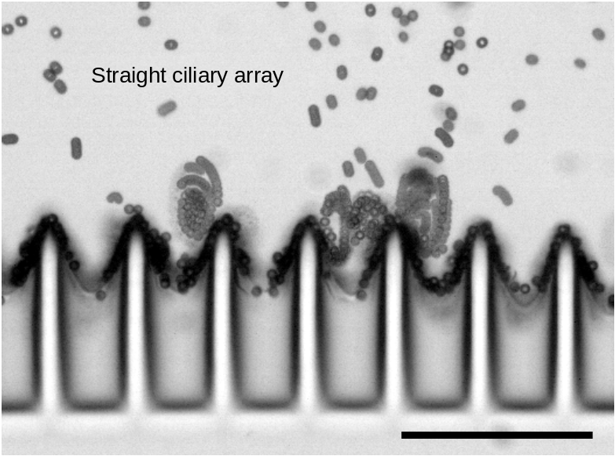

Fig. S5 | The control experiment demonstrates counter-rotating vortices developed at tips of the straight ciliary array at excitation frequency and amplitude of $68.5 kHz$ and $20 V_{PP}$, respectively. The stacked images captured at $2871$ fps (frames per second) show no tangential movement of the tracer particles (see also Movie S3). Scale bar, $100 µm$.

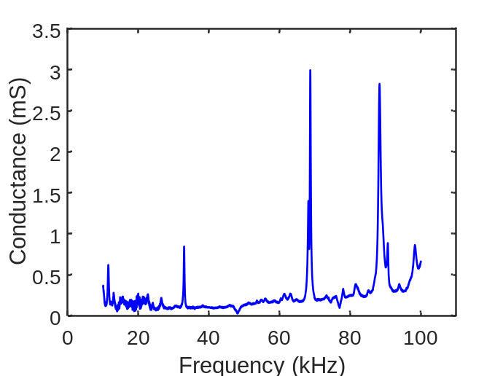

Fig. S6 | Admittance measurement (Real part of admittance = conductance) of the piezo transducer coupled with a glass slide using an impedance analyzer (SinePhase, Impedance Analyzer 16777k). The experimental setup showed resonances at $\sim 32.9$, $\sim 68.7$ and $\sim 88.3 kHz$.

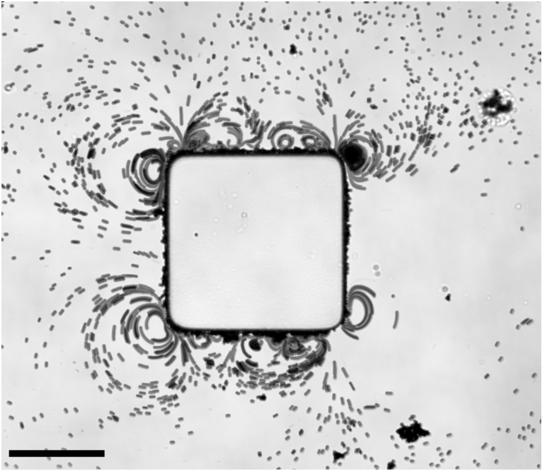

Fig. S7 | Non-ciliated microstructure induces weak streaming when exposed to ultrasound with frequency and amplitude of $68.5 kHz$and$20 V_{PP}$, respectively. No net displacement of the microstructure with similar dimensions as the ciliated microrobot was observed. Scale bar, $200 µm$.

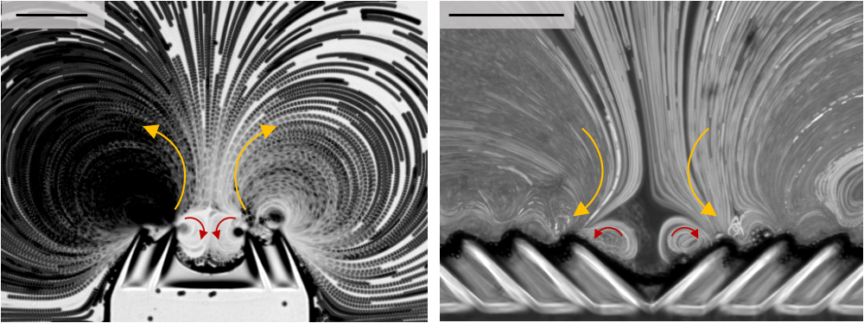

Fig. S8 | Counter-rotating vortices (red) developed at the innermost ciliary tips at excitation frequency and amplitude of $68.5 kHz$ and $20 V_{PP}$, respectively. Scale bars, $100 µm$.

Movie S1. Tangential streaming along an angled oscillating ciliary array at excitation frequency and amplitude of $33.7 kHz$ and $5 V_{PP}$, respectively.

Movie S2. Acoustic streaming of a + and a – ciliary band at excitation frequency and amplitude of $68.5 kHz$ and $20 V_{PP}$, respectively.

Movie S3. Acoustic steaming of a straight (non-angulated) ciliary band at excitation frequency and amplitude of $68.5 kHz$ and $20 V_{PP}$, respectively.

Movie S4. A bioinspired microrobot is developed by arranging + and – ciliary bands opposite to each other. The microrobot executing translational motion with a mean velocity of $v ≈ 2.6 mm/s$ at excitation frequency and amplitude of $68.8 kHz$ and $20 V_{PP}$, respectively.

Movie S5. Acoustic streaming profile of the bioinspired microrobot at excitation frequency and amplitude of $68.8 kHz$ and $20 V_{PP}$, respectively.

Movie S6. The oscillation amplitude of the ciliary array is visualized when acoustic was switched on and off at excitation frequency and amplitude of $68.5 kHz$ and $20 V_{PP}$, respectively.

Movie S7. A bioinspired trapping mechanism is developed based on a combinatorial arrangement of a + and – configuration of ciliary bands at excitation frequency and amplitude of $68.5 kHz$ and $20 V_{PP}$, respectively. This configuration exhibits the capability to trap neighboring $10 µm$ microparticles.

References

1. Nama, N., Huang, P. H., Huang, T. J. & Costanzo, F. Investigation of acoustic streaming patterns around oscillating sharp edges. Lab Chip (2014) doi:10.1039/c4lc00191e.
2. Nama, N., Huang, T. J. & Costanzo, F. Acoustic streaming: an arbitrary Lagrangian--Eulerian perspective. J. Fluid Mech. 825, 600–630 (2017).
3. Nama, N., Huang, P.-H., Huang, T. J. & Costanzo, F. Investigation of micromixing by acoustically oscillated sharp-edges. Biomicrofluidics 10, 24124 (2016).

