Supplementary Information
Amphiphilic porphyrin-based nanoparticles as a nuclei-approaching delivery platform for enhanced cancer photochemotherapy

Supplementary Figures
Syntheses of the compounds
Supplementary Figure 1. Synthesis of 1, 2, 3 and 4.
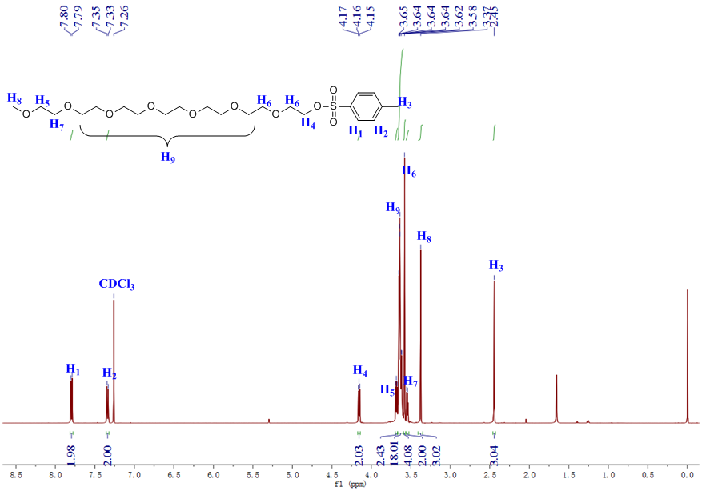
Supplementary Figure 2. ¹H NMR spectrum (500 MHz, chloroform-d, room temperature) of 1.
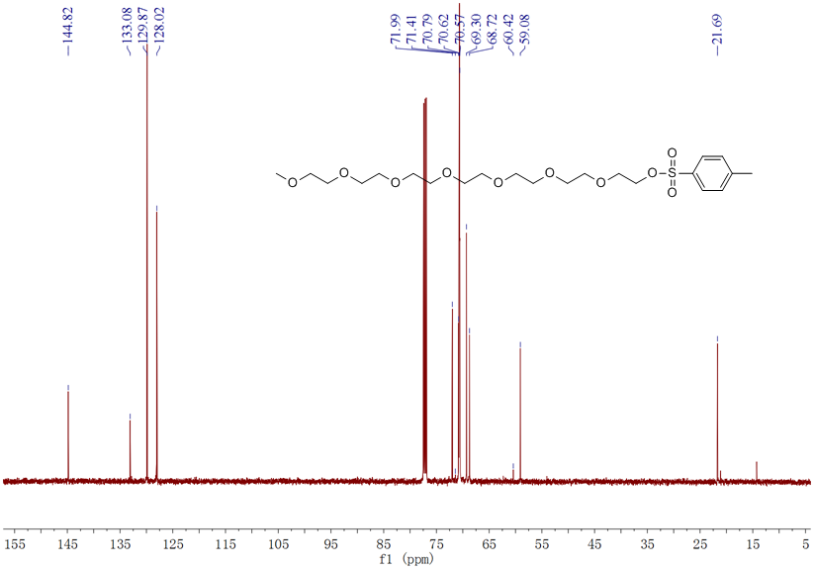
Supplementary Figure 3. ¹³C NMR spectrum (126 MHz, chloroform-d, room temperature) of 1.
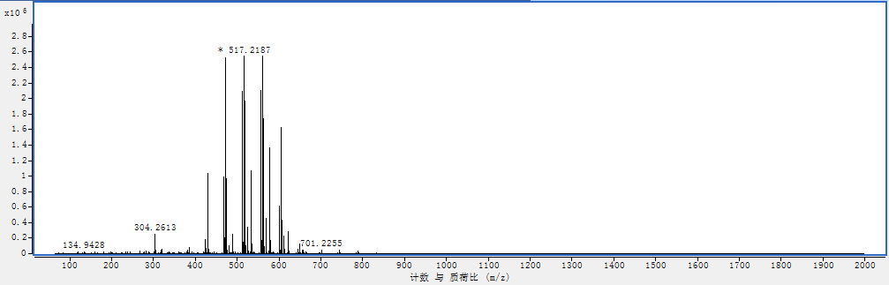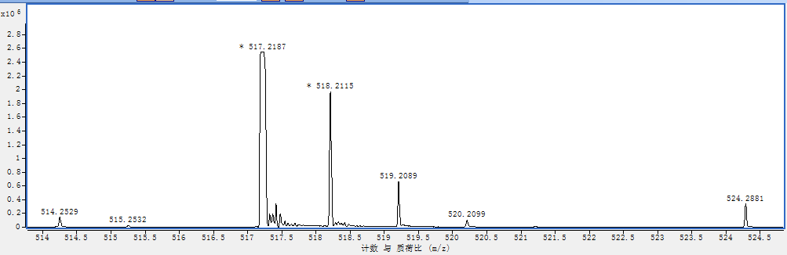
Supplementary Figure 4. Electrospray ionization mass spectrum of 1. Calcd for C₂₂H₃₈NaO₁₀S [M + Na]⁺: 517.2078, Found: 517.2284.
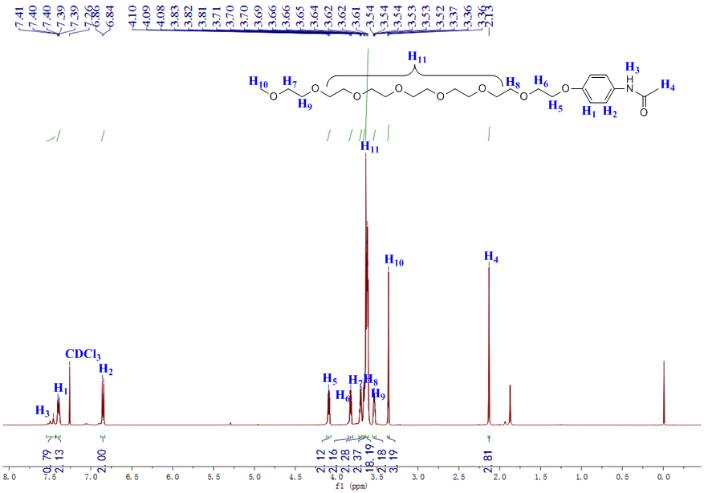
Supplementary Figure 5. ¹H NMR spectrum (500 MHz, chloroform-d, room temperature) of 2.
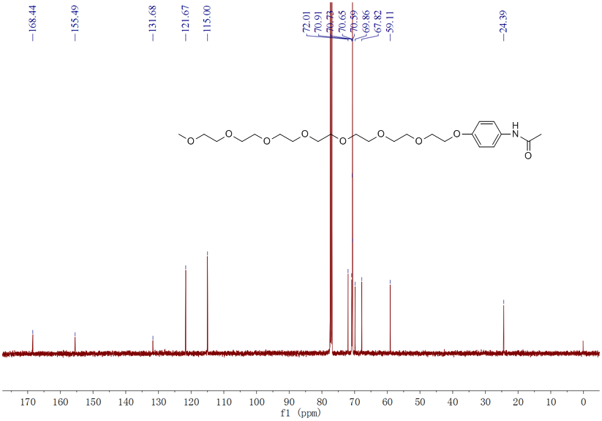
Supplementary Figure 6. ¹³C NMR spectrum (126 MHz, chloroform-d, room temperature) of 2.
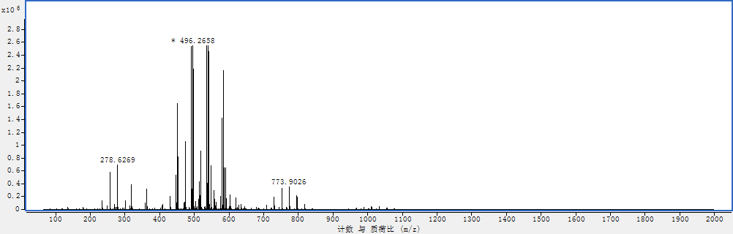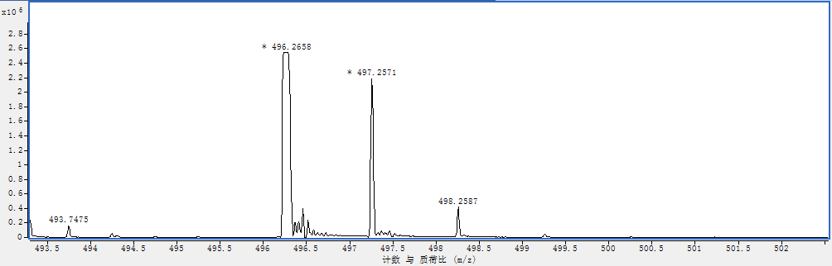
Supplementary Figure 7. Electrospray ionization mass spectrum of 2. Calcd for C₂₃H₃₉NNaO₉ [M + Na]⁺: 496.2523, Found: 496.2658.
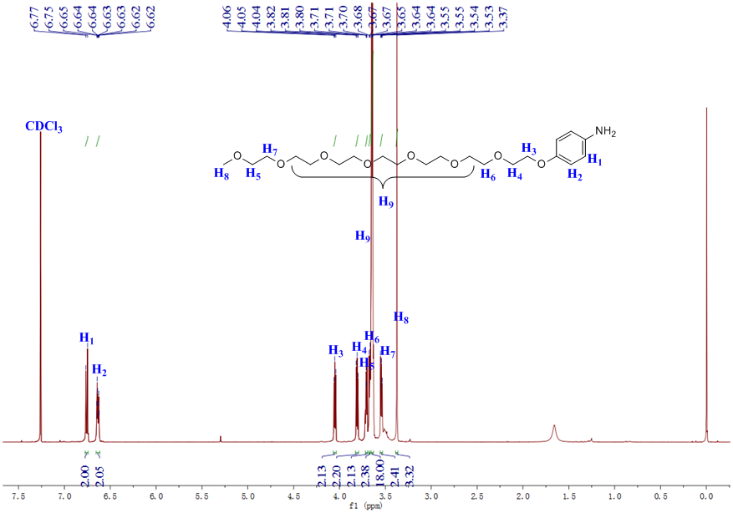
Supplementary Figure 8. ¹H NMR spectrum (500 MHz, chloroform-d, room temperature) of 3.
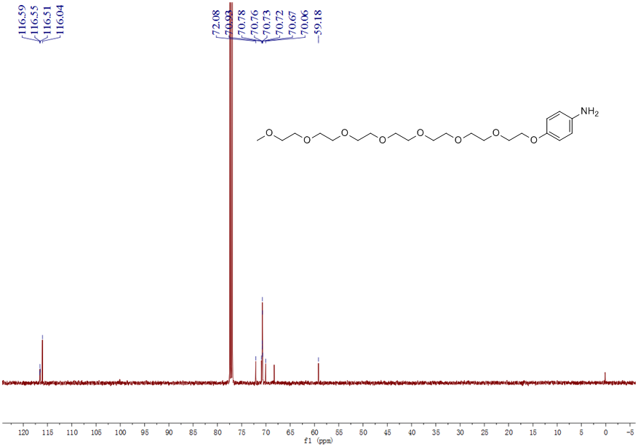
Supplementary Figure 9. ¹³C NMR spectrum (126 MHz, chloroform-d, room temperature) of 3.
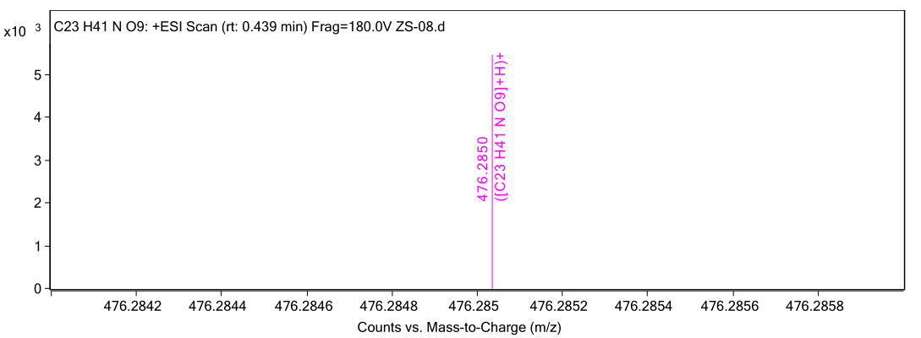
Supplementary Figure 10. Electrospray ionization mass spectrum of 3. Calcd for C₂₃H₄₁NO₉ [M + H]⁺: 475.2781, Found: 475.2850.
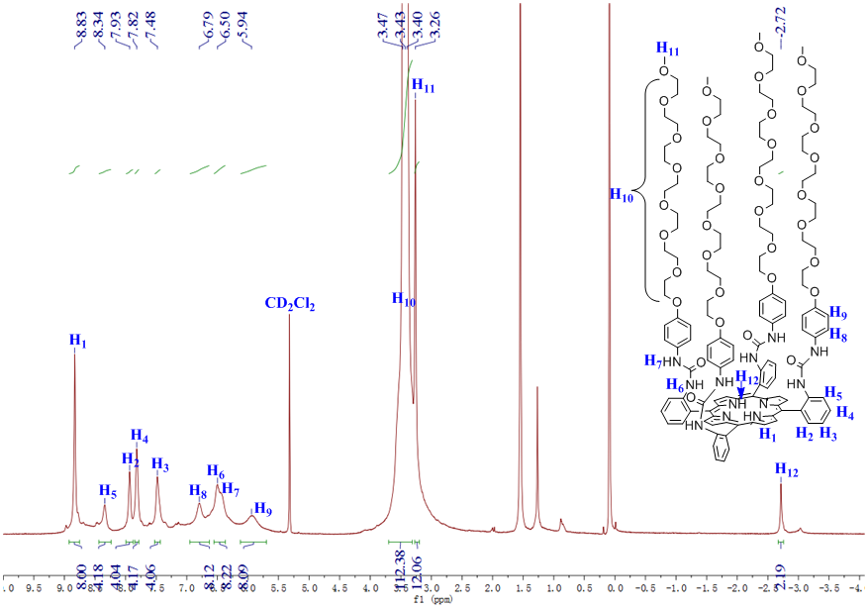
Supplementary Figure 11. ¹H NMR spectrum (500 MHz, dichloromethane-d, room temperature) of 4.
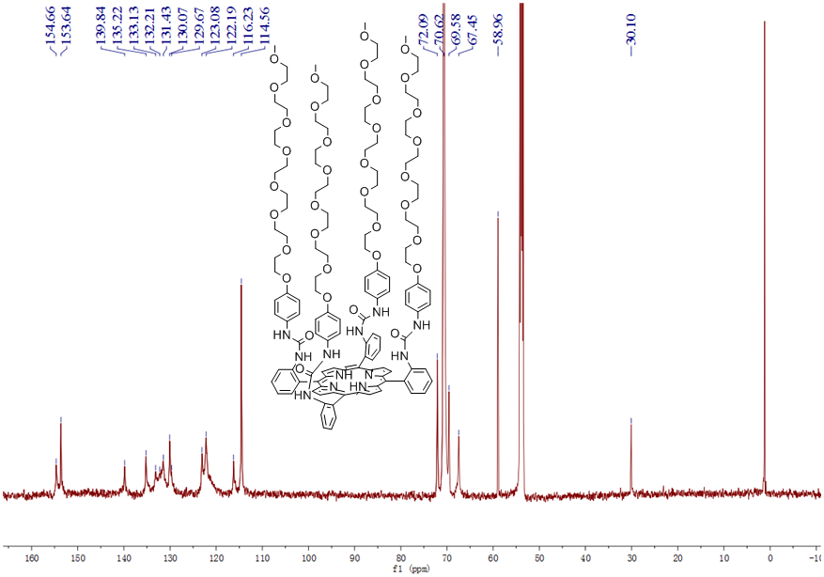
Supplementary Figure 12. ¹³C NMR spectrum (126 MHz, dichloromethane-d, room temperature) of 4.
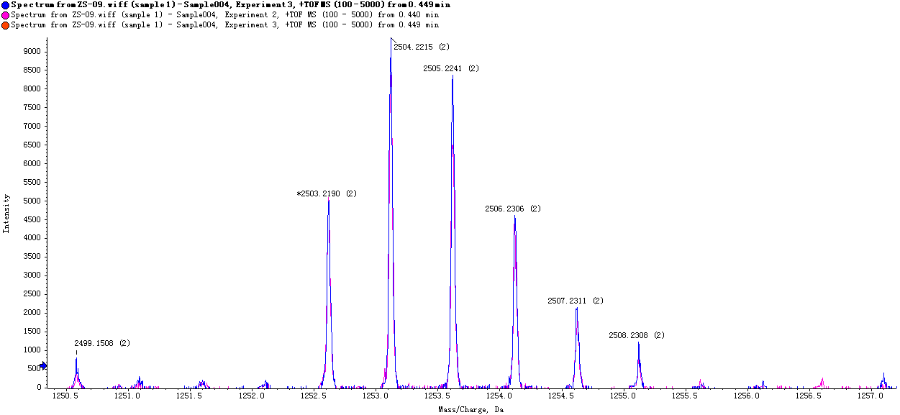
Supplementary Figure 13. ESI-TOF-MS of 5. Calcd for C₁₃₂H₁₇₄N₁₂O₃₆ [M + 2H]²⁺: 2505.2299, Found: 2505.2241.
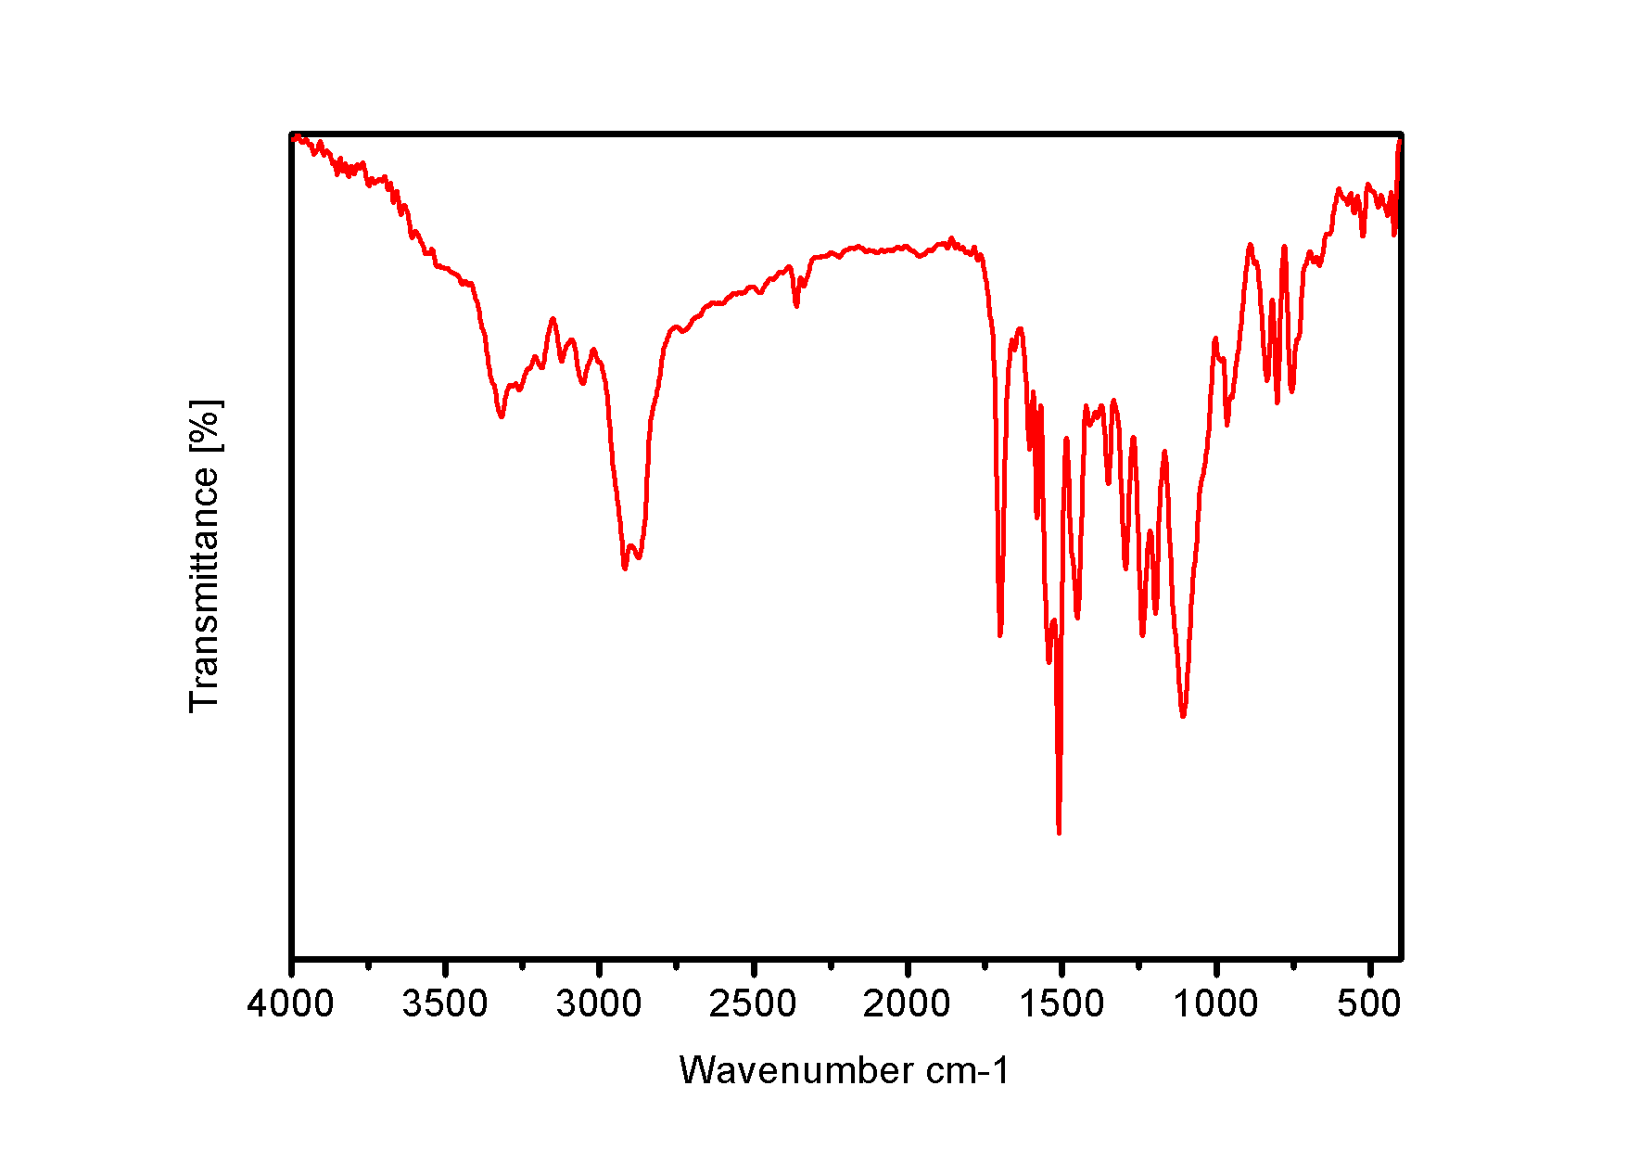
Supplementary Figure 14. FT-IR spectrum of 4.
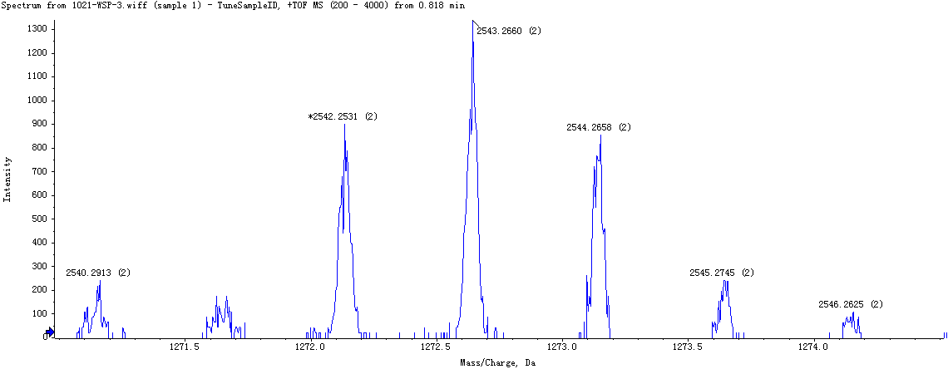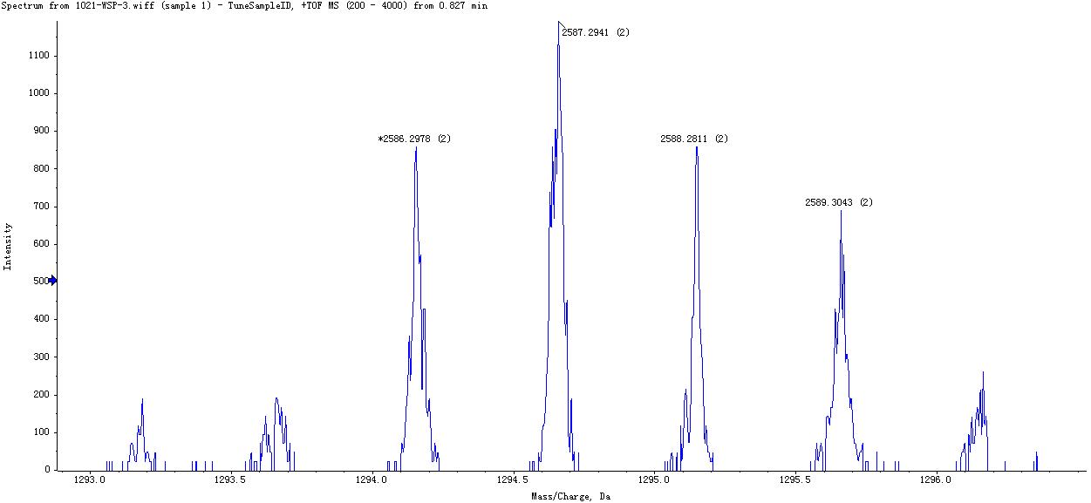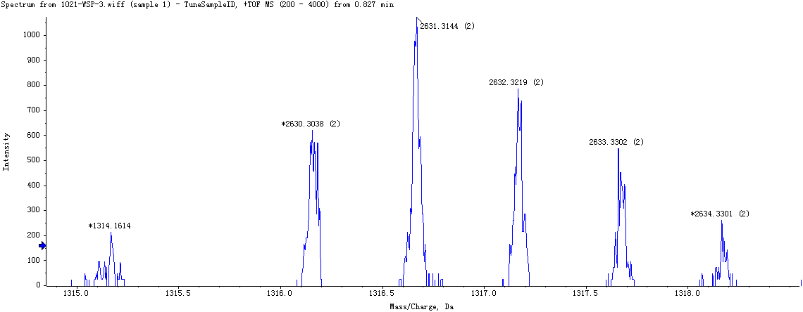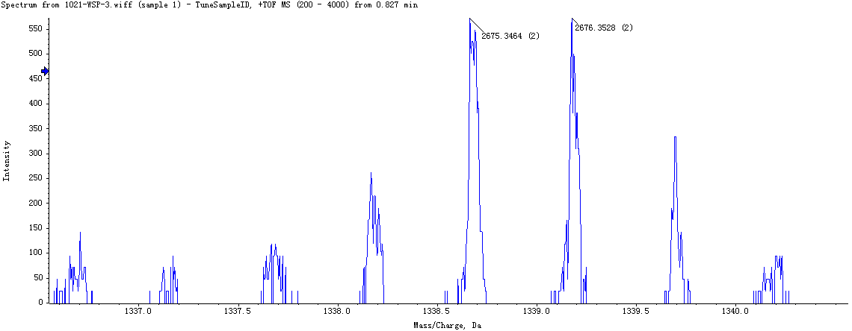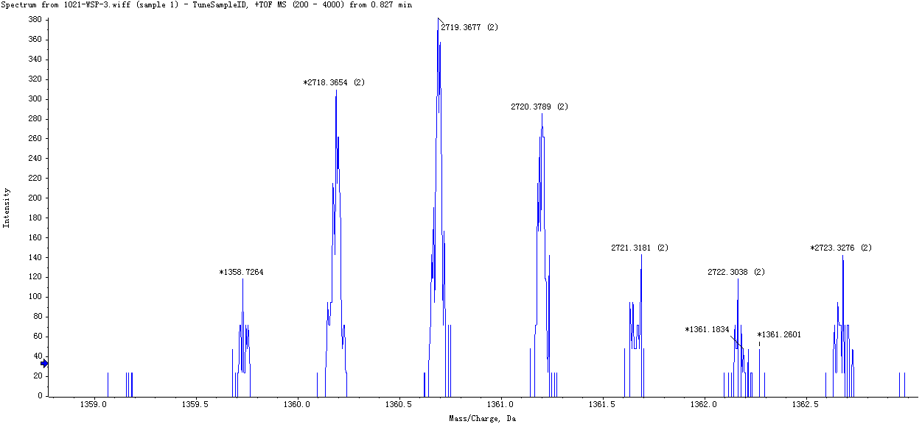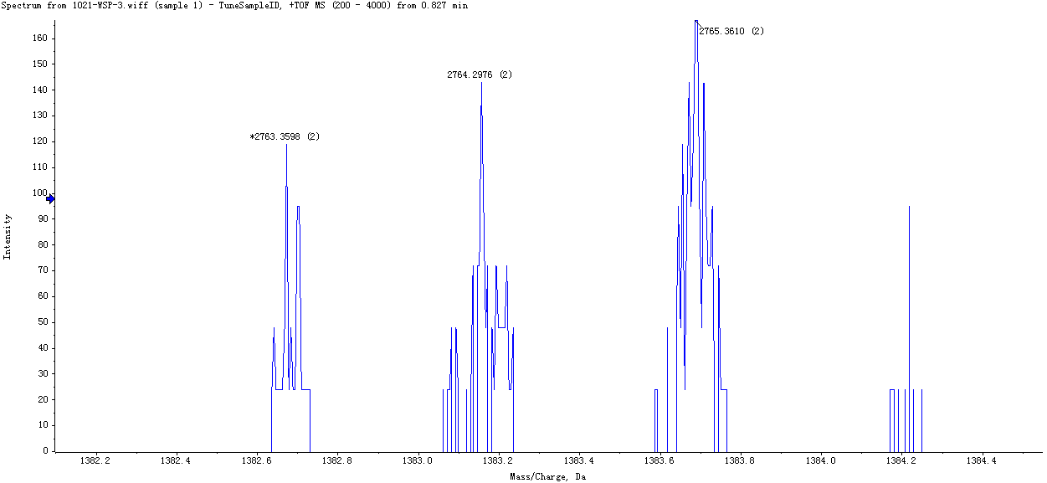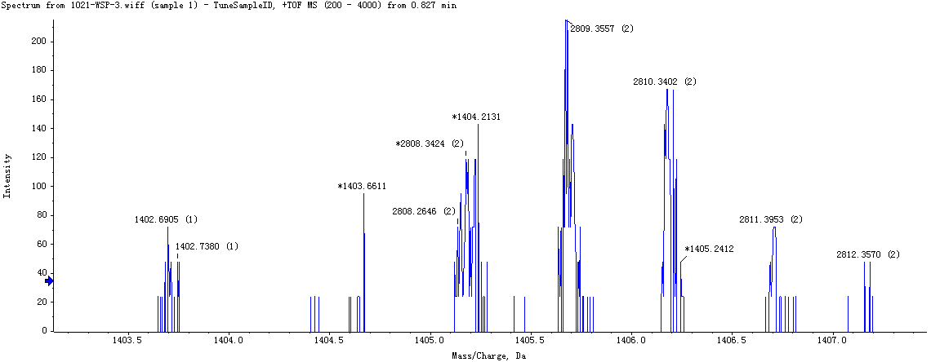
Supplementary Figure 15. ESI-TOF-MS of 4 : CPT= 1 : 1. Calcd for C₁₃₈H₁₆₂N₁₄O₃₃ [4 + CPT]: 2543.1429, Found: 2543.2660. Calcd for C₁₄₀H₁₆₆N₁₄O₃₄ [4 + CPT]: 2587.1691, Found: 2587.2941. Calcd for C₁₄₂H₁₇₀N₁₄O₃₅ [4 + CPT]: 2631.1953, Found: 2631.3144. Calcd for C₁₄₄H₁₇₄N₁₄O₃₆ [4 + CPT]: 2675.2215, Found: 2675.3464. Calcd for C₁₄₆H₁₇₈N₁₄O₃₇ [4 + CPT]: 2719.2477, Found: 2719.3677. Calcd for C₁₄₈H₁₈₂N₁₄O₃₈ [4 + CPT]: 2763.2739, Found: 2763.3598.
Several mass peaks related to individual 4 with different PEG chains and individual CPT were also observed, and no peaks consistent with self-assemblies formed with other stoichiometries were found (Supplementary Figure 15).
Supplementary Figure 16. TEM images of self-assemblies formed from CPT@P at different concentrations in water. a 1 × 10⁻³ mol/L. b 5 × 10⁻⁴ mol/L. c 1 × 10⁻⁴ mol/L. d 5 × 10⁻⁵ mol/L. e 1 × 10⁻⁵ mol/L. f 5 × 10⁻⁶ mol/L.
Supplementary Figure 17. TEM images of CPT@P and M in different mass ratio compositions in PBS. a, b, c, d, e and g M : CPT@P=1 : 8, 1 : 4, 1 : 2, 1 : 1, 2 : 8, 4 : 1, respectively. f is the enlargement of e. h DLS data of M : CPT@P=2 : 1 in PBS. i the stability image of nanoparticles with different mass ratio after a week.
The preparation process of the cancer cell membrane-camouflaged nanoparticles CPT@P«M was divided into three steps: preparation of nanoparticles CPT@P, cell membrane-derived vesicles from B16F10 or 4T1 cells and vesicle-nanoparticle fusion.
Firstly, CPT@P nanoparticles with different concentrations in aqueous solutions were prepared by adding a solution of P and CPT at a molar ratio of 1:1 in THF into water and then volatilizing the organic solvent. It was found that the shape and size of the self-assemblies could be controlled by adjusting the concentration. As well-known, the materials with reasonable sizes can enhance tumor accumulation of nanoparticles, reduce or eliminate undesirable “biofouling”, and avoid adverse immune responses. After optimization, we chose the concentration of 1 × 10⁻⁴ mol/L to prepare CPT@P nanoparticles in aqueous solutions. As shown in the TEM images (Supplementary Figure 16), CPT@P self-assembled into regular spherical nanoparticles with an average diameter of ~100 nm, which can prevent uptake by the reticuloendothelial system (RES) and prolong the circulation lifetime. Secondly, the derivation of cancer cell membrane vesicles was performed by following a previously reported method^{[2]} with slight modifications. Briefly, using B16F10 mouse melanoma cell and 4T1 mouse breast cell as the model cancer cell lines, membrane derivation was achieved by emptying harvested cells of their intracellular contents through a combination of hypotonic lysing, liquid nitrogen freeze-thaw disruption, and differential centrifugation. Next, the emptied cancer cell membrane vesicles were washed and extruded through 400 nm porous membranes to create cancer cell-membrane-derived vesicles. Finally, the cancer cell-membrane-camouflaged self-assembly nanoparticles were prepared by fusing the CPT@P nanoparticles with the cell-membrane-derived vesicles. The previously prepared CPT@P nanoparticles were mixed with the cell-membrane-derived vesicles and stored in a fridge overnight before physically extruded through an apparatus with 200 nm pores. The mechanical force facilitated the CPT@P nanoparticles to cross the lipid bilayers, thus resulting in vesicle-particle fusion.
In order to optimize the membrane coating, the CPT@P nanoparticles were fused with the cell-membrane-derived vesicles with different mass ratios (M : CPT@P = 1:8, 1:4, 1:2, 1:1 and 2:1) through a 200 nm porous polycarbonate membrane. As shown in the TEM images, one milligram of CPT@P nanoparticles mixed with two milligram cancer cell membrane derived vesicles showed completely encapsulation, the final CPT@P«M was approximately 100 nm in size and remained stable over a span of 7 days (Supplementary Figure 17).
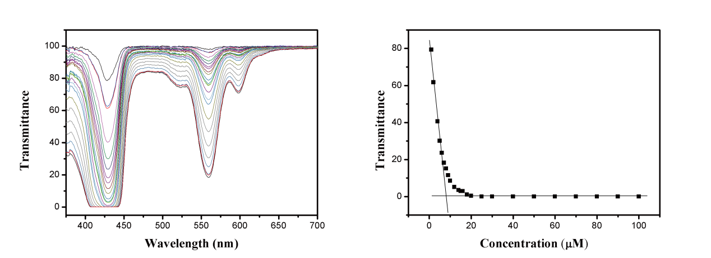
Supplementary Figure 18. CAC of CPT@P«M measured via the UV-vis transmittance at different concentrations.
Supplementary Figure 19. The diameter changes of CPT@P determined by DLS tests in PBS containing 10% FBS after different time periods of incubation.
Supplementary Figure 20. The fluorescence intensity changes at 530 nm of the solution containing SOSG in the presence of CPT@P (a) and CPT@P«M (b) with/without NaN₃ after irradiation for different cycles. The irradiation time was 30 s for each irradiation cycle (645 nm, 15mW/cm²).
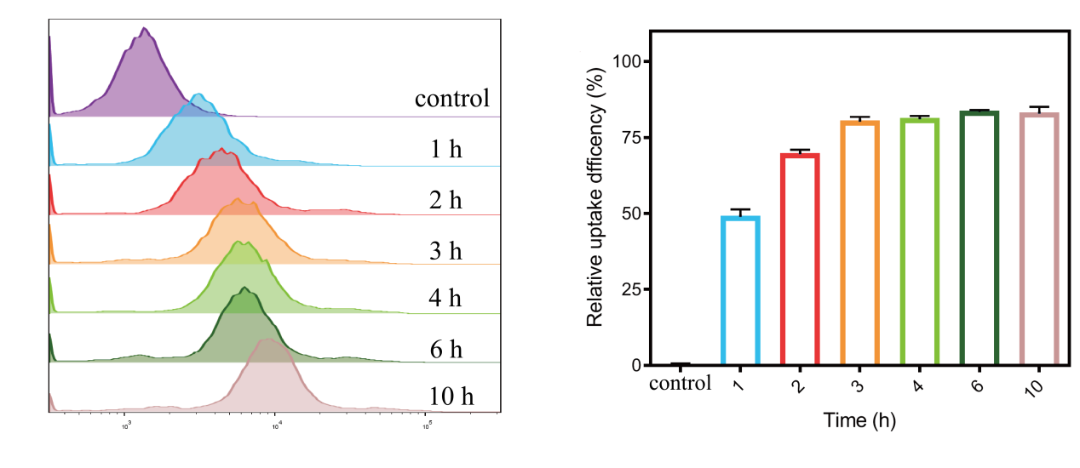
Supplementary Figure 21. Flow cytometric analysis and statistical result of B16F10 cells treated with CPT@P«M for 1 h, 2 h, 3 h, 4 h, 6 h and 10 h.
Supplementary Figure 22. Hemolysis rates of P, CPT@P and M at various concentrations after different time periods of incubation.
Supplementary Figure 23. Serum levels of a total protein (TP), b Albumin (ALB), c Albumin/Globulin (A/G), d Alanine aminotransferase (ALT), e Aspartate aminotransferase (AST), f Aspartate aminotransferase/Alanine aminotransferase (AST/ALT), g Alkaline phosphatase (ALP), h Uric acid (UA) and i Urea nitrogen (BUN) were quantified (mean ± SD, n = 3).
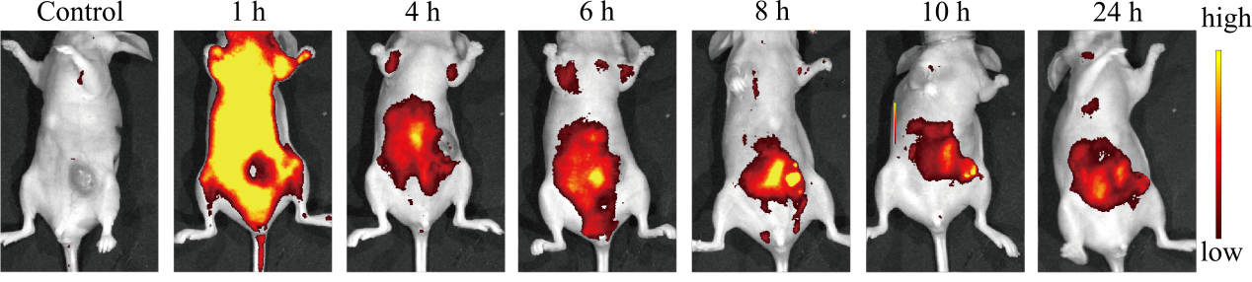
Supplementary Figure 24. Time-dependent fluorescence images of 4T1 tumor-bearing mouse after intravenous injection of CPT@P«M_{4T1}.
Supplementary Figure 25. In vivo tumor growth inhibition curves of the mice bearing orthotopic B16F10 melanoma tumours after different treatments (n = 5). The irradiation density was 80 mW/cm² at 645nm and the irradiation time was 10 min.
Supplementary Figure 26. Fluorescence images of frozen section of tumor tissues after different treatment via intravenous injection, where the DAPI nuclear stain was shown in blue and P, CPT@P and CPT@P«M_{B16F10} were shown in red. Scale bar is 50 μm.
Supplementary Figure 27. Body weight changes of the mice bearing orthotopic B16F10 melanoma tumours after different treatments (n = 5). The irradiation density was 80 mW/cm² at 645 nm and the irradiation time was 10 min.
Supplementary Figure 28. The biosafety evaluation of P, CPT@P and CPT@P«M_{B16F10}. H&E staining of the major organs (heart, liver, spleen, lung, and kidney) at the end of the experiments. Scale bar is 100 μm.

