Supplement

Methods: In Figure 1a), we plot the transformation curve for histogram equalization. The histeq function can return a 1-by-256 vector that shows, for each possible input value, the resulting output value, see Figure 1b). The registered texture feature maps on the MNI space were fed into a 10x10 nested cross-validation deep learning scheme for group classification, see Figure 2.
Grey matter: Across texture feature maps, regions contributing mostly to the recognition of FEP compared to HC (Figure 3) were the thalamus, amygdala, striatum, hypothalamus, hippocampus, frontal gyrus, caudate nucleus, cerebellum (energy) and frontal gyrus (sum of entropy). Regions contributing mostly to the recognition of FEP patients against CHR_NT patients (Figure 4) were parahippocampal, amygdala, precuneus, caudate, putamen, thalamus, hippocampus, insula, cerebellum, vermis, pallidum lingual and motor area (homogeneity). On the other hand, the region contributing mostly to the recognition of CHR_T patients that classified in the FEP group (Figure 5) was located in putamen (energy).
White matter: For the classification schema a), regions that contribute to the recognition of FEP against HC were in fornix(cres)/stria terminalis, posterior thalamic radiation left, superior corona radiata right (energy), medial lemniscus left, posterior limb of internal capsule right, superior and posterior fronto-occipital fasciculus right, superior longitudinal fasciculus right, corona radiata right (entropy), splenium of corpus callosum and middle cerebellar peduncle (homogeneity), superior fronto-occipital fasciculus, middle cerebellar peduncle and posterior limb of internal capsule right (sum of entropy) (Figure 3). Regions that contribute to the recognition of FEP patients against CHR_NT were in cerebral peduncle right, posterior limb of internal capsule right and external capsule right, body of corpus callosum, superior corona radiata right and superior longitudinal fasciculus right, posterior corona radiata right (energy) (Figure 4). The same regions were contributed to the classification of CHR_T patients as FEP using the energy map (Figure 5).
Across classification schemas, the white matter volumetric changes do not impact the values of the PR indicating that texture features capture inter-relation voxels dynamic with predictive power for psychosis. Changes in the CSF captured by the entropy and sum of entropy maps for the classification schema a) (Figure 3) and the homogeneity map for the classification schema b) (Figure 4). Using the entropy, energy, homogeneity and sum of entropy maps no correlation was revealed between PR and grey matter volumetric changes across classification schemas.

Figure 1: Representation of a) the transformation curve for histogram equalization and b) the adjusted intensities using histogram equalization.

a) | 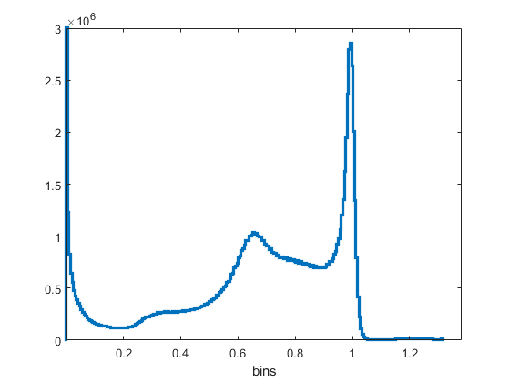  b)

Figure 2: Nested cross-validation schema.

Hold-out testing set
Training set splits into 10 folds
Validation set select the winner model
Training set

10 folds

Dataset

10 folds

10 repetitions

Figure 3
FEP vs HC

Entropy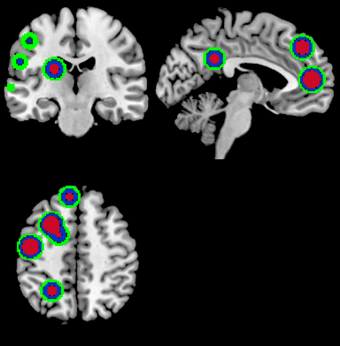 | Sum of Entropy  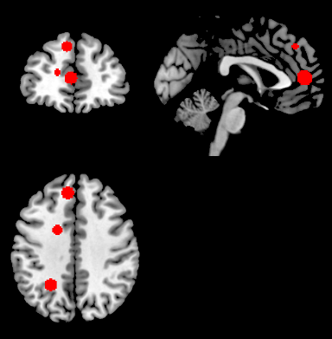
Homogeneity  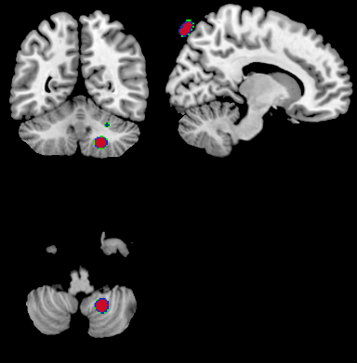 | Energy  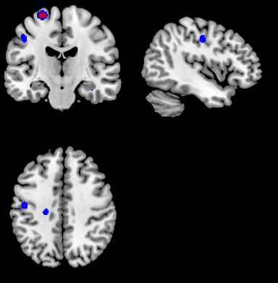

Figure 4
FEP vs CHR_NT

Homogeneity  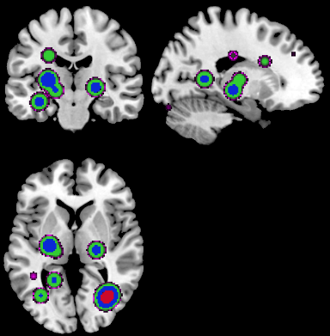 | Energy  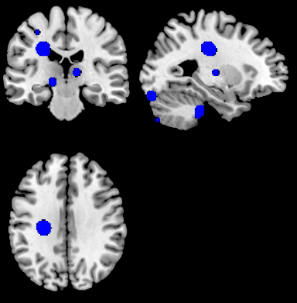

Figure 5
External validation CHR_T classified as FEP using the Energy map

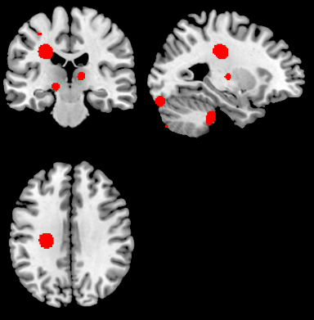

Figure 6: Correlation of the PR with the volumes for the correct classified FEP subjects in classification schema a) using the difference of entropy map a) and the contrast b).

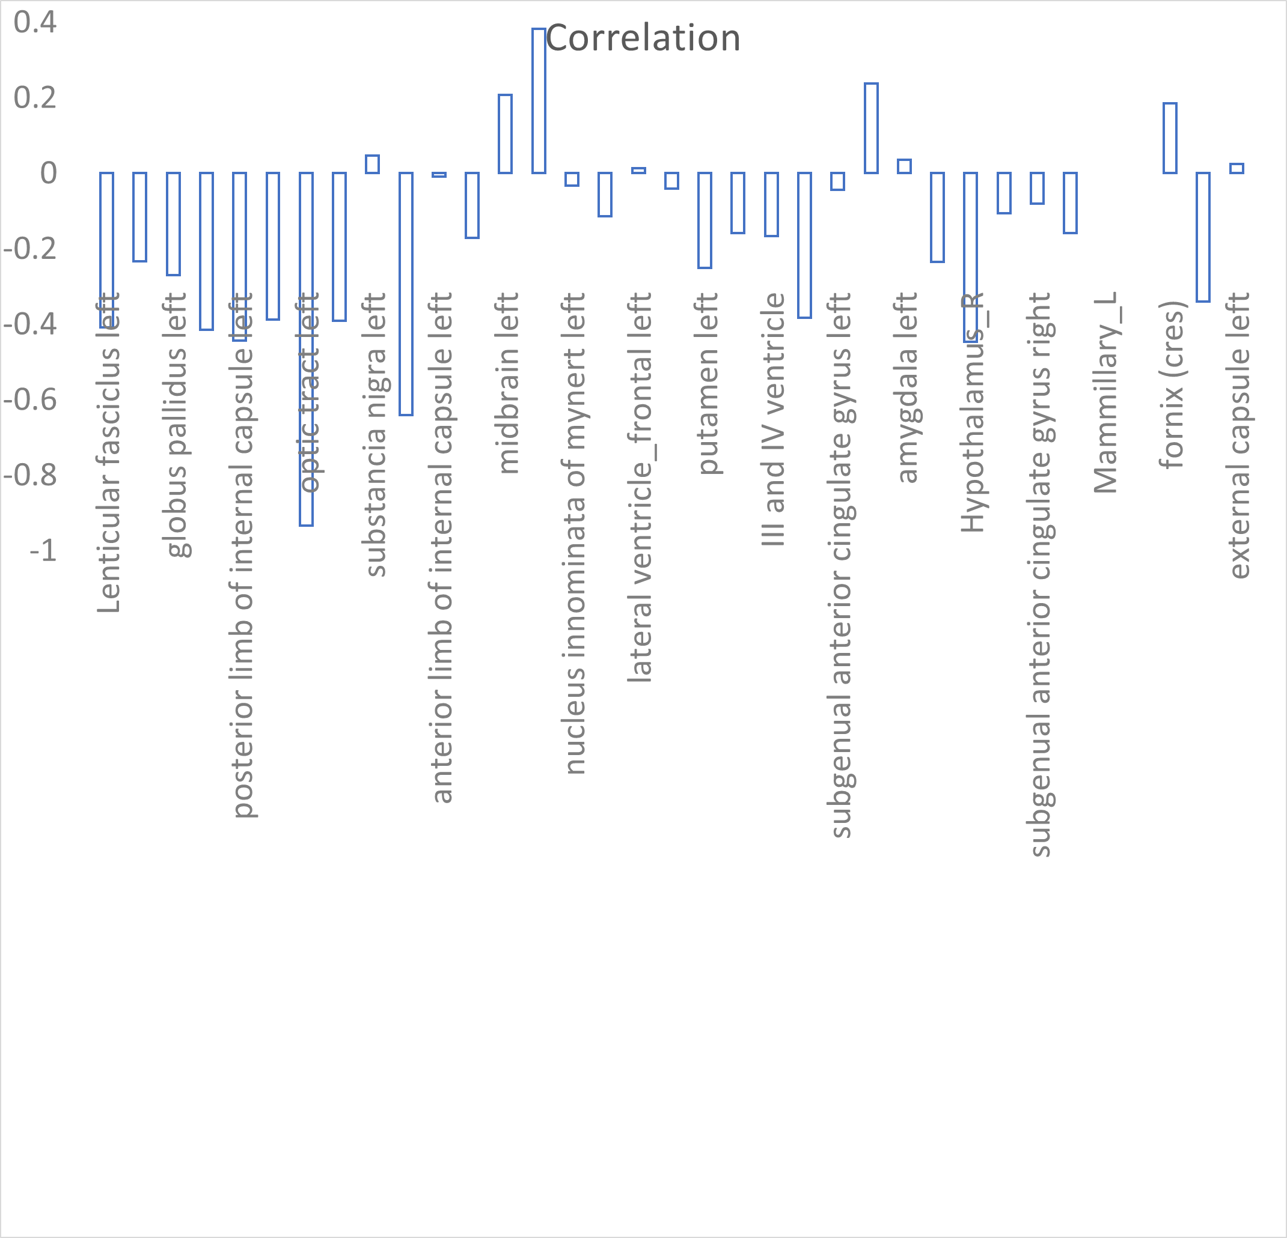
a)

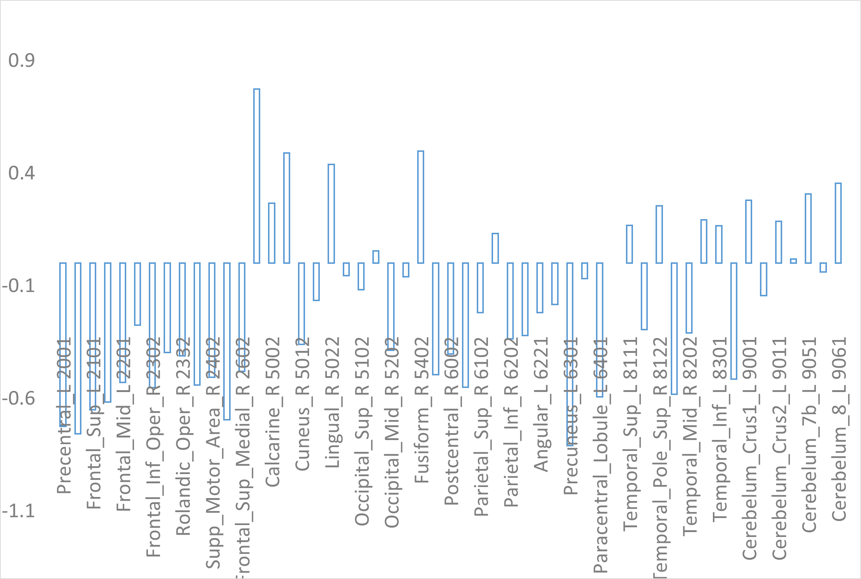
b)

Figure 7: Correlation of the PR with the volumes for the correct classified FEP subjects in classification schema b) using the difference of entropy map a) and the contrast b).

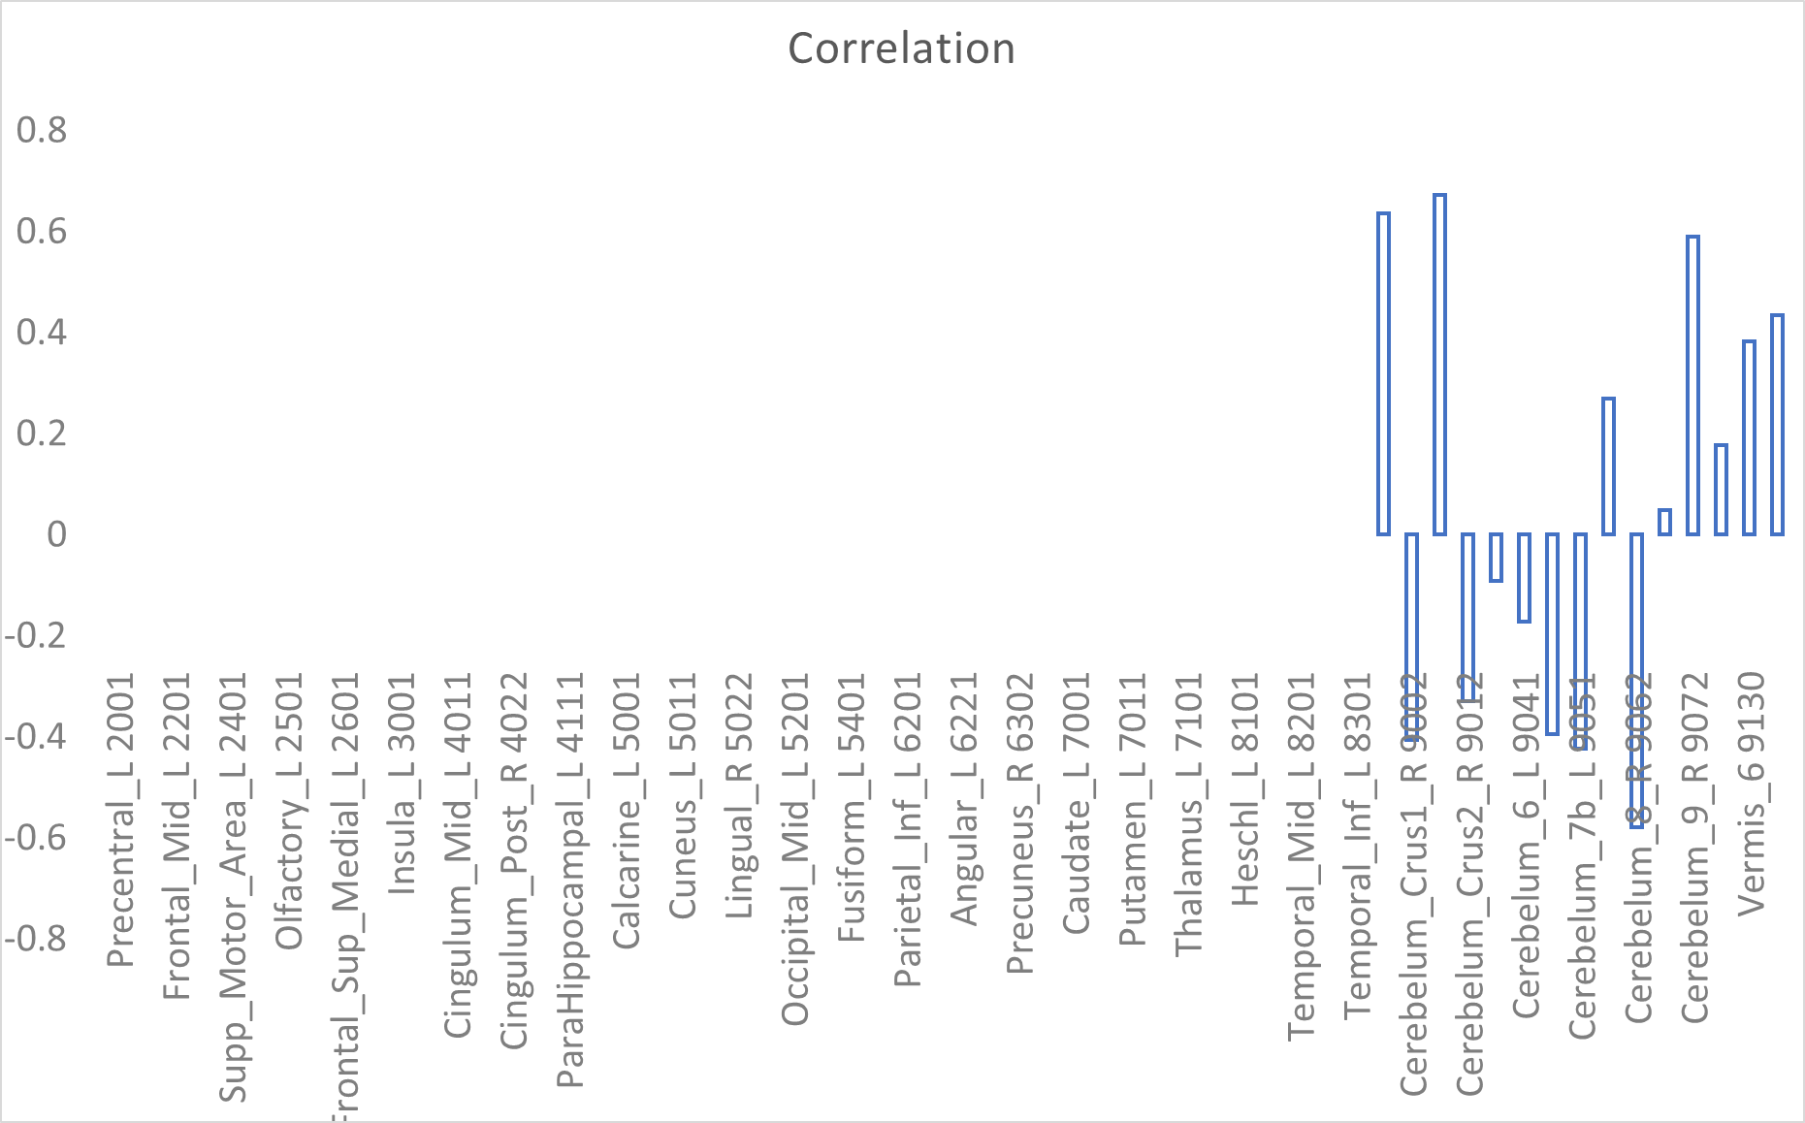
a)

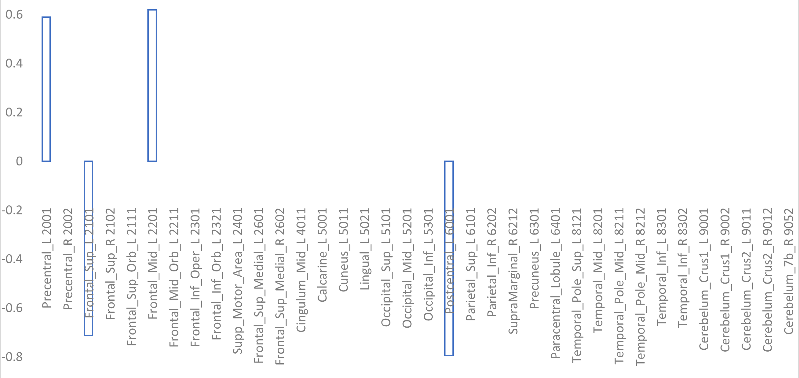
b)

Figure 8: Correlation of the PR with the volumes for the correct classified CHR_T patients as FEP in classification schema b) using the difference of entropy map.

