Tables

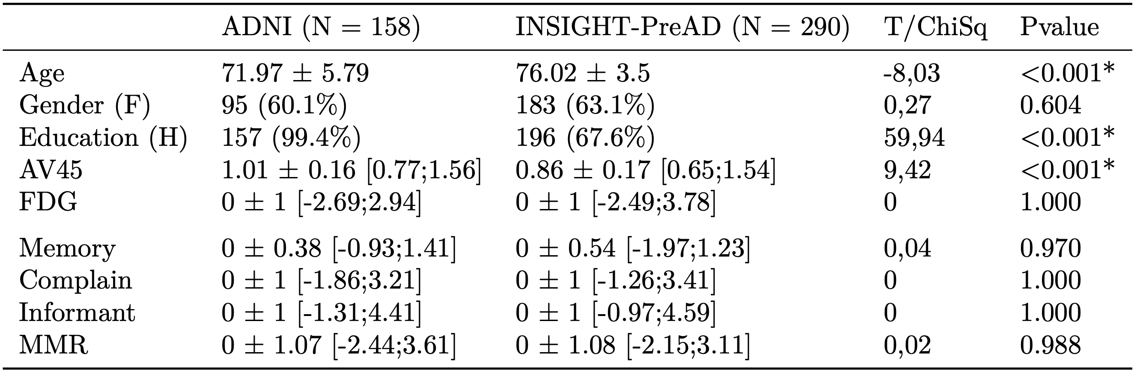
Table 1. Differences between cohorts. Notes: MMR = Meta Memory Ratio. Mean ± Standard-Deviation [Minimum ; Maximum].
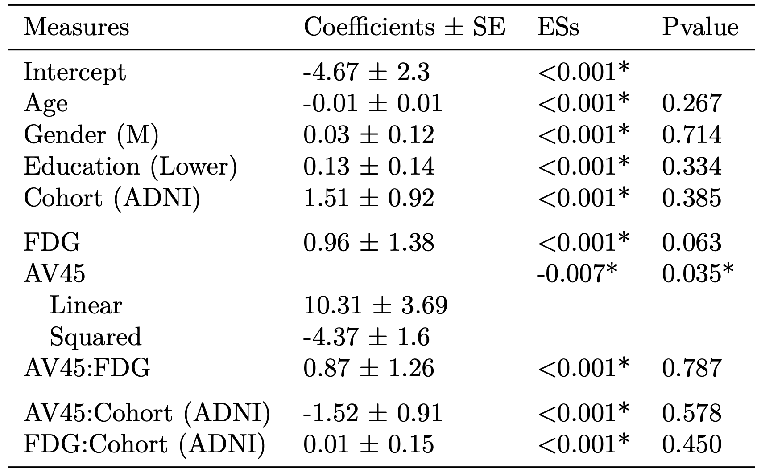
Table 2. Results of linear models on MMR. Notes: Coefficients and standard error (S.E.) were extracted from complete LMs with all interactions. For each categorical effect, the reference category is given in bracket. S.E. = Standard Error; ESs = Effect Sizes (Cohen’s F2).

